1. Explain telnet,ftp,ssh commands.

1. Telnet (TELecommunication NETwork)

**Def:** Allows remote access to a server's command-line interface. It enables users to execute commands on a remote machine as if they were directly at its console.

**Syntax:** telnet [hostname or IP address] [port]

2. FTP (File Transfer Protocol)

**Def:** Facilitates the transfer of files between a local machine and a remote server.

**syntax:** ftp [hostname or IP address]

3. SSH (Secure Shell)

**Def:** Provides a secure, encrypted channel for remote access to a server's command-line interface and for secure file transfers (via SFTP).

**syntax:** ssh [username]@[hostname or IP address]

2. Create a file commands.txt . write linux commands in it .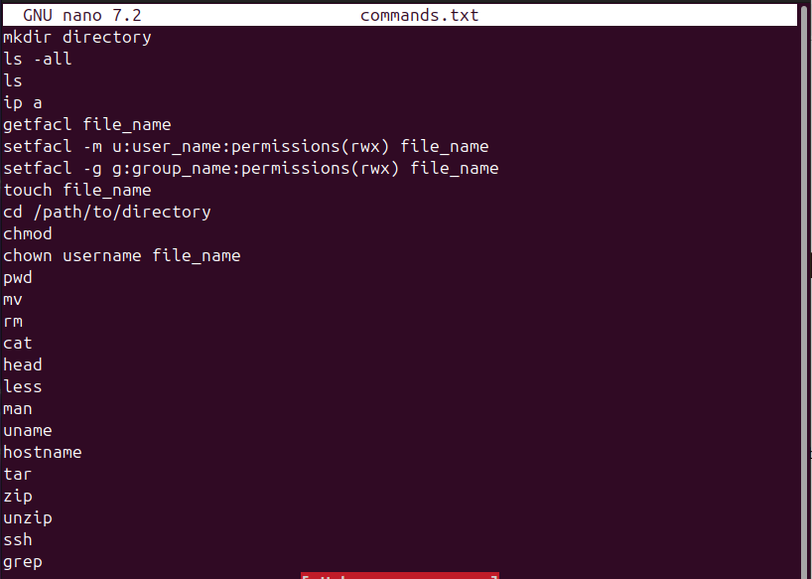

3. Count words in that file. Sort contents of file in reverse order.  
search the word “ls” in this file .

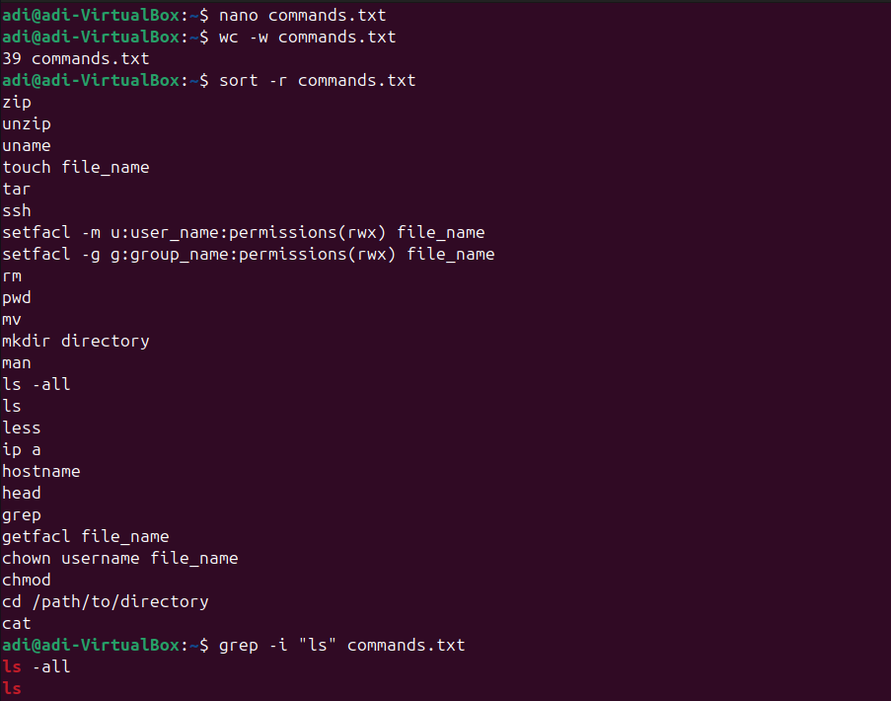

4. [count the number of lines](http://man7.org/linux/man-pages/man1/wc.1.html) in the file that contain "pwd”



5. Write a command that do not display lines containing “dbda”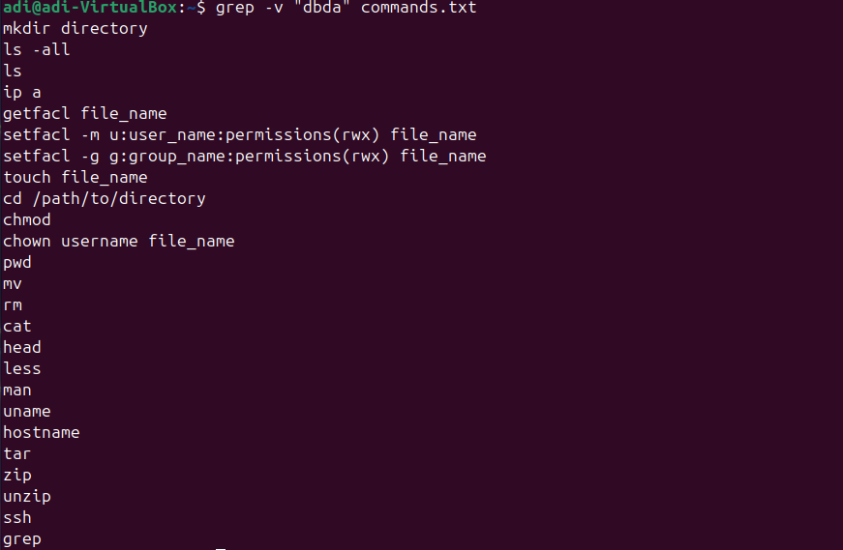

6. List all files and directories and give them as input to `grep` command using piping store in file.txt

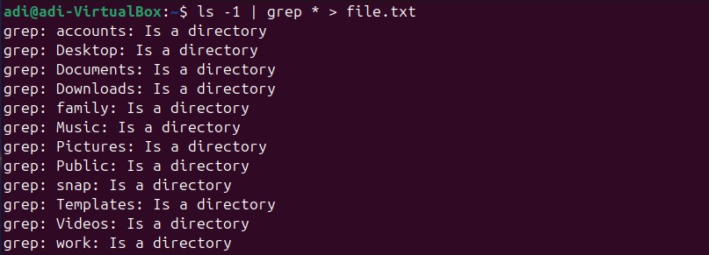

7. Sort file.txt

8. Write a Shell Script to find maximum between three numbers.

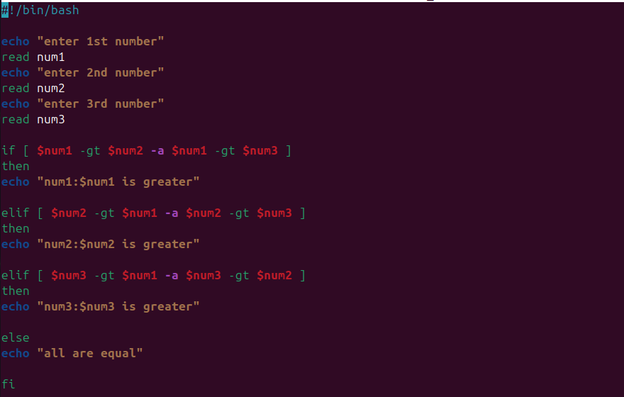

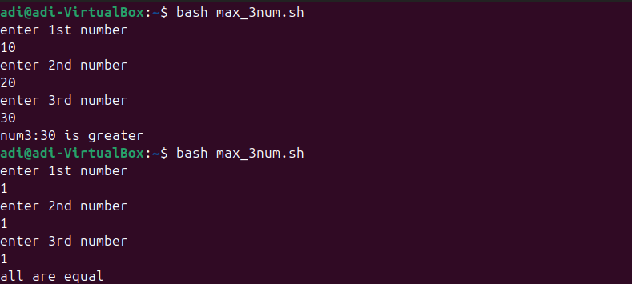

9. Write a Shell Script to check whether a number is negative, positive or zero.

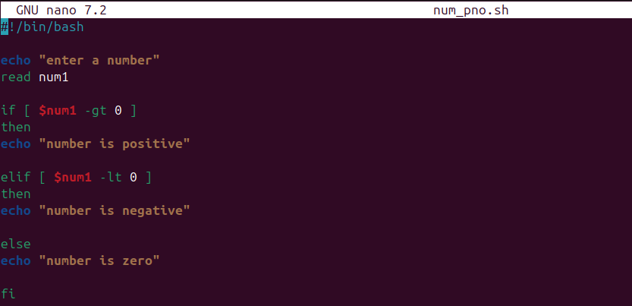

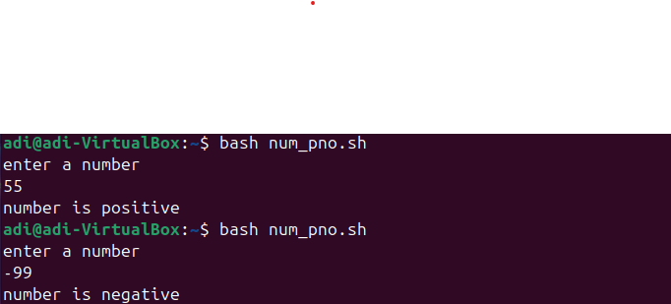

10. Write a Shell Script to check whether a number is divisible by 5 and 11 or not.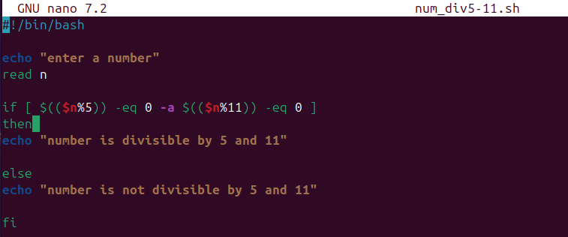

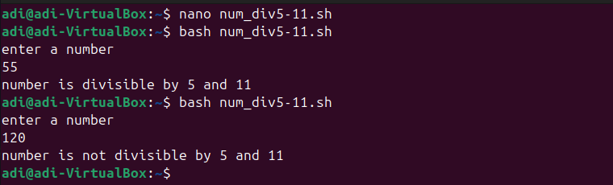

11. Write a Shell Script to check whether a number is even or odd.

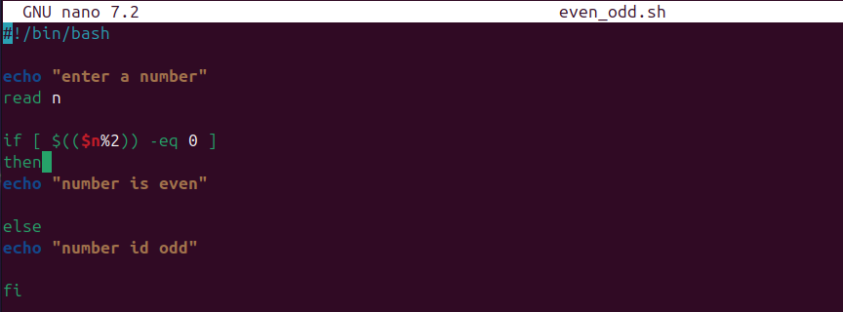

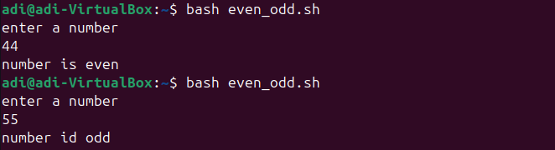

12. Write a Shell Script to check whether a year is leap year or not.

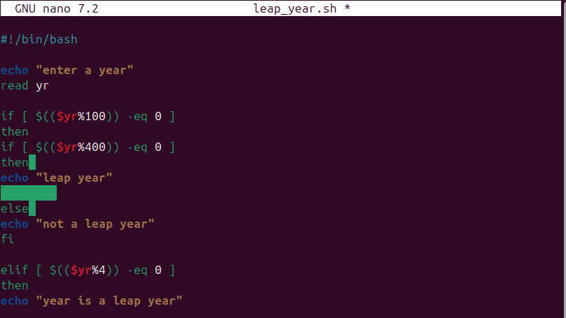

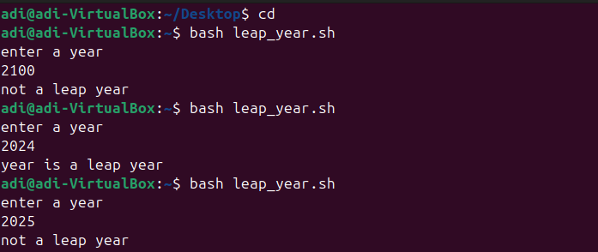

13. Write shell script to check eligibility of candidate for voter id card

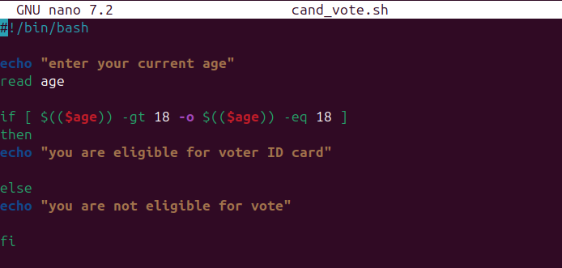



14. Shell Script to display the first 10 natural numbers.

