Kubernetes
3-Node Cluster
Deployment Guide
Created by – Aditya Yadav, Consulting Engineer, Cisco

Version | Kubernetes v1.35.3
Runtime | containerd
CNI Plugin | Cilium (eBPF-based)
Master Node | 10.197.226.100
Worker Node 1 | 10.197.226.103
Worker Node 2 | 10.197.226.104
OS | Ubuntu 22.04 LTS
Proxy | proxy.esl.cisco.com:8080
Pod CIDR | 192.168.0.0/16
Service CIDR | 10.96.0.0/12

1. Overview & Architecture

This document provides a complete, step-by-step deployment guide for a production-grade Kubernetes 3-node cluster running on Ubuntu 22.04 VMs inside a corporate proxy environment. It is derived from a real deployment session and includes every command, configuration file, error encountered, and fix applied.

1.1 Node Inventory
Node Name | IP Address | Role | OS
master-node | 10.197.226.100 | Control Plane (Master) | Ubuntu 22.04 LTS
worker-node-1 | 10.197.226.103 | Worker Node | Ubuntu 22.04 LTS
worker-node-2 | 10.197.226.104 | Worker Node | Ubuntu 22.04 LTS

1.2 Software Stack
Component | Version / Detail
Kubernetes | v1.35.3
Container Runtime | containerd (CRI-compatible)
CNI Plugin | Cilium — installed via: cilium install
Cilium Reference | https://docs.cilium.io/en/stable/installation/k8s-install-kubeadm/
Init Tool | kubeadm
Node Agent | kubelet
CLI | kubectl
Pod Network CIDR | 192.168.0.0/16
Service CIDR | 10.96.0.0/12
Corporate Proxy | http://proxy.esl.cisco.com:8080

1.4 kubectl Request Flow — How API Calls Work
Every kubectl command is translated into an HTTPS REST call to the Kubernetes API server on port 6443. The diagram below traces a full request lifecycle from the kubectl client on a remote Mac through the API server, etcd, scheduler, and down to the kubelet on a worker node.
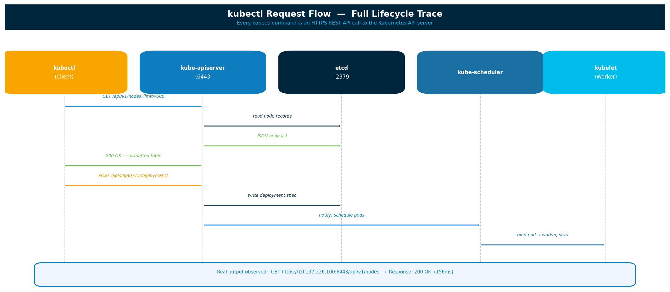

2. Prerequisites — All 3 Nodes

Every step in this section must be completed on all three nodes — master (10.197.226.100), worker-1 (10.197.226.103), and worker-2 (10.197.226.104) — before proceeding to cluster initialisation.

2.1 Disable Swap
⚠ Critical
Kubernetes scheduler will not function correctly if swap is enabled.
This must be disabled permanently — i.e. across reboots.

# Disable swap immediately
sudo swapoff -a

# Comment out swap entry to keep it off after reboot
sudo sed -i '/ swap / s/^/#/' /etc/fstab

2.2 Enable Required Kernel Modules
cat <<EOF | sudo tee /etc/modules-load.d/k8s.conf
overlay
br_netfilter
EOF

sudo modprobe overlay
sudo modprobe br_netfilter

2.3 Configure sysctl — Network Parameters
cat <<EOF | sudo tee /etc/sysctl.d/k8s.conf
net.bridge.bridge-nf-call-iptables = 1
net.bridge.bridge-nf-call-ip6tables = 1
net.ipv4.ip_forward = 1
EOF

sudo sysctl --system

2.4 Force IPv4 — Corporate Network Requirement
⚠ Required in Corporate / Proxy Environments
DNS servers in some corporate networks return only IPv6 addresses for registry.k8s.io.
containerd will attempt IPv6 by default and the connection will time out.
Both fixes below should be applied.

# Fix 1: Force IPv4 address selection preference
sudo nano /etc/gai.conf
# Uncomment the following line (remove the leading #):
# precedence ::ffff:0:0/96 100

# Fix 2: Disable IPv6 via sysctl
sudo nano /etc/sysctl.conf
# Append these two lines:
net.ipv6.conf.all.disable_ipv6 = 1
net.ipv6.conf.default.disable_ipv6 = 1

sudo sysctl -p

2.5 Install and Configure containerd
Kubernetes v1.24 and later no longer use Docker directly. The cluster communicates with the container runtime via the CRI (Container Runtime Interface). containerd is the recommended CRI-compatible runtime.

Install containerd
sudo apt update
sudo apt install -y containerd

# Generate a full default configuration
sudo mkdir -p /etc/containerd
containerd config default | sudo tee /etc/containerd/config.toml

Edit /etc/containerd/config.toml — Two Required Changes
⚠ Both Changes Are Required
Change 1: disabled_plugins must NOT include 'cri'.
Change 2: SystemdCgroup must be set to true.
Without these, kubeadm init will fail with: unknown service runtime.v1.RuntimeService

sudo nano /etc/containerd/config.toml

# CHANGE 1 — Enable the CRI plugin
# Find this line and change it:
# disabled_plugins = ["cri"]
# To:
disabled_plugins = []

# CHANGE 2 — Enable systemd cgroup driver
# Find this line (under runtimes.runc.options) and change it:
# SystemdCgroup = false
# To:
SystemdCgroup = true

# Restart and enable containerd
sudo systemctl daemon-reexec
sudo systemctl restart containerd
sudo systemctl enable containerd

# Verify containerd is healthy
sudo systemctl status containerd
sudo crictl info

2.6 Configure Proxy for containerd and kubelet
Shell proxy variables (export HTTP_PROXY=...) apply only to interactive shell processes. containerd and kubelet are managed by systemd and require proxy settings to be injected via systemd drop-in files.

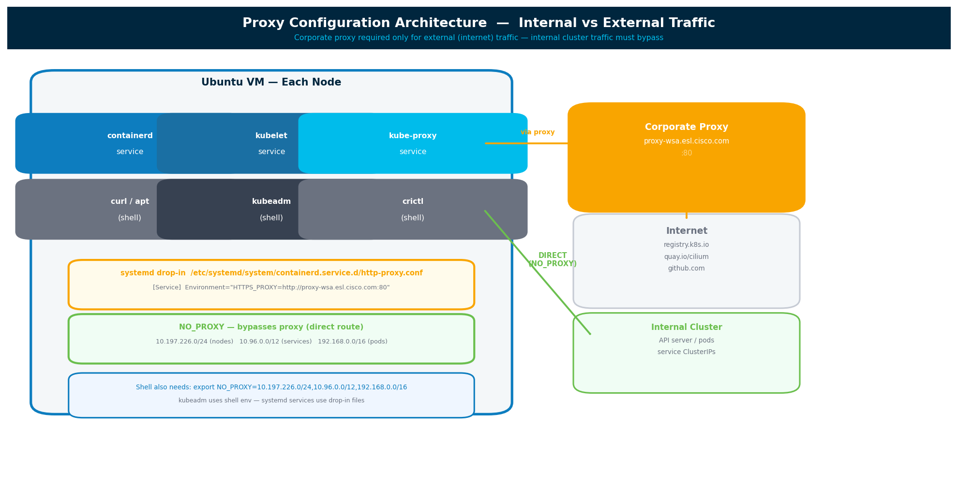
⚠ Common Mistake: Missing [Service] Header
If the http-proxy.conf file does not begin with [Service], systemd ignores
all entries and logs: 'Assignment outside of section. Ignoring.'
This results in containerd having no proxy and image pulls timing out.

# Create the override directory for containerd
sudo mkdir -p /etc/systemd/system/containerd.service.d

# Create the proxy configuration file
sudo nano /etc/systemd/system/containerd.service.d/http-proxy.conf

# File contents — [Service] header is REQUIRED:
[Service]
Environment="HTTP_PROXY=http://proxy.esl.cisco.com:8080"
Environment="HTTPS_PROXY=http://proxy.esl.cisco.com:8080"
Environment="NO_PROXY=localhost,127.0.0.1,10.197.226.0/24,10.96.0.0/12,192.168.0.0/16"

# Repeat for kubelet
sudo mkdir -p /etc/systemd/system/kubelet.service.d
sudo nano /etc/systemd/system/kubelet.service.d/http-proxy.conf

[Service]
Environment="HTTP_PROXY=http://proxy.esl.cisco.com:8080"
Environment="HTTPS_PROXY=http://proxy.esl.cisco.com:8080"
Environment="NO_PROXY=localhost,127.0.0.1,10.197.226.0/24,10.96.0.0/12,192.168.0.0/16"

# Apply changes
sudo systemctl daemon-reexec
sudo systemctl daemon-reload
sudo systemctl restart containerd
sudo systemctl restart kubelet

# Verify the proxy is visible to the service
systemctl show containerd | grep -i proxy
# Expected: Environment=HTTP_PROXY=... HTTPS_PROXY=... NO_PROXY=...

2.7 NO_PROXY Reference
CIDR / Host | Traffic Type | Must Bypass Proxy?
10.197.226.0/24 | All three cluster node IPs | Yes — direct
10.96.0.0/12 | Kubernetes Service ClusterIP range | Yes — direct
192.168.0.0/16 | Pod network CIDR (Cilium) | Yes — direct
localhost | Loopback — local API calls | Yes — direct
127.0.0.1 | IPv4 loopback | Yes — direct
registry.k8s.io | Kubernetes container images | No — via proxy
quay.io | Cilium container images | No — via proxy

2.8 Install Kubernetes Components
ℹ New GPG Key Method
The old apt-key method is deprecated. Ubuntu removed proper support.
The old Google GPG URL (packages.cloud.google.com) is no longer valid.
Use the new /etc/apt/keyrings method shown below.

sudo apt update
sudo apt install -y apt-transport-https ca-certificates curl

# Create keyrings directory
sudo mkdir -p /etc/apt/keyrings

# Add Kubernetes GPG key — new method
curl -fsSL https://pkgs.k8s.io/core:/stable:/v1.29/deb/Release.key | \
sudo gpg --dearmor -o /etc/apt/keyrings/kubernetes-apt-keyring.gpg

# Add Kubernetes apt repository
echo 'deb [signed-by=/etc/apt/keyrings/kubernetes-apt-keyring.gpg] \
https://pkgs.k8s.io/core:/stable:/v1.29/deb/ /' | \
sudo tee /etc/apt/sources.list.d/kubernetes.list

# Install the three core tools
sudo apt update
sudo apt install -y kubelet kubeadm kubectl

# Pin versions to prevent unintended upgrades
sudo apt-mark hold kubelet kubeadm kubectl

2.9 Set Shell Proxy Variables
export HTTP_PROXY=http://proxy.esl.cisco.com:8080
export HTTPS_PROXY=http://proxy.esl.cisco.com:8080
export NO_PROXY=localhost,127.0.0.1,10.197.226.100,10.197.226.103,10.197.226.104,10.197.226.0/24,10.96.0.0/12,192.168.0.0/16

2.10 Test Image Pull Before Initialisation
# Test that containerd can pull through the proxy
sudo crictl pull registry.k8s.io/pause:3.9

# If successful, pre-pull all control-plane images
kubeadm config images pull
✓ Success Checkpoint
If the pull succeeds, containerd, proxy configuration, and IPv4 routing are all correct.
Proceed to Section 3 to initialise the master node.

3. Initialise the Master Node

Run the following steps on 10.197.226.100 only.

3.1 Run kubeadm init
sudo kubeadm init

3.2 What kubeadm Does — Phase Breakdown
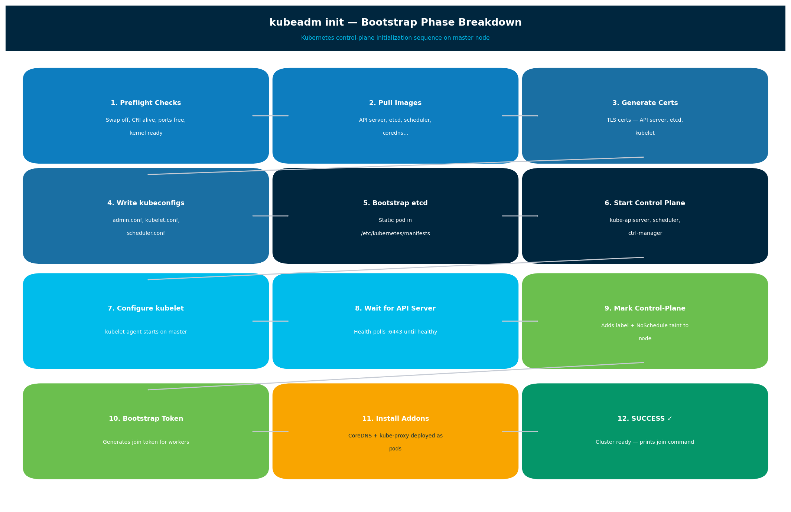
Phase | Action | Why It Exists
Preflight Checks | Validates swap, CRI, ports, sysctl | Prevents silent failures during operation
Pull Images | Downloads API server, etcd, scheduler, proxy | All control-plane components run as containers
Generate Certs | TLS certificates for all components | Kubernetes is secure-by-default; no cert = no access
Write kubeconfigs | admin.conf, kubelet.conf, scheduler.conf | Each component needs its own auth config
Bootstrap etcd | Static pod in /etc/kubernetes/manifests | etcd is the entire cluster's database
Start Control Plane | kube-apiserver, scheduler, controller-manager | Core brain of the cluster
Configure kubelet | Kubelet agent starts on master | Kubelet manages pods on the local node
Wait for API | Polls :6443 until healthy | Ensures cluster is actually usable before continuing
Mark Node | Adds label + NoSchedule taint | Prevents application pods from running on master
Bootstrap Token | Generates join token for workers | Workers authenticate with this token when joining
Install Addons | CoreDNS + kube-proxy as pods | DNS resolution and service routing inside the cluster

3.3 Configure kubectl Access on Master
mkdir -p $HOME/.kube
sudo cp -i /etc/kubernetes/admin.conf $HOME/.kube/config
sudo chown $(id -u):$(id -g) $HOME/.kube/config

3.4 Configure kubectl on a Remote Machine (Mac)
# Copy the kubeconfig from master to your local machine
scp ubuntu@10.197.226.100:/etc/kubernetes/admin.conf ~/.kube/config2

# Point kubectl at the remote cluster
export KUBECONFIG=~/.kube/config2
kubectl get nodes

3.5 Save the Join Command
kubeadm prints the join command at the end of a successful init. Save it immediately for use in Section 5.
kubeadm join 10.197.226.100:6443 \
--token <TOKEN> \
--discovery-token-ca-cert-hash sha256:<HASH>
ℹ Token Expiry
Join tokens expire after 24 hours by default.
If the token expires before workers are joined, regenerate with:
kubeadm token create --print-join-command

4. Install Cilium CNI

After kubeadm init, all nodes show NotReady. This is expected. Kubernetes requires a CNI (Container Network Interface) plugin before pods can communicate and nodes become Ready. Cilium was chosen as the CNI for this cluster because of its eBPF-based dataplane, high performance, and built-in observability via Hubble.

⚠ Do NOT Join Workers Yet
Install Cilium on the master before joining any worker nodes.
Workers that join before a CNI is installed will remain in NotReady indefinitely.

4.1 Cilium vs Calico — Comparison
Feature | Cilium | Calico
Dataplane | eBPF (Linux kernel) | iptables / nftables
Performance | High | Medium
Observability | Hubble (live traffic) | Limited
L7 Policies | Supported | Limited
kube-proxy | Can replace fully | Standard
Install Simplicity | cilium install | kubectl apply -f

4.2 Install Cilium CLI
# Download and install Cilium CLI on the master node
curl -LO https://github.com/cilium/cilium-cli/releases/latest/download/cilium-linux-amd64.tar.gz
tar xzvf cilium-linux-amd64.tar.gz
sudo mv cilium /usr/local/bin/

# Verify installation
cilium version

4.3 Install Cilium into the Cluster
Following the official Cilium kubeadm installation guide at:
https://docs.cilium.io/en/stable/installation/k8s-install-kubeadm/
cilium install

ℹ Note on Additional Parameters
The official Cilium kubeadm guide specifies only: cilium install
No additional --set flags are required for a standard kubeadm deployment.
Cilium automatically detects the Kubernetes API server and pod CIDR.

4.4 Verify Cilium Status
# Wait for all Cilium components to become healthy
cilium status --wait

# Expected output:
# Cilium: OK
# Operator: OK
# Envoy DaemonSet: OK
# Cluster Mesh: disabled

# Check that nodes are now Ready
kubectl get nodes

# Check kube-system pods — CoreDNS should now be Running
kubectl get pods -n kube-system

4.5 Enable Hubble Observability (Optional)
Hubble is Cilium's built-in observability platform. It provides real-time visibility into pod-to-pod traffic, DNS queries, and network policy decisions.
# Enable Hubble
cilium hubble enable

# Forward Hubble UI to local machine
cilium hubble port-forward &

# Observe live pod-to-pod traffic
cilium hubble observe

5. Join Worker Nodes

Repeat all steps from Section 2 on each worker node (10.197.226.103 and 10.197.226.104) before proceeding.

5.1 Worker Node Checklist
- Swap disabled: swapoff -a and /etc/fstab updated
- Kernel modules loaded: overlay and br_netfilter
- sysctl parameters applied: ip_forward, bridge-nf-call
- IPv6 disabled or IPv4 preference forced via /etc/gai.conf
- containerd installed with CRI plugin enabled and SystemdCgroup = true
- containerd proxy configured in /etc/systemd/system/containerd.service.d/http-proxy.conf
- kubelet proxy configured in /etc/systemd/system/kubelet.service.d/http-proxy.conf
- kubelet, kubeadm, kubectl installed and held at current version

5.2 Run the Join Command on Each Worker
# Run this command on worker-node-1 (10.197.226.103)
# Run this command on worker-node-2 (10.197.226.104)

kubeadm join 10.197.226.100:6443 \
--token <TOKEN> \
--discovery-token-ca-cert-hash sha256:<HASH>

ℹ Shell NO_PROXY Before Joining
Set the following in the shell before running kubeadm join:
export NO_PROXY=localhost,127.0.0.1,10.197.226.0/24,10.96.0.0/12,192.168.0.0/16
This prevents kubeadm from routing the API server connection through the proxy.

5.3 Verify from Master Node
kubectl get nodes

# Expected output:
# NAME STATUS ROLES AGE VERSION
# master-node Ready control-plane 16h v1.35.3
# worker-node-1 Ready <none> 85m v1.35.3
# worker-node-2 Ready <none> 83m v1.35.3
✓ Cluster Ready
All three nodes in Ready state confirms the cluster is fully operational.
CoreDNS pods in kube-system namespace should also show Running.

6. Troubleshooting Guide

This section documents every real error encountered during the deployment of this cluster, along with the exact root cause and fix applied. All errors are from the actual deployment session.

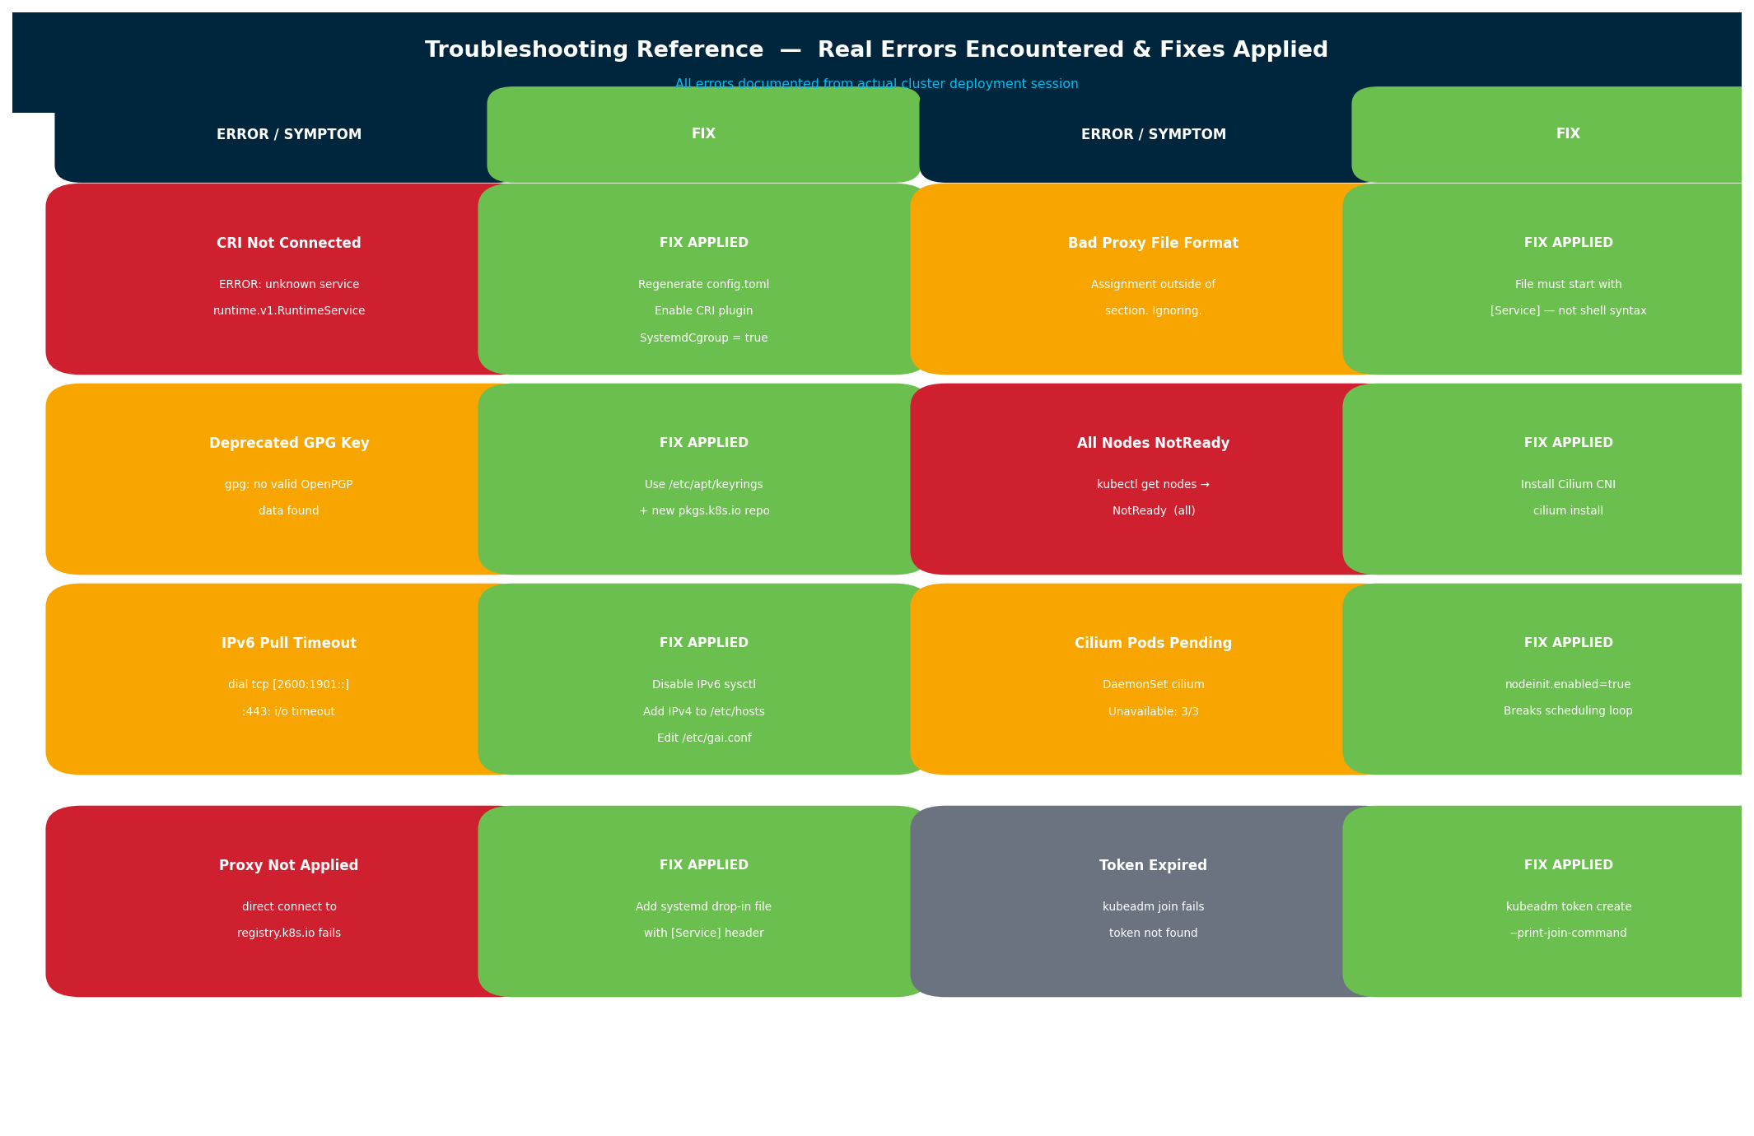

6.1 CRI Not Connected
✗ Error Message
[ERROR CRI]: could not connect to the container runtime
unknown service runtime.v1.RuntimeService

Root Cause
- containerd is running but the CRI plugin is explicitly disabled
- disabled_plugins = ["cri"] is set in /etc/containerd/config.toml
- SystemdCgroup is false — kubelet and containerd are on different cgroup drivers

Fix
# Full reset of containerd
sudo systemctl stop containerd
sudo rm -f /etc/containerd/config.toml
sudo apt purge -y containerd && sudo apt install -y containerd

# Regenerate clean config
sudo mkdir -p /etc/containerd
containerd config default | sudo tee /etc/containerd/config.toml

# Apply required changes:
# disabled_plugins = [] (was ["cri"])
# SystemdCgroup = true (was false)

sudo systemctl daemon-reexec
sudo systemctl restart containerd
sudo systemctl enable containerd

# Verify CRI is now working
sudo crictl info

# Reset kubeadm state before retrying
sudo kubeadm reset -f

6.2 Deprecated GPG Key (apt-key)
✗ Error Message
gpg: no valid OpenPGP data found
Warning: apt-key is deprecated. Manage keyring files directly.

Root Cause
The old Kubernetes APT repository used apt-key and a Google-hosted GPG URL that is no longer valid. Ubuntu has deprecated apt-key in favour of per-repository keyring files.
Fix
# Remove stale repository entry
sudo rm -f /etc/apt/sources.list.d/kubernetes.list

# New method — repository-scoped keyring
sudo mkdir -p /etc/apt/keyrings
curl -fsSL https://pkgs.k8s.io/core:/stable:/v1.29/deb/Release.key | \
sudo gpg --dearmor -o /etc/apt/keyrings/kubernetes-apt-keyring.gpg

echo 'deb [signed-by=/etc/apt/keyrings/kubernetes-apt-keyring.gpg] \
https://pkgs.k8s.io/core:/stable:/v1.29/deb/ /' | \
sudo tee /etc/apt/sources.list.d/kubernetes.list

sudo apt update
sudo apt install -y kubelet kubeadm kubectl

6.3 Image Pull Timeout — IPv6 Issue
✗ Error Message
dial tcp [2600:1901:0:bbc4::]:443: i/o timeout
failed to pull image from registry.k8s.io

Root Cause
DNS resolved registry.k8s.io to an IPv6 address. The corporate proxy does not support IPv6 or the VM's network stack has IPv6 connectivity issues. Confirmed by running: getent hosts registry.k8s.io — which returned only an IPv6 address.
Fix
# Confirm diagnosis
getent hosts registry.k8s.io
# If only IPv6 shown — apply these fixes:

# Fix 1: Force IPv4 preference in address selection
sudo nano /etc/gai.conf
# Uncomment: precedence ::ffff:0:0/96 100

# Fix 2: Add IPv4 /etc/hosts entry (if DNS returns no IPv4 A record)
dig +short registry.k8s.io A # Get current IPv4
echo '34.120.x.x registry.k8s.io' | sudo tee -a /etc/hosts

# Fix 3: Disable IPv6 entirely
sudo nano /etc/sysctl.conf
# Add: net.ipv6.conf.all.disable_ipv6 = 1
# net.ipv6.conf.default.disable_ipv6 = 1
sudo sysctl -p

# Restart containerd and test
sudo systemctl restart containerd
sudo crictl pull registry.k8s.io/pause:3.9

6.4 Proxy Not Applied to containerd
✗ Error Message
dial tcp 34.96.108.209:443: i/o timeout (direct connection to registry blocked)
Warning: Connection to 'https://10.197.226.100' uses proxy
Warning: Connection to '10.96.0.0/12' uses proxy

Root Cause — Two Separate Issues
- Issue 1: containerd systemd service has no proxy — shell export does not propagate to systemd
- Issue 2: NO_PROXY is missing cluster IP ranges — internal traffic is being routed through the proxy

Fix
# Create / fix the containerd proxy drop-in file
sudo nano /etc/systemd/system/containerd.service.d/http-proxy.conf

# CRITICAL: File must begin with [Service]
[Service]
Environment="HTTP_PROXY=http://proxy.esl.cisco.com:8080"
Environment="HTTPS_PROXY=http://proxy.esl.cisco.com:8080"
Environment="NO_PROXY=localhost,127.0.0.1,10.197.226.0/24,10.96.0.0/12,192.168.0.0/16"

sudo systemctl daemon-reexec
sudo systemctl daemon-reload
sudo systemctl restart containerd

# Confirm proxy environment is visible
systemctl show containerd | grep -i proxy

6.5 systemd Drop-in File: Assignment Outside Section
✗ systemd Journal Warning
Assignment outside of section. Ignoring.
(Proxy settings are silently ignored — containerd has no proxy configured)

Root Cause
The http-proxy.conf file was written as a plain shell variable assignment (KEY=value) without the required [Service] section header. systemd requires all drop-in files to be structured as INI files with section headers.
Incorrect vs Correct Format
# WRONG — Missing [Service] header, systemd ignores everything below:
HTTP_PROXY=http://proxy.esl.cisco.com:8080
HTTPS_PROXY=http://proxy.esl.cisco.com:8080

# CORRECT — [Service] header required for systemd drop-in files:
[Service]
Environment="HTTP_PROXY=http://proxy.esl.cisco.com:8080"
Environment="HTTPS_PROXY=http://proxy.esl.cisco.com:8080"
Environment="NO_PROXY=localhost,127.0.0.1,10.197.226.0/24,10.96.0.0/12,192.168.0.0/16"

6.6 All Nodes NotReady After kubeadm init / join
✗ kubectl get nodes Output
master-node NotReady control-plane
worker-node-1 NotReady <none>
worker-node-2 NotReady <none>

Root Cause
No CNI (Container Network Interface) plugin is installed. Kubernetes requires a CNI plugin for pod networking before nodes transition to Ready state. This is normal and expected immediately after kubeadm init.
Fix — Install Cilium
# On master node
cilium install

# Wait for all components to become healthy
cilium status --wait

# Nodes should now transition to Ready
kubectl get nodes

6.7 Error Summary Table
Error / Symptom | Root Cause | Fix
CRI not connected | CRI plugin disabled / SystemdCgroup=false | Regenerate config.toml; set disabled_plugins=[] and SystemdCgroup=true
gpg no valid OpenPGP | Deprecated apt-key method and old URL | Use /etc/apt/keyrings with new pkgs.k8s.io repository
i/o timeout — IPv6 address | DNS returns only IPv6; proxy/network rejects it | Disable IPv6 sysctl; set IPv4 preference in /etc/gai.conf
Direct connect timeout | containerd missing proxy — shell export not enough | Add systemd drop-in file with [Service] header
Assignment outside of section | http-proxy.conf missing [Service] header | Ensure [Service] is the first line of the conf file
Nodes NotReady | No CNI plugin installed | Run: cilium install
Token expired for join | kubeadm join tokens last 24 hours | Run: kubeadm token create --print-join-command

7. Cluster Verification Commands

7.1 Node and Pod Status
# Node overview
kubectl get nodes
kubectl get nodes -o wide # Includes IP and kernel version
kubectl describe node master-node # Full detail for one node

# Pod status across all namespaces
kubectl get pods --all-namespaces
kubectl get pods -n kube-system
kubectl get pods -n kube-system -o wide # Shows which node each pod runs on

7.2 Cilium Health
cilium status
cilium status --wait
cilium connectivity test # Full end-to-end pod-to-pod connectivity test

7.3 API Server Request Tracing
# Show actual HTTP requests kubectl sends to the API server
kubectl get nodes -v=8

# Output includes:
# Config loaded from file: /Users/.../.kube/config2
# Request verb=GET url=https://10.197.226.100:6443/api/v1/nodes?limit=500
# Accept: application/json
# User-Agent: kubectl/v1.35.3 (darwin/arm64)
# Response status=200 OK milliseconds=156

# View API server container logs
sudo crictl ps | grep kube-apiserver
sudo crictl logs <container-id>

7.4 Enable API Audit Logging
# Step 1: Create audit policy
sudo vi /etc/kubernetes/audit-policy.yaml

apiVersion: audit.k8s.io/v1
kind: Policy
rules:
- level: Metadata

# Step 2: Add flags to API server manifest
sudo vi /etc/kubernetes/manifests/kube-apiserver.yaml

# Add under spec.containers[0].command:
- --audit-policy-file=/etc/kubernetes/audit-policy.yaml
- --audit-log-path=/var/log/kubernetes/audit.log

# kubelet auto-restarts the API server

# Step 3: Watch live audit log
sudo tail -f /var/log/kubernetes/audit.log

7.5 General Debug Reference
# containerd
sudo systemctl status containerd
journalctl -u containerd -xe
sudo crictl info
sudo crictl ps
sudo crictl images

# kubelet
sudo systemctl status kubelet
journalctl -u kubelet -f

# Pod debugging
kubectl describe pod -n kube-system <pod-name>
kubectl logs -n kube-system <pod-name>
kubectl events -n kube-system

# Proxy verification
systemctl show containerd | grep -i proxy
systemctl show kubelet | grep -i proxy

# Network / DNS check
getent hosts registry.k8s.io # Should return an IPv4 address
curl -4 https://registry.k8s.io

8. Next Steps

With the 3-node cluster operational, the following are recommended next steps:

- Deploy first application: kubectl create deployment nginx --image=nginx
- Expose via NodePort: kubectl expose deployment nginx --type=NodePort --port=80
- Enable Hubble observability: cilium hubble enable
- Deploy Kubernetes Dashboard for a web-based management UI
- Configure RBAC for multi-user or service-account access control
- Add persistent storage with a StorageClass (e.g. local-path-provisioner)
- Deploy NGINX Ingress Controller or Cilium Gateway API for L7 routing
- Set up cluster monitoring: Prometheus + Grafana via kube-prometheus-stack Helm chart
- Configure CI/CD pipeline to deploy workloads into this cluster

