EmbedUR Online Training
Advanced C Programming
Assignment – 2
Topics Covered: Processes and Threads

Name: G Adithya Prasad
- Write a C program to define 3 different threads with the following purposes where N is the input
  - Thread A - To run a loop and return the sum of first N prime numbers
  - Thread B & C - should run in parallel. One prints "Thread 1 running" every 2 seconds, and the other prints "Thread 2 running" every 3 seconds for 100 seconds.
Code:
#include <stdio.h> #include <pthread.h> #include <unistd.h>

int N;

int isPrime(int n){ if(n < 2) return 0;
for(int i = 2; i * i <= n; i++){ if(n % i == 0) return 0;
}
return 1;
}

void* threadA(void* arg){
int count = 0, num = 2, sum = 0;

while(count < N){ if(isPrime(num)){
sum += num; count++;
}
num++;
}

printf("Sum of first %d prime numbers = %d\n", N, sum); return NULL;
}

void* threadB(void* arg){ for(int i = 0; i < 50; i++){
printf("Thread 1 running\n"); sleep(2);
}
return NULL;
}

void* threadC(void* arg){ for(int i = 0; i < 34; i++){
printf("Thread 2 running\n");

sleep(3);
}
return NULL;
}

int main(){
pthread_t t1, t2, t3;

printf("Enter N: ");
scanf("%d", &N);

pthread_create(&t1, NULL, threadA, NULL); pthread_create(&t2, NULL, threadB, NULL); pthread_create(&t3, NULL, threadC, NULL);

pthread_join(t1, NULL); pthread_join(t2, NULL); pthread_join(t3, NULL);

return 0;
}

Sample Output:
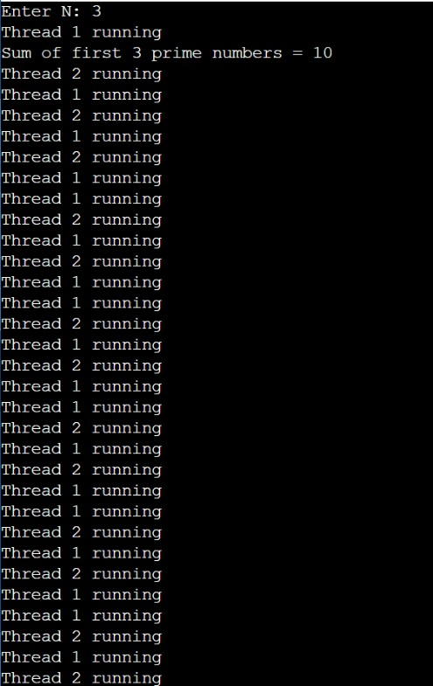
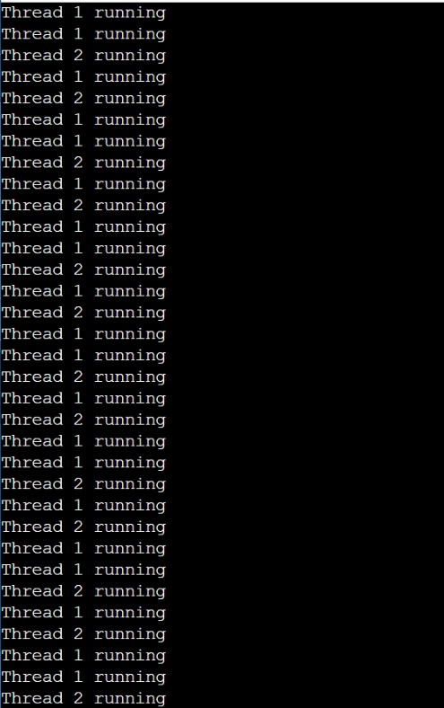
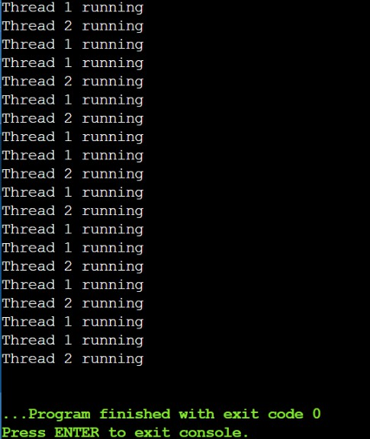

- In the above program,
  - add signal handling for SIGINT (etc) and prevent termination.
  - Convert the above threads to individual functions and note down the time taken and the flow of execution.
Sample Code:
#include <signal.h>

void handler(int sig){
printf("Signal %d received. Program continues...\n", sig);
}

int main(){
signal(SIGINT, handler); signal(SIGTERM, handler);
}

Actual Code:
#include <stdio.h> #include <stdlib.h> #include <pthread.h> #include <unistd.h> #include <signal.h> #include <time.h>

#define RUN_TIME 100

void signal_handler(int sig)
{
printf("\nSIGINT received! Program termination prevented.\n");
}

typedef struct
{
int N;
} ThreadData;

int isPrime(int num)
{
if (num < 2)
return 0;

for (int i = 2; i * i <= num; i++)
{
if (num % i == 0)
return 0;

}
return 1;
}

void *sumPrimes(void *arg)
{
ThreadData *data = (ThreadData *)arg; int N = data->N;

clock_t start = clock();

int count = 0; int num = 2;
long long sum = 0;

while (count < N)
{
if (isPrime(num))
{
sum += num; count++;
}
num++;
}

clock_t end = clock();

double time_taken =
((double)(end - start)) / CLOCKS_PER_SEC;

printf("\n[Thread A]\n");
printf("Sum of first %d prime numbers = %lld\n", N, sum); printf("Execution Time = %.6f seconds\n", time_taken);

pthread_exit(NULL);
}

void *thread1(void *arg)
{
time_t start_time = time(NULL);

while ((time(NULL) - start_time) < RUN_TIME)
{
printf("Thread 1 running\n"); sleep(2);
}

printf("Thread 1 finished\n");

pthread_exit(NULL);
}

void *thread2(void *arg)
{
time_t start_time = time(NULL);

while ((time(NULL) - start_time) < RUN_TIME)
{
printf("Thread 2 running\n"); sleep(3);
}

printf("Thread 2 finished\n"); pthread_exit(NULL);
}

int main()
{
signal(SIGINT, signal_handler);

pthread_t tA, tB, tC;

ThreadData data;

printf("Enter N: ");
scanf("%d", &data.N);

time_t overall_start = time(NULL);

pthread_create(&tA, NULL, sumPrimes, &data); pthread_create(&tB, NULL, thread1, NULL); pthread_create(&tC, NULL, thread2, NULL);

pthread_join(tA, NULL); pthread_join(tB, NULL); pthread_join(tC, NULL);

time_t overall_end = time(NULL);

printf("\nAll threads completed.\n"); printf("Total Program Time = %ld seconds\n",
overall_end - overall_start);

return 0;
}

- Know about the following topics and explore them (Write a note on your understandings)
  - Areas for exploration,
  - Child process - fork()
  - Handing common signals
  - Exploring different Kernel crashes
  - Time complexity
  - Locking mechanism - mutex/spinlock

Code:
- Child Process – fork():
fork() creates a new child process.
  - Parent gets child PID
  - Child gets 0
  - Runs independently Code:
#include <stdio.h> #include <unistd.h>

int main(){
pid_t pid = fork();

if(pid == 0)
printf("Child process\n");
else
printf("Parent process\n");

return 0;
}

Sample Output:
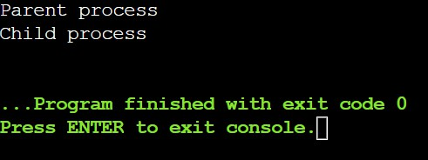

- Handling Common Signals Common signals:
  - SIGINT → Ctrl+C

  - SIGTERM → terminate request
  - SIGKILL → force kill
  - SIGSEGV → invalid memory access
  - SIGALRM → timer expired Code:
signal(SIGINT, handler);

- Different Common Kernel Crashes Examples

Kernel Panic
  - unrecoverable error NULL pointer dereference
  - invalid memory access Stack overflow
  - recursion exceeds stack Deadlock
  - threads wait forever Memory corruption
  - overwrite memory Debug tools:
  - dmesg
  - logs
  - stack trace

- Time Complexity
Measures the time taken by a code to run and produce output. Examples:
  - O(1) – Unit Time

  - O(log n) – Logarithmic Time
  - O(n) – Linear Time
  - O(n²) – Quadratic Time

for(i=2;i*i<=n;i++)
➔ Time Complexity = O(√n)

- Locking Mechanism, Mutex / Spin Locks Mutex
Thread sleeps while waiting.
pthread_mutex_lock(&m);
pthread_mutex_unlock(&m);

Spinlock
Thread keeps checking continuously.
pthread_spin_lock(&s);
pthread_spin_unlock(&s);

