# TATA STEEL

**Problem Statement**:

In order to have a real-time feedback on the quality performance of the casts rolled, if you can work on Mobile report for same.  
The format of the Grid view would be: 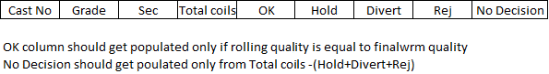

Also, build a logic that, in case number of coils kept hold/reject/divert is greater than 10, an SMS alert should be sent.