**MID-SEMESTER REPORT**



**CAPSTONE PROJECT-I (CP302)**

**PROJECT: SEMI-AUTOMATIC TRAIL OPENING AND CLOSING SYSTEM FOR ARMY APPLICATIONS**

**DATE OF SUBMISSION: 21/09/2023**

**SUBMITTED BY**

**GROUP: 17**

**TEAM MEMBERS**

|  |  |
| --- | --- |
| **NAME** | **ENTRY NUMBER** |
| SOURABH KUMAR MEENA | 2020MEB1315 |
| ADITYA MAURYA | 2020MEB1261 |
| ASHISH JAGARWAR | 2020MEB1271 |

**INTRODUCTION**

In the realm of modern artillery warfare, precision, speed, and efficiency are paramount. The process of preparing an artillery gun for firing is a complex and labour-intensive task that requires a significant number of personnel to open and position the back trails, ensuring the stability of the weapon during operation. Traditionally, this arduous operation has demanded the coordination of approximate 9 individuals, presenting logistical challenges and consuming valuable time that could be crucial on the battlefield.

To address this challenge, we propose a groundbreaking innovation: the Semi-Automating Trail Opening and Closing System for Army Artillery Applications. This project aims to revolutionize the way artillery guns are prepared for action by reducing the workforce required and expediting the process. At its core, our system introduces a novel concept that combines mechanical engineering with modern technology to simplify and streamline the critical task of trail deployment.

The fundamental principle of artillery gun operation involves opening the back trails and placing them opposite to each other at specific angles, creating a circular path. This precise maneuver is essential for maintaining stability during firing, as the tremendous forces generated by artillery rounds must be effectively counteracted. Currently, achieving this requires a labour-intensive effort that can be slow and cumbersome, hindering the rapid response required in modern military operations.

Our innovative solution is designed around the concept of a curved slot-type structure upon which the artillery gun trails will be placed. This structure minimizes friction and maximizes efficiency, allowing the trails to be easily moved into position with the assistance of a trolley system. This trolley system, equipped with advanced roller bearings, will glide smoothly along the curved slot, requiring minimal physical effort from the operating crew. Moreover, we will implement a rack and gearing system that provides precise control over the trolley's movement, ensuring accurate positioning of the trails.

**Objective/Aim**

The primary objective of this project is to create a cutting-edge solution that addresses the labour-intensive and time-consuming process of preparing artillery guns for firing. This ambitious project aims to revolutionize artillery operations by achieving the following key aims:

1. **Workforce Reduction:** The project's foremost goal is to significantly reduce the number of personnel required to open and position the back trails of artillery guns. By automating this critical task, we aim to minimize the manpower needed for artillery deployment, freeing up personnel for other essential duties and increasing operational flexibility.
2. **Speed and Efficiency:** We aim to enhance the speed and efficiency of the trail deployment process. Through the use of innovative mechanical and technological components, our system will streamline the movement of the trails, allowing for rapid readiness and quick response times during military operations.
3. **Precision and Safety:** Precision is paramount in artillery operations. Our project aims to ensure the precise placement of the back trails, which is essential for maintaining the stability and accuracy of artillery guns during firing. This will contribute to enhanced safety for both the gun operators and nearby personnel.
4. **Modernization and Readiness:** By integrating modern technology, such as the rack and gearing system and roller bearings, our project seeks to modernize artillery preparation procedures. This modernization will enable artillery units to be better prepared for the challenges of contemporary warfare, improving their readiness and effectiveness on the battlefield.
5. **Enhanced National Defence:** Ultimately, the overarching aim of this project is to bolster national defence capabilities. By reducing the time and manpower required for artillery deployment, we aim to enhance the responsiveness and agility of military forces, ensuring they are better equipped to meet evolving security threats and protect the interests of our nation.

**Problem Description**

Traditionally, preparing artillery guns for firing involves the manual deployment of the back trails, which are essential for stabilizing the weapon during the firing process. This labour-intensive task currently requires the coordination of nine personnel, imposing significant logistical challenges and consuming valuable time. The manual nature of this process not only makes it slow but also presents various operational and safety concerns.

First and foremost, the reliance on a large workforce hampers the rapid deployment of artillery units, limiting their readiness in critical situations. The time-consuming nature of this process can result in delays that impact mission success. Moreover, the physical exertion required from the personnel can lead to fatigue and potential injuries, reducing the overall effectiveness of the artillery crew.

Additionally, the manual nature of trail deployment introduces the risk of human error, which can have catastrophic consequences in artillery operations. Accurate positioning of the trails is essential to counteract the powerful recoil forces generated during firing. Any inaccuracies in this process can compromise the stability and accuracy of the artillery gun, posing a safety risk to the operators and nearby personnel.

Furthermore, in modern military operations, agility and speed are paramount. The current method of trail deployment is not in line with the need for quick response times in dynamic and evolving battlefield scenarios.

**Overview**

This project represents a pioneering initiative designed to transform the preparation process of artillery guns in military operations. Rooted in a deep understanding of the challenges faced by artillery units, this project endeavors to introduce an innovative and efficient solution that promises to significantly enhance the readiness, speed, precision, and safety of artillery operations.

Traditionally, the preparation of artillery guns has relied upon a labour-intensive and time-consuming process, involving the manual deployment of the back trails. This method, which requires the coordination of numerous personnel and substantial physical exertion, poses several challenges. It not only consumes valuable time but also increases the risk of human error, which can have severe consequences in the high-stakes environment of military operations.

The project's core concept revolves around the creation of a semi-automated system that replaces the traditional manual method. It features a curved slot-type structure upon which the artillery trails will be placed and maneuvered. This innovative design reduces friction, simplifies movement, and minimizes the physical effort required for trail deployment.

A key component of the system is a trolley mechanism equipped with advanced roller bearings, which ensures smooth and precise movement along the curved slot. To control this trolley system, a rack-and-gearing mechanism is employed, enabling operators to achieve accurate positioning of the trails. This sophisticated design aims to modernize artillery preparation procedures, aligning them with the agility and efficiency demanded by contemporary military operations.

The anticipated benefits of this project are profound. It is expected to substantially reduce the number of personnel needed for trail deployment, thereby freeing up valuable manpower for other critical tasks. Furthermore, the system promises to expedite the deployment process, improving artillery readiness and response times. The enhanced precision and safety features inherent in the design are anticipated to mitigate human errors and reduce the risk associated with artillery operations.

**Existing Studies**

Existing studies in the field of artillery trail deployment have primarily relied on a plate-based system, where the artillery trail is guided along a slot using rollers. However, these systems have encountered several significant limitations and challenges, which have prompted the need for innovative solutions.

Traditionally, the use of a plate with a slot has required the coordination of approximately six personnel to operate effectively. This labour-intensive process not only consumes valuable manpower but also slows down the preparation of artillery guns, which can be detrimental in time-sensitive military scenarios.

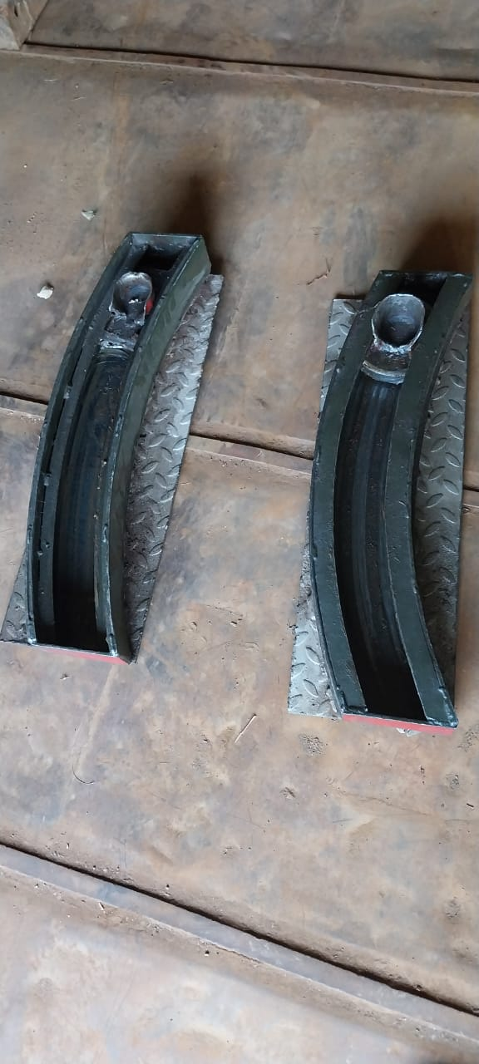

Figure 1: Conventional Trail Deployment Platform

One of the critical issues associated with this approach is the substantial force required to move the trail along the slot. The physical effort exerted by the operators can lead to fatigue, affecting the overall effectiveness of the artillery crew. Moreover, the need for a substantial workforce can limit the mobility and agility of artillery units on the battlefield.

Another notable problem is the susceptibility of the slot to dust and debris accumulation during operations and warfare. Dust and other contaminants can hinder the smooth movement of the artillery trail along the slot, potentially compromising the precision and safety of the deployment process. This issue poses operational challenges and increases maintenance requirements, affecting the reliability of the system.

**Methodology**

1. **Project Planning and Requirement Analysis:** Begin by defining the project scope, objectives, and requirements. This step involves a comprehensive analysis of the existing artillery trail deployment process to identify specific needs and challenges.
2. **Conceptual Design:** Develop a conceptual design for the semi-automated trail opening and closing system. This design should incorporate innovative elements like the curved slot-type structure, trolley system, roller bearings, and rack-and-gearing mechanism. Ensure that the design aligns with project objectives.
3. **Mechanical Design:** Create detailed mechanical plans for the system components, considering factors such as load-bearing capacity, precision, safety features, and power requirements. Ensure that the design meets military standards and safety regulations.
4. **Prototype Development:** Build a functional prototype of the system based on the approved design. Test the prototype under controlled conditions to evaluate its performance, accuracy, and durability. Make necessary adjustments and improvements as needed.
5. **Testing and Validation:** Conduct rigorous testing of the semi-automated system in simulated military scenarios. Evaluate its ability to deploy artillery trails accurately, quickly, and safely. Collect data on performance, reliability, and any potential issues.
6. **Refinement and Optimization:** Based on testing results, refine and optimize the system's design, components. Address any identified shortcomings to enhance overall system performance and reliability.
7. **Final Evaluation:** Conduct a final evaluation of the fully implemented system to ensure it meets project objectives and military requirements. Gather feedback from users and make any necessary adjustments.
8. **Deployment:** Once the system has been validated and approved, deploy it to artillery units in the military for real-world applications, ensuring that it enhances the readiness and effectiveness of these units.

**Innovation in Action: Redefining Trail Deployment method**

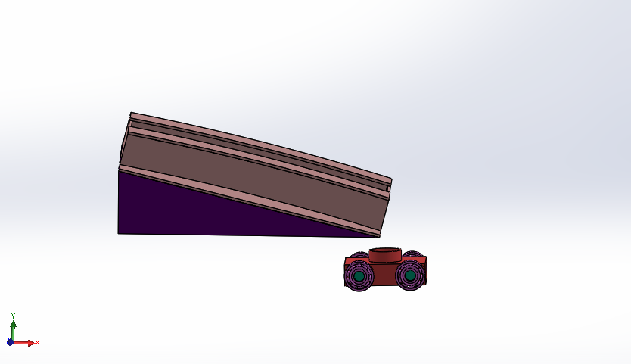

**Figure 2: side view of plate and trolley**

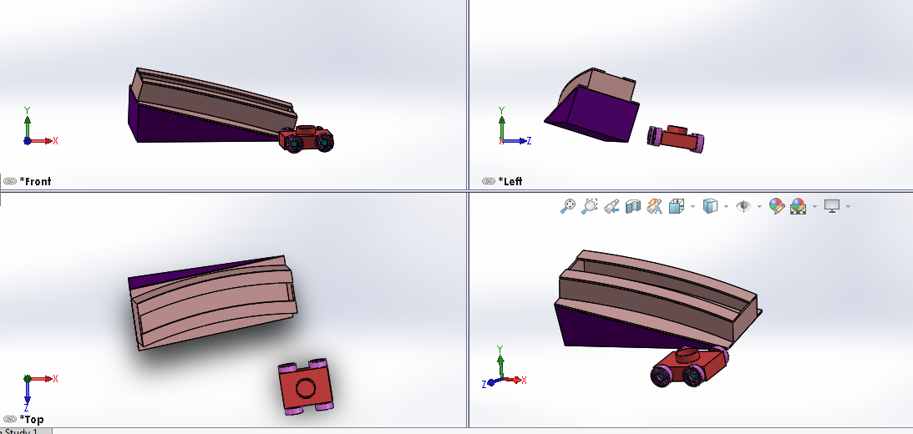

**Figure 3: Different view of plate and trolley**

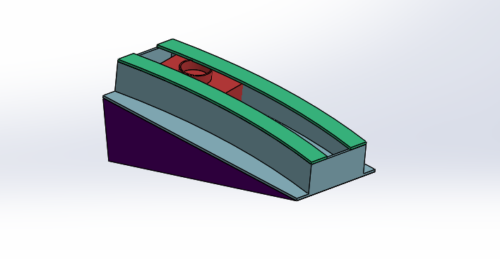

**Figure 4: plate trolley assembly**

**Results**

* **Workforce Reduction:** We anticipate a significant reduction in the personnel required for trail deployment, potentially reducing the workforce from approximately nine personnel to a much smaller number. This is expected to free up valuable manpower for other essential tasks within the artillery unit.
* **Improved Speed and Efficiency:** We expect the semi-automated system to dramatically expedite the trail deployment process. Preliminary calculations suggest that the time required for this task will be significantly reduced, contributing to faster artillery readiness.
* **Enhanced Precision and Safety:** The system's design incorporates precision controls, reducing the risk of human error during trail placement. We anticipate improved precision and safety in artillery operations as a result.
* **Modernization and Readiness:** The incorporation of modern technology, such as the rack-and-gearing mechanism and roller bearings, is expected to modernize artillery preparation procedures. This modernization aligns with the need for rapid readiness and agility in contemporary military operations.

These anticipated outcomes are based on the project's design and objectives and **will be validated upon project completion and testing.**

**Conclusion**

In conclusion, this project represents a promising and innovative endeavor aimed at addressing critical challenges in artillery operations. While the project remains in its planning and development stages, the potential impact it holds for military applications is substantial.

The project's methodology, as outlined, demonstrates a systematic approach to creating a semi-automated system that promises to streamline the trail deployment process. By reducing the required workforce, improving speed and efficiency, enhancing precision and safety, and modernizing artillery preparation, this project aligns with the evolving needs of modern military operations.

The expected outcomes, as previously outlined, offer a glimpse into the transformative potential of this system. The projected reductions in manpower, improvements in operational speed, and heightened precision and safety standards all underscore the potential benefits for military units tasked with rapid response and readiness in dynamic operational environments.

Furthermore, the project's emphasis on reducing maintenance requirements by minimizing dust and debris accumulation within the system underscores its commitment to long-term reliability and sustainability.

In essence, while this project is yet to reach its fruition, it holds great promise in addressing the inefficiencies and challenges that have long plagued artillery trail deployment. As the project progresses from its planning and development phases to real-world testing and implementation, it is our hope that it will ultimately enhance the capabilities of military artillery units, contributing to the safety and effectiveness of our armed forces in defense of our nation.

**Future Scope**

* **Integration with Autonomous Systems:** Explore possibilities for integrating the semi-automated system with autonomous technologies to further reduce human intervention and enhance operational autonomy.
* **Enhanced Remote Control:** Develop remote control capabilities, allowing personnel to operate the system from a safe distance, especially in high-risk or hazardous environments.
* **Adaptability to Various Artillery Platforms:** Investigate the adaptability of the system for use with different types and sizes of artillery guns, expanding its applicability across various military scenarios.
* **Advanced Sensor Integration:** Incorporate advanced sensors and monitoring systems to provide real-time feedback on trail deployment, enhancing precision and safety.
* **Incorporation of Predictive Maintenance:** Implement predictive maintenance techniques to anticipate system maintenance needs, minimizing downtime and optimizing system reliability.
* **Collaborative Swarming Techniques:** Research collaborative swarming techniques to enable multiple artillery guns to work together seamlessly, further improving artillery unit coordination and effectiveness.
* **Continuous Improvement:** Commit to ongoing research and development to continually enhance the system's capabilities, efficiency, and reliability in response to evolving military requirements and technological advancements.

**Reference**

1. [Indian Artillery – Current and Future Status (spslandforces.com)](https://www.spslandforces.com/story/?id=479&-Current-and-Future-Status)