My Contribution In The Project:

First of all we were assigned the task of learning Maya to take images of objects
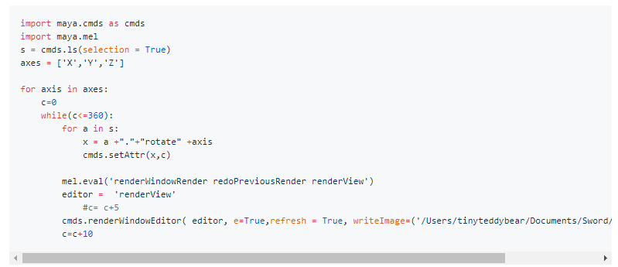

Then I Wrote a script to get the image properties like it's shape, resolution and datatype.
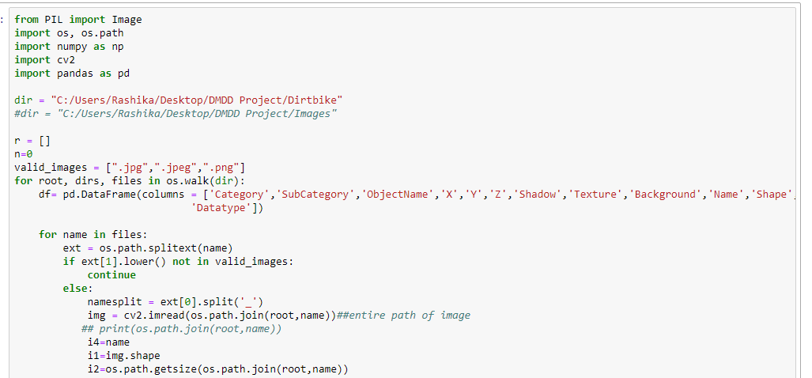

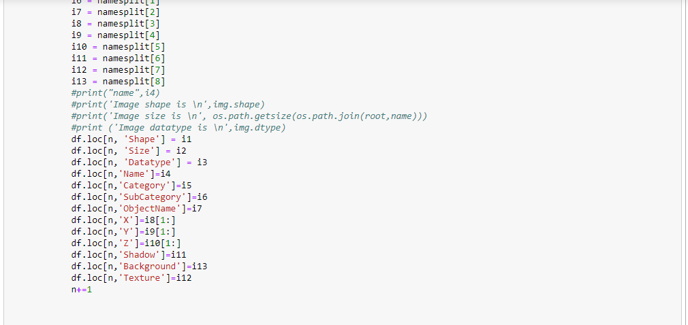

Create a conceptual database schema along with the ERDiagram.

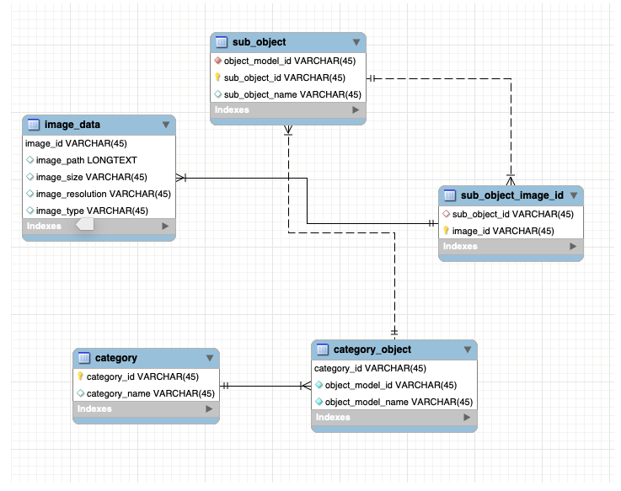

In the website, populated the images from database provided the path of the image
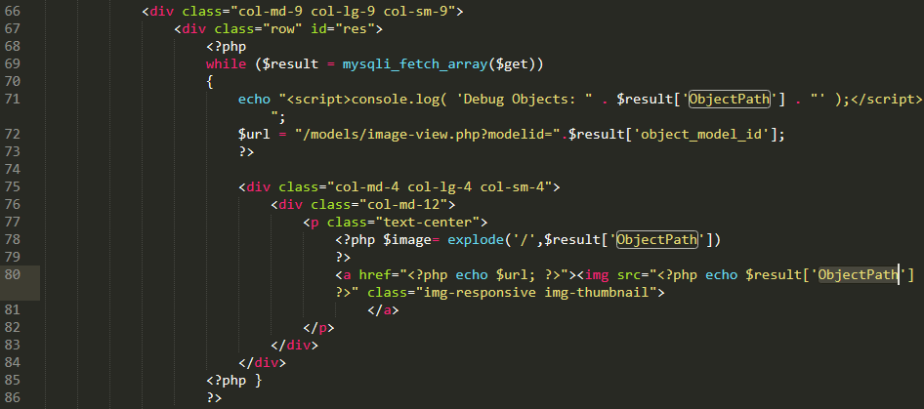

Created an updated Database accordingly and wrote use cases to get images from the website.

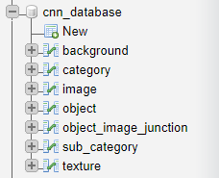

---SQL QUERIES---

1)search by category and display subcategories
SELECT s.subcategory_name,s.subcategory_id from sub_category s, category c where s.category_id = c.category_id and c.category_name like 'car'

2)search by subcategories and display objects
SELECT o.object_id, o.object_name from object o, sub_category s where s.subcategory_id = o.subcategory_id and s.subcategory_name like 'audi'

3)search by object and display all it's images
SELECT i.* from image i, object o, object_image_junction j where i.image_id = j.image_id and o.object_id = j.object_id and o.object_name like 'AudiA4'

4)search by angle and display images
SELECT * FROM image where x = 0 Or y = 0 or z = 100

5)search images of a particular object by it's texture
SELECT i.* from image i, object o, object_image_junction j, texture t where i.image_id = j.image_id and o.object_id = j.object_id and t.texture_id = o.texture_id and t.texture_name like 'white' and o.object_name like 'AudiA4'

Files attached:

1) Database---Contains the sql file of the CNN Database, ERDiagram and Use-Cases
2) Image Properties Scripting---Contains the jupyter Notebook for Image Properties Scripting and csv files containing Enfield,Dirtbike,R8 and RS4 Object Properties
3) Maya---Python Script to rotate objects and capture it's images
4) Website---grid.php file contains how to retrieve images stored on server by providing the path in database
5) License

