Section 1:
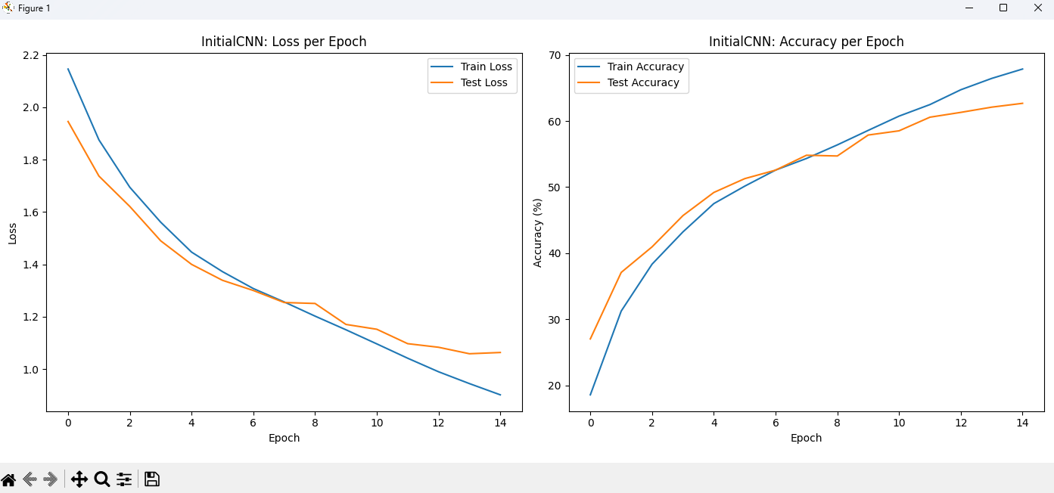
In the plot we can see that the train loss and the test loss are both going down as we do more epochs, which mean that the model succeed to learn. We can also see this from the right plot, where the accuracy of the model is rising as we do more epochs.
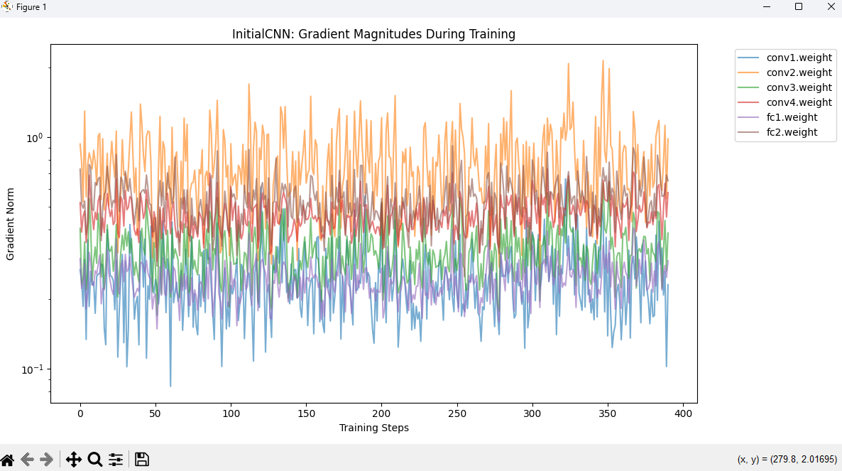
In this plot, we can see a very interesting phenomenon, the vanishing gradient.
Y-axis represents the magnitude of the gradients being applied to the weights of our network (we plot this in a logarithmic scale so this is why it jumps from 10^-1 to 10^0).
X-axis represents the number of batches that our model has processed during the training.
When we look at the graph we can see that the layers closest to the output have relatively large gradient norms, and as we move backward through the network, the gradients get smaller and smaller, until we get to the first layer which has the smallest gradients of all, hovering around 10^-1.
The problem
The InitialCNN uses torch.sigmoid as its activation function. The derivative of a sigmoid function is at most 0.25. When backpropagation computes gradients for earlier layers (like conv1), it multiplies these small derivatives together repeatedly. Because the network is deep (4 convolutional layers and 2 linear layers), the gradients shrink to near-zero before they can update the earlier weights. Consequently, the network fails to learn effectively, which you will see reflected in flat or poor learning curves.
The fix
To fix this, we will swap the sigmoid activations for ReLU (which does not squash the positive gradients) and add a single Batch Normalization layer to fulfill the "one additional layer" and "normalization" requirements.
And now for the comparison between the two models:
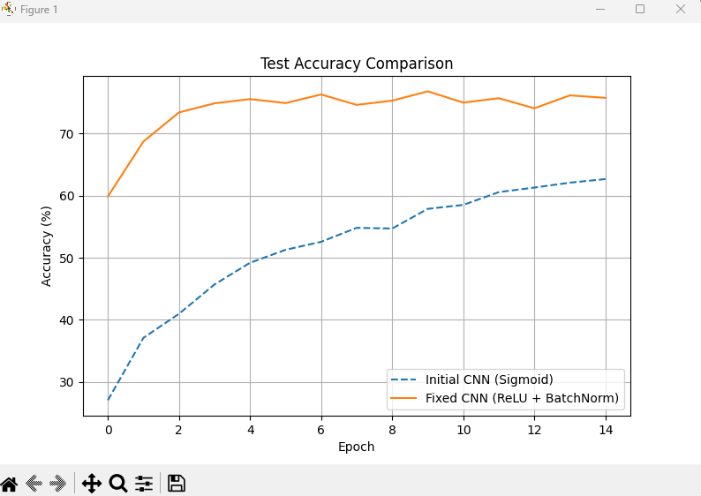

As we can see that the fixed CNN has more accuracy than the Initial CNN.

Section 2:
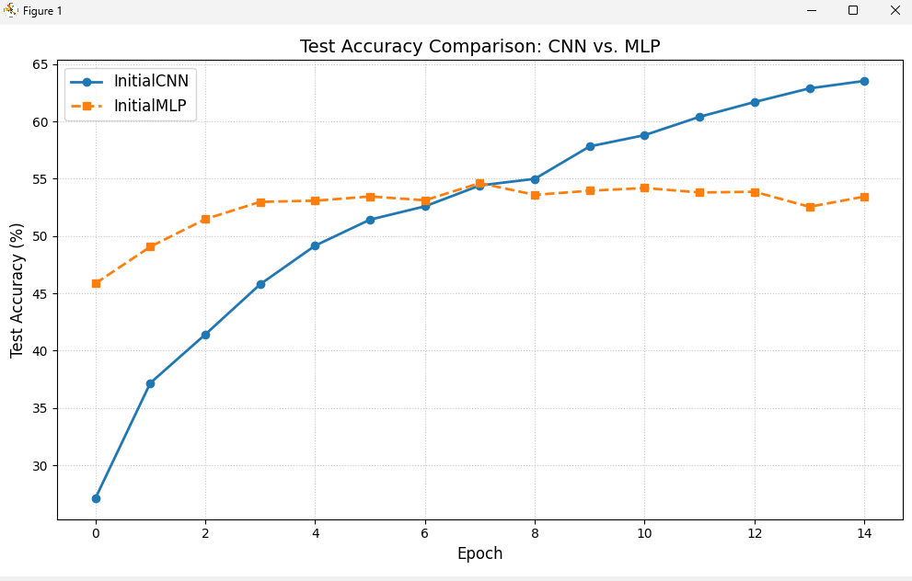
From this plot we can see that the CNN is outperforming the MLP. This is happening because the MLP treats the image as a flat 1D vector and it destroys the spatial relationships whereas the CNN preserve the 2D grid structure, allowing them to learn local patterns regardless of where they appear in the image.

If we look at the parameters of the models we can see that the MLP has vastly more parameters. The first layer alone connects 32X32X3 inputs which is 3072, to 512 neurons, resulting in over 1.5 million weights just for fc1. On the other hand, the CNN uses weight sharing, keeping the parameter count incredibly low while maintaining deeper architecture.
You can see the comparison between the parameters of each model:
InitialCNN Parameters: 653,386
InitialMLP Parameters: 1,707,274

Because the MLP has over a million weights, it requires more mempry to store the model architecture and gradients.
The CNN requires less memory for the weights themselves and this is why it consumes less memory.
InitialCNN Memory Size: 2.492 MB
InitialMLP Memory Size: 6.513 MB

All that talk but the runtime speed for the MLP is much faster than the runtime speed of the CNN, and this is happening because the MLP only do dense matrix multiplication while the CNN does convolutions which is more expensive mathematically and this is why it takes more time for each epoch.
MLP Training Time: 118.28 seconds
CNN Training Time: 165.41 seconds
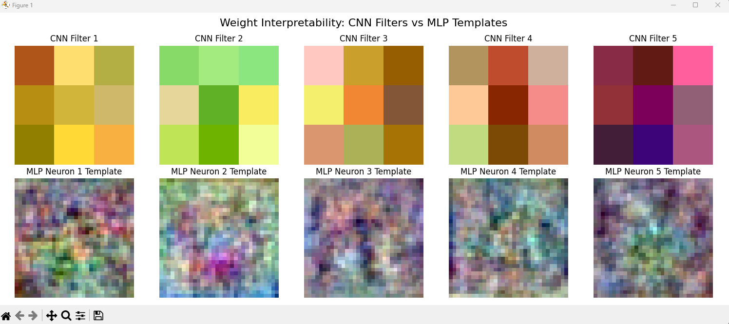
From this plot we can see how each model is learning.
The first row shows the optimized weights of the very first layer of the CNN, while the second row shows the weights from the first hidden layer of the MLP, which have been reshaped back into a 32x32 format so we can view them as images.
We can notice that the CNN learn small features in each grid while the MLP instead try to learn all the features at once.
CNNs are best for data with a known grid-like topology where spatial locality matters.
NLPs are best for unstructured data, where each feature has a distinct fixed meaning, and there is no spatial relationship between the columns.

Section 3:
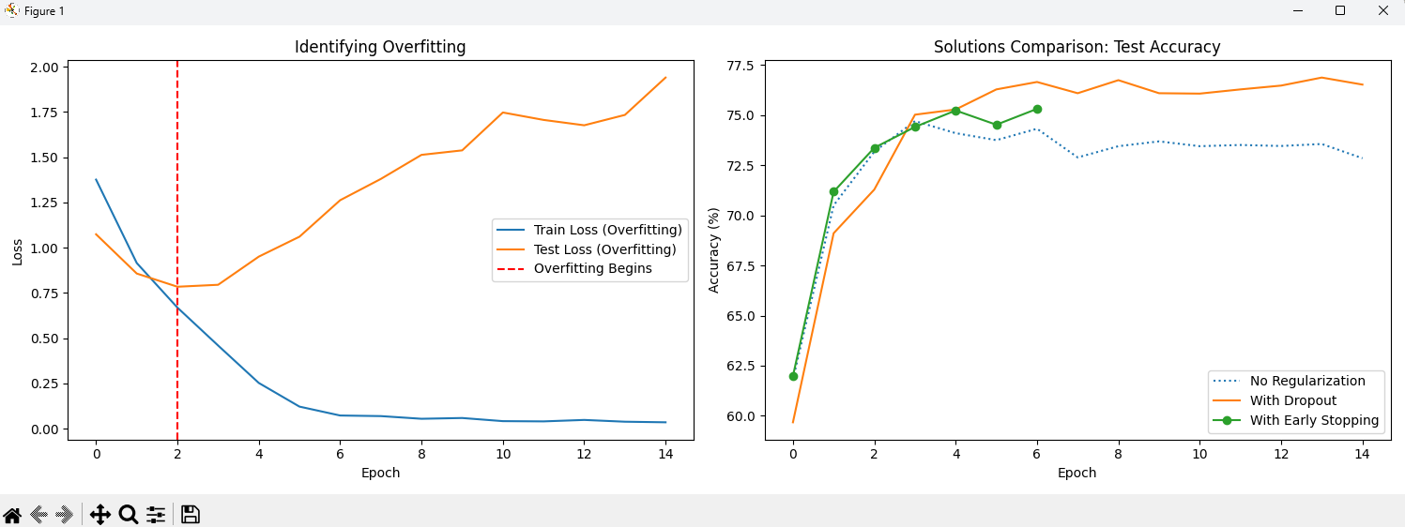
From the left plot we can see that we identify the overfitting from epoch 2, that means that the loss of the training will get smaller and smaller because the model just memorizing the dataset but the loss on the test from this epoch won't get down and only get bigger, and we can see that this is actually what is happening.
We tested two methods to reduce the overfitting, dropout and early stopping. The dropout method randomly zeroes out neurons during training, and this prevents the network from relying too heavily on any single pathway or "memorizing" specific features, forcing it to learn more robust and redundant representations.
The early stopping monitors the validation loss. Once the validation loss degrades for a set number of epochs, training is terminated and this locks the model weights at their point of optimal point.
We can see from the right plot that the accuracy of both the dropout and the early stopping is much higher than the accuracy of the overfitting model, which mean that both methods succeed to overcome the overfitting problem.

