🐾 Animalia Pet Care — User Interface & Experience Guide
Step-by-Step Plain Guidance for Pet Parents, Visitors & Staff • Rewari Centre
Welcome to the visual walkthrough of the Animalia Pet Care website and digital experience. This document provides clear, direct, and plain guidance on how to navigate every feature, book grooming appointments, calculate package prices, explore salon products, read customer reviews, and find the clinic in Rewari. Each section includes an authentic interface snapshot followed by actionable instructions.

1. Top Announcement Bar & Navigation Bar
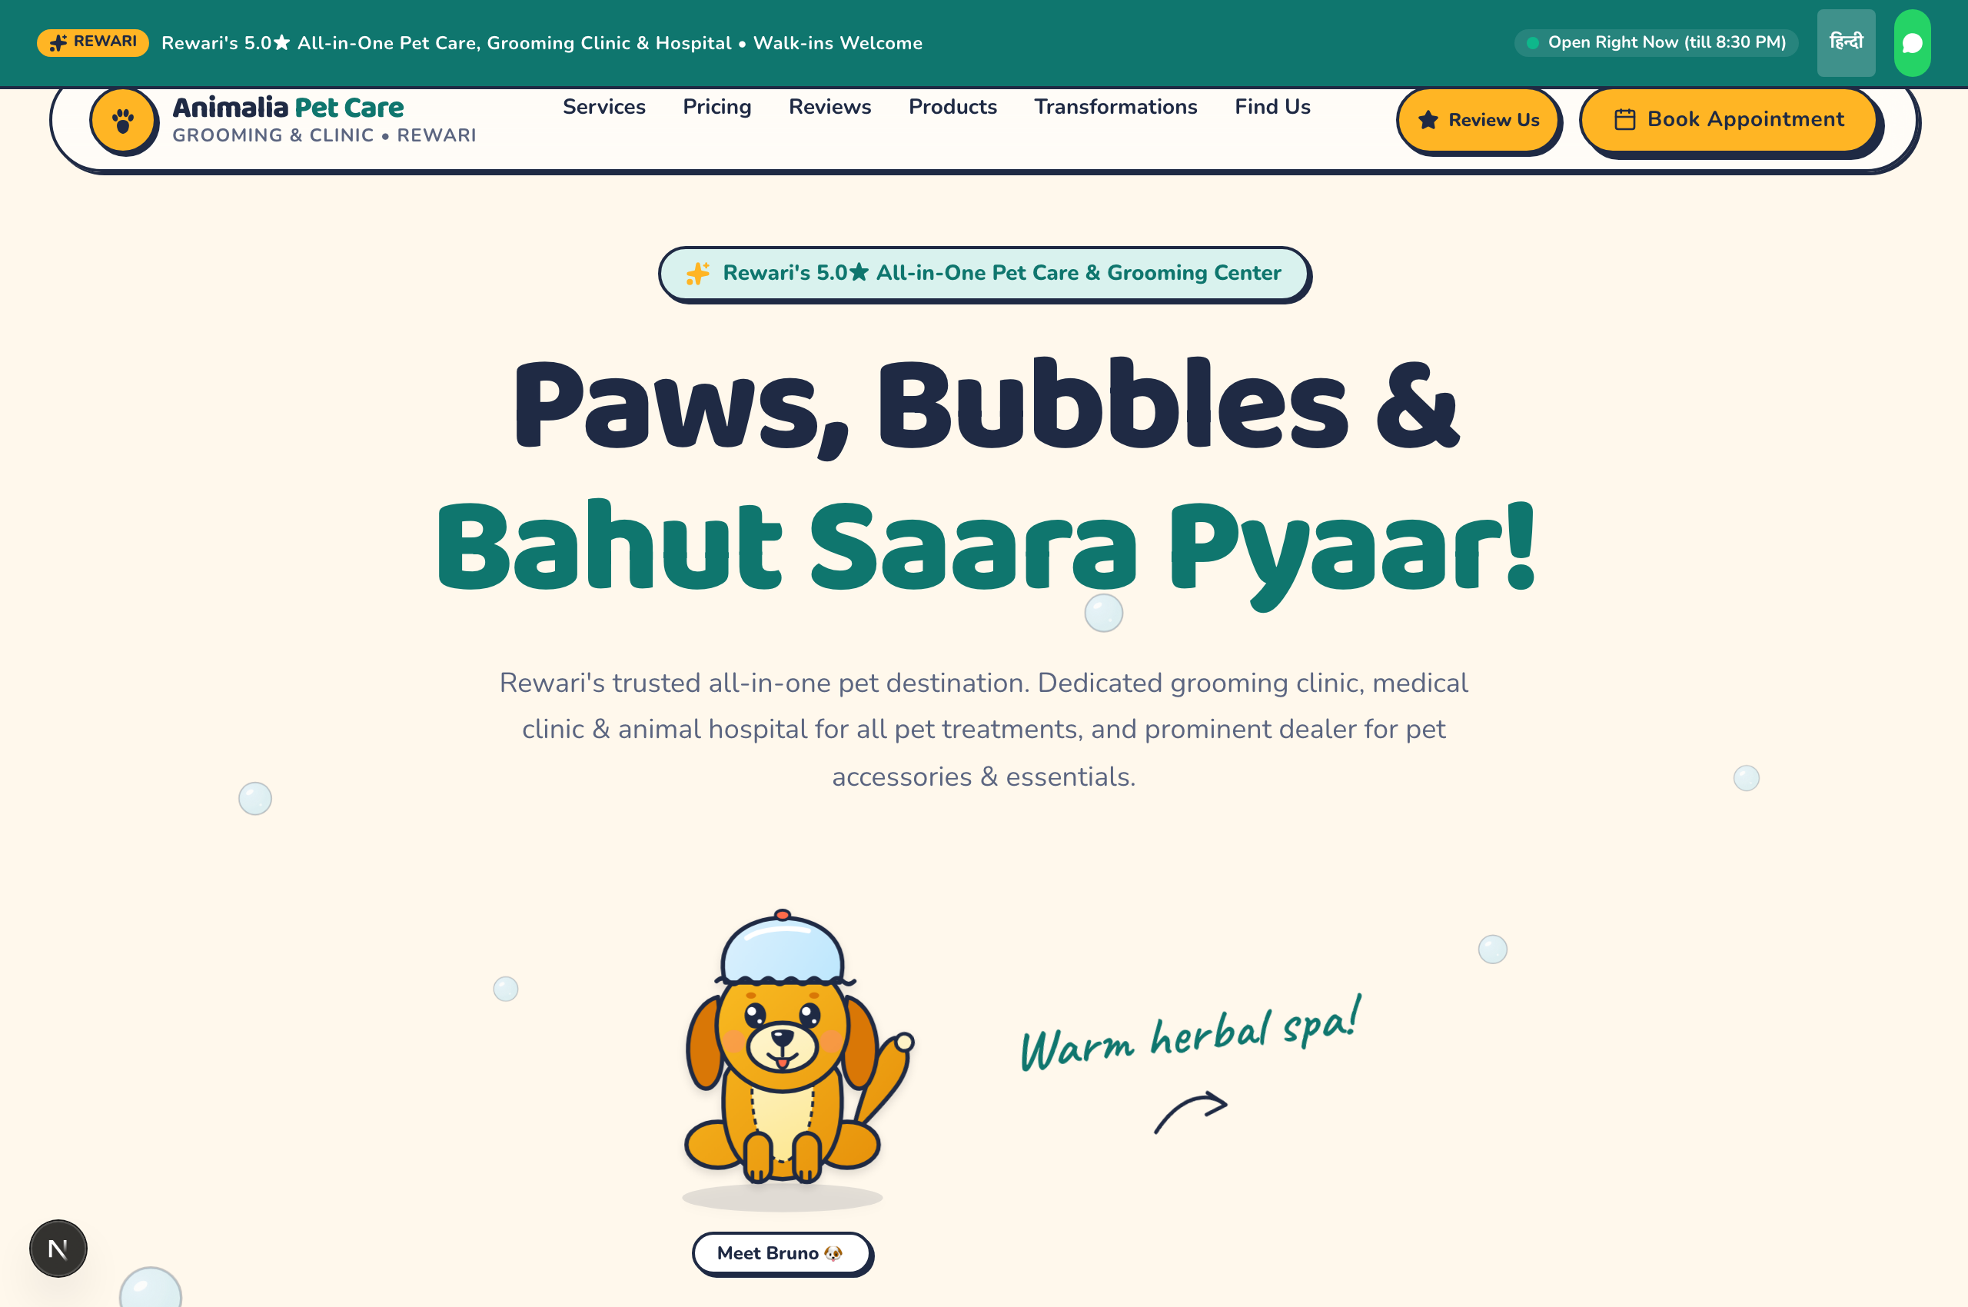
Figure 1: Top Announcement Bar & Navigation Bar View

What You See on Screen:
The very top of the page features a teal alert bar displaying live parlour open hours (with a real-time pulsing indicator), an English/Hindi language switcher, and a fast WhatsApp shortcut. Right beneath it sits the curved navigation bar displaying the brand logo, navigation links, and two prominent action buttons: 'Review Us' and 'Book Appointment'.

How to Use (Step-by-Step Guidance):
- Check Clinic Status: Look at the green pulsing dot at the top right to verify if the parlour is currently open.
- Switch Language: Click the 'हिन्दी' button at the top to instantly translate key content into Hindi.
- Navigate Fast: Click any menu link (Services, Pricing, Reviews, Products, Transformations, Find Us) to smooth-scroll directly to that section.
- Book Instantly: Tap the golden 'Book Appointment' button at any time to jump straight to the 30-second reservation form.
- Write a Review: Tap the yellow 'Review Us' star button to open the guided 3-step review assistant.
💡 PRO TIP: The navigation bar stays neatly attached to the top as you scroll down, so you can always book or reach support with one click.

2. Hero Section ('Paws, Bubbles & Bahut Saara Pyaar!')
Figure 2: Hero Section ('Paws, Bubbles & Bahut Saara Pyaar!') View

What You See on Screen:
The cheerful opening welcome banner featuring a bold headline ('Paws, Bubbles & Bahut Saara Pyaar!'), an interactive Bruno puppy mascot wearing a cozy shower cap, floating ambient bubbles, and a clear statement of Animalia Pet Care's three integrated services: Grooming Clinic, Animal Hospital, and Authorized Pet Dealer.

How to Use (Step-by-Step Guidance):
- Read Overview: Review the clinic credentials—rated 5.0 stars with walk-ins warmly welcomed.
- Interact with Bruno: Hover your mouse or tap on Bruno the mascot to see playful animated reactions.
- Scroll or Jump: Scroll down naturally to explore services or use the quick navigation buttons.
💡 PRO TIP: All animals are handled with gentle cage-free care. If your pet has fear of groomers, mention it during your visit.

3. Trust Strip & Clinical Hygiene Standards
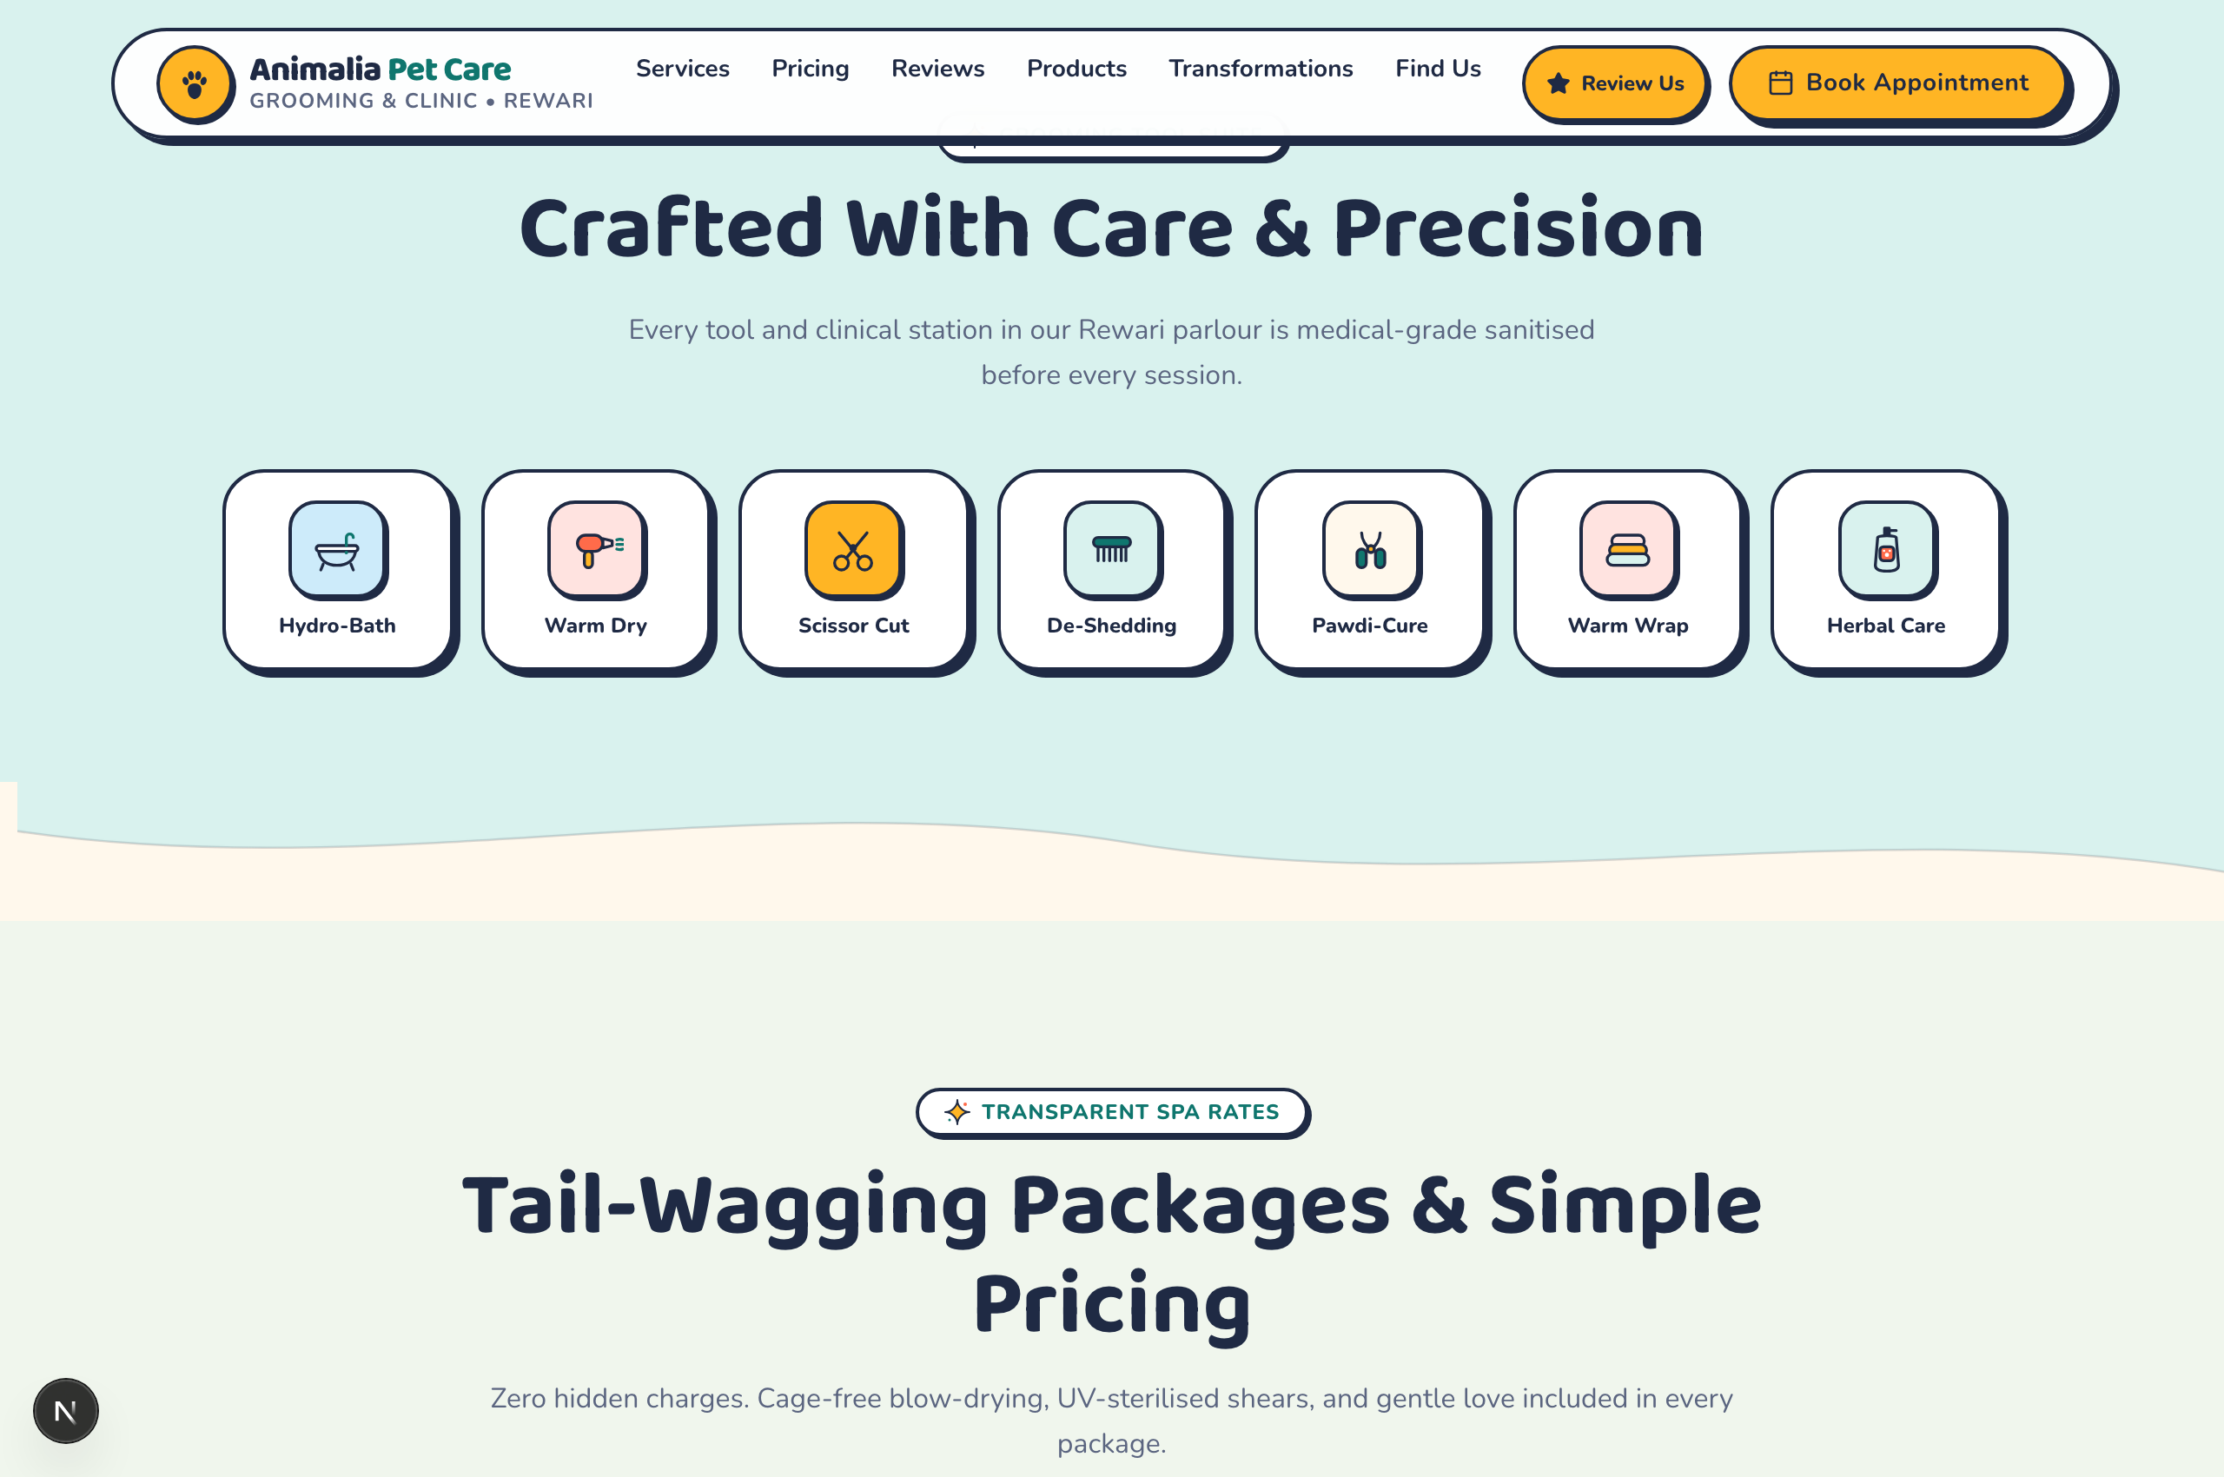
Figure 3: Trust Strip & Clinical Hygiene Standards View

What You See on Screen:
A horizontal strip of 7 clinical care badges outlining the hygienic workflow: Hydro-Bath, Warm Dry, Scissor Cut, De-Shedding, Pawdi-Cure, Warm Wrap, and Herbal Care. Above the icons is a sanitation guarantee: 'Every tool and clinical station in our Rewari parlour is medical-grade sanitised before every session.'

How to Use (Step-by-Step Guidance):
- Inspect Hygiene Measures: Note that every pair of shears is UV-sterilised between pet visits.
- Zero Cold Cages: Confirm that blow-drying is done with sound-dampened handheld warm dryers, never loud confining metal cages.
- Herbal Formulation: Shampoos and conditioners are tearless, natural, and hypoallergenic.
💡 PRO TIP: If your pet suffers from skin allergies or tick infections, the in-house veterinary hospital can prescribe medicated baths.

4. Transparent Pricing & Weight-Based Plans
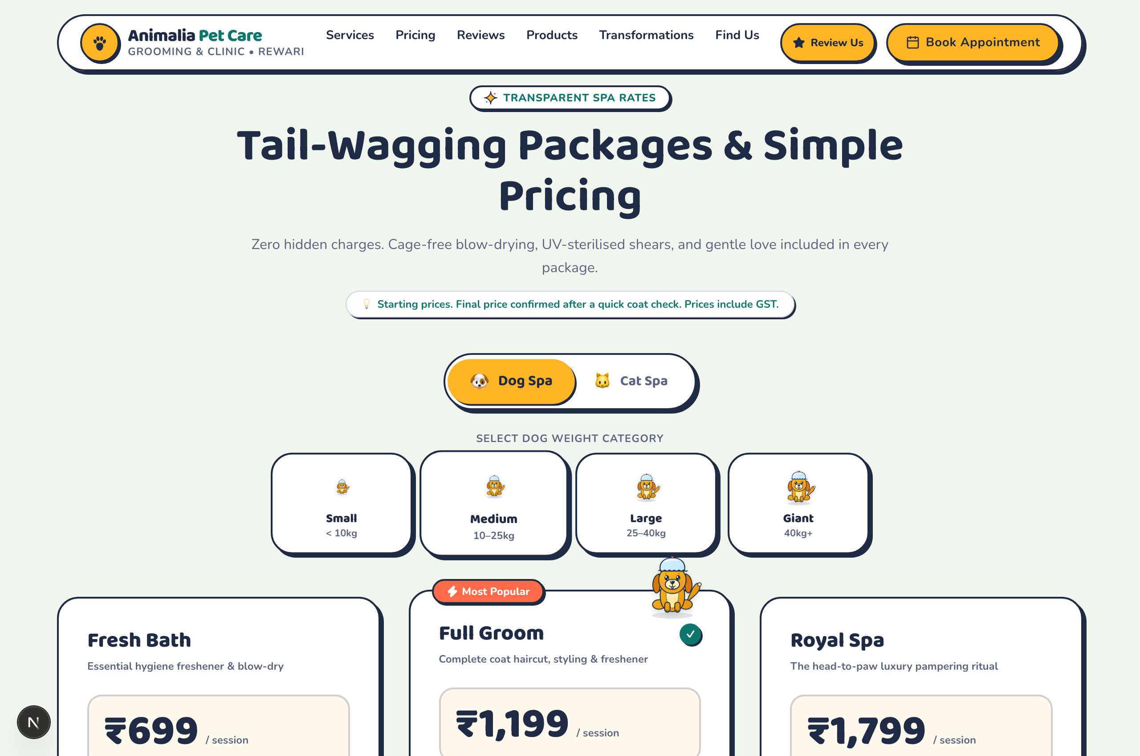
Figure 4: Transparent Pricing & Weight-Based Plans View

What You See on Screen:
A transparent rate calculator featuring Dog Spa and Cat Spa tabs, a 4-tier dog weight selector (Small <10kg, Medium 10-25kg, Large 25-40kg, Giant 40kg+), and 3 transparent package cards: Fresh Bath (₹699), Full Groom (₹1,199), and Royal Spa (₹1,799).

How to Use (Step-by-Step Guidance):
- Select Pet Type: Choose between 'Dog Spa' and 'Cat Spa' tabs.
- Choose Dog Weight: Tap on the pill corresponding to your dog's size (e.g. Small for Shih Tzu/Pug, Large for Golden Retriever).
- Compare Packages: Review the 3 transparent packages:
- • Fresh Bath (₹699): Herbal bath, blow dry, nail clip, ear cleaning.
- • Full Groom (₹1,199): Full haircut, styling, sanitary trim, blueberry facial, and freshener.
- • Royal Spa (₹1,799): Aroma oil soak, de-shedding spa, dental clean, anti-tick coat shield, and bow-tie.
- Book via WhatsApp: Click 'Book This Package' to pre-load the selected package and price into a WhatsApp chat.
💡 PRO TIP: Prices include GST with zero hidden add-ons. Final price is confirmed after a quick physical coat check on arrival.

5. Google Reviews & Local Social Proof
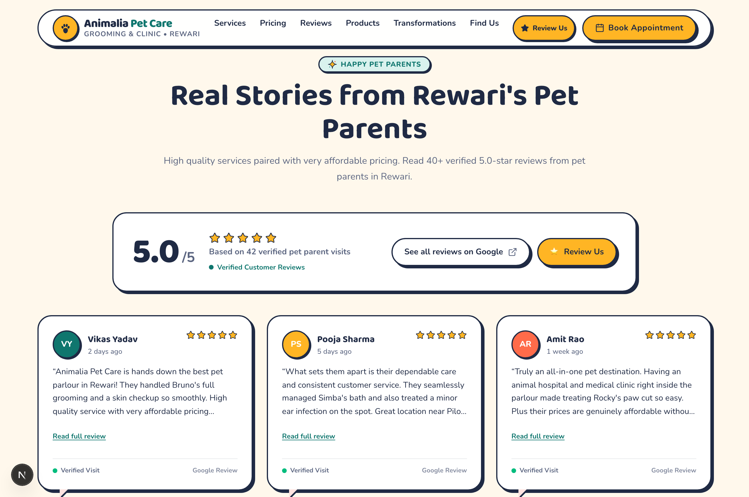
Figure 5: Google Reviews & Local Social Proof View

What You See on Screen:
A summary card highlighting Animalia's verified 5.0/5 star rating across 42+ local pet parent reviews, accompanied by direct links to Google Maps and an engaging Wall of Love displaying honest experiences from verified pet parents in Rewari (Vikas Yadav, Pooja Sharma, Amit Rao).

How to Use (Step-by-Step Guidance):
- Verify Reputation: Review the 5.0 rating badge verified by Google.
- Read Local Experiences: Read testimonials highlighting patient handling, on-the-spot veterinary assistance, and fair pricing.
- Check Google Maps Directly: Tap 'See all reviews on Google' to inspect live reviews in your browser.
💡 PRO TIP: All customer reviews are authentic and unmodified in strict compliance with Google Local Review Guidelines.

6. Interactive 3-Step Review Assistant
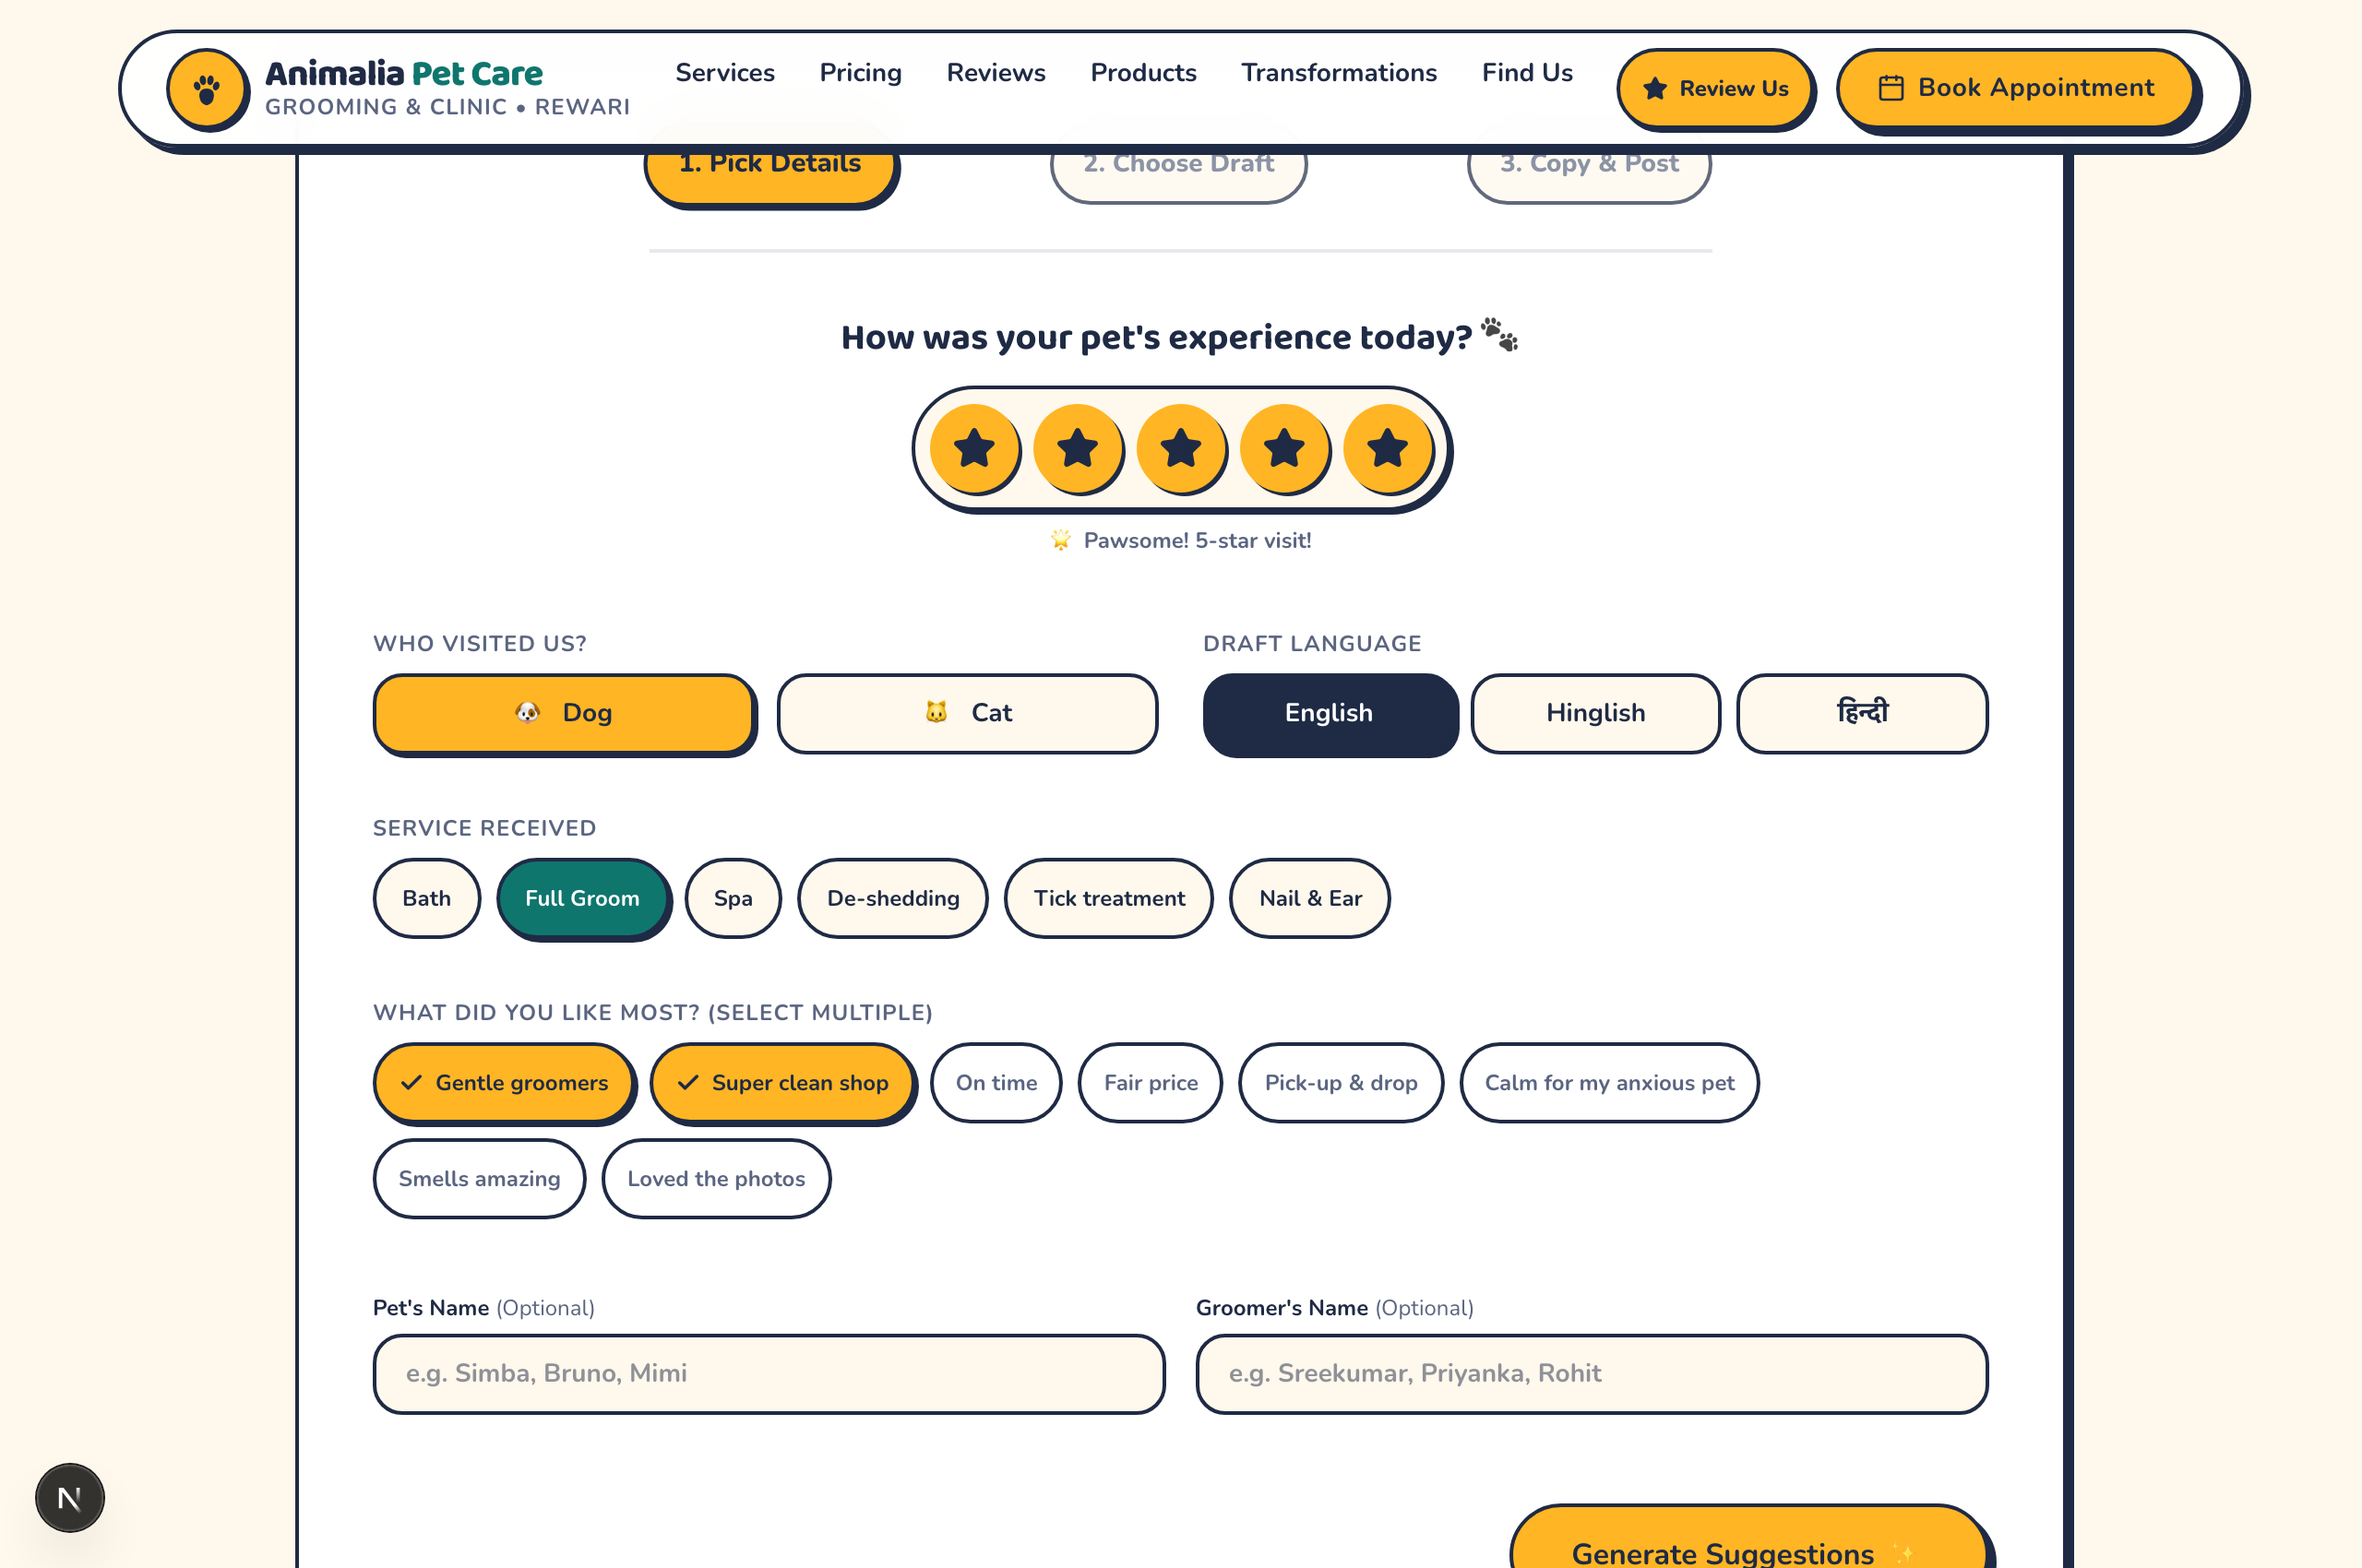
Figure 6: Interactive 3-Step Review Assistant View

What You See on Screen:
An intuitive review generation wizard designed to help customers leave thoughtful Google reviews in 30 seconds. It features star rating buttons, pet type toggles, draft language selectors (English, Hinglish, Hindi), service chips, and positive feature tags.

How to Use (Step-by-Step Guidance):
- Step 1 - Rate Your Visit: Tap the 5-star button to indicate your satisfaction level.
- Step 2 - Select Details: Tap who visited (Dog or Cat), pick your draft language (English, Hinglish, or Hindi), and tap the services received.
- Step 3 - Pick Highlights: Tap tags like 'Gentle groomers', 'Super clean shop', 'Fair price', or 'Calm for anxious pet'.
- Step 4 - Generate & Copy: Click 'Generate Suggestions', review the drafted sentence, and tap 'Copy & Open Google Maps' to paste it directly onto Google!
💡 PRO TIP: You do not have to spend time typing a long review from scratch; the wizard creates a natural text in your chosen language ready to paste.

7. The Groomer's Shelf & Salon Products
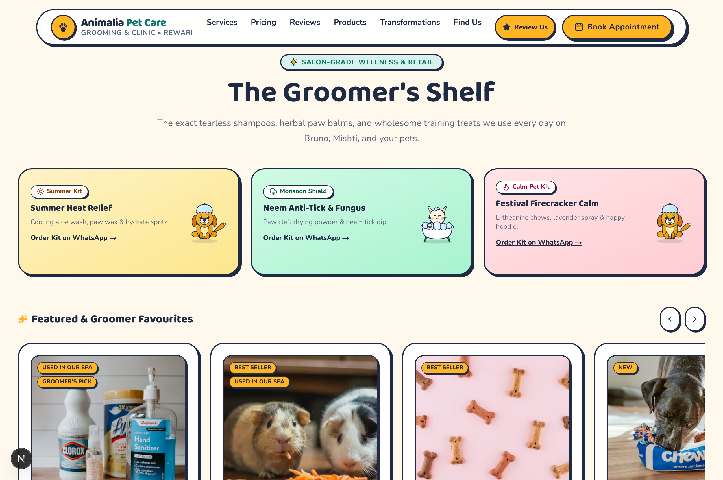
Figure 7: The Groomer's Shelf & Salon Products View

What You See on Screen:
A curated retail catalog showcasing salon-grade wellness kits and products: Summer Heat Relief Kit, Neem Anti-Tick & Fungus Monsoon Kit, Festival Firecracker Calm Kit, as well as organic shampoos, treats, and balms.

How to Use (Step-by-Step Guidance):
- Browse Seasonal Kits: Inspect the top cards for weather-specific remedies (heat cooling, monsoon moisture, Diwali noise calming).
- View Product Details: Tap on any product card to open the Quick View modal detailing active ingredients and directions.
- Add to Basket: Tap the yellow 'Add to Basket' button. A playful floating paw print (+1) confirms the addition.
- Direct Inquiry: If you prefer instant ordering, tap 'Order Kit on WhatsApp' under any seasonal kit card.
💡 PRO TIP: Every product listed is exactly what our certified stylists use in the parlour daily—tested safe and non-toxic.

8. Enquiry Basket & WhatsApp Commerce
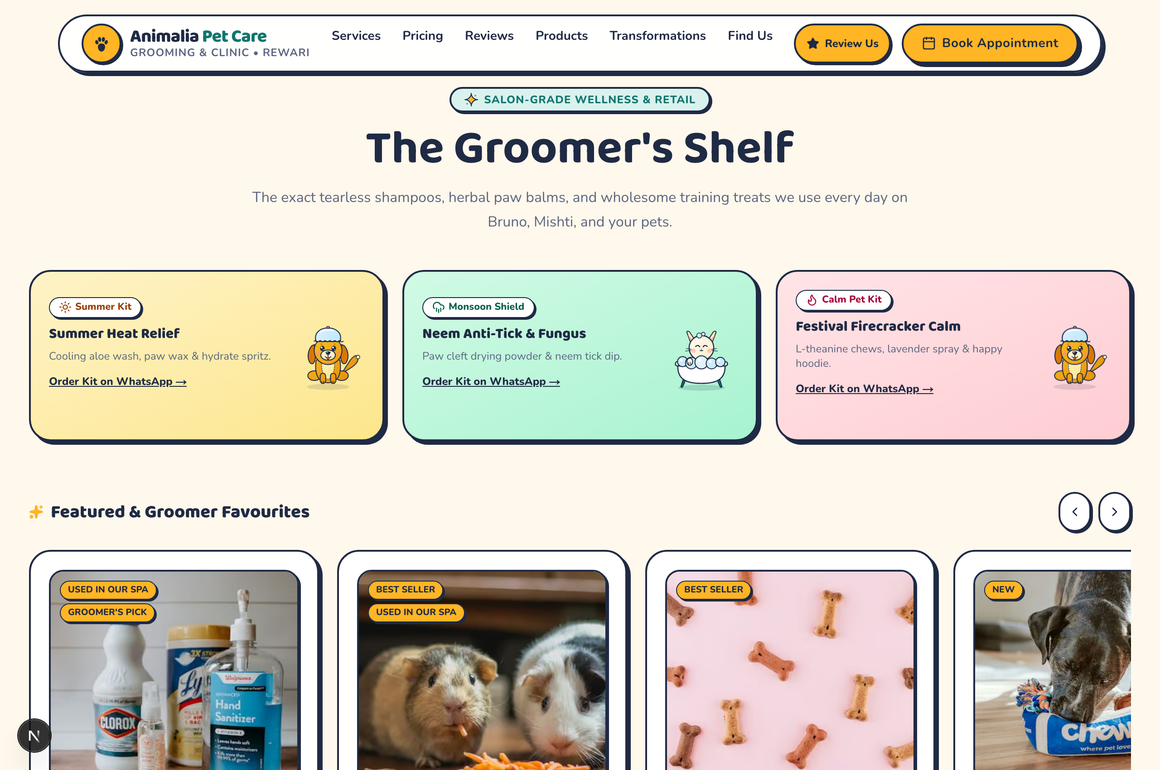
Figure 8: Enquiry Basket & WhatsApp Commerce View

What You See on Screen:
A slide-over cart drawer showing your selected retail items, quantity adjusters (+/-), total price in INR, fulfillment method selector (In-Store Pickup vs Express Rewari Delivery), and a direct 'Order via WhatsApp' button.

How to Use (Step-by-Step Guidance):
- Open Cart: Tap the floating yellow 'Enquiry Basket' pill at the bottom-right of your screen.
- Adjust Quantities: Use the plus (+) and minus (-) buttons or trash icon to customize your items.
- Choose Delivery Mode: Select 'In-Store Pickup (Ready in 30 mins)' or 'Express Delivery in Rewari'.
- Send WhatsApp Order: Tap the green WhatsApp button. It opens WhatsApp with a pre-typed message containing your full order list and delivery preference.
💡 PRO TIP: No credit card or complicated checkout is required. Payment can be made via UPI, cash, or card upon pickup or delivery.

9. Before & After Transformations Gallery
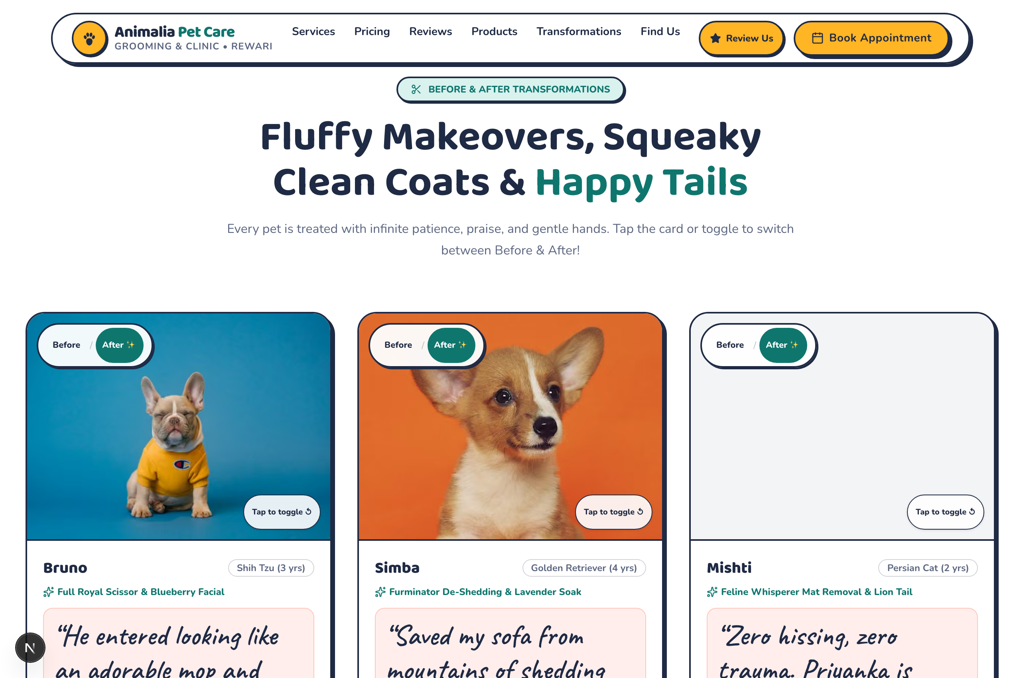
Figure 9: Before & After Transformations Gallery View

What You See on Screen:
An interactive gallery displaying dramatic before-and-after grooming makeovers for real local pets: Bruno the Shih Tzu (Full Royal Scissor Cut), Simba the Golden Retriever (Furminator De-Shedding), and Mishti the Persian Cat (Gentle Mat Removal).

How to Use (Step-by-Step Guidance):
- Toggle Photos: Click the 'Before / After' pill or tap anywhere on the picture card to switch between the pre-groom and post-groom look.
- Read Pet Details: Check the pet's age, breed, and specific treatment performed.
- View Parent Quotes: Read authentic handwritten feedback from the pet's family regarding how relaxed their pet felt.
💡 PRO TIP: Notice that dogs and cats with severe matting or heavy double coats are groomed patiently without aggressive shaving.

10. The Fear-Free Grooming Journey (4 Simple Steps)
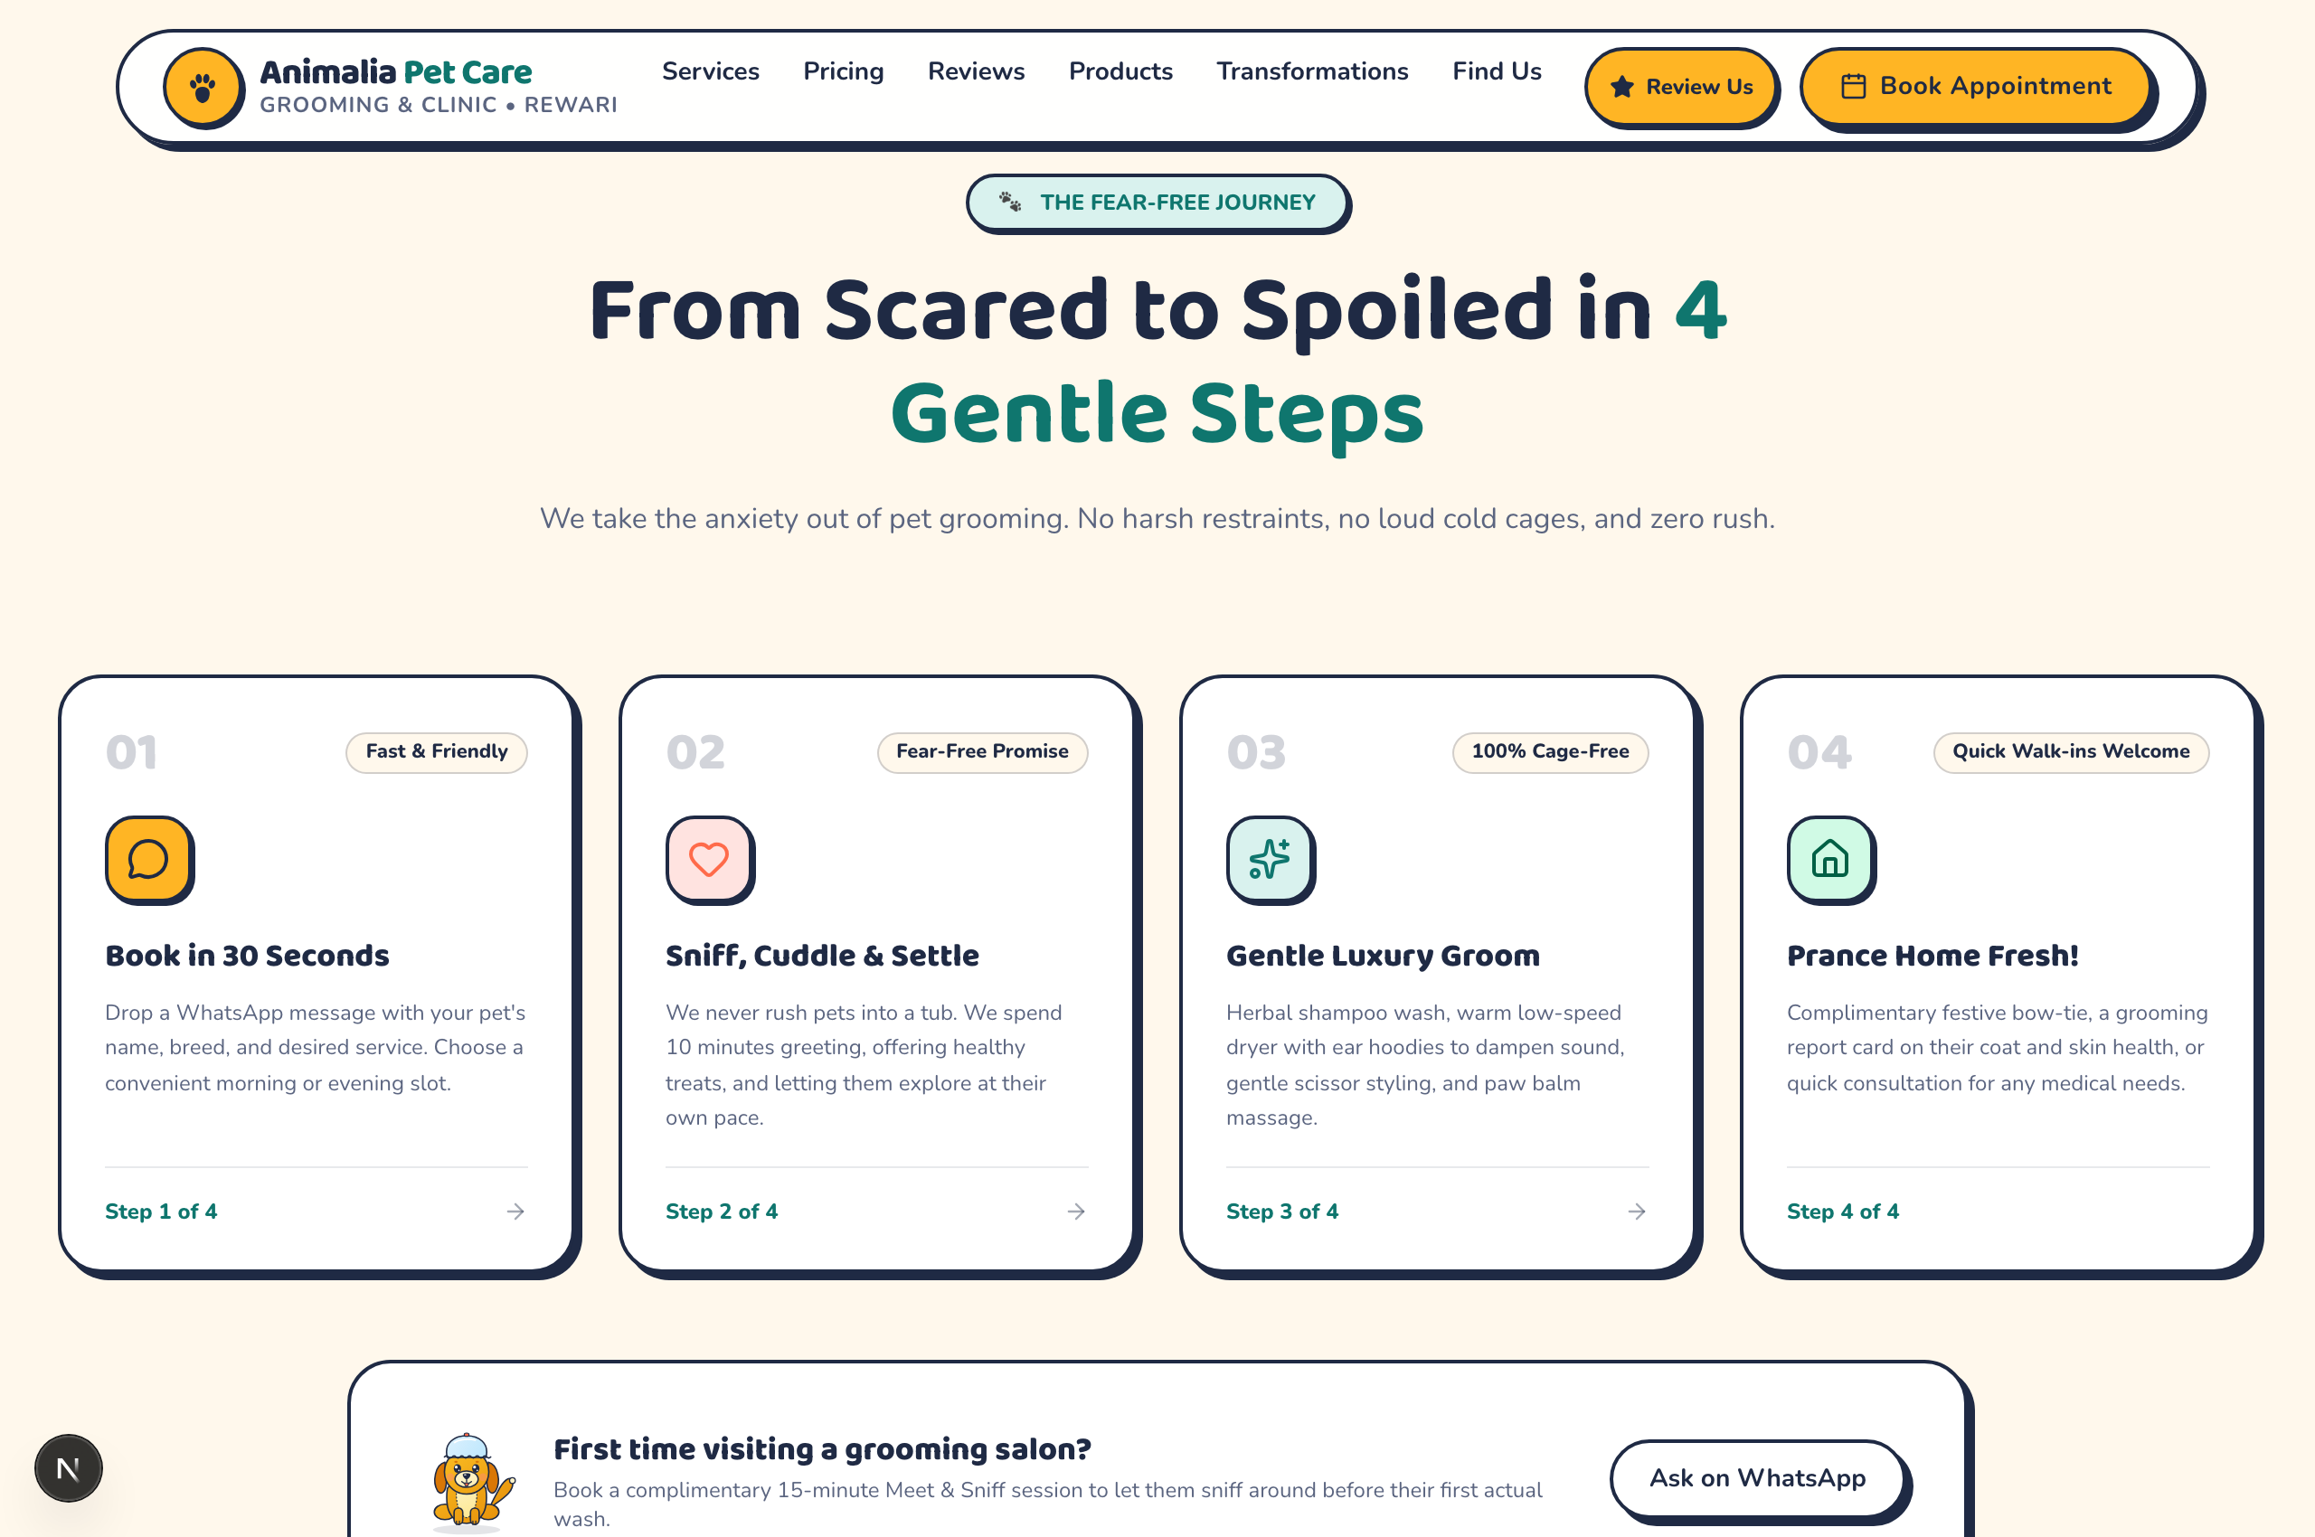
Figure 10: The Fear-Free Grooming Journey (4 Simple Steps) View

What You See on Screen:
A clear 4-step roadmap illustrating the gentle, anxiety-free appointment process: 01 Book in 30 Seconds, 02 Sniff, Cuddle & Settle, 03 Gentle Luxury Groom, and 04 Prance Home Fresh.

How to Use (Step-by-Step Guidance):
- Step 1 - Book: Send a quick WhatsApp text with pet details and pick your preferred time.
- Step 2 - Settle In: On arrival, pets spend 10 minutes greeting stylists, enjoying healthy treats, and exploring the parlour at their own pace.
- Step 3 - Pampering: Gentle warm bath, ear hoodies to dampen blower sound, and herbal paw balm application.
- Step 4 - Return Home: Receive your pet freshly scented with a complimentary festive bow-tie and health report card.
💡 PRO TIP: First-time visitors can book a free 15-minute 'Meet & Sniff' session so their pet gets comfortable before their actual bath day.

11. Meet the Certified Groomers & Stylists
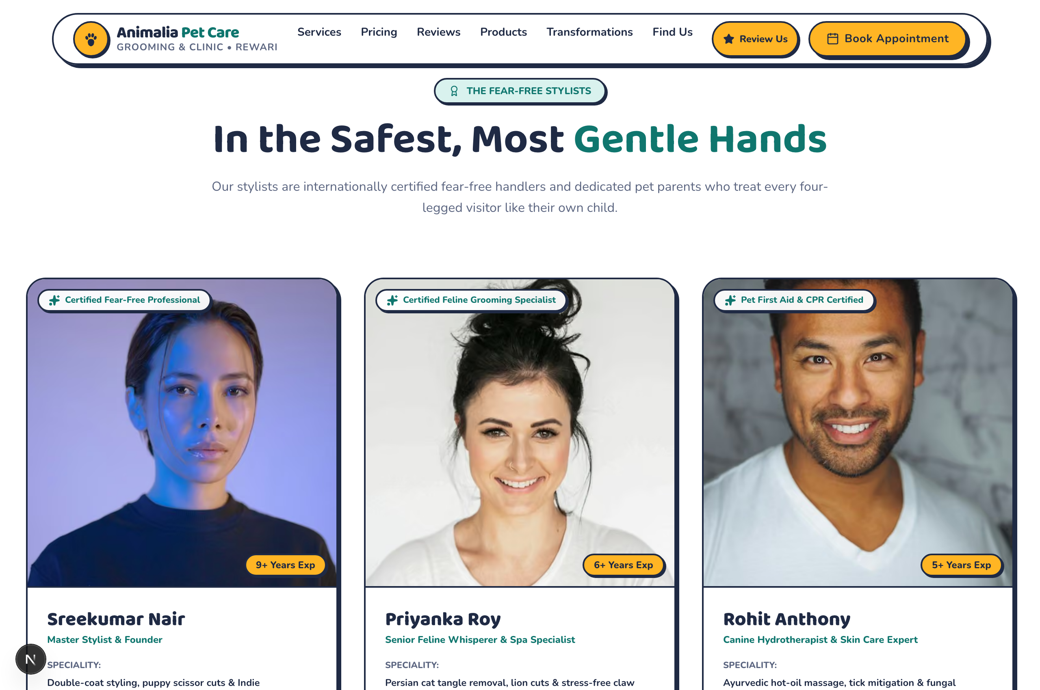
Figure 11: Meet the Certified Groomers & Stylists View

What You See on Screen:
Profile cards for Animalia's professional team members: Sreekumar Nair (Master Stylist & Founder, 9+ yrs exp), Priyanka Roy (Senior Feline Whisperer, 6+ yrs exp), and Rohit Anthony (Canine Hydrotherapist, 5+ yrs exp), complete with verified international certifications.

How to Use (Step-by-Step Guidance):
- Review Credentials: Look for certification badges including 'Certified Fear-Free Professional' and 'Pet First Aid & CPR Certified'.
- Match Your Pet's Need: Choose Priyanka for delicate cat grooming, Sreekumar for breed show cuts, or Rohit for skin soothing baths.
- Request a Specific Stylist: You can mention your preferred groomer when filling the booking form or messaging on WhatsApp.
💡 PRO TIP: Our staff treats every visiting pet like their own child—harsh handling or rough restraints are strictly prohibited.

12. Frequently Asked Questions (FAQ Accordion)
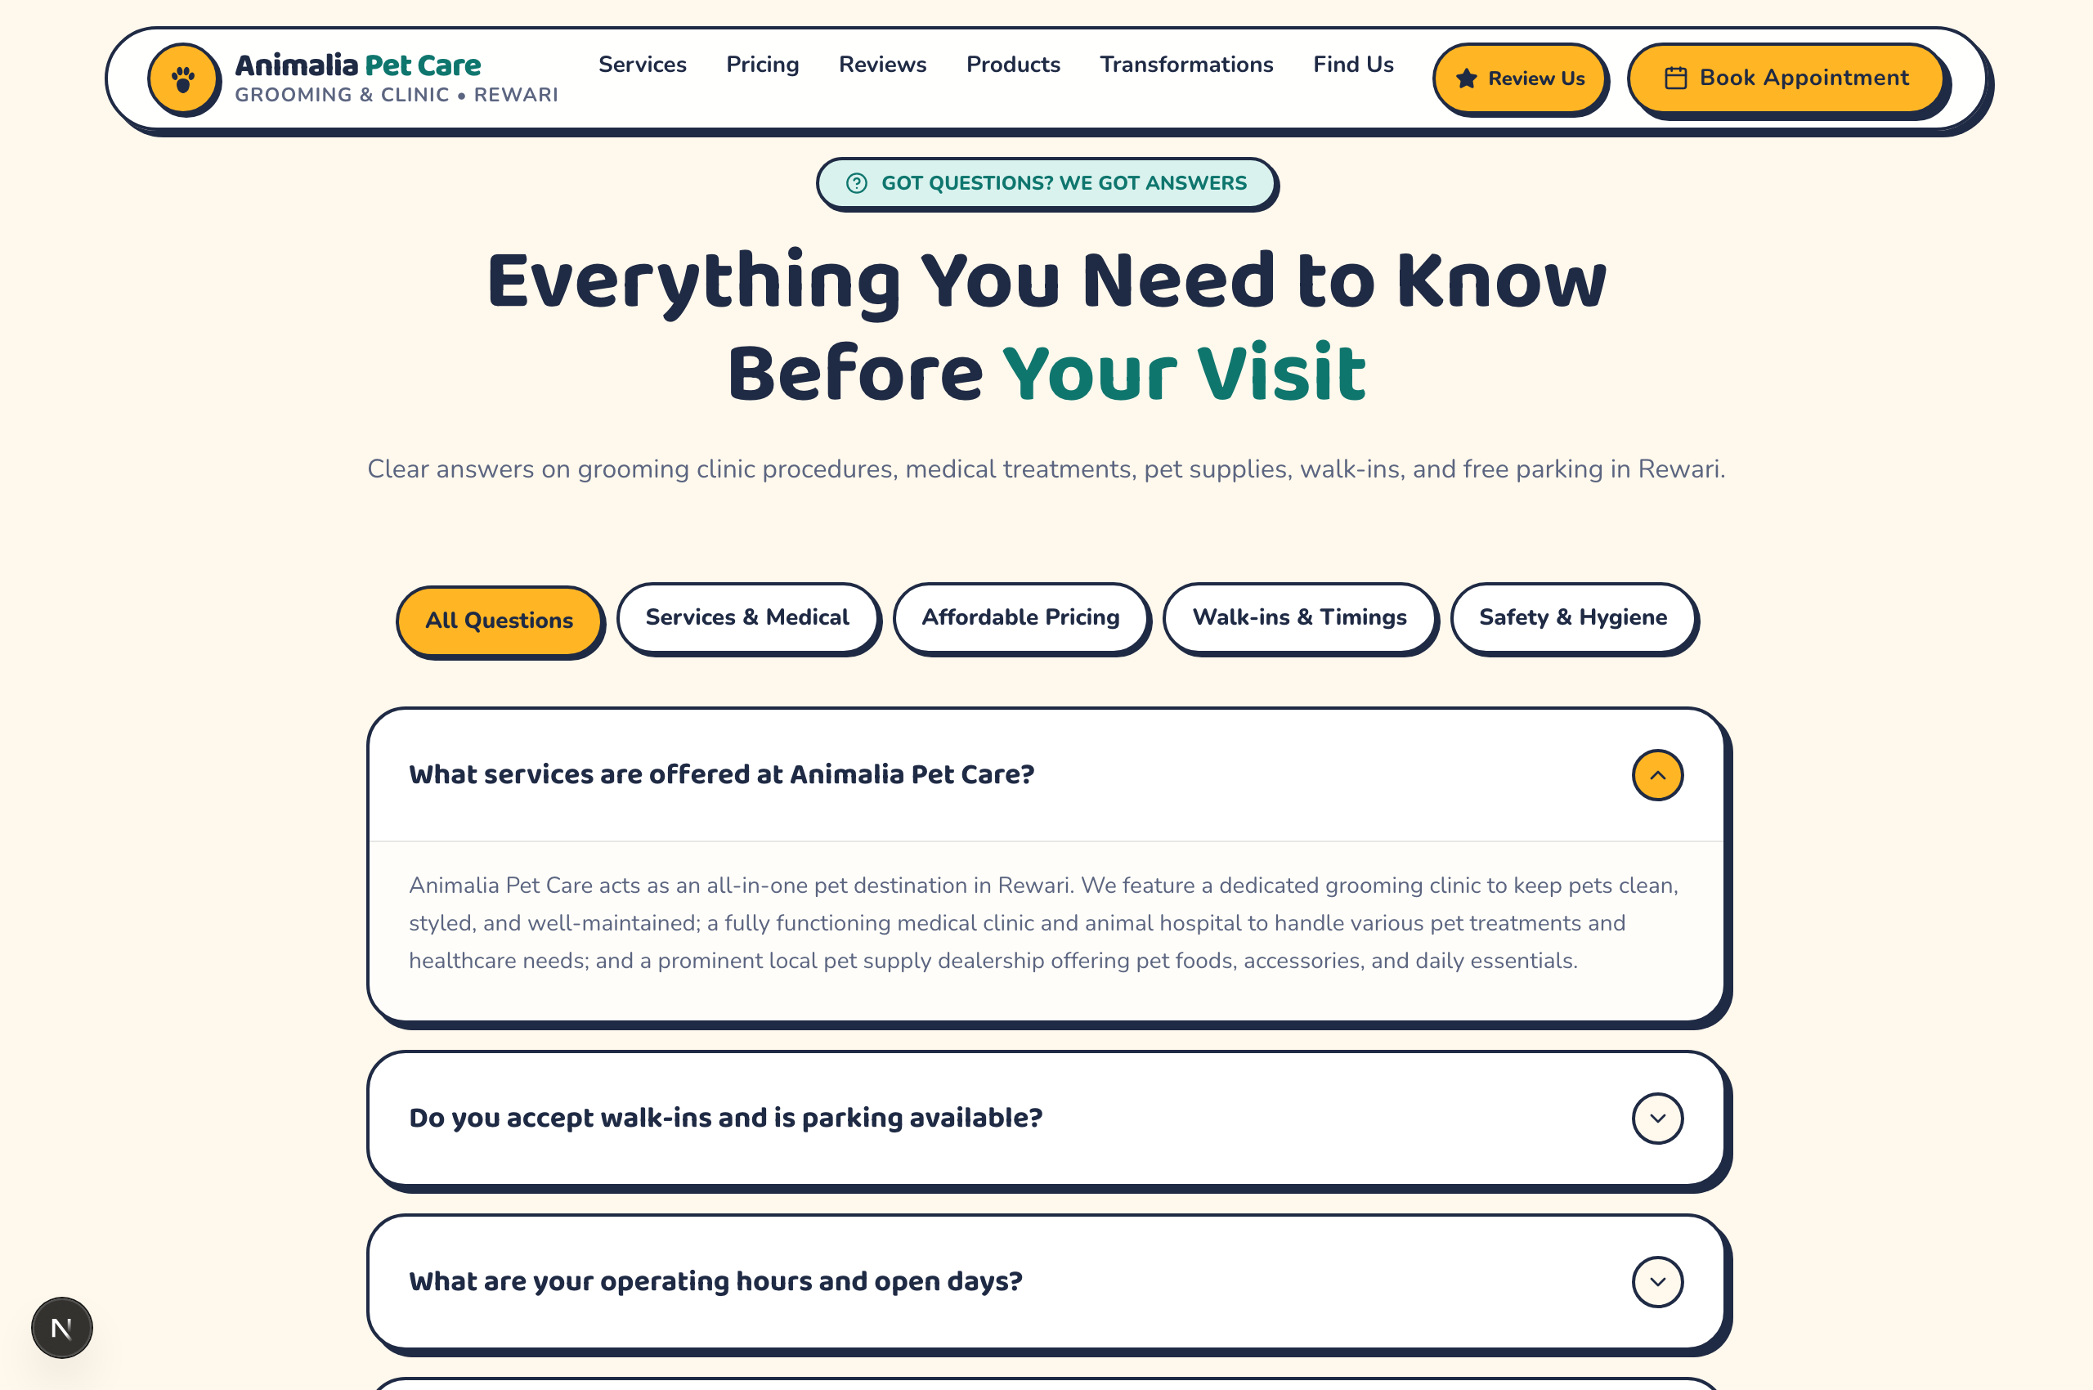
Figure 12: Frequently Asked Questions (FAQ Accordion) View

What You See on Screen:
An interactive FAQ accordion with filter category buttons: All Questions, Services & Medical, Affordable Pricing, Walk-ins & Timings, and Safety & Hygiene. Clicking any question smoothly expands its comprehensive answer.

How to Use (Step-by-Step Guidance):
- Filter Topics: Tap on any category button at the top (e.g. 'Safety & Hygiene') to see related queries.
- Expand Answers: Click on any question card to reveal the complete answer.
- Find Critical Reassurances: Read clear clarifications on walk-in policies, sedation stance (100% no sedatives), and parking availability.
💡 PRO TIP: If your question is not listed, the WhatsApp button is available at the bottom of the section for instant 1-on-1 assistance.

13. 30-Second Quick Appointment Booking Form
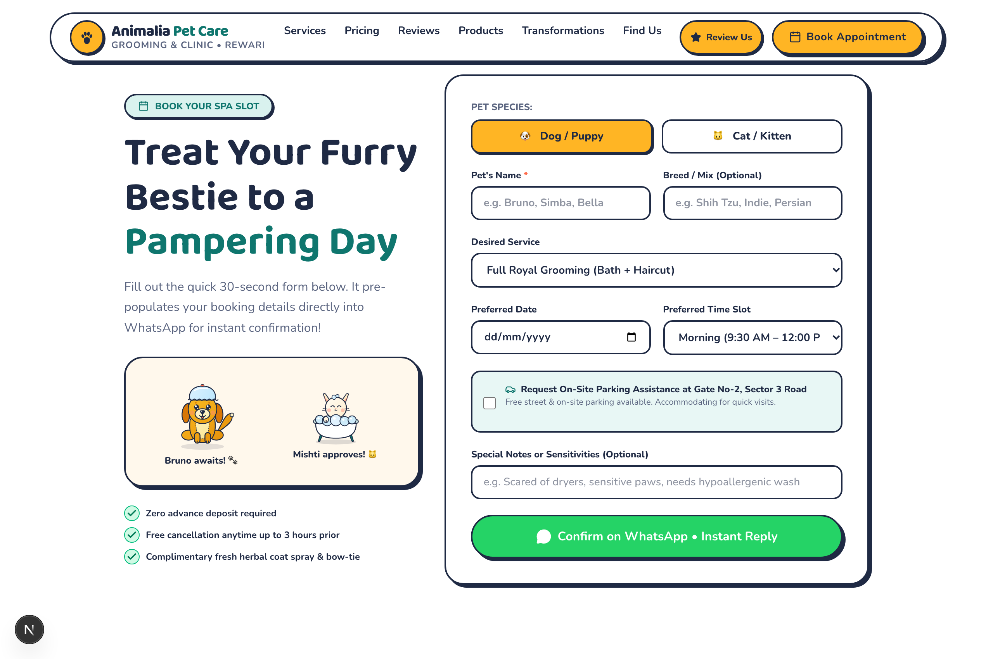
Figure 13: 30-Second Quick Appointment Booking Form View

What You See on Screen:
A clean, non-intimidating booking form designed for speedy completion without credit card requirements. Fields include Pet Species toggle, Pet's Name, Breed, Desired Service dropdown, Preferred Date & Time Slot, Parking Assistance checkbox, and a Special Notes box.

How to Use (Step-by-Step Guidance):
- Select Species: Tap '🐶 Dog / Puppy' or '🐱 Cat / Kitten'.
- Enter Pet Details: Type your pet's name and breed (e.g., Bruno, Shih Tzu).
- Choose Service: Pick your desired package from the dropdown list.
- Choose Date & Time: Select your preferred date and slot (Morning 9:30 AM–12:00 PM, Afternoon, or Evening).
- Parking Assistance: Check the box if you would like on-site parking assistance at Gate No-2 on Sector 3 Road.
- Special Requests: Note any medical conditions, nervousness, or allergies in the optional box.
- Submit via WhatsApp: Tap 'Confirm on WhatsApp • Instant Reply' to dispatch the booking instantly to the clinic.
💡 PRO TIP: Zero advance deposit is required. You can reschedule or cancel for free anytime up to 3 hours prior to your slot.

14. Location, Operating Hours & Maps Directions
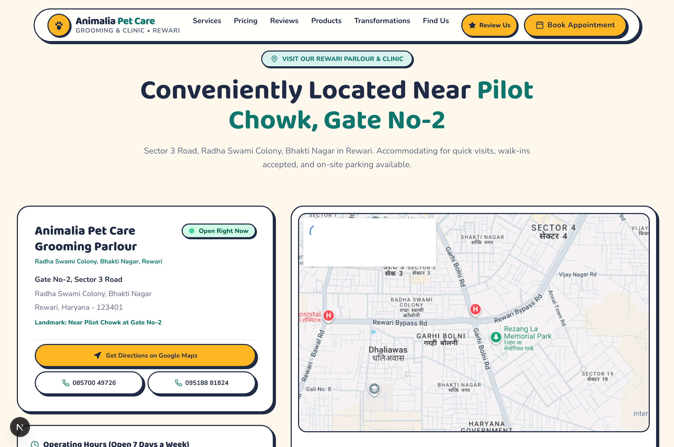
Figure 14: Location, Operating Hours & Maps Directions View

What You See on Screen:
A comprehensive location panel providing the physical address, landmark directions ('Near Pilot Chowk at Gate No-2'), an interactive neighborhood map, direct phone dialer buttons, and a prominent 'Get Directions on Google Maps' button.

How to Use (Step-by-Step Guidance):
- Locate Address: Near Pilot Chowk, Gate No-2, Sector 3 Road, Radha Swami Colony, Bhakti Nagar, Rewari, Haryana 123401.
- Start Navigation: Click 'Get Directions on Google Maps' to launch Google Maps GPS navigation directly on your phone.
- Direct Phone Call: Tap '📞 085700 49726' or '📞 095188 81824' to place an instant voice call to the front desk.
- Verify Timings: Open 7 days a week from 9:30 AM to 8:30 PM with walk-in arrivals accommodated.
💡 PRO TIP: Free street parking and secure on-site parking are available directly outside Gate No-2.

15. Reception Counter QR Standee Display (/review-qr)
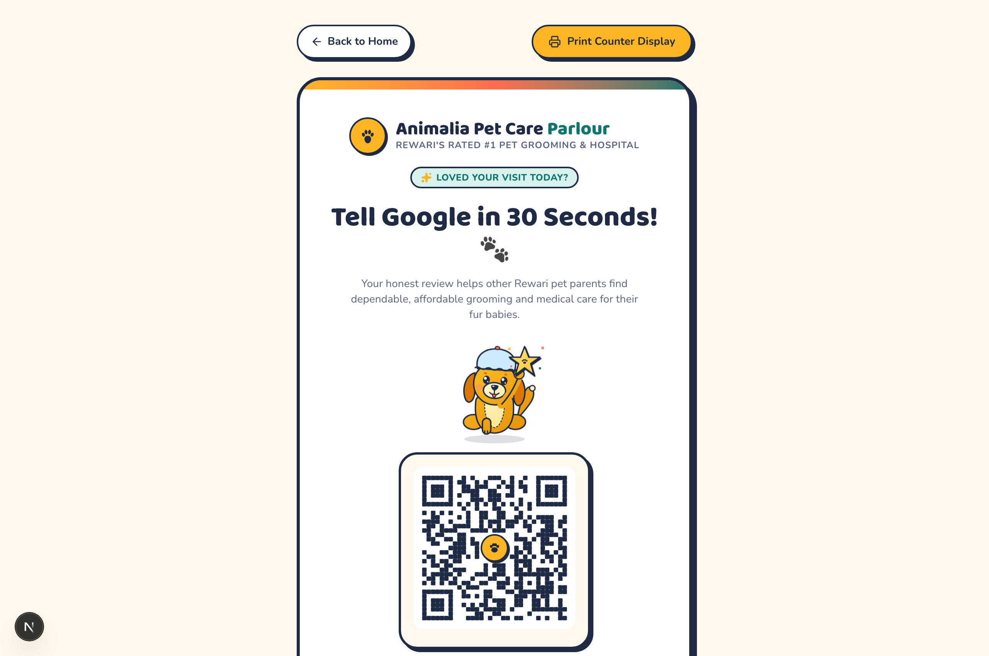
Figure 15: Reception Counter QR Standee Display (/review-qr) View

What You See on Screen:
A standalone, clean display page designed for in-store counter tablets or physical acrylic standees. It showcases the clinic banner, Bruno mascot, an oversized high-contrast QR code, and a 'Print Counter Display' button.

How to Use (Step-by-Step Guidance):
- Access Page: Visit the URL '/review-qr' from any computer or reception tablet.
- Print Physical Standee: Click the golden 'Print Counter Display' button at the top to output a ready-to-frame A4/A5 display.
- Customer Scan: When pet parents are at the billing counter, invite them to scan the QR code using their smartphone camera.
- Direct 30-Second Review: Scanning opens Google Maps review dialogue immediately without needing to search for the business.
💡 PRO TIP: Placing this standee next to the card payment terminal dramatically increases Google 5-star review volume.

16. Mobile Experience & Persistent Bottom Navigation
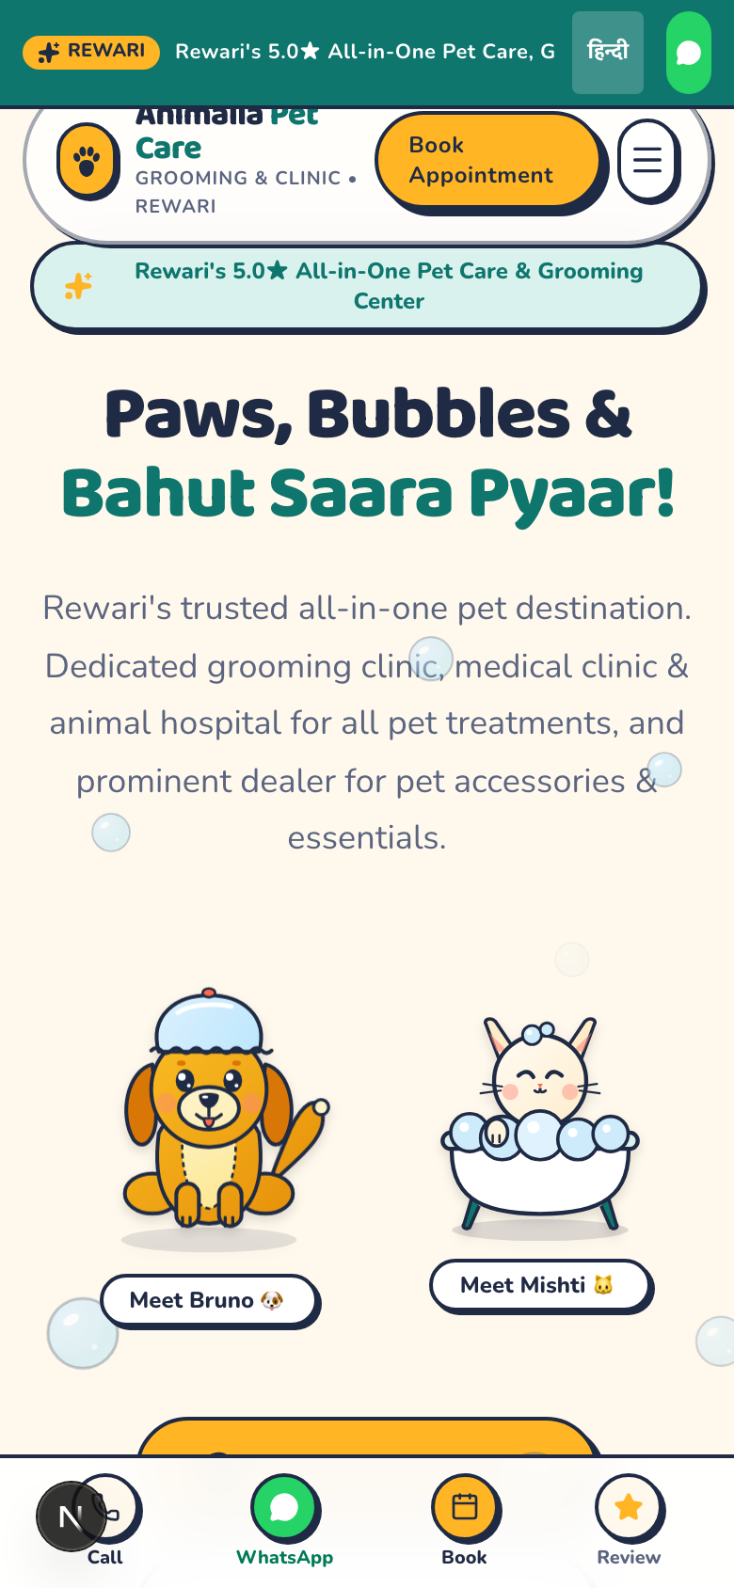
Figure 16: Mobile Experience & Persistent Bottom Navigation View

What You See on Screen:
The optimized smartphone layout featuring touch-friendly cards, high-contrast text, smooth drawer menu, and a thumb-zone sticky action bar at the very bottom with 4 primary shortcuts: Call, WhatsApp, Book, and Review.

How to Use (Step-by-Step Guidance):
- Call Front Desk: Tap the phone icon ('Call') in the bottom bar to launch your device dialer.
- Chat on WhatsApp: Tap the green WhatsApp bubble to launch WhatsApp with the clinic support team.
- Quick Book: Tap the calendar ('Book') icon to instantly glide down to the booking form.
- Leave Review: Tap the star ('Review') icon to jump straight to the feedback wizard.
- Hamburger Menu: Tap the top-right 3-line icon to open the full slide-down navigation menu.
💡 PRO TIP: All touch targets are sized at 48px or larger, ensuring easy one-handed navigation while holding your pet's leash.

