ATAL COMMUNITY DAY

HANDOUT

Online repository for the content

**github.com/adiagr/atl**

**Breadboard connections**

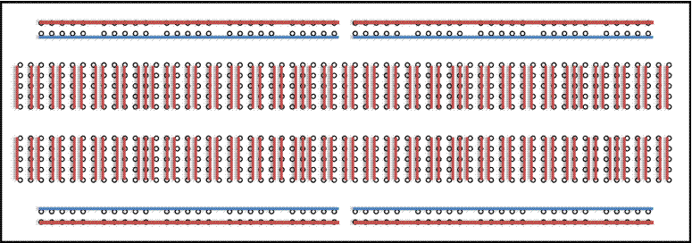

**Circuit Diagrams**

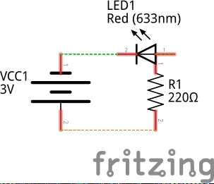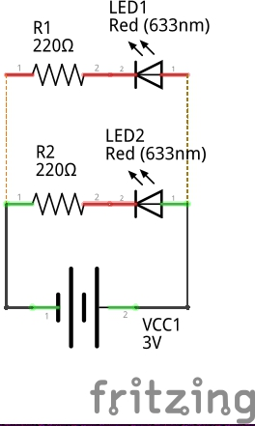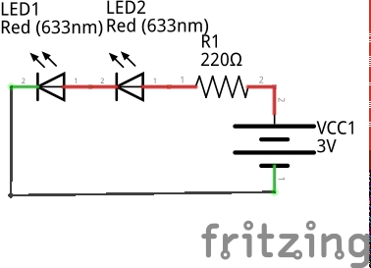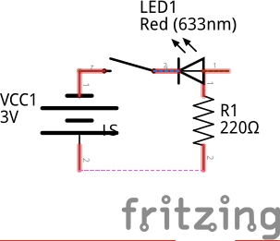

**Normal LED Parallel LED Series LED LED with Switch**

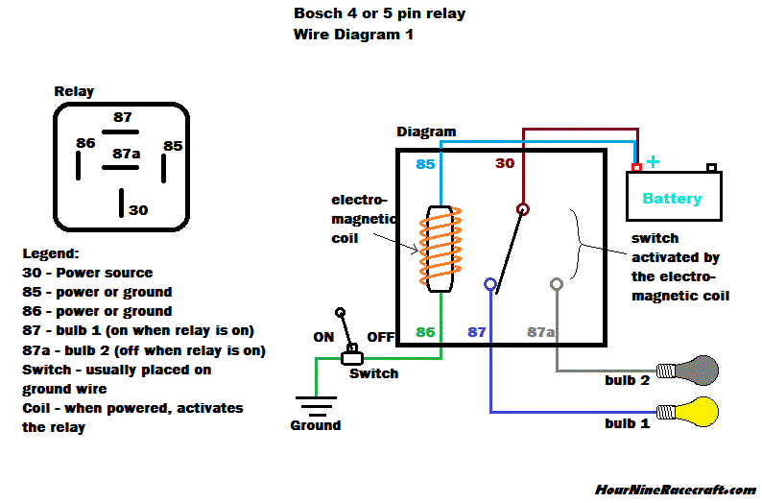

**Relay**

**Common Sensors**

|  |  |  |
| --- | --- | --- |
| Sensor Name | Means of operation | Uses |
| HCSR-04 Ultrasonic Sensor | Ultrasonic waves | Finding distance |
| IR sensor | Infrared Light | Distance, Gesture, Color |
| Light Dependent resistance | Visible Light | Color, ambient light intensity |
| DHT-11 Temprature humidity | Temprature and moisture | To measure temprature, humidity |
| MQ-2 Smoke Sensor | Coil | Detect Smoke, LPG, etc |

**Arduino Cheat Sheet**

Remember!!

First set the input mode of the pin

USE:

pinMode(pinNumber, Mode[INPUT/OUTPUT])

Arduino is Case-Sensitive

void setup() executes only once before void loop(), do all your initializing in void setup()

Put your main code in void loop()

that will loop over and over

**Output Functions:**

digitalWrite(PinNumber, Mode[HIGH/LOW])

analogWrite(PinNumber, Value[0-255])

**Input Functions**

digitalRead(pinNumber)

analogRead(pinNumber)

pulseIn(pinNumber, type[HIGH/LOW])