TIC-TAC-TOE GAME

PPS MINI PROJECT

**BRANCH :- Mechatronics w/s Robotics**

**- SECTION ‘B’**

**BATCH – 5:**

1. TANIYA AGGARWAL {RA2111038010018}
2. AKANKSHA KUKKAL {RA2111038010019}
3. ADITYA AGARWAL {RA2111038010020}
4. PRAKHAR ADITYA {RA2111038010022]

BRIEF ABOUT THE TIC-TAC-TOE GAME:

The tic-tac-toe game is played on a 3x3 grid the game is played by two players, who take turns. The first player marks moves with a circle, the second with a cross. The player who has formed a horizontal, vertical, or diagonal sequence of three marks wins. Your program should draw the game board, ask the user for the coordinates of the next mark, change the players after every successful move, and pronounce the winner.

*SOURCE CODE:*

#include <stdio.h>

#include <conio.h>

char square[10] = { 'o', '1', '2', '3', '4', '5', '6', '7', '8', '9' };

int checkwin();

void board();

int main()

{

int player = 1, i, choice;

char mark;

do

{

board();

player = (player % 2) ? 1 : 2;

printf("Player %d, enter a number: ", player);

scanf("%d", &choice);

mark = (player == 1) ? 'X' : 'O';

if (choice == 1 && square[1] == '1') square[1] = mark;

else if (choice == 2 && square[2] == '2') square[2] = mark;

else if (choice == 3 && square[3] == '3') square[3] = mark;

else if (choice == 4 && square[4] == '4') square[4] = mark;

else if (choice == 5 && square[5] == '5') square[5] = mark;

else if (choice == 6 && square[6] == '6') square[6] = mark;

else if (choice == 7 && square[7] == '7') square[7] = mark;

else if (choice == 8 && square[8] == '8') square[8] = mark;

else if (choice == 9 && square[9] == '9') square[9] = mark;

else

{

printf("Invalid move ");

player--;

getch();

}

i = checkwin();

player++;

}

while (i == - 1);

board();

if (i == 1) printf("==>\aPlayer %d win ", --player);

else printf("==>\aGame draw");

getch();

return 0;

}

/*********************************************

FUNCTION TO RETURN GAME STATUS 1 FOR GAME IS OVER WITH RESULT -1 FOR GAME IS IN PROGRESS O GAME IS OVER AND NO RESULT

**********************************************/

int checkwin()

{

if (square[1] == square[2] && square[2] == square[3]) return 1;

else if (square[4] == square[5] && square[5] == square[6]) return 1;

else if (square[7] == square[8] && square[8] == square[9]) return 1;

else if (square[1] == square[4] && square[4] == square[7]) return 1;

else if (square[2] == square[5] && square[5] == square[8]) return 1;

else if (square[3] == square[6] && square[6] == square[9]) return 1;

else if (square[1] == square[5] && square[5] == square[9]) return 1;

else if (square[3] == square[5] && square[5] == square[7]) return 1;

else if (square[1] != '1' && square[2] != '2' && square[3] != '3' && square[4] != '4' && square[5] != '5' && square[6] != '6' && square[7] != '7' && square[8] != '8' && square[9] != '9')

return 0;

else

return - 1; }

/*******************************************************************

FUNCTION TO DRAW BOARD OF TIC TAC TOE GAME

********************************************************************/

void board()

{

system("cls");

printf("\n\n\tTic Tac Toe\n\n");

printf("Player 1 (X) - Player 2 (O)\n\n\n");

printf(" | | \n");

printf(" %c | %c | %c \n", square[1], square[2], square[3]);

printf("_____|_____|_____\n");

printf(" | | \n");

printf(" %c | %c | %c \n", square[4], square[5], square[6]);

printf("_____|_____|_____\n");

printf(" | | \n");

printf(" %c | %c | %c \n", square[7], square[8], square[9]);

printf(" | | \n\n");

}

/*******************************************************************

END OF MINI PROJECT

********************************************************************/

*OUTCOME :*

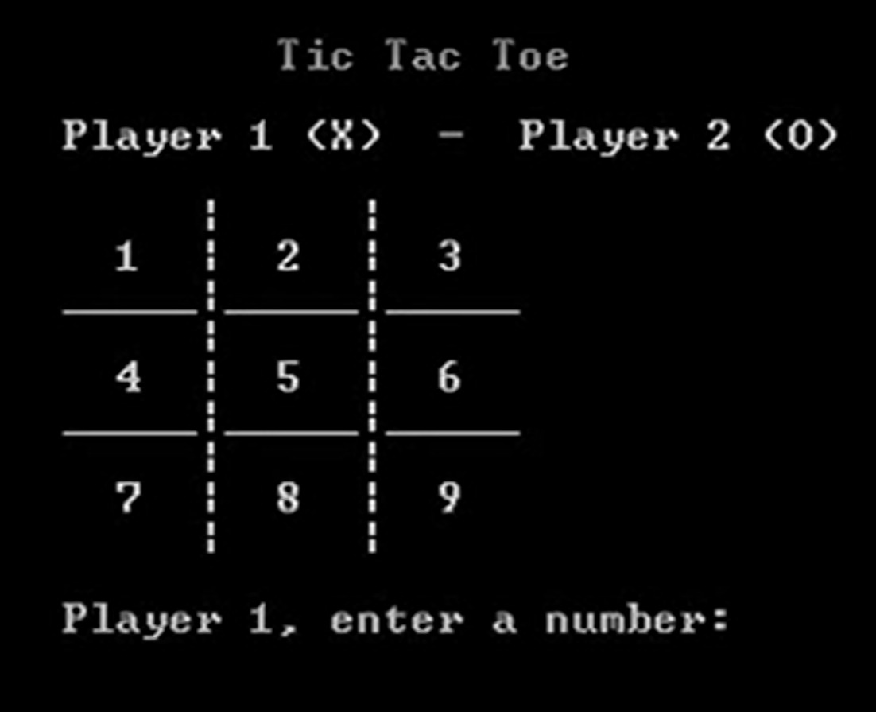

Link:

<https://drive.google.com/file/d/1twZhrYNevORApkM2Gq7aQZHkzQ7W8g8p/view?usp=sharing>

THANK YOU