Homework 4

if we kill an other broker, the last become a manager and the system is still running well

zookeeper start :
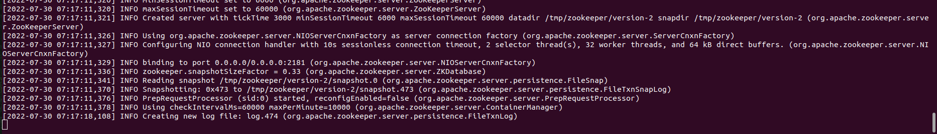
broker id=1
broker id=2
broker id=3
broker id=4
broker id=5
I create a topic(hw4) with 5 partition and 1 replication-factor
producer :
consumer :
we can see the consumer receive the message
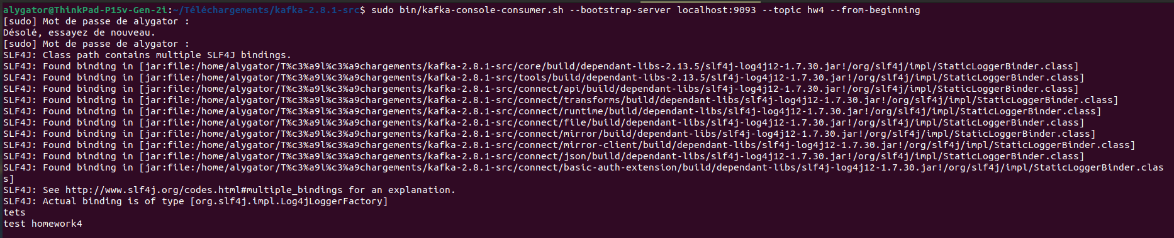
i killed broker1 and 2 :
Consumer continues to receive message from producter despite the error messsage that broker 1 and 2 is not working

