**Interview** **challenge**

**Remarks:**

1. I have virtual-Box with Ubuntu 16.04 LTS, my native machine is Windows 10.
2. I had installed docker before but docker-compose is not built in on Linux distribution there for I’ve needed to install it.

**Ideas:**

I’ve had a bunch of ideas about solving this task:

1. **Editing only docker-compose.yml**
2. I’ve edited docker-compose.yml
3. I’ve ran the commands:

*sudo docker-compose build*

*sudo docker stack deploy -c docker-compose.yml interview_app*

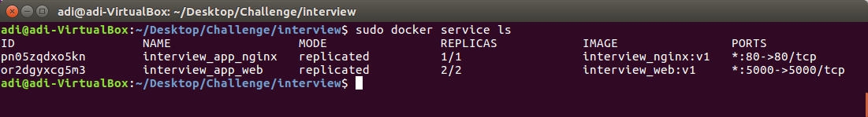

1. I’ve changed the code of app.py and build a new image:

*sudo docker build -t interview_web:v2*

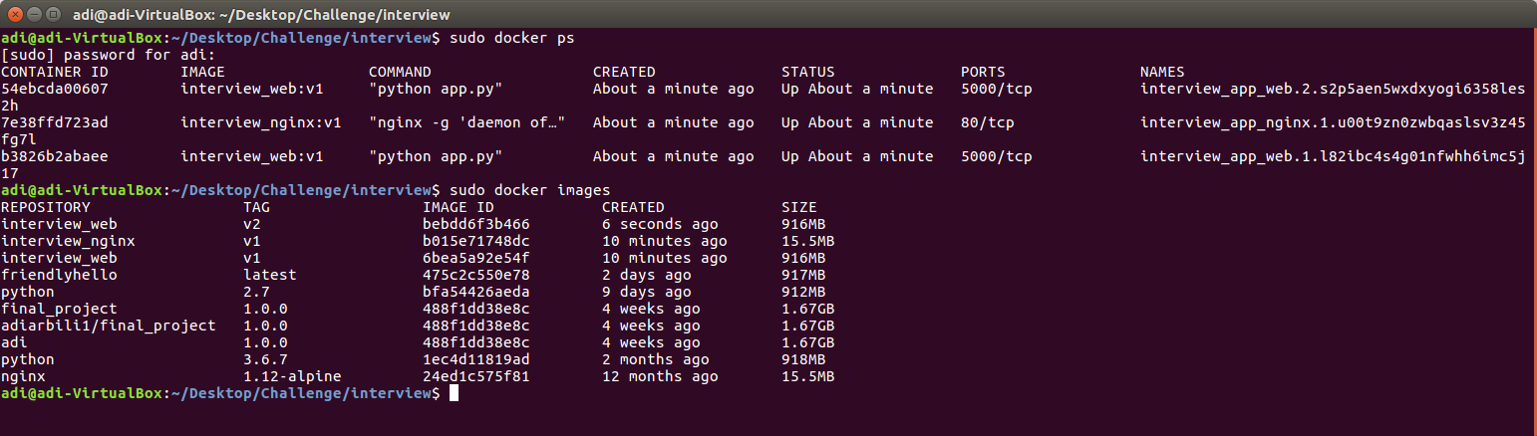

After running the aforementioned commands I thought about running the following command:

*sudo docker swarm init*

Then I’ve inserted: *localhost/sleep/59* and on the terminal I’ve typed the following command:

*sudo docker service update --image interview_web:v2 web*

But that **didn’t** work as expected. The service has updated successfully but the client didn’t get the expected response.

1. **Make Nginx as load balancer editing nginx.conf, docker-compose.yml**

1. I’ve removed the images:
   * interview_web:v1
   * interview_nginx:v1
2. I’ve edited docker-compose.yml
3. I’ve ran the commands:

*sudo docker-compose build*

*sudo docker-compose rm -f*

*sudo docker stack deploy -c docker-compose.yml interview_app*

But the services weren’t stable, don’t know why.

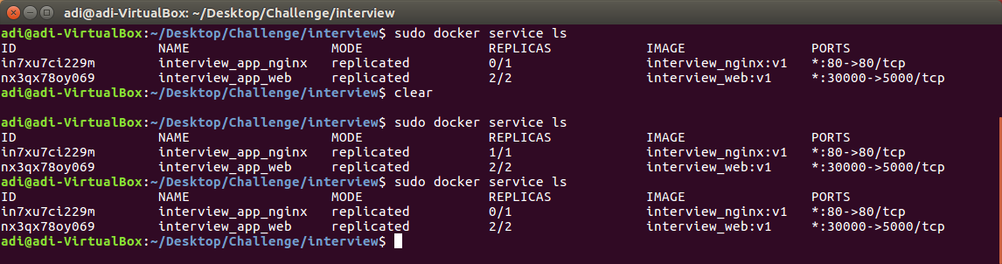

Though, load-balancing is working:

1. I’ve removed the images:
   * interview_web:v1
   * interview_nginx:v1
2. I’ve ran the commands:

*sudo docker-compose build*

*sudo docker-compose up --scale web=2*

You can see that, for two GET requests, two **different** containers are answering:

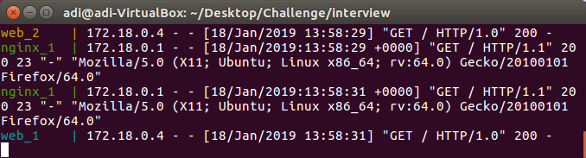

1. **Use HAProxy**
   1. I’ve edited docker-compose.yml
   2. I’ve ran the following command:

*sudo docker-compose up --scale web=2*

* 1. I’ve change the docker-compose.yml on the “web” service on the filed image to “interview_web:v2”
  2. I’ve ran the following command:

*sudo docker-compose up --no-recreate --scale web=4*

That should create two more web containers of “interview_web:v2” and after the creation they should run.

Then I tried a command which supposedly drain the traffic from the container, but the socat command didn’t work.

*docker exec -it interview_proxy_1 sh -c interview_web_10 | socat stdio /var/run/haproxy.sock"*