Aditya Jain

Answer images for question 3 and 4

Answer 4 – Page 1

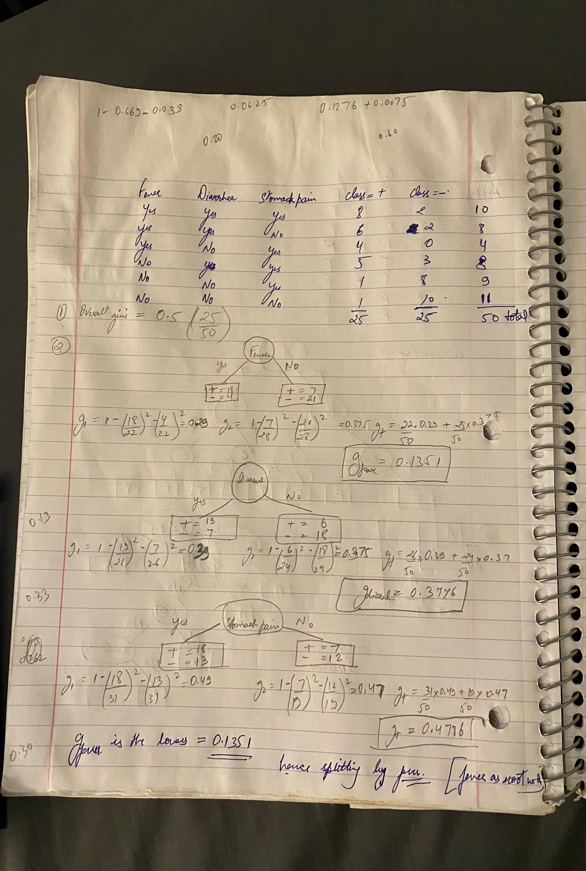

Page -2 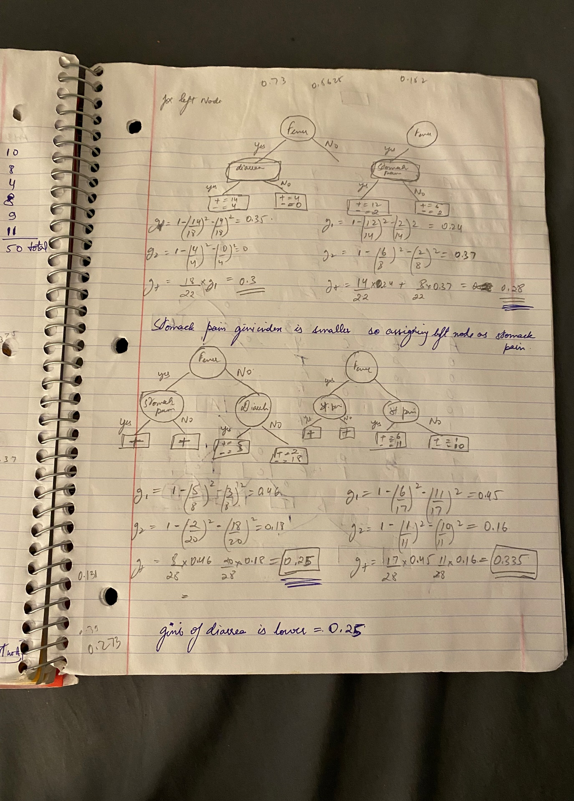

Page - 3