**In-Class Assignment 14**

1. For the price field in the diamonds dataset
   1. First plot a histogram of the data. Does it look approximately exponential?

It has an exponential distribution.

* 1. Adapt the LL optimization code to find the maximum likelihood estimate for an exponential distribution for the price data.

1. From diamonds dataset take the field z. Adopt the code to find the MLE’s for the parameters of the normal distribution.

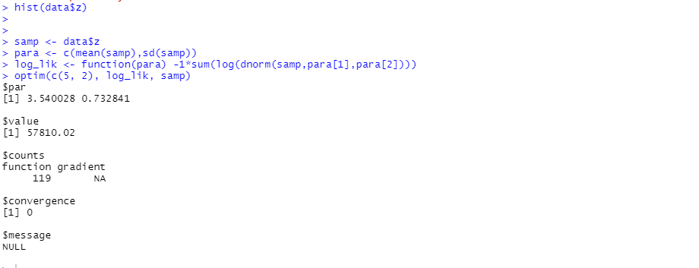

1. A sample consists of {0.1, 0.2, 0.5, 0.7, 0.8, 0.9, 0.95}. It is thought to fit a probability distribution of the form p(x) = (α+1)xα, for 0 ≤ x ≤ 1. Find the maximum likelihood estimate for the parameter α.

