Software Required:

Software Requirements

1. **visual studio code** (Editor for writing code)
2. **nodejs**(Node.js is an open source server environment, to run JavaScript on the server)
3. **mongodb** (MongoDB is an open source NoSQL database management program. )

Installation process:

1. Visual studio code https://code.visualstudio.com/download
   1. Download software according to your system/laptop specifications.
   2. Follow the instructions accordingly and go on to install software.
2. Node.js https://nodejs.org/en/download/
   1. Download software according to your system/laptop specifications.
   2. Follow the instructions accordingly and go on to install software.
3. MongoDB https:/[/www.mongodb.com/try/download/community](http://www.mongodb.com/try/download/community)
   1. Download community software according to your system/laptop specifications.
   2. Follow the instructions accordingly and go on to install software.

# EXPERIMENT 1

## 1.a) Write a JavaScript program which accepts a string as input and swap the case of each character. For example if you input 'The Quick Brown Fox' the output should be 'tHEqUICKbROWNfOX'. – “one.js”

const readline = require('readline');

var RL = readline.createInterface(process.stdin, process.stdout); RL.question('Please Enter Text: ', (name)=>{

let x=name; let y="";

for(let i=0;i<x.length;i++)

{

if (x.charAt(i) >='A' && x.charAt(i) <= 'Z') y=y+x.charAt(i).toLowerCase();

else if(x.charAt(i) >='a' && x.charAt(i) <= 'z') y=y+x.charAt(i).toUpperCase();

}

console.log(`Output is is ${y}`);

});

# EXPECTED OUTPUT:

## b) . Write a JavaScript program to find the most frequent item of an array. – “two.js”

var arr1=[3, 'a', 'a', 'a', 2, 3, 'a', 3, 'a', 2, 4, 9, 3];

var mf = 1; var m = 0; var item;

for (var i=0; i<arr1.length-1; i++)

{

for (var j=i; j<arr1.length; j++)

{

if (arr1[i] == arr1[j]) m++;

if (mf<m)

{

mf=m;

item = arr1[i];

}

}

m=0;

}

console.log(item+" ( " +mf +" times ) ") ;

# EXPECTED OUTPUT

## c). Write a JavaScript program to remove duplicate items from an array – „three.js‟

function removeDuplicates(num) { len=num.length; uniqueChars=[];

num.forEach((c) => {

if (!uniqueChars.includes(c)) { uniqueChars.push(c);

}

});

return uniqueChars;

}

let Mynum = [1, 2, 2, 4, 5, 4, 7, 8, 7, 3, 6];

result = removeDuplicates(Mynum); console.log("Original List: "+Mynum); console.log("Unique List: "+result);

# EXPECTED OUTPUT:

## Write a JavaScript program to perform a binary search. – “four.js”

let iterativeFunction = function (arr, x) {

let start=0, end=arr.length-1;while (start<=end){ let mid=Math.floor((start + end)/2);

if (arr[mid]===x) return true; else if (arr[mid] < x)

start = mid + 1; else

end = mid - 1;

}

return false;

}

let arr = [1, 3, 5, 7, 8, 9];

let x = 5; console.log(iterativeFunction(arr, x) ) ;

# EXPECTED OUTPUT:

## Write a JavaScript program to list the properties of a JavaScript object – “five.js”

let object = { name: 'Jack', age: 25, college: 'KMIT', year: 3,

sem: 1

};

let properties = Object.keys(object) console.log(properties);

# EXPECTED OUTPUT:

## Write a JavaScript function to check whether an object contains given property. – “six.js”

* 1. ***hasOwnProperty()* method**

let object = { name: 'Jack', age: 25, college: 'KMIT', year: 3,

sem: 1

};

console.log(object.hasOwnProperty('name'));

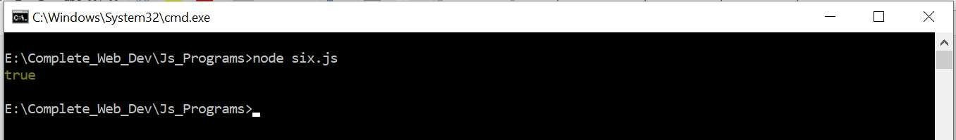

* 1. ***in operator Method:***

let object = { name: 'Jack', age: 25,

college: 'KMIT', year: 3, sem: 1

};

console.log(‘name’ in object);

* 1. ***Comparing with undefined Method:***

let object = { name: 'Jack', age: 25,

college: 'KMIT', year: 3, sem: 1

};

console.log(object.name); console.log(object.fee);

Expected output: here Name property is available so programs gives you output as ‘Jack’ but fee property is not available so it is giving output as undefined.

## Write a JavaScript program to sort a list of elements using Quick sort. –“seven.js”

function quick_Sort(origArray) { if (origArray.length <= 1) {

return origArray;

} else {

var left = []; var right = [];

var newArray = [];

var pivot = origArray.pop(); var length = origArray.length;

for (var i = 0; i < length; i++) {

if (origArray[i] <= pivot) { left.push(origArray[i]);

} else {

}

}

right.push(origArray[i]);

return newArray.concat(quick_Sort(left), pivot, quick_Sort(right));

}

}

var myArray = [3, 0, 2, 5, -1, 4, 1 ];

console.log("Original array: " + myArray); var sortedArray = quick_Sort(myArray); console.log("Sorted array: " + sortedArray);

**Expected Output:**

## Write a JavaScript program to implement Bubble Sort. –“eight.js”

function swap(arr, first_Index, second_Index){ var temp = arr[first_Index];

arr[first_Index] = arr[second_Index]; arr[second_Index] = temp;

}

function bubble_Sort(arr){ var len = arr.length,

i, j, stop;

for (i=0; i < len; i++){

for (j=0, stop=len-i; j < stop; j++){ if (arr[j] > arr[j+1]){

swap(arr, j, j+1);

}

}

}

return arr;

}

myArray=[3, 0, 2, 5, -1, 4, 1];

console.log("Original array: " + myArray); var sortedArray = bubble_Sort(myArray); console.log("Sorted array: " + sortedArray);

Expected Output:

## Write a JS program to read from a JSON object and display the data in a table (HTML page)

**s1.json**

**{ "student":[**

**{"name": "Bhavana", "age": 20, "college": "KMIT", "year": 3, "sem": 1 },**

**{ "name": "Ram", "age": 21, "college": "JNTU", "year": 4,"sem": 2 },**

**{ "name": "John", "age": 26, "college": "KMEC", "year": 1,"sem": 1 },**

**{ "name": "Reena", "age": 19, "college": "NGIT", "year": 3,"sem": 1 }**

**]**

**}**

**nineIX.html**

<!DOCTYPE html>

<html>

<head>

<title>Convert JSON Data to HTML Table</title>

<style>

th, td, p, input { font:14px Verdana;

}

table, th, td

{

border: solid 2px #DDD; border-collapse: collapse; padding: 2px 3px;

text-align: center;

}

th {

font-weight:bold;

}

</style>

</head>

<body>

<input type="button" onclick="CreateTableFromJSON()" value="Create Table From JSON"

/>

<p id="showData"></p>

</body>

<script>

function CreateTableFromJSON() {fetch("s1.json")

.then (response => response.json())

.then(data => {

// EXTRACT VALUE FOR HTML HEADER.

// ('Name', 'Age', 'College', 'Year',Sem)var col = [];

for (var i = 0; i < data.student.length; i++) {for (var key in data.student[i]) {

if (col.indexOf(key) === -1) {col.push(key);

}

}

}

console.log(col);

// CREATE DYNAMIC TABLE.

var table = document.createElement("table");

// CREATE HTML TABLE HEADER ROW USING THEEXTRACTED HEADERS ABOVE.

var tr = table.insertRow(-1); // TABLE ROW. for (var i = 0; i < col.length; i++) {

var th = document.createElement("th"); // TABLE

HEADER.

}

th.innerHTML = col[i]; tr.appendChild(th);

// ADD JSON DATA TO THE TABLE AS ROWS.

for (var i = 0; i < data.student.length; i++) {tr = table.insertRow(-1);

for (var j = 0; j < col.length; j++) {var tabCell = tr.insertCell(-1);

tabCell.innerHTML = data.student[i][col[j]];

}

}

// FINALLY ADD THE NEWLY CREATED TABLEWITH JSON DATA TO A CONTAINER.

var divContainer = document.getElementById("showData");

divContainer.innerHTML = ""; divContainer.appendChild(table);

})

}

</script>

</html>

# EXPECTED OUTPUT:

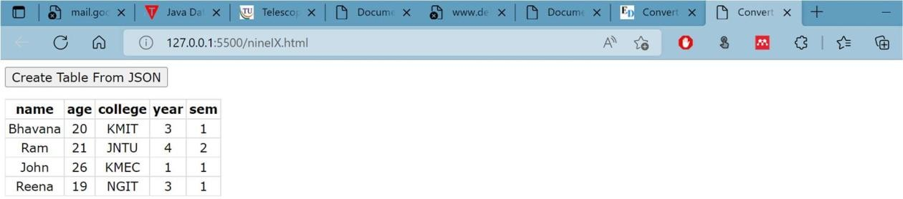

## Create a JS application that accepts the student's roll number, name, and marks and, when the form has been submitted, displays the student's name, roll number, and marks in a tabular format along with their GPA ( like a marks sheet) – “ten.html”

<!DOCTYPE html>

<html lang="en">

<head>

<meta charset="UTF-8">

<meta http-equiv="X-UA-Compatible" content="IE=edge">

<meta name="viewport" content="width=device-width, initial-scale=1.0">

<title>Student-Marks-Sheet</title>

<!-- CSS only -->

<link href="[https://cdn.jsdelivr.net/npm/bootstrap@5.2.0-beta1/dist/css/bootstrap.min.css](https://cdn.jsdelivr.net/npm/bootstrap%405.2.0-beta1/dist/css/bootstrap.min.css)" rel="stylesheet" integrity="sha384- 0evHe/X+R7YkIZDRvuzKMRqM+OrBnVFBL6DOitfPri4tjfHxaWutUpFmBp4vmVor" crossorigin="anonymous">

<script src="https://maxcdn.bootstrapcdn.com/bootstrap/4.4.1/js/bootstrap.min.js"></script>

<style>

.sdetails{

}

</style>

</head>

<body>

<div id="mydata">

</div>

<div id="myformdiv">

<h3> Enter Student Details and Marks</h3>

<form id="myForm" method="post" >

<label>Student name:</label>

<input type="text" id="sname" ><br> <br>

<label>Roll number:&nbsp; </label>

<input type="text" id="rollno"><br><br>

<label>subject1 Marks:</label>

<input type="text" id="sub1name" placeholder="sub1">

<input type="number" id="marks1"><br><br>

<label>subject2 Marks:</label>

<input type="text" id="sub2name" placeholder="sub2" >

<input type="number" id="marks2"><br><br>

<label>subject3 Marks:</label>

<input type="text" id="sub3name" placeholder="sub3">

<input type="number" id="marks3"><br><br>

<input type="button" onclick="myFunction()" value="Submit">

</form>

</div>

<script>

function myFunction() { document.getElementById('myformdiv').style.display='none'; let myInfo = `

<div class='sdetails'>

<h3> Student Details and Marks</h3>

<table class=table-bordered table-primary>

<tr>

<td class="bg-primary"> Name</td> <td>${ document.getElementById('sname').value}</td>

</tr>

<tr> <td class="bg-primary"> Hallicket Number: </td> <td>${ document.getElementById('rollno').value}</td>

</tr>

<tr>

<td > ${ document.getElementById('sub1name').value} Marks </td><td>${ document.getElementById('marks1').value}.</td>

</tr>

<tr> <td> ${ document.getElementById('sub2name').value} Marks </td><td> ${ document.getElementById('marks2').value}</td>

</tr>

<tr> <td> ${ document.getElementById('sub3name').value} Marks </td><td> ${ document.getElementById('marks3').value}</td>

</tr>

</tr>

</table>

</div>

`;

document.getElementById('mydata').innerHTML = myInfo;

}

</script>

</body>

</html>

# EXPECTED OUTPUT

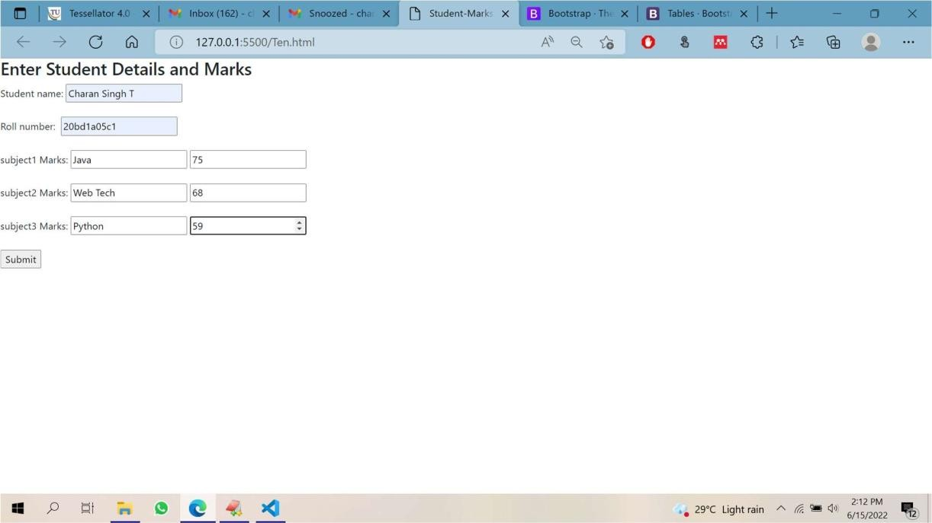

**on submit**

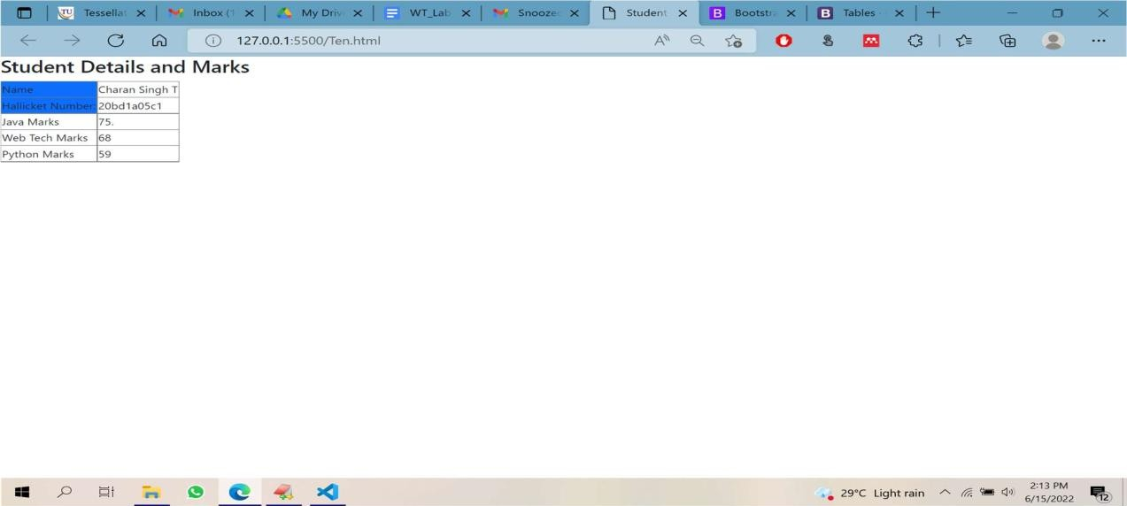

# EXPERIMENT 2

## Write JS code in an HTML page such that based on location selected by the user an AJAX request is made and weather details for that location are fetched and displayed. –

**“index.html”**

<!DOCTYPE html>

<html lang="en">

<head>

<meta charset="UTF-8">

<meta http-equiv="X-UA-Compatible" content="IE=edge">

<meta name="viewport" content="width=device-width, initial-scale=1.0">

<link rel="stylesheet" href="https://maxcdn.bootstrapcdn.com/bootstrap/4.4.1/css/bootstrap.min.css">

<link rel="stylesheet" href="https://cdnjs.cloudflare.com/ajax/libs/font- awesome/4.7.0/css/font-awesome.min.css">

<script src="https://ajax.googleapis.com/ajax/libs/jquery/3.4.1/jquery.min.js"></script>

<script src="https://cdnjs.cloudflare.com/ajax/libs/popper.js/1.16.0/umd/popper.min.js"></script>

<script src="https://maxcdn.bootstrapcdn.com/bootstrap/4.4.1/js/bootstrap.min.js"></script>

<link rel="stylesheet" href="mystyle.css">

<title>Weather App</title>

<style>

#weather {

font-family: Arial, Helvetica, sans-serif; border-collapse: collapse;

width: 50%; margin-left:25%; margin-right:15%;

}

#weather td, #weather th { border: 1px solid #ddd; padding: 8px;

}

#weather tr:nth-child(even){background-color: #f2f2f2;} #weather tr:hover {background-color: #ddd;}

#weather th { padding-top: 12px;

padding-bottom: 12px; text-align: left;

background-color: #04AA6D; color: white;

}

</style>

<script>

function getWeather(){

//doucment.getElementBy

let request = new XMLHttpRequest();

let zip=document.getElementById('tb1').value;

request.open('GET','https://api.openweathermap.org/data/2.5/weather?q='+zip+'&appid=93f26e 3c57081a6210de53b8dcfdfea4',true);

request.onload = function() {

if( request.status >=200 && request.status < 400){ let data = JSON.parse(request.responseText); console.log(data);

var icon = "https://openweathermap.org/img/w/"+data.weather[0].icon+".png" document.getElementById('temp').innerHTML = data.main.temp+ 'F'; document.getElementById('country').innerHTML=data.sys.country; document.getElementById('city').innerHTML=data.name;

let tim= new Date(data.sys.sunrise * 1000);

document.getElementById('sunrise').innerHTML=tim; let tim1= new Date(data.sys.sunset * 1000); document.getElementById('sunset').innerHTML=tim1;

document.getElementById('windspeed').innerHTML=data.wind.speed; document.getElementById('humid').innerHTML=data.main.humidity;

}

else{

console.log('failed connecting')

}

}

request.onerror = function() { console.log(" Error ")

}

request.send();

}

</script>

</head>

<body>

<div class="container">

<div class="jumbotron text-center">

<h1>Please enter Zip code to get weather report.</h1>

<input type="text" placeholder="enter zip code"id="tb1"><br><br>

<button type="submit" vlaue="Click for weather" onclick="getWeather()">Click me</button>

</div>

<table class="table-bordered table-striped" id="weather" >

<thead>

<tr>

<th>Key</th>

<th>Value</th>

</tr>

</thead>

<tbody>

<tr>

<td>Country</td>

<td><label id="country"></label></td>

</tr>

<tr>

<td>City</td>

<td ><label id="city"></label></td>

</tr>

<tr>

<td>Temperature</td>

<td ><label id="temp"></label></td>

</tr>

<tr>

<td>Humidity</td>

<td ><label id="humid"></label></td>

</tr>

<tr>

<td>Sunrise</td>

<td ><label id="sunrise"></label></td>

</tr>

<tr>

<td>Sunset</td>

<td ><label id="sunset"></label></td>

</tr>

<tr>

<td>WindSpeed</td>

<td ><label id="windspeed"></label></td>

</tr>

</tbody>

</table>

</div>

</body>

</html>

# EXPECTED OUTPUT :

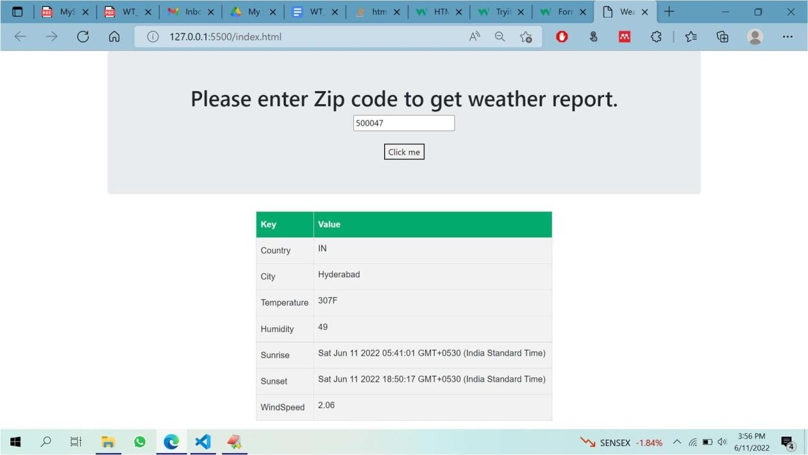

**EXPERIMENT 3**

## Write a Node JS program that accepts a port from the user and runs a node server at that port --“server.js”

var http = require('http');

var server = http.createServer(function (req, res) {

if (req.url == '/') { //check the URL of the current request

// set response header

res.writeHead(200, { 'Content-Type': 'text/html' });

// set response content

res.write('<html><body><p>This is home Page.</p></body></html>'); res.end();

}

else if (req.url == "/student") {

res.writeHead(200, { 'Content-Type': 'text/html' }); res.write('<html><body><p>This is student Page.</p></body></html>'); res.end();

}

else if (req.url == "/admin") {

res.writeHead(200, { 'Content-Type': 'text/html' }); res.write('<html><body><p>This is admin Page.</p></body></html>'); res.end();

}

else

res.end('Invalid Request!');

});

server.listen(8000);

console.log('Node.js web server at port 8000 is running..')

# EXPECTED OUTPUT

**node server.js**

**Node.js web server at port 8000 is running..**

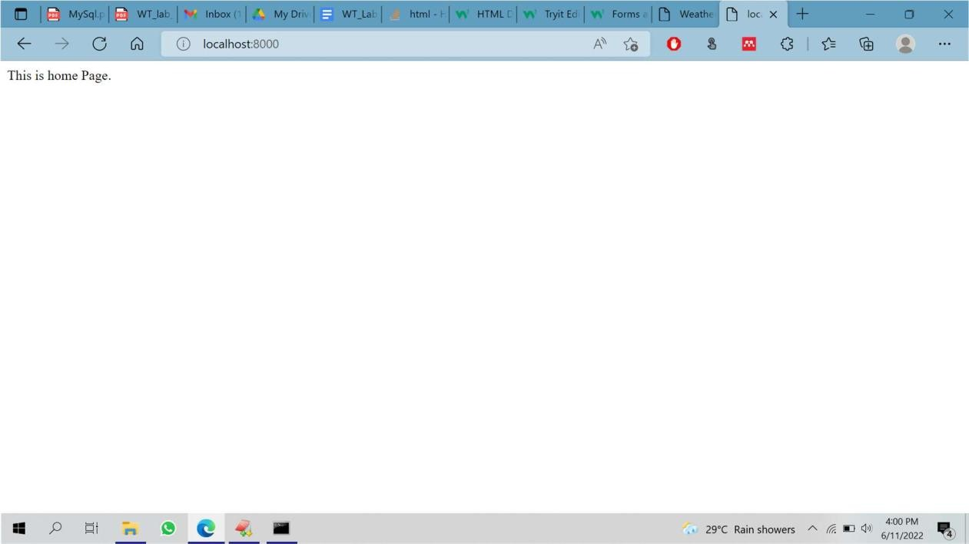

# EXPERIMENT 4

## Write a NodeJS program to read from a file and display the content on screen – “readfile.js”

var fs = require('fs'); try {

var data = fs.readFileSync('my-file.txt', 'utf8'); console.log(data);

} catch(e) { console.log('Error:', e.stack);

}

my-file.txt

Keshav Memorial Institute of Technology (KMIT), established in 2007, is one of the premier engineering colleges in the state of Telangana.

KMIT is sponsored by Keshav Memorial Education Society (KMES), well known in Hyderabad, for the past 75 years, for running various educational institutions of repute.

KMIT is approved by All India Council for Technical Education (AICTE), New Delhi, and affiliated to Jawaharlal Nehru Technological University (JNTU), Hyderabad and recognized by the Govt. of Telangana.

KMIT is co-promoted and powered by Genesis Solutions Pvt. Ltd, a premier institute in Hyderabad imparting industry focused software training and education in emerging technologies and having tie-ups with leading MNCs.

KMIT campus is located in Narayanaguda, a central locality in the city of Hyderabad. 1

2

3

# EXPECTED OUTPUT

**EXPERIMENT 5**

## Create a NodeJS programme that allows users to submit text and a file name, and if the file already exists, appends the text to the file. If not, make a fresh file and include the text in it.

var fs = require('fs');

// appendFile function with filename, content and callback function fs.appendFile('newfile.txt', `Learn Node FS module \r\n`, function (err) { if (err) throw err;

console.log('File is Appended successfully.');

});

# EXPECTED OUTPUT

**File is appended successfully.**

**newfile.txt –**

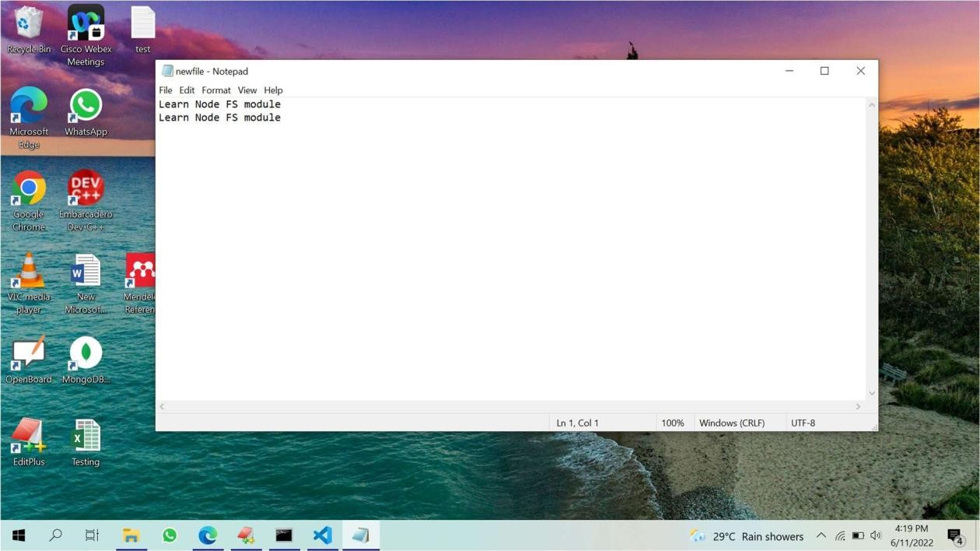

# EXPERIMENT 6

## Create a student database in MongoDB with all the details of students of a class

1. show dbs;

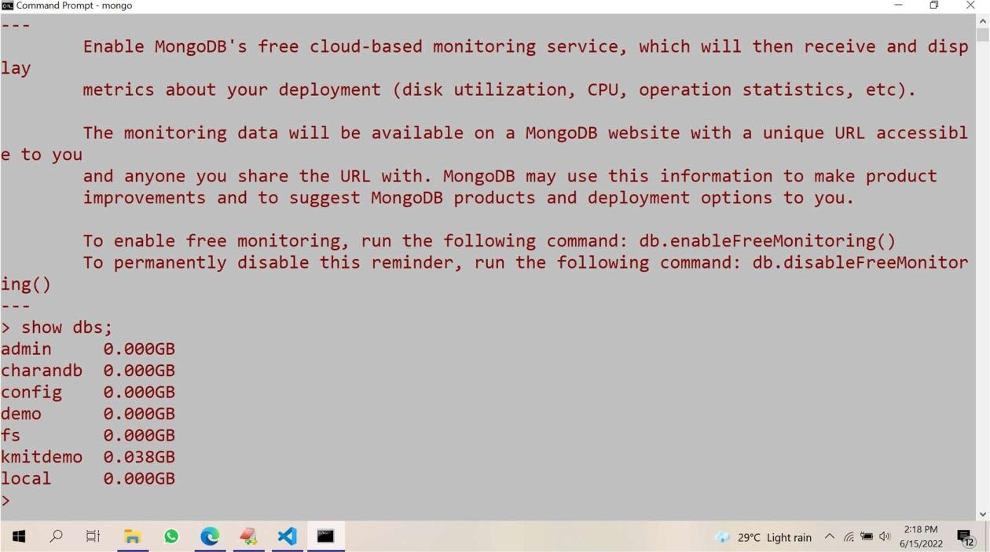

1. use student; switched to db student

insert into studentinfo collection

1. db.studentinfo.insert({name:"john",id:"20bd1a05051",course:"b.tech",branch:"cse"}) WriteResult({ "nInserted" : 1 })
2. db.studentinfo.insert({name:"reena",id:"20bd1a0502",course:"M.tech",branch:"it"}) WriteResult({ "nInserted" : 1 })
3. db.studentinfo.insert({name:"ram",id:"20bd1a0503",course:"b.tech",branch:"cse"}) WriteResult({ "nInserted" : 1 })

# EXPECTED OUTPUT

**view studentinfo collection:**

1. **db.studentinfo.find({})**

**{ "_id" : ObjectId("62a99e693dbaba59a0af05cf"), "name" : "john", "id" : "20bd1a05051", "course" : "b.tech", "branch" : "cse" }**

**{ "_id" : ObjectId("62a99ebd3dbaba59a0af05d0"), "name" : "reena", "id" : "20bd1a0502", "course" : "M.tech", "branch" : "it" }**

**{ "_id" : ObjectId("62a99f123dbaba59a0af05d1"), "name" : "ram", "id" : "20bd1a0503", "course" : "b.tech", "branch" : "cse" }**

# EXPERIMENT 7

## Create a form such that, based on student roll number provided by user, the student details should be fetched ( using ExpressJS)

**File structure :**

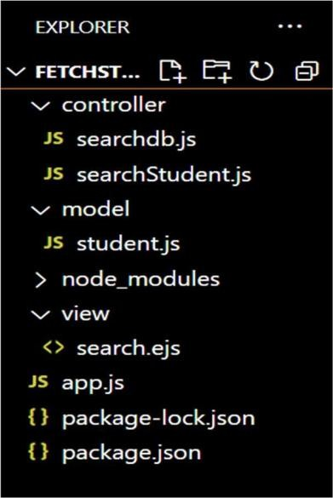

## app.js

var express = require('express'); var app = express();

const html = require('ejs') const path=require('path') app.use(express.json()); app.use(express.urlencoded({ extended: true

}));

app.set('views', path.join( dirname, 'view')) app.set('view engine','ejs')

const mongoose=require('mongoose') mongoose.connect('mongodb://localhost/student', function(error){

if(error) console.log(error);

console.log("connection successful");

});

const searchStudentController = require('./controller/searchStudent') const fetchController= require('./controller/searchdb'); app.get('/search',searchStudentController) app.post('/student/fetch',fetchController);

app.listen(3000, () => console.log("App listening on port 3000!"));

## searchdb.js

const Student = require('../model/student.js') module.exports = (req,res)=>{

// console.log(req.body.rollno);

// var test=Student.find({id: req.body.rollno}); Student.find({id: req.body.rollno}, (error, student) => {

if(error){ console.log(student)

res.render('search',{stuData:student});

}

else{

console.log(student) res.render('search',{stuData:student, view:true});

}

})

}

## searchStudent.js

module.exports = (req, res) =>{

student=[]

res.render('search',{stuData:student, view:false});

}

## model/student.js

const mongoose = require('mongoose') const Schema = mongoose.Schema;

const StudentSchema = new Schema({ name: {

type: String, required: true, unique: true

},

id: {

type: String, required: true

},

course: {

type: String, required: true

} ,

branch: { type: String,

required: true

}

})

// export model

const Student = mongoose.model('studentinfo',StudentSchema); module.exports = Student

## view/search.ejs

<html>

<head>

<title>Student Portal</title>

<link rel="stylesheet" href="https://maxcdn.bootstrapcdn.com/bootstrap/4.5.2/css/bootstrap.min.css">

<script src="https://maxcdn.bootstrapcdn.com/bootstrap/4.5.2/js/bootstrap.min.js"></script>

</head>

<body>

<nav class="navbar navbar-expand-lg navbar-light bg-primary fixed-top">

<div class="container-fluid">

<button

class="navbar-toggler" type="button"

data-mdb-toggle="collapse"

data-mdb-target="#navbarExample01" aria-controls="navbarExample01"

aria-expanded="false"

aria-label="Toggle navigation"

>

<i class="fas fa-bars"></i>

</button>

<div class="collapse navbar-collapse" id="navbarExample01">

<ul class="navbar-nav me-auto mb-2 mb-lg-0">

<li class="nav-item active">

<a class="nav-link" aria-current="page" href="/">Home</a>

</li>

<li class="nav-item">

<a class="nav-link" href="#">Add new Student</a>

</li>

<li class="nav-item">

<a class="nav-link" href="./search.ejs">Search for an Student </a>

</li>

<li class="nav-item">

<a class="nav-link" href="#">Update Student details</a>

</li>

</ul>

</div>

</div>

</nav>

<br><br><br>

<h3 style="text-align: center;">Student Details </h3>

<form action="/student/fetch" method="POST">

<input type="text" placeholder="Search by rollno" id="rollno" name="rollno"> <br><br>

<button type="submit">Fetch</button>

</form>

<br><br>

<br><br>

<%

if(view){

%>

<table border="1" id="table">

<tr>

<th>Sl.No</th>

<th>Name</th>

<th>Roll No</th>

<th>Course</th>

<th>Branch</th>

</tr>

<%

if(stuData.length!=0){ var i=1;

stuData.forEach(function(data){

%>

<tr>

<td><%=i; %></td>

<td><%=data.name %></td>

<td><%=data.id %></td>

<td><%=data.course %></td>

<td><%=data.branch %></td>

</tr>

<% i++; }) %>

<% } else{ %>

<tr>

<td colspan="4">No Data Found</td>

</tr>

<% } %>

</table>

<% } %>

</body>

</html>

# EXPECTED OUTPUT

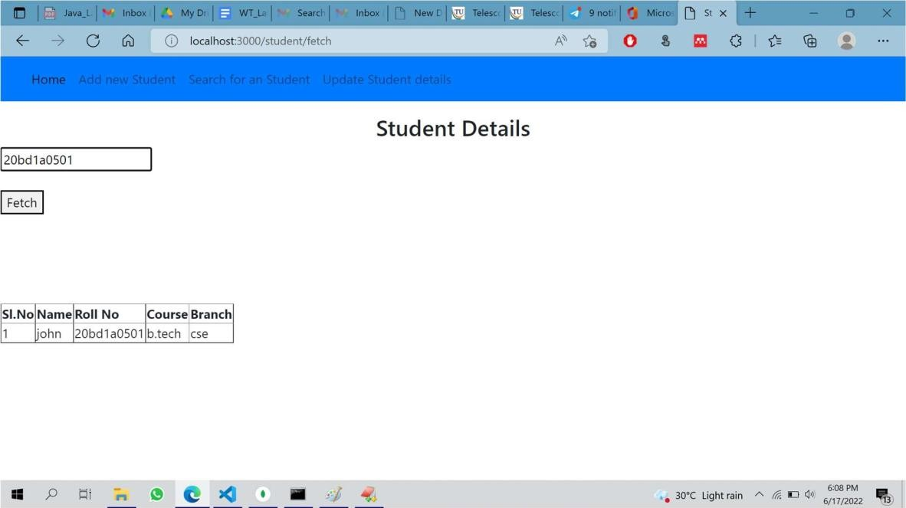

**EXPERIMENT 8**

## Create a form with ExpressJS that enables CRUD (Create, Read, Update and Delete) operations on the student database.

**home.ejs**

<html>

<head>

<title>Customer Portal</title>

<link rel="stylesheet" href="https://maxcdn.bootstrapcdn.com/bootstrap/4.5.2/css/bootstrap.min.css">

<script src="https://maxcdn.bootstrapcdn.com/bootstrap/4.5.2/js/bootstrap.min.js"></script>

</head>

<body>

<nav class="navbar navbar-expand-lg navbar-light bg-primary fixed-top">

<div class="container-fluid">

<button

class="navbar-toggler" type="button"

data-mdb-toggle="collapse"

data-mdb-target="#navbarExample01" aria-controls="navbarExample01"

aria-expanded="false"

aria-label="Toggle navigation"

>

<i class="fas fa-bars"></i>

</button>

<div class="collapse navbar-collapse" id="navbarExample01">

<ul class="navbar-nav me-auto mb-2 mb-lg-0">

<li class="nav-item active">

<a class="nav-link" aria-current="page" href="/">Home</a>

</li>

<li class="nav-item">

<a class="nav-link" href="/page/register">Add new Student</a>

</li>

<li class="nav-item">

<a class="nav-link" href="/page/search">Search for an Student </a>

</li>

<li class="nav-item">

<a class="nav-link" href="/page/update">Update Student details</a>

</li>

</ul>

</div>

</div>

</nav>

<br><br><br>

<h3 style="text-align: center;">Welcome to Student CRUD Application Portal </h3>

</body>

</html>

# EXPECTED OUTPUT :

35

## register.ejs

<html>

<head>

<title>Customer Portal</title>

<link rel="stylesheet" href="https://maxcdn.bootstrapcdn.com/bootstrap/4.5.2/css/bootstrap.min.css">

<script src="https://maxcdn.bootstrapcdn.com/bootstrap/4.5.2/js/bootstrap.min.js"></script>

</head>

<body>

<nav class="navbar navbar-expand-lg navbar-light bg-primary fixed-top">

<div class="container-fluid">

<button

class="navbar-toggler" type="button"

data-mdb-toggle="collapse"

data-mdb-target="#navbarExample01" aria-controls="navbarExample01"

aria-expanded="false"

aria-label="Toggle navigation"

>

<i class="fas fa-bars"></i>

</button>

<div class="collapse navbar-collapse" id="navbarExample01">

<ul class="navbar-nav me-auto mb-2 mb-lg-0">

<li class="nav-item active">

<a class="nav-link" aria-current="page" href="/">Home</a>

</li>

<li class="nav-item">

<a class="nav-link" href="/page/register">Add new Student</a>

</li>

<li class="nav-item">

<a class="nav-link" href="/page/search">Search for a Student </a>

</li>

<li class="nav-item">

<a class="nav-link" href="/page/update">Update Student details</a>

</li>

</ul>

</div>

</div>

</nav>

<br><br><br>

<h3 style="text-align: center;">Welcome to Student CRUD Application Portal </h3>

<form action="/customer/register" method="POST">

<label for="sname">Student Name:</label>

<input type="text" placeholder="Student Name" id="name" name="name"> <br><br>

<label for="id">Student Roll No:</label>

<input type="text" placeholder="Roll No" id="id" name="id"> <br><br>

<label for="course">Course:</label>

<input type="text" placeholder="Course" id="course" name="course" > <br><br>

<label for="branch">Branch:</label>

<input type="text" placeholder="Branch" id="branch" name="branch"> <br><br>

<button type="submit" >Add</button>

</form>

<h1> <%= status %> </h1>

</body>

</html>

# EXPECTED OUTPUT :

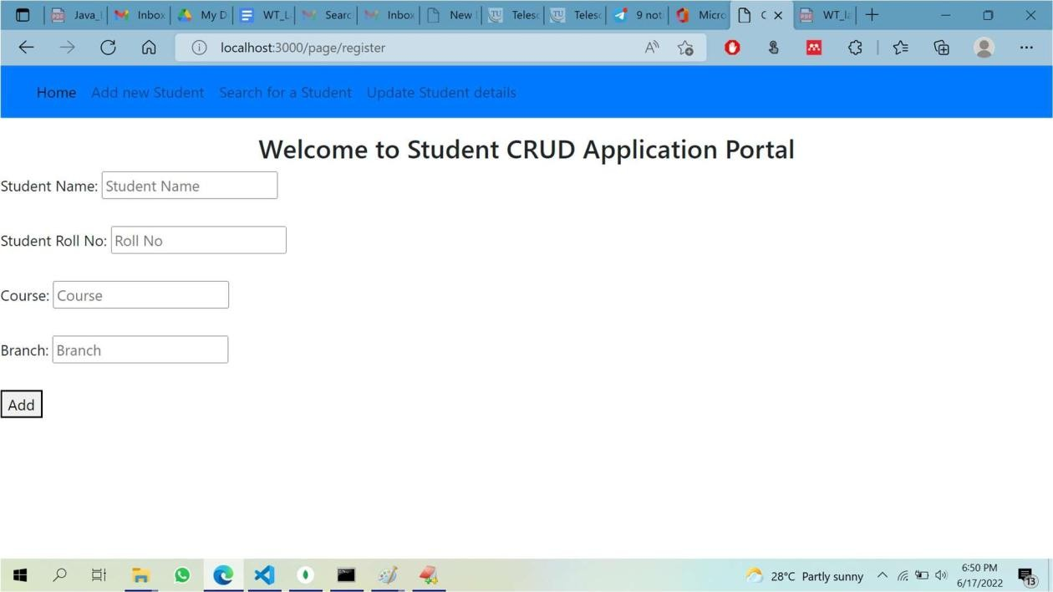

## search.ejs

<html>

<head>

<title>Student Portal</title>

<link rel="stylesheet" href="https://maxcdn.bootstrapcdn.com/bootstrap/4.5.2/css/bootstrap.min.css">

<script src="https://maxcdn.bootstrapcdn.com/bootstrap/4.5.2/js/bootstrap.min.js"></script>

</head>

<body>

<nav class="navbar navbar-expand-lg navbar-light bg-primary fixed-top">

<div class="container-fluid">

<button

class="navbar-toggler" type="button"

data-mdb-toggle="collapse"

data-mdb-target="#navbarExample01" aria-controls="navbarExample01"

aria-expanded="false"

aria-label="Toggle navigation">

<i class="fas fa-bars"></i>

</button>

<div class="collapse navbar-collapse" id="navbarExample01">

<ul class="navbar-nav me-auto mb-2 mb-lg-0">

<li class="nav-item active">

<a class="nav-link" aria-current="page" href="/">Home</a>

</li>

<li class="nav-item">

<a class="nav-link" href="/page/register">Add new Student</a>

</li>

<li class="nav-item">

<a class="nav-link" href="./search.ejs">Search for a Student </a>

</li>

<li class="nav-item">

<a class="nav-link" href="/page/update">Update Student details</a>

</li>

</ul>

</div>

</div>

</nav>

<br><br><br>

<h3 style="text-align: center;">Student Details </h3>

<form action="/student/fetch" method="POST">

<input type="text" placeholder="Search by rollno" id="rollno" name="rollno"> <br><br>

<button type="submit">Fetch</button>

</form>

<br><br>

<br><br>

<%

if(view){

%>

<table border="1" id="table">

<tr>

<th>Sl.No</th>

<th>Name</th>

<th>Roll No</th>

<th>Course</th>

<th>Branch</th>

</tr>

<%

if(stuData.length!=0){ var i=1;

stuData.forEach(function(data){

%>

<tr>

<td><%=i; %></td>

<td><%=data.name %></td>

<td><%=data.id %></td>

<td><%=data.course %></td>

<td><%=data.branch %></td>

</tr>

<% i++; }) %>

<% } else{ %>

<tr>

<td colspan="4">No Data Found</td>

</tr>

<% } %>

</table>

<% } %>

</body>

</html>

# EXPECTED OUTPUT :

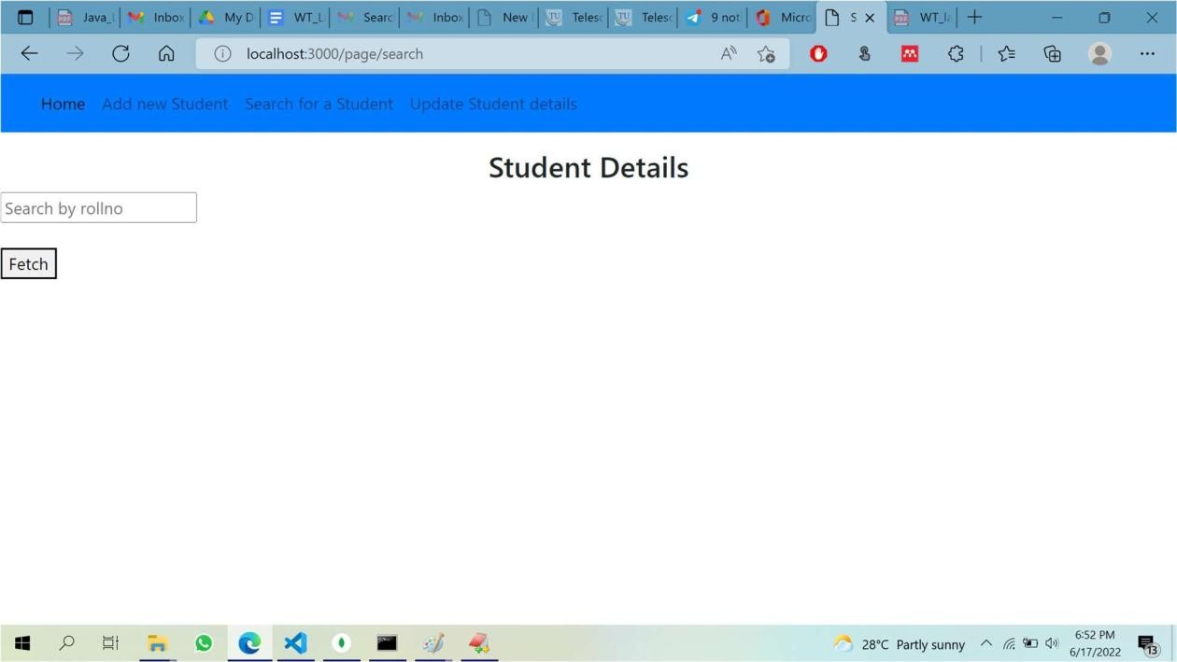

## update.ejs

<html>

<head>

<title>Customer Portal</title>

<link rel="stylesheet" href="https://maxcdn.bootstrapcdn.com/bootstrap/4.5.2/css/bootstrap.min.css">

<script src="https://maxcdn.bootstrapcdn.com/bootstrap/4.5.2/js/bootstrap.min.js"></script>

</head>

<body>

<nav class="navbar navbar-expand-lg navbar-light bg-primary fixed-top">

<div class="container-fluid">

<button

class="navbar-toggler" type="button"

data-mdb-toggle="collapse"

data-mdb-target="#navbarExample01" aria-controls="navbarExample01"

aria-expanded="false"

aria-label="Toggle navigation"

>

<i class="fas fa-bars"></i>

</button>

<div class="collapse navbar-collapse" id="navbarExample01">

<ul class="navbar-nav me-auto mb-2 mb-lg-0">

<li class="nav-item active">

<a class="nav-link" aria-current="page" href="/">Home</a>

</li>

<li class="nav-item">

<a class="nav-link" href="/page/register">Add new Student</a>

</li>

<li class="nav-item">

<a class="nav-link" href="/page/search">Search for a Student </a>

</li>

<li class="nav-item">

<a class="nav-link" href="/page/update">Update Student details</a>

</li>

</ul>

</div>

</div>

</nav>

<br><br><br>

<h3 style="text-align: center;">Welcome to the Express mongo connection Portal </h3>

<form action="/customer/update" method="POST">

<input type="text" placeholder="StudentbName to be update" id="cname" name="cname"><br><br>

<input type="text" placeholder="Student Name" id="name" name="name"> <br><br>

<input type="email" placeholder="Roll No" id="id" name="id"> <br><br>

<input type="text" placeholder="Course" id="course" name="course" > <br><br>

<input type="text" placeholder="Branch" id="branch" name="branch"> <br><br>

<button type="submit" >Update</button>

</form>

<h1> <%= status %> </h1>

</body>

</html>

# EXPECTED OUTPUT :

42

**EXPERIMENT 9**

1. **Create a simple website for the CRUD operations on student DB and apply Express Routing.**

**file Structure:**

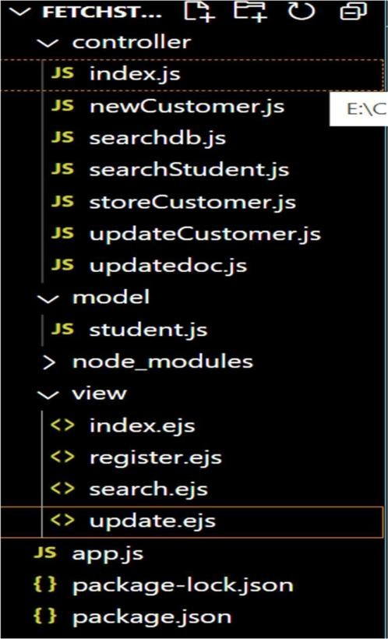

**controller/index.js**

module.exports = (req, res) =>{ res.render('index')

}

newCustomer.js module.exports = (req, res) =>{

data = ' '

res.render('register',{status:data}); // render register.ejs

}

## searchdb.js

const Student = require('../model/student.js') module.exports = (req,res)=>{

// console.log(req.body.rollno);

// var test=Student.find({id: req.body.rollno}); Student.find({id: req.body.rollno}, (error, student) => {

if(error){ console.log(student)

res.render('search',{stuData:student});

}

else{

console.log(student) res.render('search',{stuData:student, view:true});

}

})

}

## searchStudent.js

module.exports = (req, res) =>{ student=[]

res.render('search',{stuData:student, view:false});

}

storeCustomer.js

const Student = require('../model/student.js') const path = require('path')

module.exports = (req,res)=>{ console.log(req.body)

Student.create(req.body, (error, student) => { if(error){

console.log(error)

data='Can Not Insert Student Details Please Try Agin'; res.render('register',{status:data});

}

else{

data = 'Student Details Inserted Successfully' res.render('register',{status:data});

}

})

}

## updateCustomer.js

module.exports = (req, res) =>{ data = ' '

res.render('update',{status:data}); // render update.ejs

}

updatedoc.js

const Student = require('../model/student.js') module.exports = (req,res)=>{

var test={}; if(req.body.name){ test.name=req.body.name }; if(req.body.id){

test.id=req.body.id }; if(req.body.course){

test.course=req.body.course };

if(req.body.branch){

test.branch=req.body.branch };

// console.log(test);

Student.updateOne({name: req.body.cname}, { $set: test },(error, student) => { if(error){

console.log(student)

data='Can Not Update Student Details Please Try Agin'; res.render('update',{status:data});

}

else{

data = 'Student Details Updated Successfully' res.render('update',{status:data});

}

}

)

}

//{cname: req.body.cnamenew, email: req.body.email, phone: req.body.phone, city: req.body.city }

## model/student.js

const mongoose = require('mongoose') const Schema = mongoose.Schema;

const StudentSchema = new Schema({ name: {

type: String, required: true, unique: true

},

id: {

type: String,

required: true

},

course: {

type: String, required: true

} ,

branch: { type: String,

required: true

}

})

// export model

const Student = mongoose.model('studentinfo',StudentSchema); module.exports = Student

## home.ejs

<html>

<head>

<title>Customer Portal</title>

<link rel="stylesheet" href="https://maxcdn.bootstrapcdn.com/bootstrap/4.5.2/css/bootstrap.min.css">

<script src="https://maxcdn.bootstrapcdn.com/bootstrap/4.5.2/js/bootstrap.min.js"></script>

</head>

<body>

<nav class="navbar navbar-expand-lg navbar-light bg-primary fixed-top">

<div class="container-fluid">

<button

class="navbar-toggler" type="button"

data-mdb-toggle="collapse"

data-mdb-target="#navbarExample01" aria-controls="navbarExample01"

aria-expanded="false"

aria-label="Toggle navigation"

>

<i class="fas fa-bars"></i>

</button>

<div class="collapse navbar-collapse" id="navbarExample01">

<ul class="navbar-nav me-auto mb-2 mb-lg-0">

<li class="nav-item active">

<a class="nav-link" aria-current="page" href="/">Home</a>

</li>

<li class="nav-item">

<a class="nav-link" href="/page/register">Add new Student</a>

</li>

<li class="nav-item">

<a class="nav-link" href="/page/search">Search for an Student </a>

</li>

<li class="nav-item">

<a class="nav-link" href="/page/update">Update Student details</a>

</li>

</ul>

</div>

</div>

</nav>

<br><br><br>

<h3 style="text-align: center;">Welcome to Student CRUD Application Portal </h3>

</body>

</html>

## register.ejs

<html>

<head>

<title>Customer Portal</title>

<link rel="stylesheet" href="https://maxcdn.bootstrapcdn.com/bootstrap/4.5.2/css/bootstrap.min.css">

<script src="https://maxcdn.bootstrapcdn.com/bootstrap/4.5.2/js/bootstrap.min.js"></script>

</head>

<body>

<nav class="navbar navbar-expand-lg navbar-light bg-primary fixed-top">

<div class="container-fluid">

<button

class="navbar-toggler" type="button"

data-mdb-toggle="collapse"

data-mdb-target="#navbarExample01" aria-controls="navbarExample01"

aria-expanded="false"

aria-label="Toggle navigation"

>

<i class="fas fa-bars"></i>

</button>

<div class="collapse navbar-collapse" id="navbarExample01">

<ul class="navbar-nav me-auto mb-2 mb-lg-0">

<li class="nav-item active">

<a class="nav-link" aria-current="page" href="/">Home</a>

</li>

<li class="nav-item">

<a class="nav-link" href="/page/register">Add new Student</a>

</li>

<li class="nav-item">

<a class="nav-link" href="/page/search">Search for a Student </a>

</li>

<li class="nav-item">

<a class="nav-link" href="/page/update">Update Student details</a>

</li>

</ul>

</div>

</div>

</nav>

<br><br><br>

<h3 style="text-align: center;">Welcome to Student CRUD Application Portal </h3>

<form action="/customer/register" method="POST">

<label for="sname">Student Name:</label>

<input type="text" placeholder="Student Name" id="name" name="name"> <br><br>

<label for="id">Student Roll No:</label>

<input type="text" placeholder="Roll No" id="id" name="id"> <br><br>

<label for="course">Course:</label>

<input type="text" placeholder="Course" id="course" name="course" > <br><br>

<label for="branch">Branch:</label>

<input type="text" placeholder="Branch" id="branch" name="branch"> <br><br>

<button type="submit" >Add</button>

</form>

<h1> <%= status %> </h1>

</body>

</html>

## search.ejs

<html>

<head>

<title>Student Portal</title>

<link rel="stylesheet" href="https://maxcdn.bootstrapcdn.com/bootstrap/4.5.2/css/bootstrap.min.css">

<script src="https://maxcdn.bootstrapcdn.com/bootstrap/4.5.2/js/bootstrap.min.js"></script>

</head>

<body>

<nav class="navbar navbar-expand-lg navbar-light bg-primary fixed-top">

<div class="container-fluid">

<button

class="navbar-toggler" type="button"

data-mdb-toggle="collapse"

data-mdb-target="#navbarExample01" aria-controls="navbarExample01"

aria-expanded="false"

aria-label="Toggle navigation"

>

<i class="fas fa-bars"></i>

</button>

<div class="collapse navbar-collapse" id="navbarExample01">

<ul class="navbar-nav me-auto mb-2 mb-lg-0">

<li class="nav-item active">

<a class="nav-link" aria-current="page" href="/">Home</a>

</li>

<li class="nav-item">

<a class="nav-link" href="/page/register">Add new Student</a>

</li>

<li class="nav-item">

<a class="nav-link" href="./search.ejs">Search for a Student </a>

</li>

<li class="nav-item">

<a class="nav-link" href="/page/update">Update Student details</a>

</li>

</ul>

</div>

</div>

</nav>

<br><br><br>

<h3 style="text-align: center;">Student Details </h3>

<form action="/student/fetch" method="POST">

<input type="text" placeholder="Search by rollno" id="rollno" name="rollno"> <br><br>

<button type="submit">Fetch</button>

</form>

<br><br>

<br><br>

<%

if(view){

%>

<table border="1" id="table">

<tr>

<th>Sl.No</th>

<th>Name</th>

<th>Roll No</th>

<th>Course</th>

<th>Branch</th>

</tr>

<%

if(stuData.length!=0){ var i=1;

stuData.forEach(function(data){

%>

<tr>

<td><%=i; %></td>

<td><%=data.name %></td>

<td><%=data.id %></td>

<td><%=data.course %></td>

<td><%=data.branch %></td>

</tr>

<% i++; }) %>

<% } else{ %>

<tr>

<td colspan="4">No Data Found</td>

</tr>

<% } %>

</table>

<% } %>

</body>

</html>

## update.ejs

<html>

<head>

<title>Customer Portal</title>

<link rel="stylesheet"

href="https://maxcdn.bootstrapcdn.com/bootstrap/4.5.2/css/bootstrap.min.css">

<script src="https://maxcdn.bootstrapcdn.com/bootstrap/4.5.2/js/bootstrap.min.js"></script>

</head>

<body>

<nav class="navbar navbar-expand-lg navbar-light bg-primary fixed-top">

<div class="container-fluid">

<button

class="navbar-toggler" type="button"

data-mdb-toggle="collapse"

data-mdb-target="#navbarExample01" aria-controls="navbarExample01"

aria-expanded="false"

aria-label="Toggle navigation"

>

<i class="fas fa-bars"></i>

</button>

<div class="collapse navbar-collapse" id="navbarExample01">

<ul class="navbar-nav me-auto mb-2 mb-lg-0">

<li class="nav-item active">

<a class="nav-link" aria-current="page" href="/">Home</a>

</li>

<li class="nav-item">

<a class="nav-link" href="/page/register">Add new Student</a>

</li>

<li class="nav-item">

<a class="nav-link" href="/page/search">Search for a Student </a>

</li>

<li class="nav-item">

<a class="nav-link" href="/page/update">Update Student details</a>

</li>

</ul>

</div>

</div>

</nav>

<br><br><br>

<h3 style="text-align: center;">Welcome to the Express mongo connection Portal </h3>

<form action="/customer/update" method="POST">

<input type="text" placeholder="StudentbName to be update" id="cname" name="cname">

<br><br>

<input type="text" placeholder="Student Name" id="name" name="name"> <br><br>

<input type="email" placeholder="Roll No" id="id" name="id"> <br><br>

<input type="text" placeholder="Course" id="course" name="course" > <br><br>

<input type="text" placeholder="Branch" id="branch" name="branch"> <br><br>

<button type="submit" >Update</button>

</form>

<h1> <%= status %> </h1>

</body>

</html>

**EXPECTED OUTPUT**

