**Team #20 Final Project – “DICE DASH”**

**Design Document**

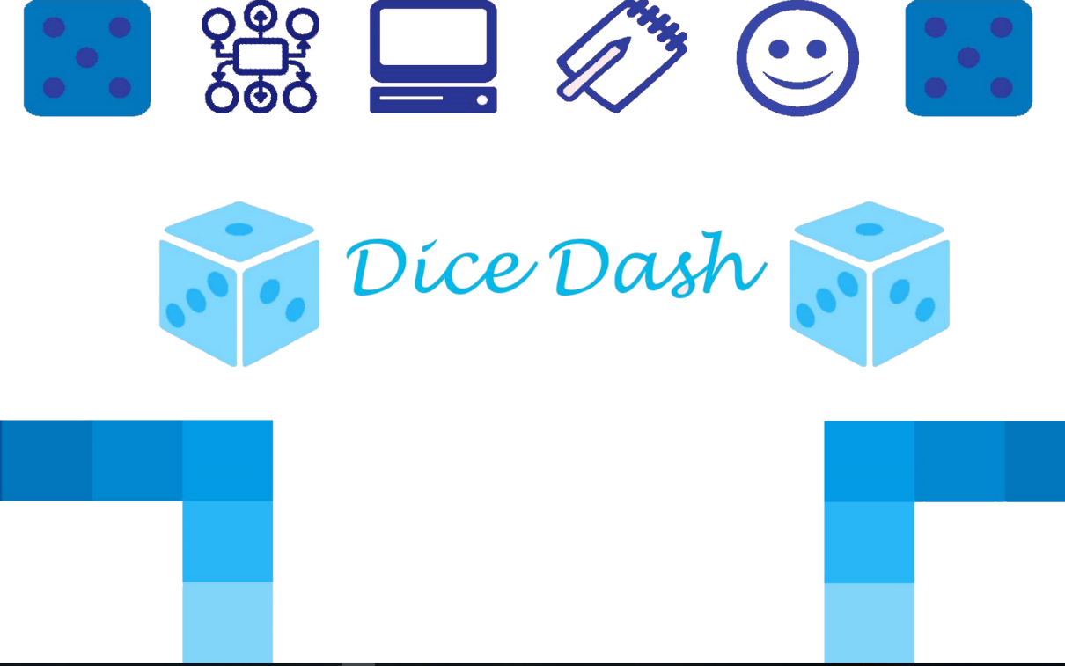

**Written by:**

Alex Ryan

Angel Diaz

Hunter Brady

Itay Braverman

Jordan Bruno

Spring 2016

CSE360

Dr. Debra Callis

|  |  |
| --- | --- |
| 1. **Game Description****….……………………………..…………….……………………………….** | **3** |
| 1. **Game Rules****………………………………………………………….………………………………** | **3** |
| 1. **Development Technology** **……………………………………….………………………….** | **3** |
| 1. **User Stories****………………………………………………………..………………….……………** | **4** |
| 1. **Use Case Diagram****……………………………………………………………………………….** | **5** |
| 1. **Flow Diagram****…………………..………………………………………………………………..** | **6** |
| 1. **UML Class Diagram****….…………………………………………………………………………** | **7** |
| 1. **Project Timeline** **……….……………………………………………………………………….** | **8** |
| 1. **GUI Mock-ups****….………………………………………………………………………………..** | **9** |
| 1. **Project Backlog****…..………………………………………………………………………………** | **10** |
| 1. **Project testing****…..…………………………………………………………………………..……** | **11** |

**Table of Contents**

1. **Game Description**

This dice based educational 3D trivia game will allow the user to learn and practice different subjects from ASU’s Introduction to Software Engineering – CSE360 course. The user goal is to reach the end of the path by throwing the dice and answer material based questions while doing it as fast as possible.

1. **Game Rules**
   * Movement is made based on the dice result
   * Correct answer – stays in the new spot
   * False answer – move to the pervious spot
   * 3 Correct answers in a row – jump additional 2 spots
   * 3 False answers in a row – jumps back 2 spots from the original place
2. **Development Technology**
   * Program - Unity 3D / C#
   * Management – Trello
   * Source Control - GitHub
3. **User Stories**

• **As a** Player, **I want** to roll the dice **so that** I can move across the board.

• **As a** Player, **I want** to answer a question **so that** I can stay on my current spot on the board.

• **As a** Player, **I want** to reach the end of the board **so that** I can win the game.

• **As a** Player, **I want** to have a Stats Button **so that** I can access the Stats database.

• **As a** Player, **I want** to have my score recorded **so that** I can view my score.

• **As a** Player, **I want** to receive a bonus for answering 3 questions correctly **so that** I can move 2 spaces forward on the board.

• **As a** Player, **I want** to answer 3 questions incorrectly **so that** I can move 2 spaces backward on the board.

• **As a** Player, **I want** to answer a question incorrectly **so that** I can move 1 space backward on the board.

• **As a** Player, **I want** to have an avatar **so that** I can distinguish myself from other players.

• **As a** Player, **I want** to choose the board **so that** I have a variety of board to play on.

• **As a** Player, **I want** to have an Exit button **so that** I can leave the game when I want.

• **As a** Player, **I want** to have Audio **so that** I can listen to music as I play my game.

• **As a** Player, **I want** to have a random path generator **so that** I have a different path each time I play.

• **As a** Player, **I want** to have Level Space Items **so that** I alter things in my level.

• **As a** Player, **I want** to have a timer **so that** I can view the current time I have left in the game.

• **As a** Player, **I want** to have an Icon EXE **so that** I see a distinguishable executable for my game.

• **As a** Player, **I want** to have a local database **so that** I can keep track of my moves and score in-game.

• **As an** Administrator, **I want** to reset the online score database **so that** I can put the score database in its original state.

• **As an** Administrator, **I want** to delete the online score database **so that** I can punish players who cheat.

1. **Use Case Diagram**

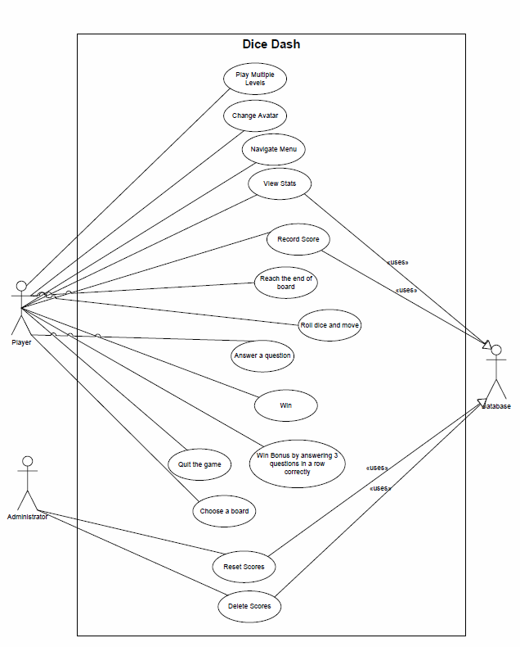

1. **Flow Diagram**

Dice Game Flow Diagram.pdf

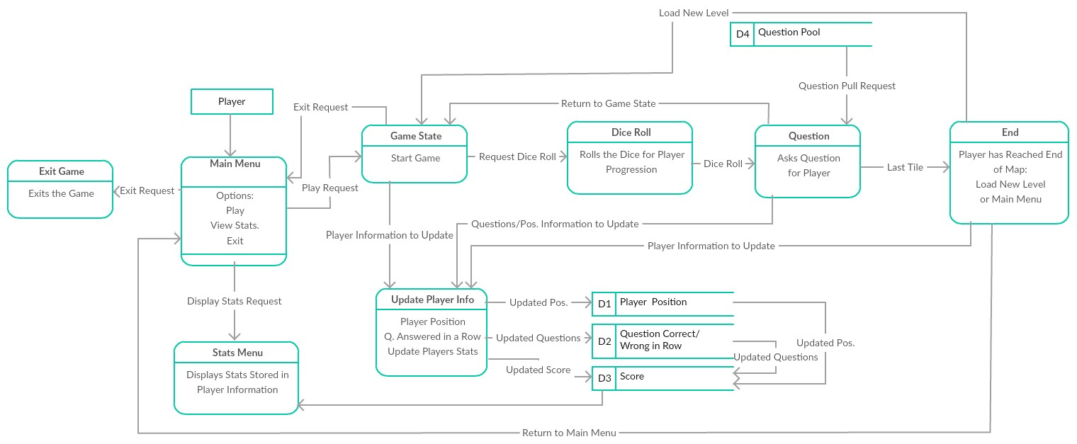

1. 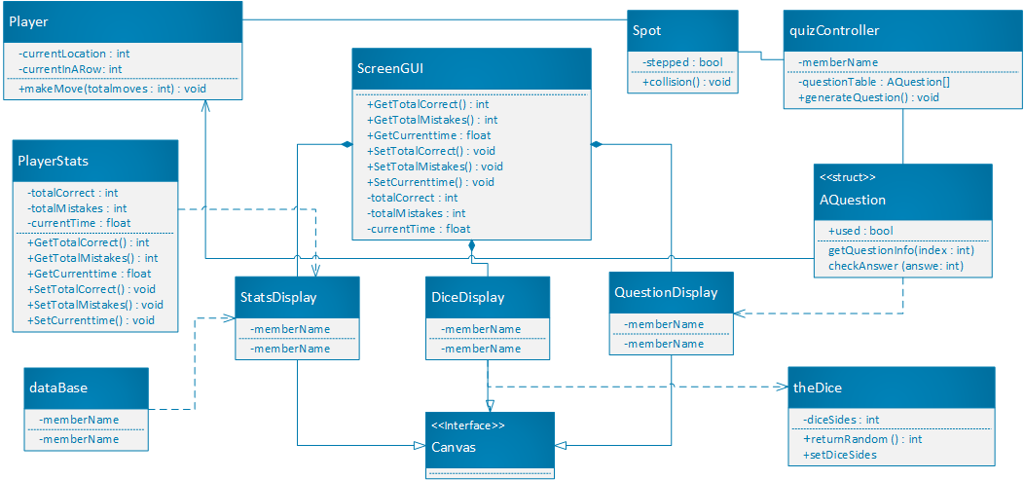**UML Class Diagram**

CSE360_Team20_UML.pdf

1. **Project Timeline**
2. **GUI Mock-ups**
   * Optional Avatars:  
     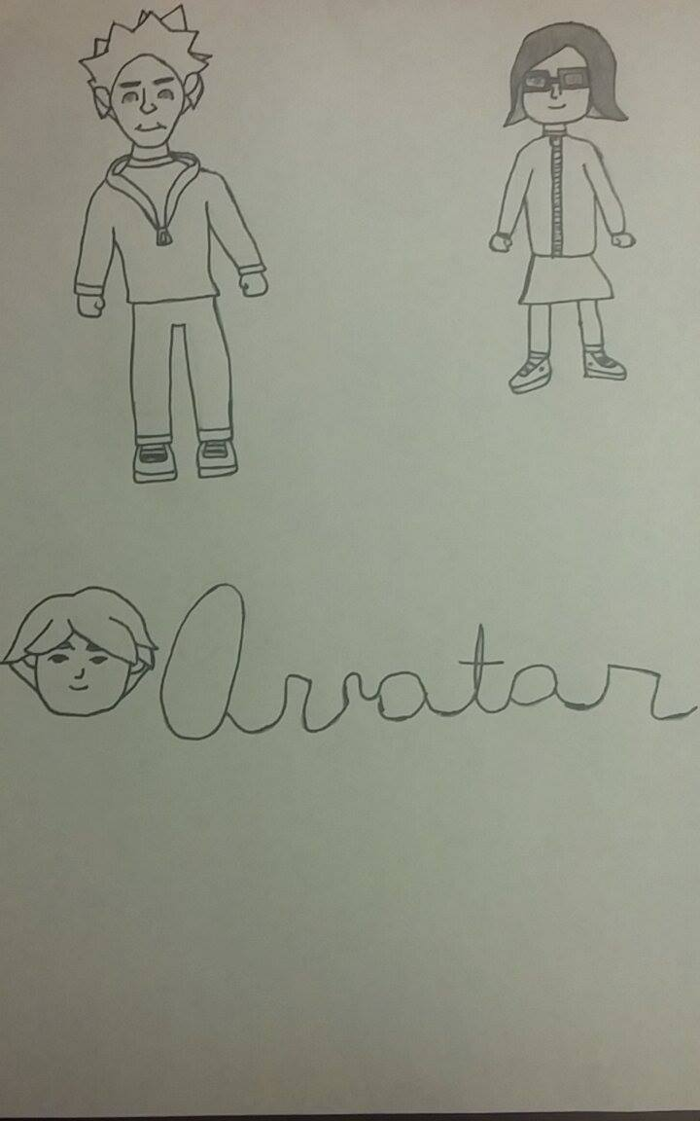
   * Main Menu screen: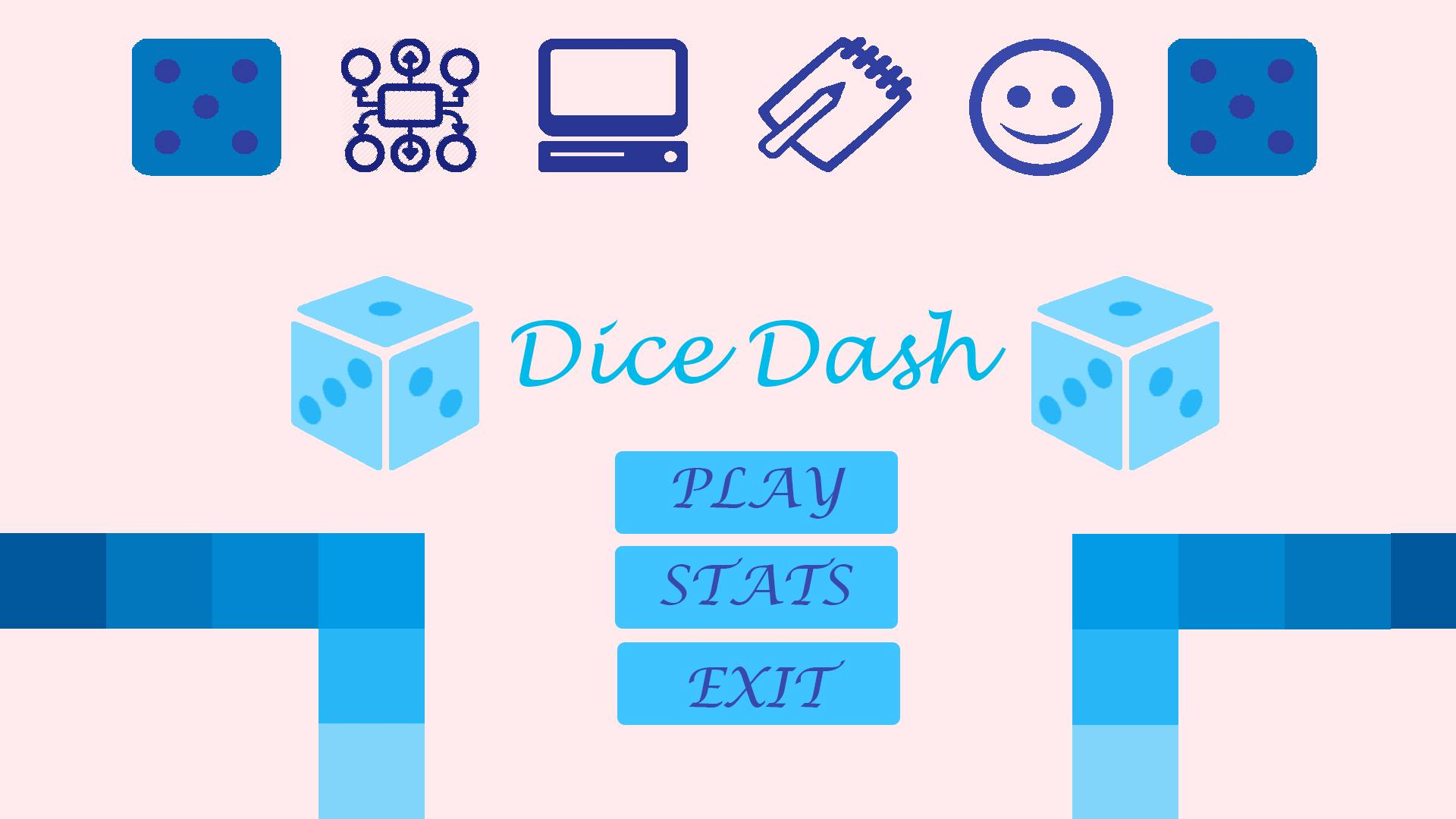
3. **Project Backlog**
4. **Project Testing**

( see project **readme** file for more info )