LINKEDIN
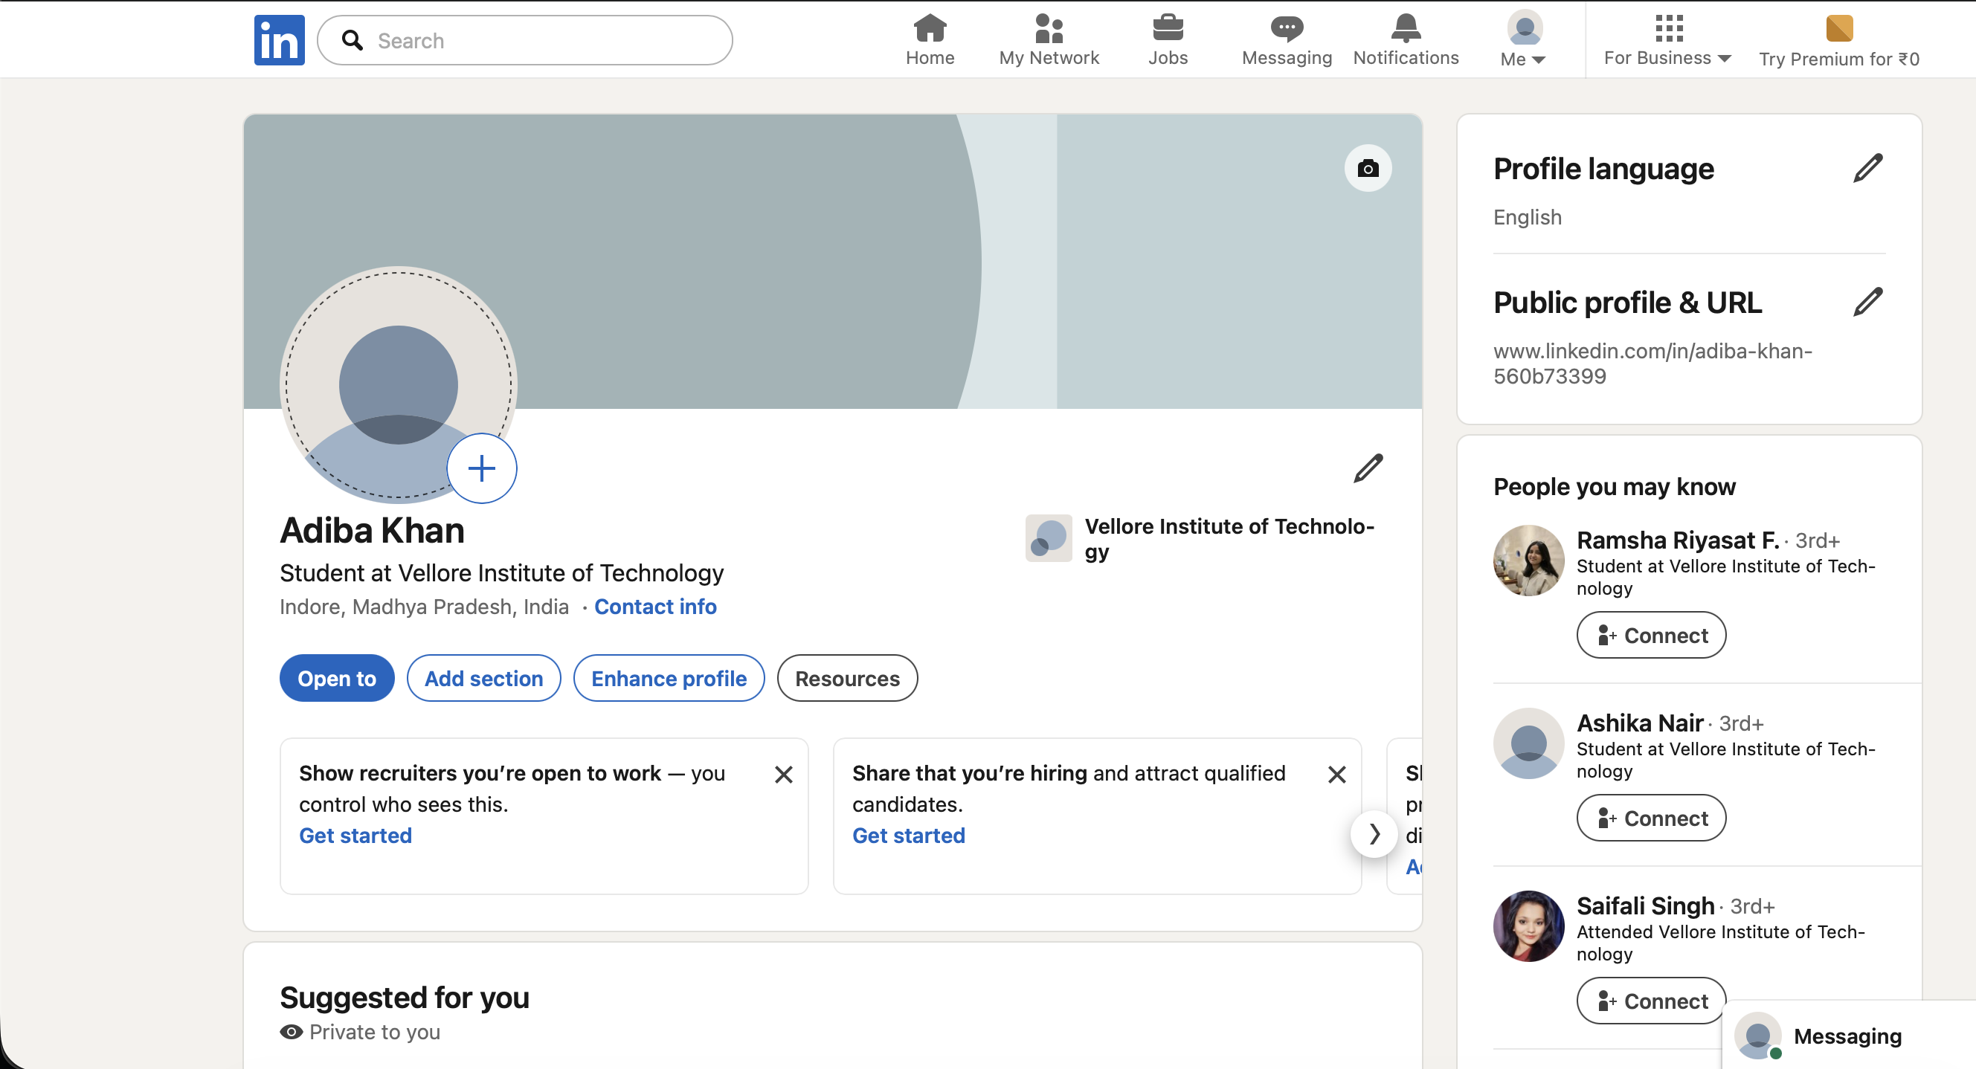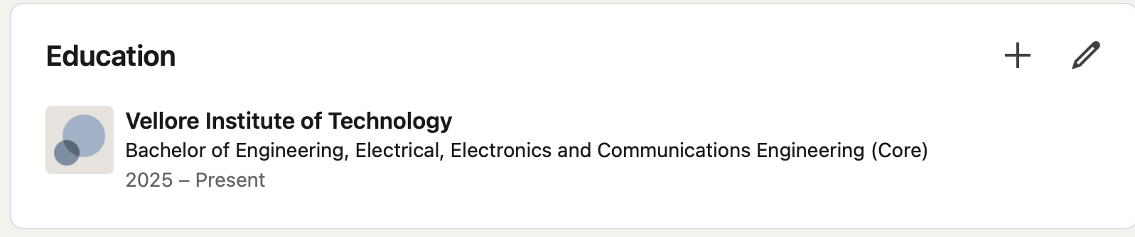

KAGGLE
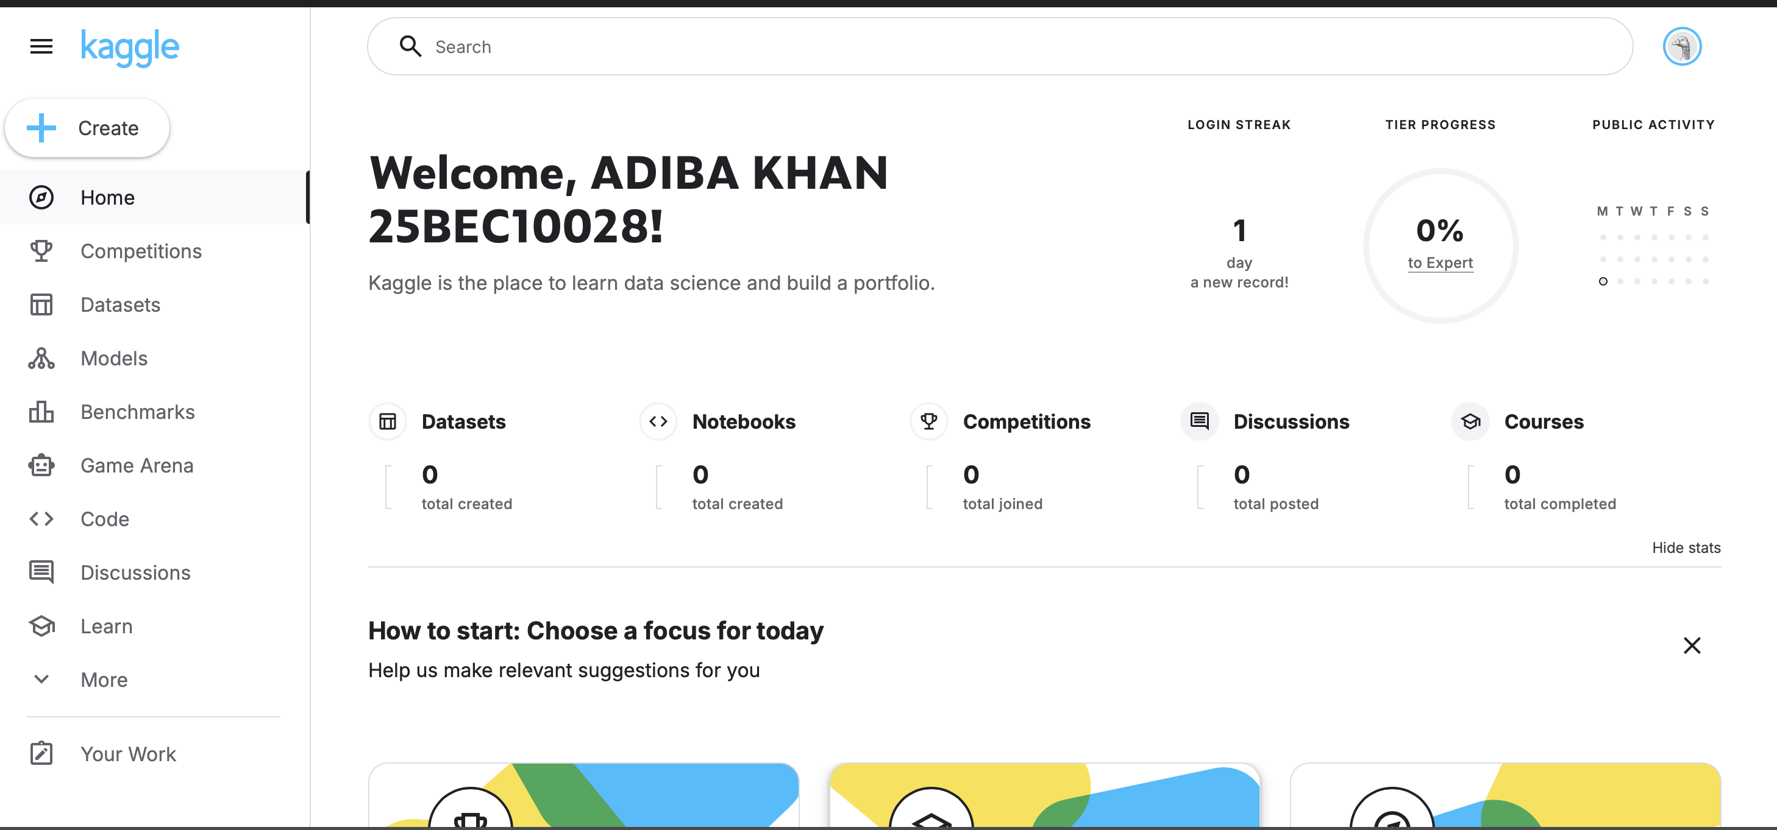

RESERCH GATE
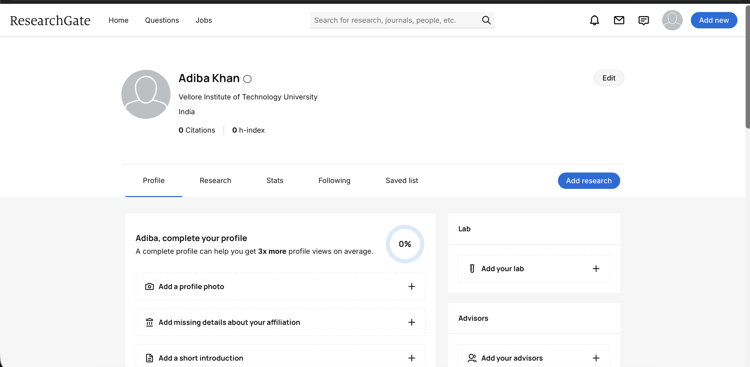
PROJECT REPORT
Platforms Selected: LinkedIn, Kaggle, and ResearchGate.
Platform Overview and Strategic Use Cases
For this project, I focused on establishing a digital presence across LinkedIn, Kaggle, and ResearchGate to bridge the gap between my academic studies and industry requirements.
LinkedIn serves as my primary professional hub. It is designed for networking, job hunting, and personal branding. Over the next four years, I plan to use it to connect with industry leaders, secure internships, and share my project milestones to stay visible to potential recruiters.
Kaggle is a specialized platform for data science and machine learning. It provides access to massive datasets and competitive coding challenges. My strategy involves participating in at least two competitions annually to refine my technical skills and building a public portfolio of notebooks that demonstrate my problem-solving capabilities to technical hiring managers.
ResearchGate is the "social network for scientists." It allows me to follow the latest publications in my field and request full-text papers from authors. Throughout my degree, I will use it to track emerging trends for my thesis and eventually upload my own research findings to contribute to the global academic community. By maintaining these three profiles, I am ensuring a well-rounded digital footprint that covers networking, technical proof-of-work , and academic credibility.

