**SMART FACTORY ACCELERATOR – DASHBOARD DEVELOPMENT GUIDE**

**Data Visualization**

ThingsBoard allows you to configure customizable IoT dashboards. Each IoT Dashboard may contain multiple dashboard widgets that visualize data from multiple IoT devices. Once IoT Dashboard is created, you may assign it to one of the customers of you IoT project.

IoT Dashboards are light-weight and you may have millions of dashboards. For example, you may automatically create a dashboard for each new customer based on data from registered customer IoT devices. Or you may modify dashboard via script when a new device is assigned to a customer. All these actions may be done manually or automated via REST API.

You can find useful links to get started below:

* [Getting started guide](https://thingsboard.io/docs/getting-started-guides/helloworld/) - will cover basic steps to create a dashboard.
* [IoT Dashboards](https://thingsboard.io/docs/user-guide/ui/dashboards/) - contains tutorials about basic IoT dashboard operations.
* [Samples](https://thingsboard.io/docs/samples/) - contains several examples that include both client-side applications and corresponding data visualization.
* [Widget Library](https://thingsboard.io/docs/user-guide/ui/widget-library/) - contains an overview of dashboard widget bundles:
  + - **Digital** and **analog** gauges for latest real-time values visualization
    - Highly customizable Bar and Line **charts** for visualization of historical and sliding-window data points
    - **Map widgets** for tracking movement and latest positions of IoT devices on Google or OpenStreet maps.
    - **GPIO** control widgets that allow sending GPIO toggle commands to devices.
    - **Card** widgets to enhance your dashboards with flexible HTML labels based on static content or latest telemetry values from IoT devices

**Dashboard development guide**

1. Go to **Dashboard section** in **ThingsBoard CE** and click on ‘**+**’ button on bottom-right of the page which says ‘**Add new dashboard**’ and select ‘**Create new dashboard**’ icon. Enter the **title** of your Dashboard and add **description** if required.

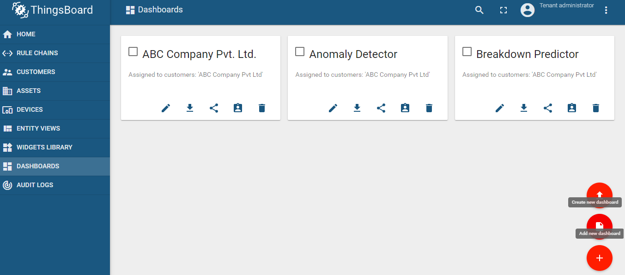

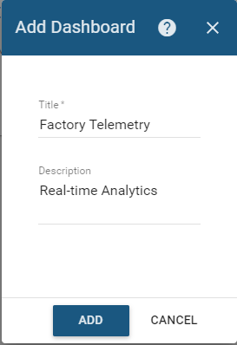

1. **Assign** your dashboard to the customer you created when working in the first phase of your work during the **Device Onboarding** process, by clicking on ‘**Manage assigned customers**’ button in your **Dashboard card**. When a form appears, **select** the **customers** to whom you want to assign your dashboard.

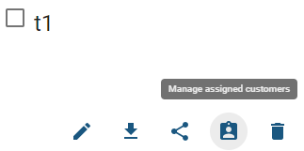

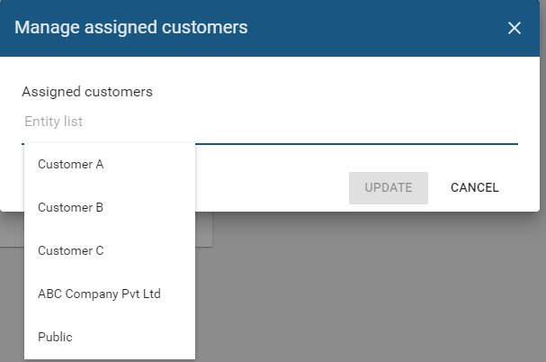

1. Go To ‘**Entity Aliases**’ section located **right** to the Clock icon, and create an entity alias, which allows to choose one or more entities names of which start with entered query, which can be device(s), asset(s), entity view(s), tenant(s), customer(s), dashboard(s), data converter(s), scheduler event(s), blob entity(-ies) or customer(s).

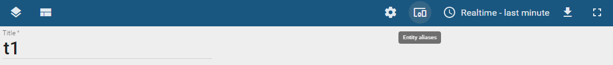

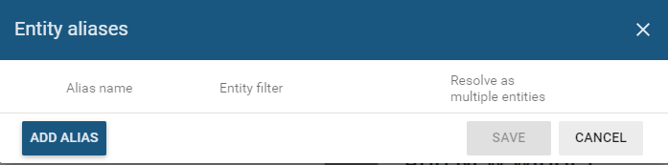

1. Open your Dashboard, and click on **red pencil** button on bottom-right and you’ll then have your dashboard in editing mode. Select ‘**Add new widget**’ button which appears only once when dashboard is empty, or click on **red ‘+’** button located at the bottom of the page, third from the right and then choose ‘**Create new widget**’ icon.

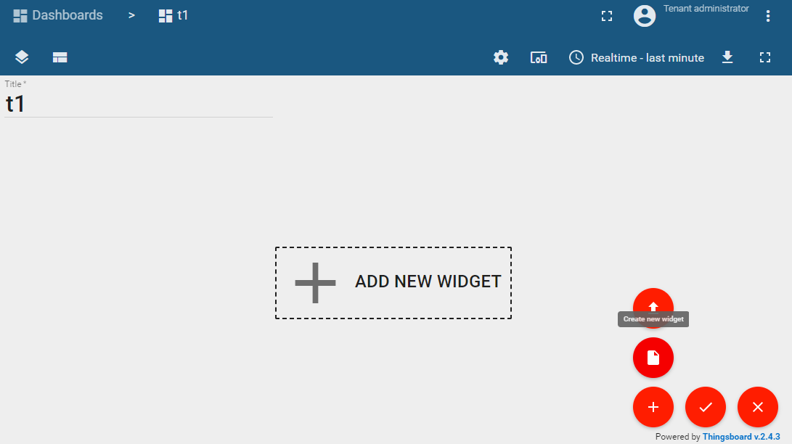

1. Now, look for the type of widget to be utilized in your dashboard.

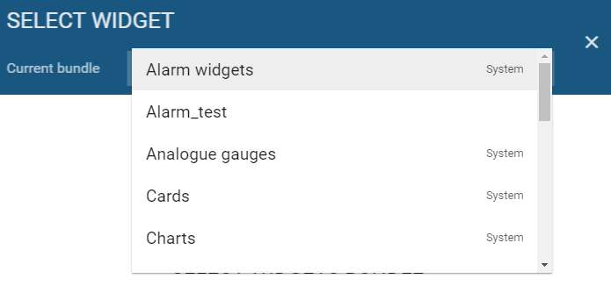

1. After choosing the widget, select the data source by clicking on ‘**ADD**’ button in **DATA** section.

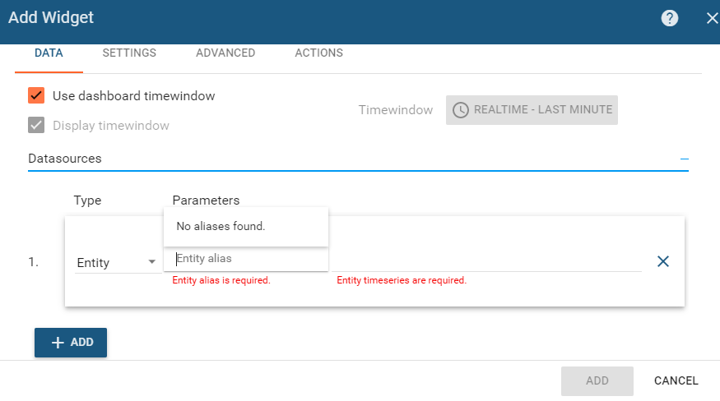

1. Similarly, explore the other sections of the Widget features for customization in widget.
2. If we want to have a navigation feature between **default** Dashboard and a **new one**, then a **dashboard state** has to be created and linked with the default dashboard, via **Widgets’ ACTION** feature.



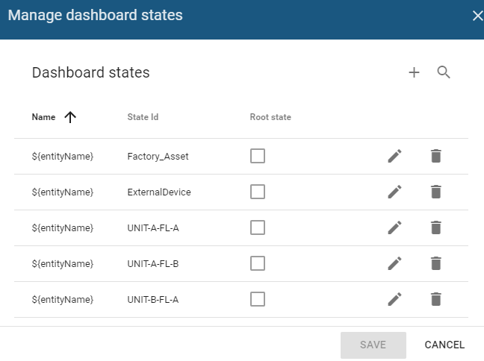

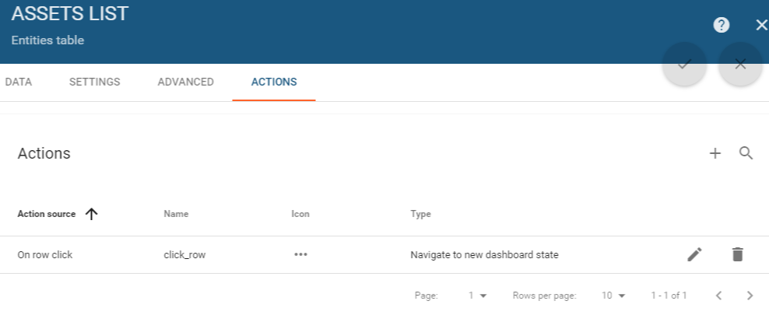

For custom action Type, where each Action Source expect to move to a particular dashboard state of their choosing then the following custom function needs to be prepared: -

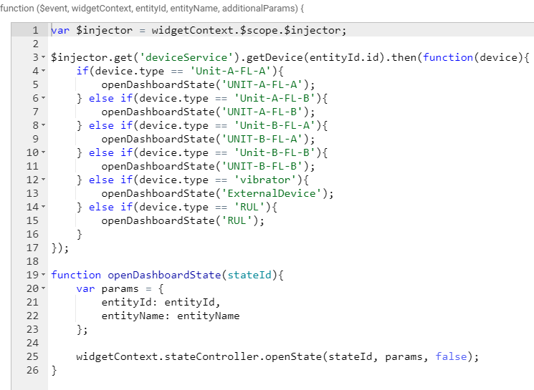

1. The following video tutorial will help you in understanding the concept of the **8th STEP** and also about **visualizing** the **attributes data** using the **Image Map widget**, **visualizing** the **telemetry data** using **Analogue** and **Digital gauges** and the **Timeseries widget**. Look below: -

<https://youtu.be/Wau2icogLrw>

1. To create a new dashboard and visualize data from the **asset attributes**.

You will learn how to:

* **create assets and devices** and **define** their **relationships.**
* add the [**server attributes**](https://thingsboard.io/docs/user-guide/attributes/#attribute-types)and create a new dashboard.
* visualize data from the asset attributes using “**Entities Table**” and “**Map**” widgets.

<https://youtu.be/5qZRSBYTDN4>

1. For the basic settings needed to configure a widget in a dashboard, the following things need to be learned: -

* **Create a widget** and modify its **layout** and **properties**
* **Add** a **title** and **enable/disable** the **widget full screen** and **shadow**
* Change the **widget color**, **title style** and **widget style**
* Configure **legend settings** and the **mobile mode**

<https://youtu.be/XkGO_9j0iyo>

For further help, refer the following links for guidance:

1. <https://thingsboard.io/docs/guides/>
2. <https://thingsboard.io/docs/user-guide/contribution/widgets-development/>
3. <https://thingsboard.io/docs/user-guide/ui/widget-library/>