**Computer Graphics Laboratory Examination 2021**

**Time : 1 Hour 30 Minutes**

**What you have to implement:**

**Specification**

The program should draw the following

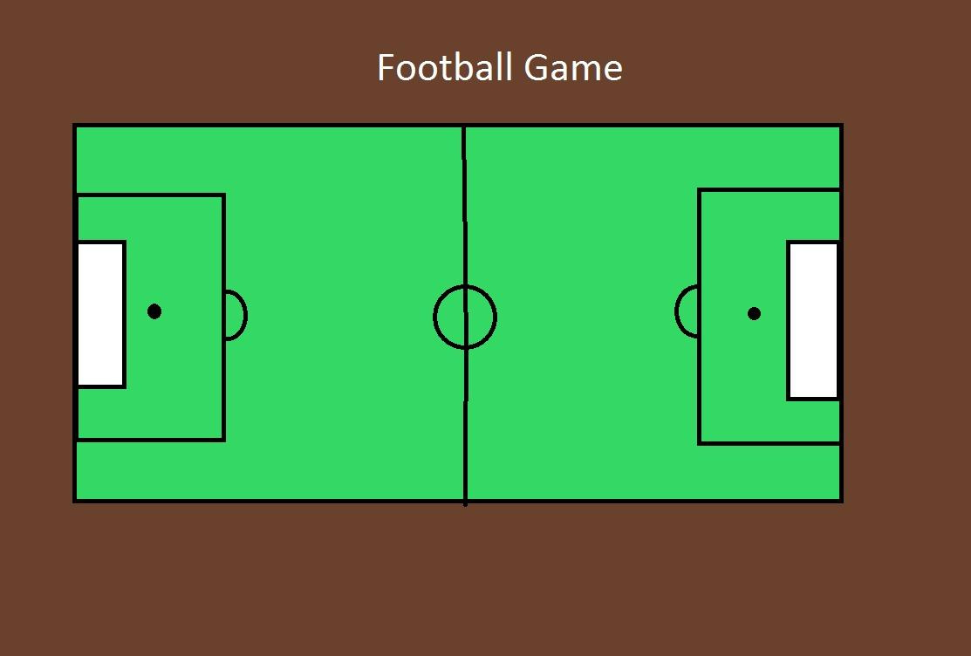

**Be creative in your design.**

1. Add Teams: Team 1 ( Left ): this choice will add 11 players on the left field and you can select any shapes to represent the player for example you can use a circle but don’t forget to color the players in the same team with the same color. Team 2 (right ): this choice will add 11 players on the Right field and you can select any shapes to represent the player for example you can use a circle but don’t forget to color the players in the same team with the same color “ .
2. Add a ball: Centre, left Penalty point, right Penalty point, corners (the corners should be numbered 1,2,3,4 and give the user a choice to select any one of them). **[Use the mouse to add the ball on the specific point as mentioned.]**
3. Using the mouse Function also you should let the user choose where to put the ball (once the user clicks the mouse anywhere inside the playground you should draw a ball there).
4. Let the user draw the Kick path [using a small line segment or any curve segment] then the ball should go through this curve (Note here you should define the starting and end points). To move the ball use the translation method to show the movement.

General 2D translation matrix is [P’] = [P] + [T]

Here, P’ (x’,y’) is the coordinate after translation, P(x, y) is the coordinate before translation and T (tx, ty) is the translation parameter.

To Draw the kicking curve you will wait until the user specify the path of the curve using mouse click ( note here that you will wait for 4 points i.e 4 clicks from the user ), see the following figure.

* The first click to specify where to draw the Ball.
* Clicks from 2 to 5 to specify the path of the curve (P1, P2, P3 and P4).
* Once completed, your program should draw the kicking curves passes through the specified points (Ball ,P1,P2,P3 and P4) as the following figure :

