Assignment 1

DBMS LAB  
IT552

Aditya Badayalya

510819056

Fifth Semester

Information Technology (HY)

**Creating the Customer Table:**

Using MySQL

create table cust(

cust_id varchar(3),

Lname varchar(15),

Fname varchar(15),

Area varchar(2),

Phone_number bigint

);

insert into cust (cust_id, Lname, Fname, Area, Phone_number)

values ('001','Doe','John','AB','12332145');

insert into cust (cust_id, Lname, Fname, Area, Phone_number)

values ('002','Parker','Peter','NY',13748713);

insert into cust (cust_id, Lname, Fname, Area, Phone_number)

values ('003','Wayne','Bruce','GM',98138713);

insert into cust (cust_id, Lname, Fname, Area, Phone_number)

values ('004','Gordon','Barbara','GM',58719023);

insert into cust (cust_id, Lname, Fname, Area, Phone_number)

values ('005','Holt','Raymond','NY',68623910);

insert into cust (cust_id, Lname, Fname, Area, Phone_number)

values ('006','Holmes','Sherlock','LN',56288971);

select * from cust;

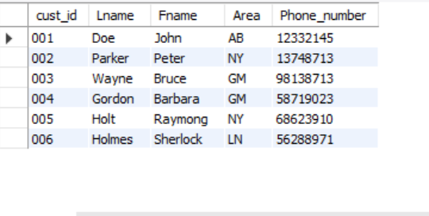

**Creating the Movie Table:**

Using MySQL

create table movie(

Mv_no int,

Title varchar(25),

Type varchar(10),

Star varchar(25),

Price decimal(8,2)

);

insert into movie (Mv_no, Title, Type, Star, Price)

values (1,'La La Land','Musical','Ryan Gosling',100.22);

insert into movie (Mv_no, Title, Type, Star, Price)

values (2,'Lost in Translation','Drama','Scarlett Johansson',502.00);

insert into movie (Mv_no, Title, Type, Star, Price)

values (3,'Deadpool','Comedy','Ryan Reynolds',216.12);

insert into movie (Mv_no, Title, Type, Star, Price)

values (4,'Mission Impossible','Action','Tom Cruise',500.00);

insert into movie (Mv_no, Title, Type, Star, Price)

values (5,'Casino Royale','Action','Daniel Craig',180.00);

insert into movie (Mv_no, Title, Type, Star, Price)

values (6,'Pride and Prejudice','Romance','Kiera Knightley',145.50);

select * from movie;

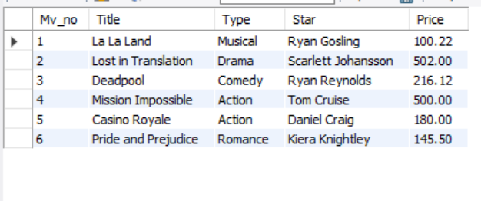

**Creating the Invoice Table:**

Using MySQL

create table invoice(

Inv_no varchar(3),

Mv_no int,

Cust_id varchar(3),

Issue_date DATE,

Return_date DATE

);

insert into invoice(Inv_no, Mv_no, Cust_id, Issue_date, Return_date)

values ('A1',2,'003',DATE_SUB(CAST(NOW() AS DATE), INTERVAL 20 DAY),DATE_SUB(CAST(NOW() AS DATE), INTERVAL 18 DAY));

insert into invoice(Inv_no, Mv_no, Cust_id, Issue_date, Return_date)

values ('B1',3,'002',DATE_SUB(CAST(NOW() AS DATE), INTERVAL 10 DAY),DATE_SUB(CAST(NOW() AS DATE), INTERVAL 5 DAY));

insert into invoice(Inv_no, Mv_no, Cust_id, Issue_date, Return_date)

values ('C1',1,'005',DATE_SUB(CAST(NOW() AS DATE), INTERVAL 1 DAY),CAST(NOW() AS DATE));

insert into invoice(Inv_no, Mv_no, Cust_id, Issue_date, Return_date)

values ('AA1',6,'001',DATE_SUB(CAST(NOW() AS DATE), INTERVAL 2 DAY),DATE_ADD(CAST(NOW() AS DATE), INTERVAL 2 DAY));

insert into invoice(Inv_no, Mv_no, Cust_id, Issue_date, Return_date)

values ('AD1',4,'003',DATE_SUB(CAST(NOW() AS DATE), INTERVAL 2 DAY),DATE_ADD(CAST(NOW() AS DATE), INTERVAL 1 DAY));

insert into invoice(Inv_no, Mv_no, Cust_id, Issue_date, Return_date)

values ('Z1D',5,'004',DATE_SUB(CAST(NOW() AS DATE), INTERVAL 20 DAY),CAST(NOW() AS DATE));

select * from invoice;

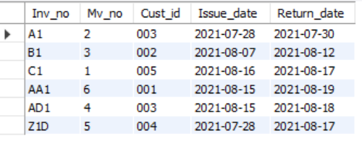

1. **Find out names of all customers:**

Using MySQL

select Fname, Lname from cust;

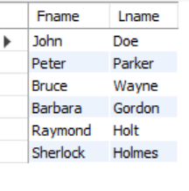

1. **List the various movie types available from the movie table:**

Using MySQL

select distinct Type from movie;

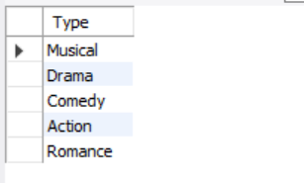

1. **Print the list of all employees whose phone numbers are greater than the value 5550000:**

Using MySQL

select * from cust where Phone_number>55550000;

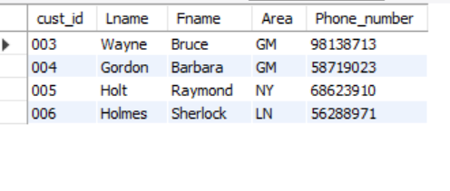

1. **Find the movies of type ‘Action’ or ‘Comedy’:**

Using MySQL

select * from movie where Type = 'Action' OR Type = 'Comedy';

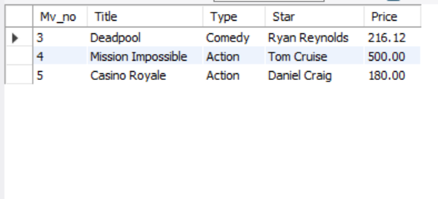

1. **Find the movies whose price is greater than 150 and less than or equal to 200:**

Using MySQL

select * from movie where price > 150.00 AND price <= 200.00;

