**Indian Institute of Engineering Science and Technology, Shibpur. Department of Information Technology**

**Programming and Data Structure Laboratory**

**Final Examination**

**Implement both the program and upload your source code as (dot) C file and also upload screenshots of your outputs.**

**Batch:- HY Time:- 2 Hours.**

1. Your input is a positive integer n, followed by an n × n square matrix A with each cell filled with a digit between 0 and 9. Write a program to display A in the terminal rotated clockwise at an angle of 45o as shown in the example below.

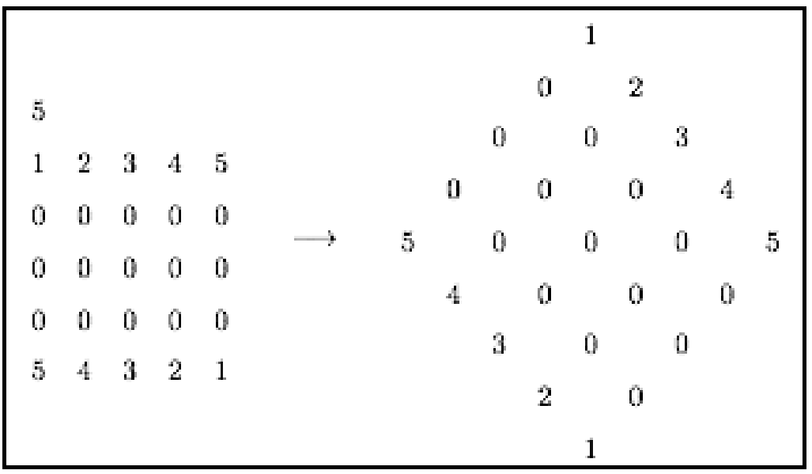

2. A binary tree is termed as a mirror twin of a binary search tree (BST) if both of them comprise the same set of data items and they are structurally mirror images to each other. Given the pre-order traversal of a BST and the in-order and pre-order traversals of a simple binary tree as user inputs, write a program to determine whether the binary tree is a mirror twin of the BST or not. As for example, the binary tree shown below (in the right side) is a mirror twin of the BST given below (in the left side).



**Input Format:**

Input will be provided via standard input in the following format. The first line of input consists of two integers, namely the number of data items in both the input trees. It is followed by three more input lines. These lines consist of sets of integers corresponding to the data items obtained from the pre-order traversal on the BST, followed by the in-order and pre-order traversals on the binary tree, respectively.

**Output Format:**

Output is to be printed on the standard output in the following format. The output simply prints ‘MIRROR TWIN’ or ‘NOT MIRROR TWIN’ corresponding to whether the input binary tree is a mirror twin to the BST or not.

**Sample Input 0**

6 6

5 3 1 4 8 9

9 8 5 4 3 1

5 8 9 3 4 1

**Sample Output 0**

MIRROR TWIN

**Sample Input 1**

5 5

7 5 3 1 4

7 5 4 3 1

7 5 3 4 1

**Sample Output 1**

MIRROR TWIN

**Sample Input 2**

6 6

5 3 1 4 8 9

1 3 4 5 8 9

5 3 1 4 8 9

**Sample Output 2**

NOT MIRROR TWIN