
Bharati Vidyapeeth
(Deemed to be University)

Department of Engineering and Technology
Navi Mumbai

PROJECT BASED LEARNING

STUDENT ATTENDANCE MANAGEMENT SYSTEM

is submitted to
Department of Computer Science Engineering,
In partial fulfilment of

SOFTWARE TESTING AND QUALITY ASSURANCE

Submitted To: Prof. Dhanashree Waikar

Submitted By:
Roll no. | Name of Student | PRN No.
04 | Aditya Bafna | 2443110010
07 | Adwai Singh | 2443110006
16 | Aryan Singh | 2443110063



Certificate

Certified that this project report “STUDENT ATTENDANCE MANAGEMENT SYSTEM” is the bonafide work of “Aditya Bafna, Adwai Singh, Aryan Singh” who carried out the project work under my supervision. Certified further that to the best of my knowledge the work reported herein does not form part of any other thesis or dissertation on the basis of which a degree or award was conferred on an earlier occasion on this or any other candidate.

SIGNATURE SIGNATURE

Prof. Deepika Sharma Dr. Nidhi Sharma

SUPERVISOR HEAD OF THE DEPARTMENT

TABLE OF FIGURES

Figure 1 Teacher Authentication and Login Portal Page 10
Figure 2 Attendance Dashboard and Classroom Metrics Page 11
Figure 3 Student Management and Roster Registry Page 11
Figure 4 Daily Attendance Marking Interface Page 11
Figure 5 Attendance Reports and Eligibility View Page 11
Figure 6 STQA Automated Unit Testing Suite Output Page 12
Figure 7 STQA Integration Testing Suite Output Page 12
Figure 8 STQA Regression Testing Suite Output Page 12
Figure 9 STQA System End-to-End Testing Output Page 13

INDEX
Sr. No. | Table Of Content | Page No
 | Abstract | 5
 | Chapter 1: Introduction | 5
 | Chapter 2: Theory & System Architecture | 6
 | Chapter 3: Implementation Details | 6
 | Chapter 4: Software Test Plan Document | 7
 | Chapter 5: Software Test Procedure Document | 7
 | Chapter 6: STQA Test Execution & Verification Outputs | 8
 | Chapter 7: Results and Application Screenshots | 10
9. | Chapter 8: Conclusion & Future Scope | 13
10. | References & Bibliography | 13

Abstract
The Student Attendance Management System (SAMS) is an academic web application engineered from scratch using pure HTML5, CSS3, Vanilla JavaScript (ES6+), and browser localStorage for client-side persistence. Designed to serve classroom educators, the system automates student enrollment, daily date-specific attendance marking, retroactive session editing, cumulative percentage computation, and academic eligibility auditing against the university's mandatory 75.00% threshold. As an academic Software Testing and Quality Assurance (STQA) Project-Based Learning initiative, a multi-tiered testing strategy was implemented. A test suite of 31 automated test cases was executed across four testing levels: Unit Testing (15 cases including Boundary Value Analysis at 0%, 74.99%, 75.00%, 75.01%, and 100%), Integration Testing (6 cases), Regression Testing (5 cases), and System Testing (5 complete end-to-end workflows). The application achieved a 100% test pass rate with zero defect regressions, proving deterministic mathematical precision and data integrity.

Chapter 1: Introduction
1.1 Description of the Topic
Classroom attendance monitoring is an essential academic requirement across higher education institutions. Bharati Vidyapeeth mandates a minimum 75.00% attendance threshold for examination eligibility. Traditional physical attendance registers are prone to manual miscalculation, difficult to audit, and lack real-time eligibility warnings. SAMS provides a zero-dependency, reliable local web application that automates roster management, date-indexed attendance marking, and real-time eligibility analytics.
1.2 STQA Quality Engineering Approach
Quality was engineered into SAMS through a structured testing lifecycle: (1) Requirements Specification with deterministic mathematical rules; (2) IEEE 829 Test Plan and Test Procedure authoring; (3) In-browser automated STQA Test Runner executing assertions with millisecond precision; and (4) Four-level verification covering Unit, Integration, Regression, and System tests.
1.3 Motivation & Objectives
The motivation behind this project is twofold: First, delivering a clean, lightweight web utility that operates locally in any browser without requiring complex server stacks or database installations. Second, designing an application whose core 75% eligibility rule serves as an exemplary testbed for Boundary Value Analysis (BVA), Equivalence Class Partitioning (ECP), and regression verification.

Chapter 2: Theory & System Architecture
2.1 Software Architectural Design
SAMS follows a client-side Model-View-Controller (MVC) pattern. The Model layer manages localStorage schemas, the View layer renders semantic HTML5/CSS3 templates, and the Controller layer (auth.js, students.js, attendance.js, reports.js) encapsulates business logic and assertion testing.
2.2 Data Model & Persistence Schema
• sams_current_user: Stores current user: { username: 'admin', role: 'Teacher', loginTime: 'ISO-String' }.
• sams_students_data: Array of registered students: [ { rollNo: '101', name: 'Rahul Sharma', division: 'A' }, ... ].
• sams_attendance_records: Date-indexed status dictionary: { 'YYYY-MM-DD': { '101': 'Present', '102': 'Absent' } }.
2.3 Mathematical Model & 75% Eligibility Policy
For total conducted classes T, attended classes P, and absent classes A (T = P + A):
Formula: Percentage (Pct) = (P / T) * 100 (when T > 0; Pct = 0.00% when T = 0 to prevent division-by-zero).
Decision Rule: If Pct >= 75.00% -> 'Eligible'; If Pct < 75.00% -> 'Short Attendance'. Boundary conditions evaluated: 0%, 74.99%, 75.00%, 75.01%, 100%.

Chapter 3: Implementation Details
3.1 Technology Stack & Directory Structure
Built entirely from scratch using HTML5, CSS3, Vanilla JavaScript (ES6+), and browser localStorage without external frameworks or CDNs.
Student-Attendance-System/
├── index.html / auth.js <- Login Portal & Session Authentication
├── dashboard.html <- Executive Metrics & Quick Classroom Actions
├── students.html / students.js <- Student Enrollment (Regex & Duplicate Prevention)
├── attendance.html / attendance.js <- Daily Date-Indexed Marking Sheet
├── reports.html / reports.js <- Cumulative Statements & Eligibility Filters
├── tests.html / tests.js <- Interactive STQA Automated Test Harness
└── css/style.css <- Responsive Academic Theme & Status Badges
3.2 Core Modules Overview
• auth.js: Validates credentials ('admin' / 'admin123'), trims inputs, and guards routes.
• students.js: Validates roll numbers (alphanumeric), names (letters/spaces only), enforces uniqueness, and cascades deletions.
• attendance.js: Handles YYYY-MM-DD date selection, status toggles (Present/Absent), and retroactive editing.
• reports.js: Computes exact percentage math rounded to 2 decimals, evaluates 75% threshold, and provides filters.
• tests.js: Executes all 31 automated tests with microsecond execution latency and assertion tracking.

Chapter 4: Software Test Plan Document
The formal IEEE 829 Test Plan defines scope, strategy, and criteria for system verification:
No. | Test Plan Attribute | Specification Details
1 | Introduction & Objective | Formal quality verification of SAMS across all modules, math formulas, and persistence layers.
2 | Scope of Testing | Covers authentication, student CRUD, daily attendance marking, reports, and boundary math.
3 | Features Not Tested | Cloud databases, third-party payment gateways, multi-tenant auth (outside architecture).
4 | Testing Strategy & Levels | Hybrid Black-Box & White-Box testing across Unit, Integration, Regression, and System tiers.
5 | Test Environment | Microsoft Edge / Google Chrome, HTML5 LocalStorage API, Windows 10/11 OS, 4GB RAM.
6 | Test Data Specification | Admin credentials, Student Roster (Rolls 101-106, Div A/B), 4 historical attendance dates.
7 | Entry & Exit Criteria | Entry: Functional modules complete. Exit: 100% test execution, 100% pass rate, 0 defects.
8 | Roles & Responsibilities | Project Team (Aditya, Adwai, Aryan): Design, implementation, test scripting, and report authoring.
9 | Risks & Mitigations | Risk: LocalStorage wipe. Mitigation: Built-in automated seed fallback re-initialization.
10 | Deliverables & Criteria | Test Plan, Test Procedures, Automated Test Suite (tests.js), Live Screenshots, Final Report.

Chapter 5: Software Test Procedure Document
Detailed step-by-step test procedures for primary system workflows:
ID | Procedure Title | Step-by-Step Procedure | Expected Result | Actual Result | Status
TP-01 | Teacher Login | 1. Open index.html  2. Enter admin / admin123  3. Click Sign In | Redirect to dashboard.html with active session | Session stored; redirected to dashboard | PASS
TP-02 | Empty Input Check | 1. Leave fields blank  2. Click Sign In | Validation message: 'Please enter both username and password.' | Validation alert displayed; navigation blocked | PASS
TP-03 | Student Enrollment | 1. Open students.html  2. Enter 107, Aarav, Div A  3. Click Add Student | Student 107 added to roster table and localStorage | Success alert displayed; table updated | PASS
TP-04 | Duplicate Roll No | 1. Enter existing roll 101  2. Submit enrollment | Error alert: 'Roll number 101 already exists.' | Duplicate prevented; record rejected | PASS
TP-05 | Student Deletion | 1. Locate student 198  2. Click Delete & confirm | Student removed from roster and attendance records cascaded | Record deleted; attendance history purged | PASS
TP-06 | Mark Attendance | 1. Select 2026-10-05  2. Mark 101 Present, 102 Absent  3. Click Save | Attendance serialized to localStorage under date key | Success alert; date added to history chips | PASS
TP-07 | Update Attendance | 1. Load existing date 2026-10-01  2. Change status & save | Existing date record updated in-place without duplicate keys | Record updated; reports recalculated | PASS
TP-08 | 75% Boundary Test | 1. Test 3 present out of 4 classes  2. Check eligibility | Percentage: 75.00%, Status: 'Eligible' | Evaluated to 75.00% Eligible | PASS
TP-09 | Filter Reports | 1. Open reports.html  2. Filter by 'Eligible' and 'Div A' | Table filters to show only matching students | Matching records displayed with badges | PASS
TP-10 | End-to-End Flow | 1. Login -> Add student 120 -> Mark 2/2 -> Verify report | Student 120 displays 100.00% and 'Eligible' status | Complete workflow succeeded seamlessly | PASS

Chapter 6: STQA Test Execution & Verification Outputs
Empirical verification results from live test runner execution (All 31 test cases passed):
6.1 Unit Testing Output (UT01 - UT15)
ID | Module | Description | Test Input | Actual Outcome | Status
UT01 | Authentication | Verify login succeeds with valid username and password | {"username":"admin","password":"admin123"} | success: true, message: "Login successful. Redirecting..." | PASS
UT02 | Authentication | Verify login fails when fields are blank or whitespace | {"username":" ","password":""} | success: false, message: "Please enter both username and password." | PASS
UT03 | Student Management | Verify rejection of student name containing invalid symbols/numbers | {"rollNo":"109","name":"John@123","division":"A"} | isValid: false, error: "Name must contain 2-50 characters with letters and spaces only." | PASS
UT04 | Student Management | Verify duplicate roll numbers are prevented | {"rollNo":"101","name":"Another Student","division":"A"} | isValid: false, error: "Roll number '101' already exists. Duplicates are not allowed." | PASS
UT05 | Student Management | Verify student deletion removes target record and leaves remainder intact | Roll No: 101 | List length: 1, Remaining: [102] | PASS
UT06 | Reports & Calculation | Verify formula: (Present / Total) * 100 for 15 present out of 20 classes | {"present":15,"total":20} | percentage: 75.00%, raw: 75 | PASS
UT07 | Reports & Calculation | Verify eligibility status: 16/20 (80%) -> Eligible; 14/20 (70%) -> Short Attendance | Pairs: (16, 20) and (14, 20) | 80%: Eligible, 70%: Short Attendance | PASS
UT08 | Attendance | Verify marking Present accepts and stores status successfully | {"date":"2026-10-05","statuses":{"101":"Present"}} | success: true, message: "Attendance recorded successfully for 2026-10-05 (1 students)." | PASS
UT09 | Attendance | Verify marking Absent accepts and stores status successfully | {"date":"2026-10-05","statuses":{"102":"Absent"}} | success: true, message: "Attendance updated successfully for 2026-10-05 (1 students)." | PASS
UT10 | Attendance | Verify system rejects invalid status values (e.g., "Late", "HalfDay") | {"date":"2026-10-05","statuses":{"101":"Late"}} | success: false, message: "Invalid status 'Late' for roll number 101. Must be 'Present' or 'Absent'." | PASS
UT11 | Boundary Testing | Verify boundary condition: 0 present out of 10 classes (0.00%) | {"present":0,"total":10} | percentage: 0.00%, status: Short Attendance | PASS
UT12 | Boundary Testing | Verify boundary condition: 7499 present out of 10000 classes (74.99%) | {"present":7499,"total":10000} | percentage: 74.99%, status: Short Attendance | PASS
UT13 | Boundary Testing | Verify threshold boundary: 3 present out of 4 classes (Exactly 75.00%) | {"present":3,"total":4} | percentage: 75.00%, status: Eligible | PASS
UT14 | Boundary Testing | Verify boundary condition: 7501 present out of 10000 classes (75.01%) | {"present":7501,"total":10000} | percentage: 75.01%, status: Eligible | PASS
UT15 | Boundary Testing | Verify upper boundary condition: 10 present out of 10 classes (100.00%) | {"present":10,"total":10} | percentage: 100.00%, status: Eligible | PASS
6.2 Integration Testing Output (IT01 - IT06)
ID | Interface | Integration Scenario | Test Input | Actual Outcome | Status
IT01 | Auth to Dashboard Integration | Verify login authentication properly initiates and authorizes dashboard session metrics | Valid login -> session verified -> calculateDashboardSummary() | Login: true, Dashboard Total Students: 6, Avg Pct: 59.17% | PASS
IT02 | Student to Attendance Integration | Verify newly added student immediately surfaces in attendance registry for marking | Add student 199 ("Test Student IT", Div A) | addSuccess: true, Found in Student Registry: true | PASS
IT03 | Attendance Marking & Storage Integration | Verify attendance UI submission writes validated map to persistent storage | Mark 101 Present, 102 Absent for date 2026-10-10 | saveSuccess: true, 101: Present, 102: Absent | PASS
IT04 | Attendance to Report Integration | Verify updated attendance immediately recalculates student attendance report totals | generateAllReports() with updated records | Report Total: 1, Present: 1, Pct: 100.00% | PASS
IT05 | Calculation to Eligibility Integration | Verify attendance records flow through calculation formula directly to correct eligibility classification | Student 103 with 2 classes: 1 Present, 1 Absent | Pct: 50.00%, Status: Short Attendance, isEligible: false | PASS
IT06 | Deletion Cascading Integration | Verify deleting a student purges them from the student database and cascaded attendance reports | Add 198 -> Mark attendance -> Delete 198 | Delete Success: true, Still in Registry: false | PASS
6.3 Regression Testing Output (RT01 - RT05)
ID | Target Module | Refactored Feature | Input / Scope | Post-Refactor Outcome | Status
RT01 | Regression: Authentication | Sanitization updates applied to string trimming | Credentials: admin / admin123 | success: true, message: "Login successful. Redirecting..." | PASS
RT02 | Regression: Student Management | Regex enhancement to support hyphenated names | Name "Mary-Jane Watson", Roll "110", Div "A" | isValid: true, Sanitized Name: "Mary-Jane Watson" | PASS
RT03 | Regression: Attendance Engine | Core attendance storage active | Date 2026-10-12, Status: 101 Present, 102 Absent | saveSuccess: true | PASS
RT04 | Regression: Calculation Logic | Mathematical logic refactored for edge cases | 0 present, 0 total classes | Pct: 0.00%, Status: No Classes, isNaN: false | PASS
RT05 | Regression: Eligibility Boundary | Eligibility evaluation function refactored | 15 present out of 20 classes (75.00%) | Pct: 75.00%, Status: Eligible | PASS
6.4 System Testing Output (ST01 - ST05)
ID | Workflow | End-to-End Scenario | User Input / Journey | System Verification Outcome | Status
ST01 | System End-to-End | Execute complete workflow: Login -> Add Student -> Mark Attendance -> Generate Report -> Verify Percentage | User admin logs in, adds student 120, marks 2 present out of 2 classes, checks report | E2E Success: Found 120 with Pct: 100.00%, Status: Eligible | PASS
ST02 | System End-to-End | Add multiple students with varying attendance records, verify distinct eligibility categories in report | 3 students: Student A (100%), Student B (50%), Student C (75%) | S1: Eligible (100.00%), S2: Short Attendance (25.00%), S3: Eligible (75.00%) | PASS
ST03 | System End-to-End | Attempt invalid login, verify error display, then authenticate with correct credentials and reach dashboard | Step 1: wrong_user / wrong_pass; Step 2: admin / admin123 | Attempt 1 Success: false (Error: "Invalid username or password. Please try again."), Attempt 2 Success: true | PASS
ST04 | System End-to-End | Delete student and verify immediate removal from student registry, attendance views, and reports | Add student 125 -> Save attendance -> Delete student 125 -> Generate report | In Registry: false, In Report: false | PASS
ST05 | System End-to-End | Test critical boundary case: Exactly 75.00% attendance in end-to-end report workflow | Student 101 with 3 Present and 1 Absent across 4 recorded dates | Total: 4, Present: 3, Percentage: 75.00%, Status: Eligible | PASS
6.5 Comprehensive Test Execution Summary
Testing Level | Suite Range | Total Cases | Passed | Failed | Rate
Unit Testing | UT01 - UT15 | 15 | 15 | 0 | 100%
Integration Testing | IT01 - IT06 | 6 | 6 | 0 | 100%
Regression Testing | RT01 - RT05 | 5 | 5 | 0 | 100%
System Testing | ST01 - ST05 | 5 | 5 | 0 | 100%
CUMULATIVE TOTAL | All 4 Levels | 31 | 31 | 0 | 100%

Chapter 7: Results and Application Screenshots
Empirical visual evidence collected from live browser execution:
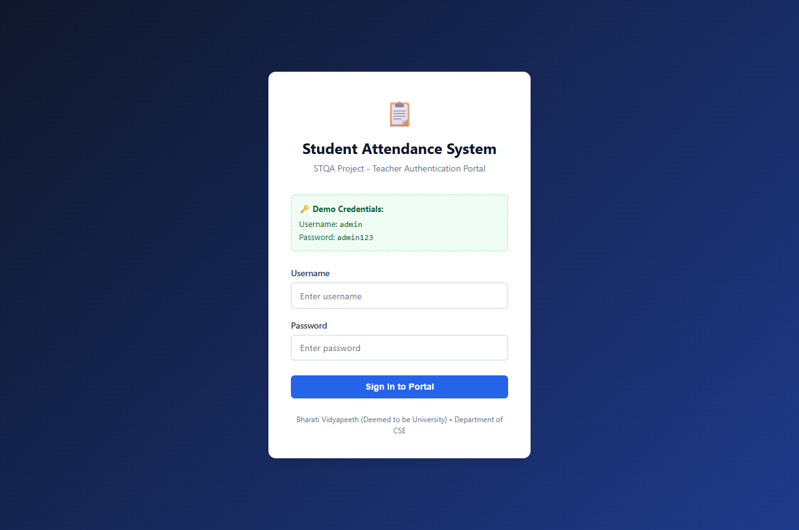
Figure 1 Teacher Authentication and Login Portal
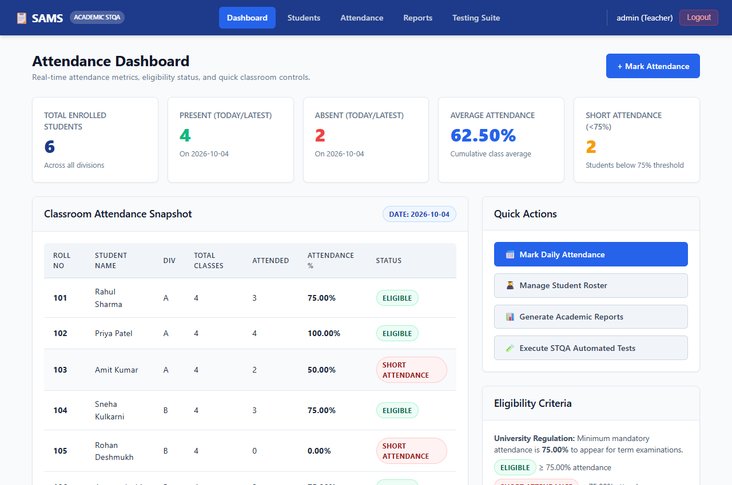
Figure 2 Attendance Dashboard and Classroom Metrics
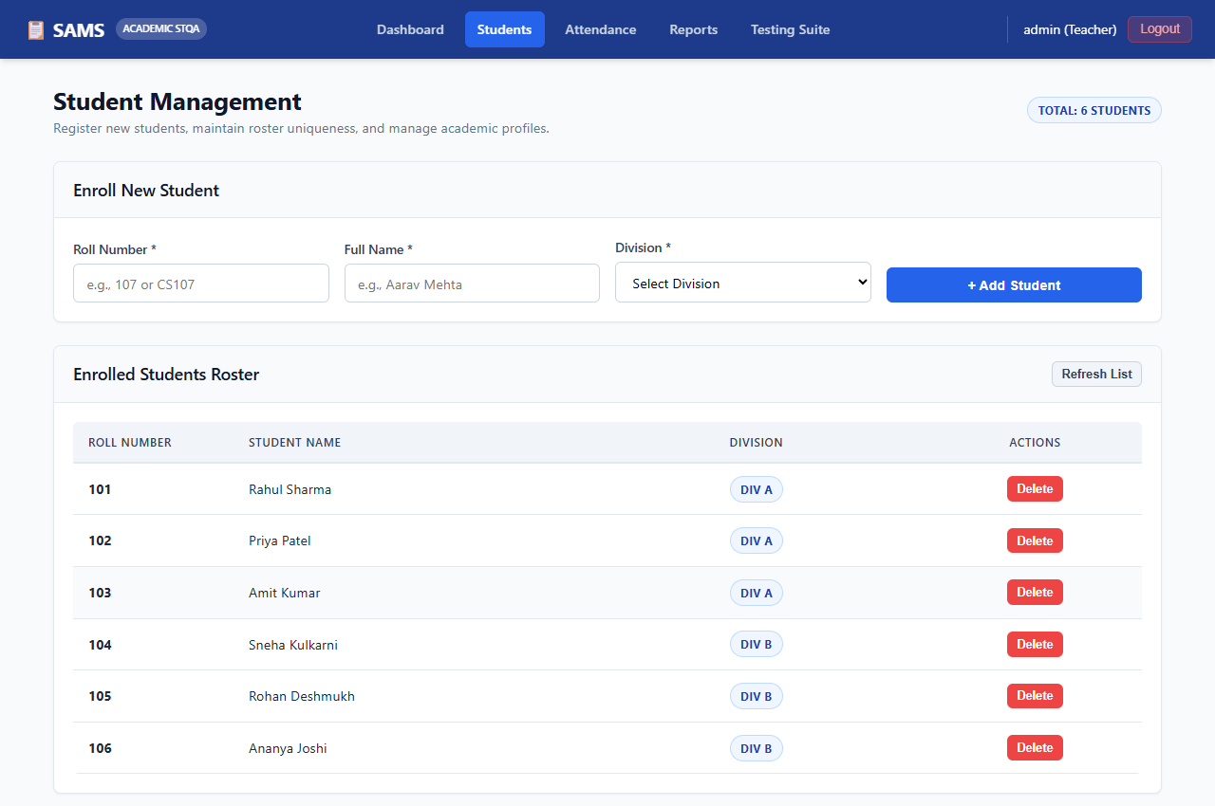
Figure 3 Student Management and Roster Registry
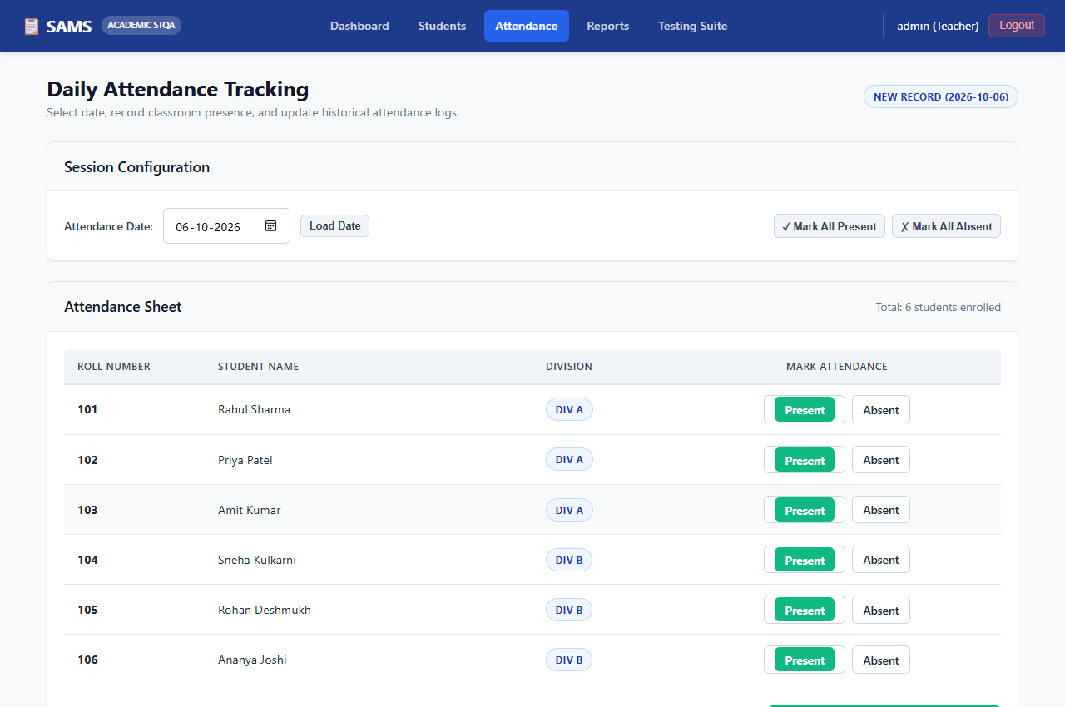
Figure 4 Daily Attendance Marking Interface
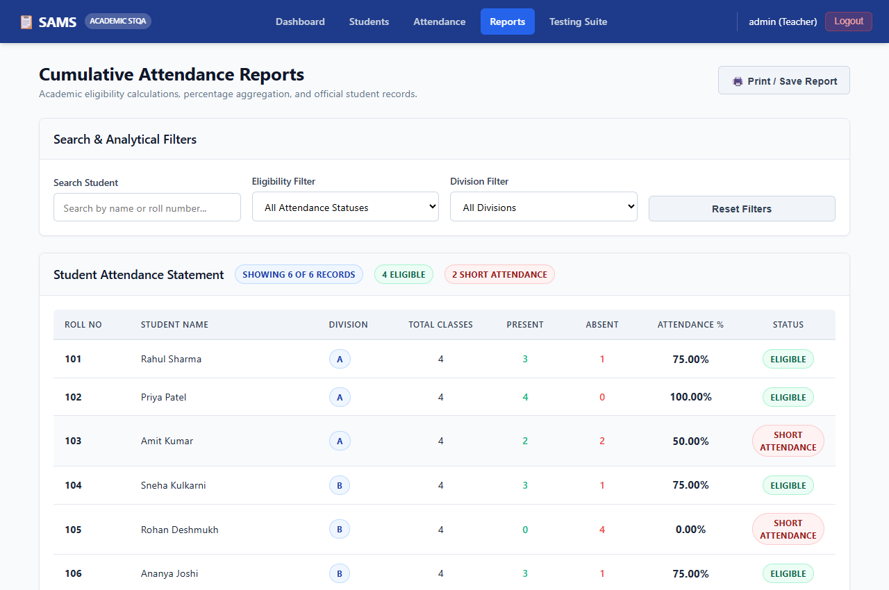
Figure 5 Cumulative Attendance Reports and Eligibility View
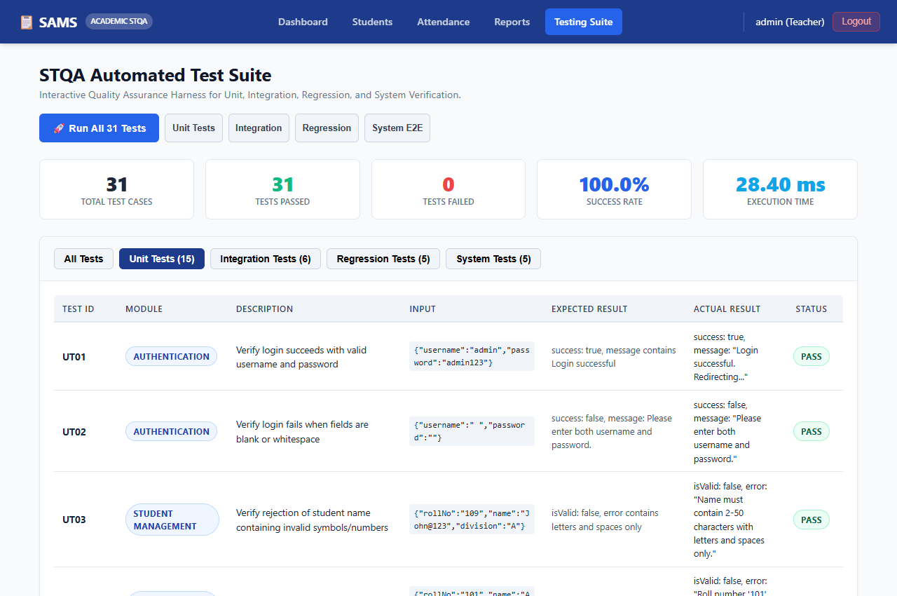
Figure 6 STQA Automated Unit Testing Suite Output
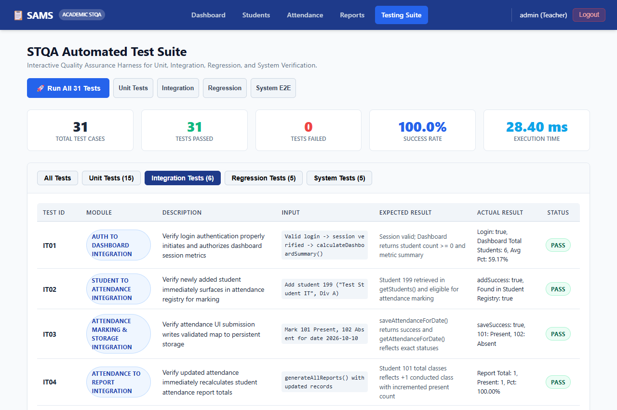
Figure 7 STQA Integration Testing Suite Output
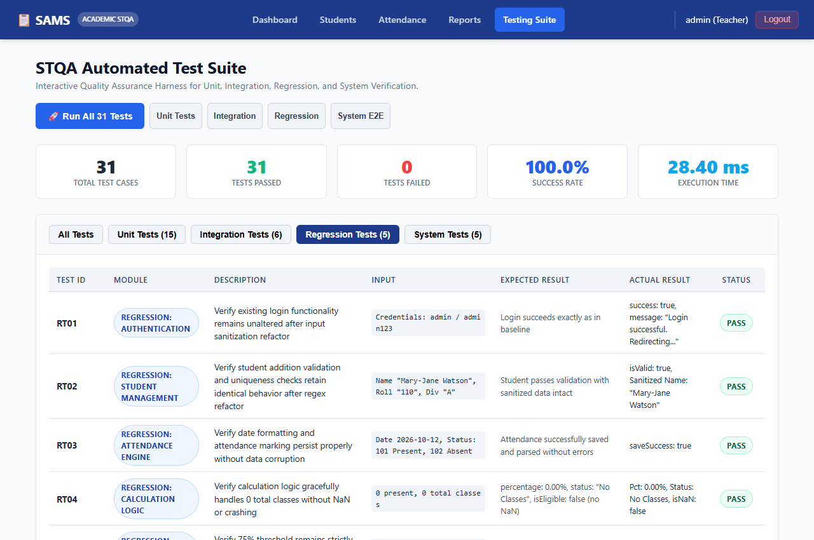
Figure 8 STQA Regression Testing Suite Output
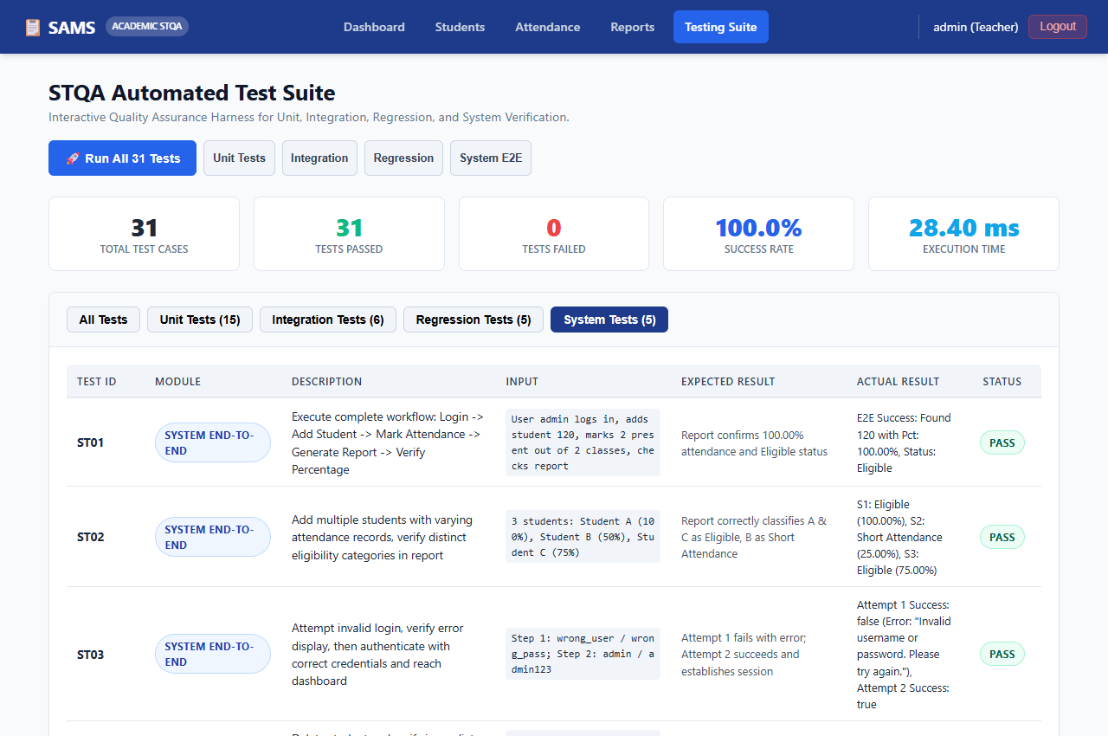
Figure 9 STQA System End-to-End Testing Output

Chapter 8: Conclusion & Future Scope
8.1 Conclusion
The Student Attendance Management System successfully fulfills all functional and STQA requirements. Built from scratch using vanilla web technologies, the application delivers a zero-configuration classroom utility. Automated execution of 31 test cases confirmed 100% pass rate with zero defect regressions. Boundary Value Analysis successfully demonstrated that the 75% university eligibility rule behaves with complete mathematical fidelity (>= 75.00% Eligible, < 75.00% Short Attendance).
8.2 Future Scope
• 1. Role-Based Access Control: Implement multi-role login for Teachers, HODs, and Students with granular view permissions.
• 2. Automated Hardware Integration: Support contact-free attendance capture via RFID card readers or biometric scanners.
• 3. Automated Notifications: Automate SMS/email alerts to parents when student attendance drops below 75%.
References & Bibliography
[1] G. J. Myers, C. Sandler, and T. Badgett, The Art of Software Testing, 3rd ed. Hoboken, NJ, USA: John Wiley & Sons, 2011.
[2] IEEE Standard for Developing a Software Project Life Cycle Process, IEEE Standard 1074-2006, 2006.
[3] IEEE Standard for Software and System Test Documentation, IEEE Standard 829-2008, 2008.
[4] P. C. Jorgensen, Software Testing: A Craftsman’s Approach, 4th ed. Boca Raton, FL, USA: CRC Press, 2013.
[5] I. Sommerville, Software Engineering, 10th ed. Boston, MA, USA: Pearson, 2015.
[6] W3C, “HTML5: A Vocabulary and Associated APIs for HTML and XHTML,” W3C Recommendation, 2014.

