

**Name:** Adiba Binte Amin

**ID:** 1910511

**Course Title:** Fundamentals of Computer System

**Course Code:** CIS 101

**Section:**  11

**Semester Name:** Autumn-2023

**Date of Submission:** 30-11-2023

**Name of the Course Instructor: Dr. Razib Hayat Khan,**

**Ph. D. Assistant Professor,**

Department of Computer Science & Engineering, School of Engineering, Technology & Science

**Name of Topic: Impact of Globalization on Business**

**Table of Contents:**

Abstract………………………………………………………………………………………….3 Keywords….…………………………………………………………………………………….4 Introduction…..………………………………………………………………………………….4 Survey Questions…………………………………………………………….……….…….….4 Research Objective…………………………………………………………………………….5 Why We are Discussing Impact of Globalization on Business…………………………….5 Research Method………………………………………………………………………………6 Brief History.…………………………………………………………………………………….6 Contributions…………………………………………………………………………………...7

Political Changes………………………………………………………….…………...7 Development of Technology………………………………………………..…….…..8 International Business Climate……………………………………………….………8 Development Market………………………………………………………….……….8

The problem of Globalization on Business……………………………………...………………..9 Effects of Globalization on Society……………………………………………………9 Effects of Globalization on politics……………………………………………………..9 Negative Effects of Globalization on the Environment………………………..…….9 Increased greenhouse gas (GHG) emissions……………………………….……...10

Invasive species…………………………..……………………………………………10 Habitat destruction………………………………………………………………….….10 Deforestation………………………………………….………………………………...11

Solution of Globalization on Business…………………………………………………….…11 Access to New Markets………………………………………………………….……11 Product Development and New Revenue Streams………………………………..12 Sharing Knowledge, Technology, and Culture……………………………………...12 Developing Universal Standards…………………………………………………….12 Access to a Diverse Talent Pool……………………………………………………..13 A Diversified Workforce and Workplace Culture……………………………………13

Impact of Global Business in our Economy…………………………………………………13 Result Discussion……..……………………………………………………………………….14 What We have learned overall……………………………………………………………….14 Conclusion..………………………………………………………………………………….…14 Reference……………………………………………….……………………………………...15

**Abstract:**

We all are living in an age of globalization. The change in business type from a single country to multiple countries for the benefit of each nation is simply called globalization. The recent great capitalistic and economic action has become a unity of things and reasons, analysis, information, means, mediums, skills, and tendencies in terms of reducing barriers and openness of the world, the essential process of globalization The improvement and reliability of business is possible by the help of globalization. Globalization increased the standard of living and allowed developing countries to create industrialized nations through manufacturing economic growth or diversification. The world’s goal is now to create economic satisfaction, minimize the risks, and make relations with other nations to meet each other's needs as well. Globalization is important to increase the size of the business & and also make and sell goods at cheaper prices. Thanks to the telecommunication system which has made globalization on business successful. However, it has increased the income & and the higher standard of living but also created problems of urbanization, crime, poverty, and some other types of. Participation in the world’s global markets, internationalization, and therefore the transfer of the business activities to all geographic locations, can create new markets and also reduce the production costs of the products. Sometimes uncertain environments may be a constant business story of the international economic activity for a minimum of three centuries ago. Globalization growing interdependence of countries worldwide. Global economic interaction is old because it is an old society in its more or less organized form. The reasons for the economic revolution are simple: business and profits don’t recognize borders, or national and cultural characteristics, where more or less a mutual advantage of certain cooperation is recognized by globalization.

**Keywords:**

Globalization, Internationalization, Business, B2B, Global Markets, Bangladesh Market, Political, Economic Growth, Export-Import, Economic Integration.

**Introduction:**

The global changes in the world, changes in economic, political, and business activities as well as the development of technology, transport, and communications, make the business man realize the need for enterprises in their struggle for survival, to change their strategies and go out from the borders of their own countries. Limited market, competitive pressure, demand for cheaper resources, and the dynamics of the postmodern era, have forced business leaders to change their focus from traditional markets to new measures for successful business and the entrance of global markets, with the purpose of making competitive advantage.

Survey Questions:

|  |  |
| --- | --- |
|  |  |
|  |  |
|  |  |

**Why We are Discussing the Impact of Globalization on Business:**

Globalization allows companies to find lower costs to produce their products. It also increases global competition among competitors, which can lower the prices of products and create a larger variety of choices for consumers. Lowered costs help people in both developing and already-developed countries live in a better way and get all necessaries in hand with less money. The important factors causing globalization of business are the digital revolution, international economic integration, socio-cultural awareness, global education providers, cross-border political influence, financial liberalization, intense competition among nations, increased international business and trade, and the need for economies of scale. However strategic alliances, joint ventures, and over all are ways of expanding business outside the nation for its benefits. So, the main need to know about globalization is to increase business growth, allowing several goods to be produced and sold in different nations at cheaper prices, and also maintaining a good relationship with other nations.

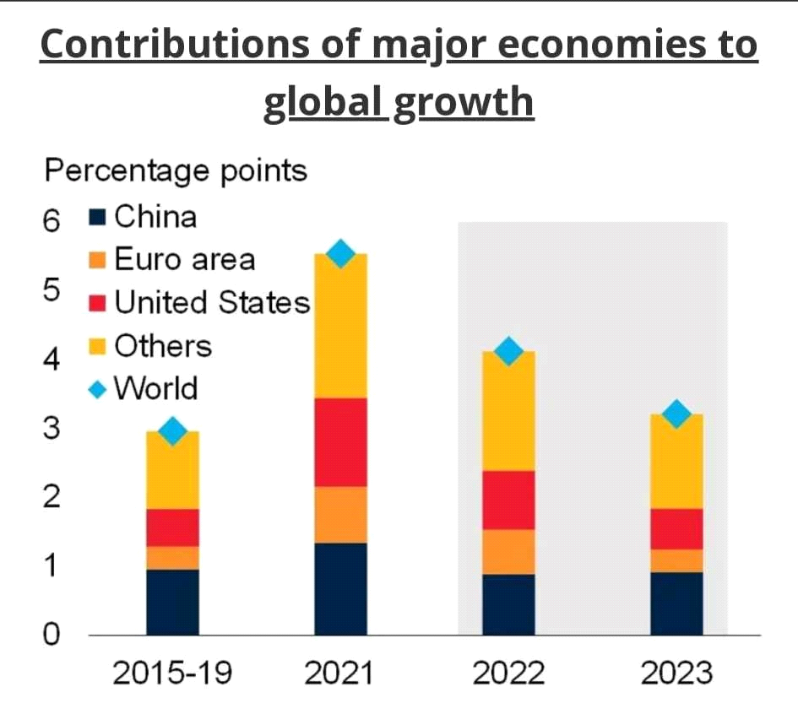

**Research Method:**

Globalization of Business has four main dimensions: economic, political, cultural, and ecological. We have done qualitative research about these four dimensions and also surveyed our university campus. Survey questions we ask questions to large participants of more than 100 students. We have completed our research based on their feedback.



**The Impact of Globalizations on the Business:**

The globalization of markets means the growing economic integration and the growing interdependence of countries worldwide. Internationalization of the companies creates the tendency for the companies to systematically increase the international scope of their business activities, while globalization refers to a market trend of intensive economic relations between the countries in the world. Globalization encourages companies to internationalize and to increase the volume and types of cross- border transactions in products, services, and capital. Also, globalization leads to the rapid circulation and spreading of products, technology, and knowledge in the world, without judging nations. The process of globalization is a natural process that is a result of the growing and rapid process of generalizing the character and process of production.

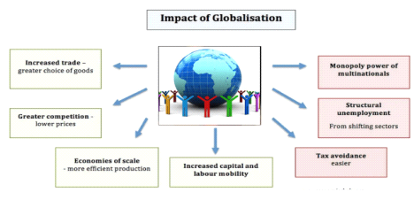

The development of science, engineering and technology and the expansion of markets for goods, worldwide, led to the internationalization of economic and financial developments and their global expansion. If globalization is understood as a process that changes to greater economic integration of national economies, as a process of fragmentation of the world economy and the international economy, then globalization is a process of opening national economies through the removal of economic and financial boundaries of national economies and thus their transformation into an international economic and financial Market. Globalization is a worldwide trend, by which economies in the world lose their borders and connect. The companies are no longer blockaded in their borders and can implement a wide range of business activities around the world. Many companies are present in markets around the world, are collecting their raw produce or conducting research and development worldwide. Trade barriers have almost gone and global trade between countries in goods and services is growing faster than the domestic production side. Globalization, developed from an economic aspect, has two main components: 1 the globalization of markets and 2 globalizations of production. The globalization of markets refers to the changing of historically different and separate national markets into one big global market. In recent years, it has been constantly discussed that the tastes and preferences of consumers in different countries and nations begin to resemble on a global level and the way that they help in the creation of a global market. The reputed companies that offer standardized products worldwide, also help in the creation of a new global market.

The most common global markets are not the markets for mass consumer products, because there are still differences between countries because different countries have different tastes and choices, due to cultural and religious choice, but these are some common markets for industrial goods and materials or electrical goods that have universal needs in the world. Like the Apple iPhone. The globalization of production companies tends to find suppliers of goods and services from different locations around the world, to get the advantage of national differences in price and quality of the factors of production.

**Contributions:**

**Political Changes**

The globalization trend to establish and socialize the global community, as well as, forming important trade agreements and groupings such as NAFTA and the European Union, which can bring more nations into a single market, also allow the companies significant new market opportunities. Two different views of this trend, which contribute to the globalization of

business operations are progressive reduction of barriers for trade and foreign investment by most governments, which leads to acute opening new markets by international companies, which also export them and build production facilities in them, and the privatization of most of the industry in the former communist countries, as well as joint venture and creating a economic competition in global markets.

**Development of Technology**

The development of the internet, computing, and communication technologies has established & and increased the flow of ideas and information across the borders of the countries, providing introduction to consumers with the different goods or products worldwide. The Internet and networking have created opportunities for smaller companies to compete globally, in the Amazon platform everyone can introduce their new product, as a result of the rapid flow of information, regardless of the physical location of the seller or buyer. Also, allows international companies to sell their product with meetings among managers from headquarters and branches, without wasting unnecessary time for travel around the world. They can deal and send their product anywhere and also can get money by international master card payments. However online buying and selling is possible for the development of technology.

**International Business Climate**

The development of communication and information technologies have contributed to the process of globalization a lot, but also provide many technologies that facilitated the processes of globalization. After covid, the international business climate has changed Newly entering markets also getting the economic benefits, for technological development and growth opportunities that globalization provides them.

**Development Market**

(ICT) Information and communication technologies, which have rapidly developed in side of international tourism, different cultural exchange, and improved living standards, in many developing countries, have contributed to the emergence of a group of consumers in different countries are exchanging products and several regions of the world with similar educational profiles, lifestyle, purchasing power and for good products, as well as, the desire for high-quality things. This scenario, in combination with the modification of international trade and the availability of global distribution channels, opens great opportunities for companies that want to offer their products to different global markets. Large market potentials are also available outside of the domestic market, which is why the companies go out on the foreign markets, sell their products and have profit opportunities that cannot be achieved in a domestic country.

**Negative effects of Globalization on Business:**

While globalization can have many positive effects, there are also negative effects associated with globalization. Let's take a look at them.

**Effects of Globalization on Society**

While there are so many positive impacts of globalization, there are also negative impacts. Empirical data has shown that globalization has raised global inequalities, thereby making the rich richer, and the poor become poorer. In practice, this has meant a concentration of global wealth and power distribution are going into the hands of the wealthier nations. There is a situation now where there are long-term winners and losers generally, with the developed world getting winners and the developing world getting losers.

As cultural identity becomes more combined, it can cause loss of cultural identity also "Western culture is now influencing more to other nations. The increasing importance of using the English language which can create the dominant language all over the world. In global business decreasing the use of certain languages, could ultimately lead to their extinction. The cheap and skilled labor in developing countries is now putting a lot of worker in the developed country so many people are becoming jobless due to labor outsourcing. Moreover, for more production many sweatshops use illegal child labor.

**Effects of globalization on politics**

On the negative side, globalization has reduced the sovereignty of nations as they have to make some international decisions. On the other hand, it creates some aspects such as trade and forces them to follow some fiscal policies which may not be beneficial to other nations' but for competitiveness and investments in a globalized world, they need to follow it. Furthermore, globalization has been said to promote the non-democratic style in decision-making, in that bigger countries usually control decision-making and dominate the smaller ones.

It is claimed that the World Trade Organization (WTO) favors richer countries, which may create trade disputes. Usually, richer countries tend to win disputes over smaller countries.

Globalization has also led to a rise in corruption and tax avoidance in many parts of the world.

**Negative Effects of Globalization on the Environment**

Some of the most significant negative impacts of globalization have been what the process has done to the environment. In the following sections, we shall examine some of these effects.

**Increased greenhouse gas (GHG) effects**

Globalization causes the increased use of non-renewable energy sources, which has increased GHG emissions in our environment. Goods are currently traveling from one place to another place, for this reason, an increase in fuel consumption and, for this reason, GHG emissions rising. The International Transport Forum has predicted that carbon dioxide emissions from transportation can be increased by 16% by the year 2050 (compared to 2015 levels)2. Also, to meet the demand of increased population in the case of global business the factories are burning fossil fuels to produce more products for more countries which also increases the GHG effect in our environment it also causes global warming and climate changing effects.

**Habitat destruction**

For making new industries, buildings, and roads for transportation and also to accommodate more farming & and industrial production to meet the rising global demand, globalization has destroyed many habitats, in addition the increasing number of ships at the ocean has raised the number of oil spills which has destroyed marine habitats & also many animals under the sea.

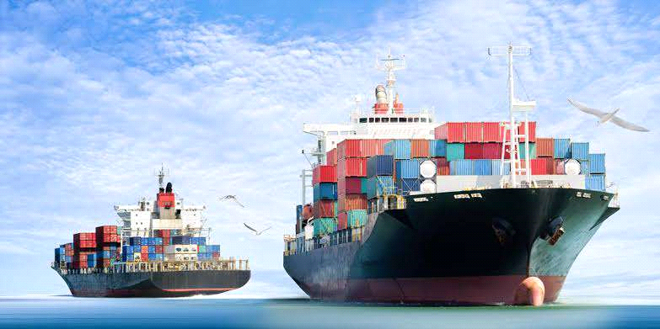

**Deforestation**

Deforestation is related with habitat destruction because more & and more forests are being destroyed to meet the demands of all over the world. People have created areas for logging and for different activities like cattle farming and others. Deforestation has many widespread environmental effects like global warming, increased flooding, animal destruction, and also increased land degradation.

**positive effect**

Globalization can be very beneficial to growing businesses around the world. But it can also create a bright future for the global economy. Both have excellent relationships. By entering new markets and expanding a new customer base, globalization can bring billions of people together and meet their demands.

**Access to New Markets**

One of the biggest benefits of globalization is that it gives businesses like yours access to new or different markets. Bilateral and multilateral trade agreements allow companies to operate in multiple jurisdictions. This means you reach more customers, get better and better market understanding, and develop your brand globally.

**Product Development and New Revenue Streams**

As you enter new markets, you will inevitably develop your products and services in new ways. This is one of the biggest benefits of globalization. As companies expand into different markets, they often have to adapt their offerings to local demand. Although this may seem like more work, it is a great opportunity for innovation. Factor: with successful products and services and building a solid customer base, you can grow your income across country or state lines.

**Sharing Knowledge, Technology, and Culture**

Another major effect of globalization is that sharing has become the norm. Knowledge, information, technology, and cultural practices and values ​​are shared around the world. This also includes business practices. Although we are still far from the multicultural utopia of global companies, sharing and building global partnerships has never been easier.

**Developing Universal Standards**

Although this may seem like whitewashing a complex issue, globalization has helped establish universal standards. By sharing information, basic industry standards have been established, and international bodies are trying to establish standards for labor and employment legislation and tax regulation. For example, the OECD created a model tax treaty in 2017 to help authorities and companies understand when companies have corporate tax and how they can prepare for internationalization.

**Access to a Diverse Talent Pool**

Selecting job candidates from an incredibly diverse pool of talent is an advantage of globalization and immediate rewards. When your company recruits remotely, you can choose based on skills and developed behaviors such as adaptability, regardless of background or location. Companies looking to hire for their offices or foreign subsidiaries can also find great talent to help them develop, transform, and grow as a company. Each new versatile employee brings many new perspectives and opportunities to the company.

**A Diversified Workforce and Workplace Culture**

A diverse pool of experts also leads to a diverse workforce. The positive impact of globalization on work culture can be enormous. Some employers fear cultural differences that affect productivity internal communication and collaboration, but a solid recruiting strategy and inclusive company culture can help. Find the right candidates by focusing on the right skills and behaviors needed to succeed in your business and industry. Then build an open company culture where different types of communication and collaboration are protected and inclusive behavior is rewarded.

**Impact of Global Business in our Economy**

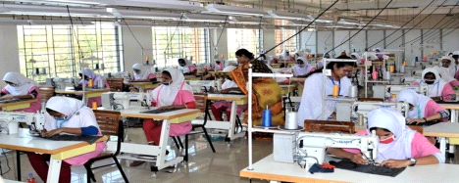

Bangladesh's export sector has played a key role in the country's economic development over the past three decades and continues to play an important role in the economy in terms of

(i) Employment, employment and social change

(ii) Investment

(iii) Foreign exchange earnings

(iv) Multiplier impacts.

**Result Discussion:**

The liberalization of trade and investment flows, born in the 80s of the last centuries and inevitably progressing, is the driving force of the globalization of businesses. The factors of globalization are the liberalization of trade, global consumption habits, the growth of development costs and the need for economies of scale, the pressure of foreign competitors on the domestic market and the development of information and communication technology.

Because it is necessary to introduce new products and invest in research, development, and innovation, to achieve economies of scale, reduce costs and obtain cheaper raw materials; companies must plan their activities considering the world market. Economies of scale and cost reduction are the main objectives of management. Therefore, companies decide to locate production in countries where development and production costs are lower.

However, according to my research, I have come to know that about 89% have an idea about globalization, and most of them agree that access to new markets, lower cost of products, and the spread of new technology all are positive impacts of globalization on business. On the other hand, increasing corruption, and reducing cultural differences are some common negative effects of globalization of business according to survey.

**What I have learned overall about the topic:**

We learned that economic globalization involves the trade of goods and services, capital flows and trade in assets (such as currency, and shares), the transfer of technology and ideas, and international labor or migration flows.

Today, the word international business is a fairly common phenomenon that reflects the real transactions and breadth of people of different cultures and approaches. In a complex network of relationships, they are united by the need for development, rapid exchange of resources and resources, and integrated cooperation, which should contribute to ensuring cooperation and capital transfer. It can be concluded that today's decisions about crossing national borders and internationalizing business activities are prerequisites for the serious growth and development of the company. As such, he is constantly looking for and analyzing potential areas where a small or medium-sized business entity could become an entrepreneurial organization that is constantly striving to expand and grow its portfolio. Making an investment decision outside our borders is a complex and extensive process. This process is achieved through several steps and approaches that include a long-term holistic analysis and scanning of new investment opportunities.

**References:**

[1] Uriel Eldan, “What Are the Benefits and Challenges of Globalization”, <https://www.omnipresent.com/articles/benefits-and-challenges-of-globalization>, October 21, 2021

[2] Tim Stobierski, “6 Pros and Cons of Globalization in Business to Consider”, <https://online.hbs.edu/blog/post/pros-and-cons-of-globalization>, 01 Apr 2021 [3] RAHMAN MD FAIZUR, “GLOBALIZATION AND ITS IMPACT ON BANGLADESH ECONOMY”, <https://apps.dtic.mil/sti/tr/pdf/ADA439177.pdf>, 17 June 2005 [4] Dr. Olubukola S. Adesina, “The Negative Impact of Globalization on Nigeria”, International Journal of Humanities and Social Science, 15 August 2012 [5] Glass, Richard, “The Age of Globalization: Impact of Information Technology on Global Business Strategies”, Bryant University, 04 October 2007

[6] Dickson Mwika, “The impact of globalization on SMEs in Emerging Economies”, International Journal of Business and Social Science. 3 March 2018 [7] Katerina Ristovska, “The Impact of Globalization on the Business”, <https://www.library.ien.bg.ac.rs/index.php/ea/article/view/300>, 3 October 2017 [8] AIContentfy team, “The impact of globalization on entrepreneurship”, <https://aicontentfy.com/en/blog/impact-of-globalization-on-entrepreneurship>, 06 November 2023

[9] Dr. Fred, “The Impact of Globalization on International Business Management Practices”,

<https://zoetalentsolutions.com/impact-of-globalization-on-international-business-manage> ment-practices/, 12 July 2023

[10] Ristovska Katerina1, Ristovska Aneta, “The Impact of Globalization on the Business”, <https://core.ac.uk/download/pdf/33812244.pdf>, 16 August 2014