**Big Red Inc – Housing Solutions for Martians**

Anthony DiBenedetto

<https://github.com/adibenedetto117/DatabaseSystems-CPSC50900>

XAMPP using HeidiSQL

Part 1

Big Red Inc. is a Martian housing solution dedicated to providing housing to the needs of Martians. Our team has a dedicated crew of 150 earth engineers and Martian consultants with the goal to make every Martian feel at home on their own planet. We would like to make Mars feel like home for many of species who arrive here, far from home.

1. The 3 raw materials we will use are regolith/adobe bricks, aerogel insulation, and aluminum windows.
2. Regolith bricks would be harvested from our own compactor on Mars. This compactor would turn the Martian soil into bricks used for construction. Also, monthly shipments from a partner company would provide adobe bricks from earth to the red planet. Aerogel insulation and aluminum windows would be manufactured and imported from earth. We also have a have these materials being importuned from AeroTech Supplies located on Venus.
3. We currently only have 2 offices. Our primary company office is located at the center of the earth, to give the earth engineers an environment like the gravitation force available on mars. Our second office is located at the capital of Mars “Molympus”.

Part 2

* Material_Suppliers – Companies that supply the construction materials needed for the housing projects.

|  |  |
| --- | --- |
| **Material_Suppliers** |  |
| Supplier_Name | char |
| Material_Type | char |
| Origin_Planet | char |

* Construction_Materials – Different materials used in the construction process of houses.

|  |  |
| --- | --- |
| **Construction_Materials** |  |
| Material_Name | char |
| Quantity_Available | Integer |
| Cost_per_unit | Float |

* Offices – Locations where Big Red Inc. operates throughout the soalar system.

|  |  |
| --- | --- |
| **Offices** |  |
| Office_Location | char |
| Number_of_Employees | integer |
| Office_Type | char |

* Employees – Information related to the companies’ workers.

|  |  |
| --- | --- |
| **Employees** |  |
| Employee_ID | Integer |
| Employee_Name | Char |
| Role | Char |

* Housing_Projects – The different housing projects taken by the company.

|  |  |
| --- | --- |
| **Housing_Projects** |  |
| Project_Name | char |
| Location | Char |
| Project_Status | char |

Part 3

ERD UML PHYSICAL MODEL

1. Material_Suppliers to Supply: Each Supply entry depends on 1 and only 1 Material_Suppliers entity, meaning a supplier can supply many different construction materials, but each individual supply entry is linked to a single supplier.
2. Construction_Materials to Supply: Each Supply entry depends on 1 and only 1 Construction_Materials entity, indicating that a particular construction material can come from many different suppliers, but each supply entry references only one material.
3. Employees to Offices: Each Employee is associated with 1 and only 1 Offices entity, and an Offices entity can have 1 or more Employees.
4. Housing Projects to Offices: Each Housing Project is managed by 1 and only 1 Offices entity, and an Offices entity can have 0 or more Housing Projects.

ERD CROW’S FOOR LOGICAL MODEL

1. Employees to Offices: Each Employee depends on 1 and only 1 Office entity, indicating that an employee can belong to only one office. Conversely, an Office can have 1 or many Employees.
2. Housing Projects to Offices: Each Housing Project depends on 1 and only 1 Office entity, showing that a housing project is managed by only one office. Conversely, an Office can have 0 or more Housing Projects under its management.
3. Material Suppliers to Supply: Each Supply entry depends on 1 and only 1 Material Supplier entity, indicating that a supply entry is provided by only one supplier. Conversely, a Material Supplier can have 0 or more Supply entries, reflecting the many supplies they can provide.
4. Construction Materials to Supply: Each Supply entry depends on 1 and only 1 Construction Material entity, indicating that a supply entry corresponds to only one type of material. Conversely, a Construction Material can appear in 0 or more Supply entries, reflecting that it can be supplied by multiple suppliers.

Part 4

Below is me showing that each of the tables are empty with no data. The SQL scripts used to create the tables are saved and uploaded to the GitHub.

Here is when I got the data to load command to work properly. The errors I had got was a simple issue where I was using \ instead of / in the path.

Here is each table now filled up with the data.

**Data Manipulation Language Scripts**

**All SQL is on GitHub in the manipulation.sql file**

Here I added a status column to the employee’s table.

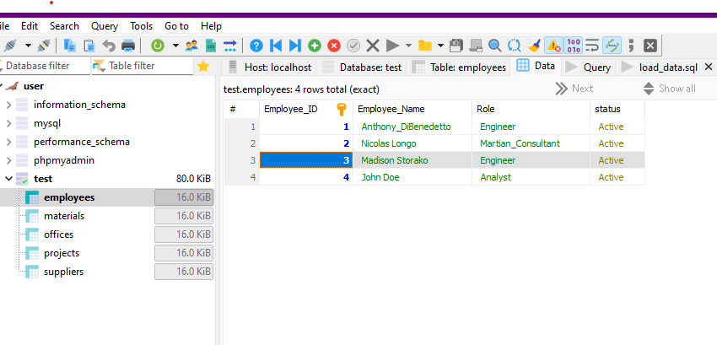 Here I added a new entry into the table.

I changed the status of the new entry to be on leave.

I now deleted the new entry from the table.

I made sure Employee_ID was primary key and used **AUTO_INCREMENT**

Added a new column called department and gave it a default of “General”.

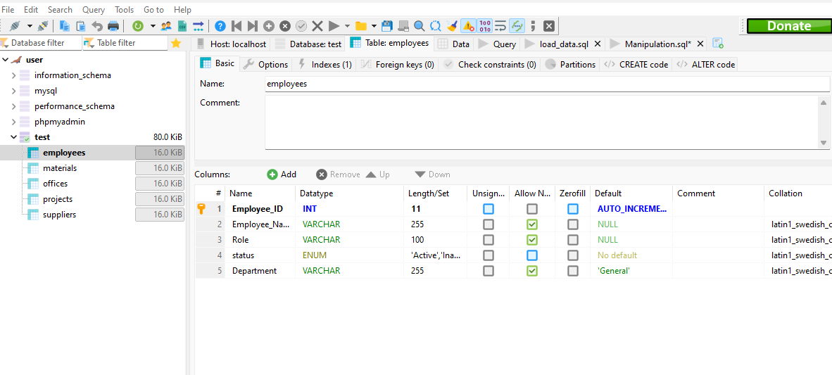 Added a new entry without specifying department and the default showed as general.

