[Business / Technical Brief Title]
  - [This can be up to three lines in length but not more. Lorem ipsum dolor sit amet. Lorem ipsum dolor sit amet lorem.]
March, 2023, Version [1.0]
Copyright © 2023, Oracle and/or its affiliates
SELECT FROM DROPDOWN OPTIONS

PLEASE READ:
  - Please ensure you are selecting an Oracle Confidentiality option on both the title page and in the footer
  - For hardware-related legal disclaimers, please see page 52 of the Oracle Brand Editorial Style Guide (VPN required)
  - Please follow the Oracle Accessibility Guidelines and best practices (VPN required) to ensure your final document is OAG compliant
  - To save as a PDF, please select ‘Save As’ from the File menu when your document is complete and ready to publish
  - If you plan to publish your document on Oracle.com properties, please ensure that you add Document Properties and tag for accessibility before publishing; details are in the PDF Guidelines (VPN required)
  - Please delete this page before saving your final document
  - Please update Table of Contents, List of Figures and List of Tables after removing this page

Word template color theme for reference:
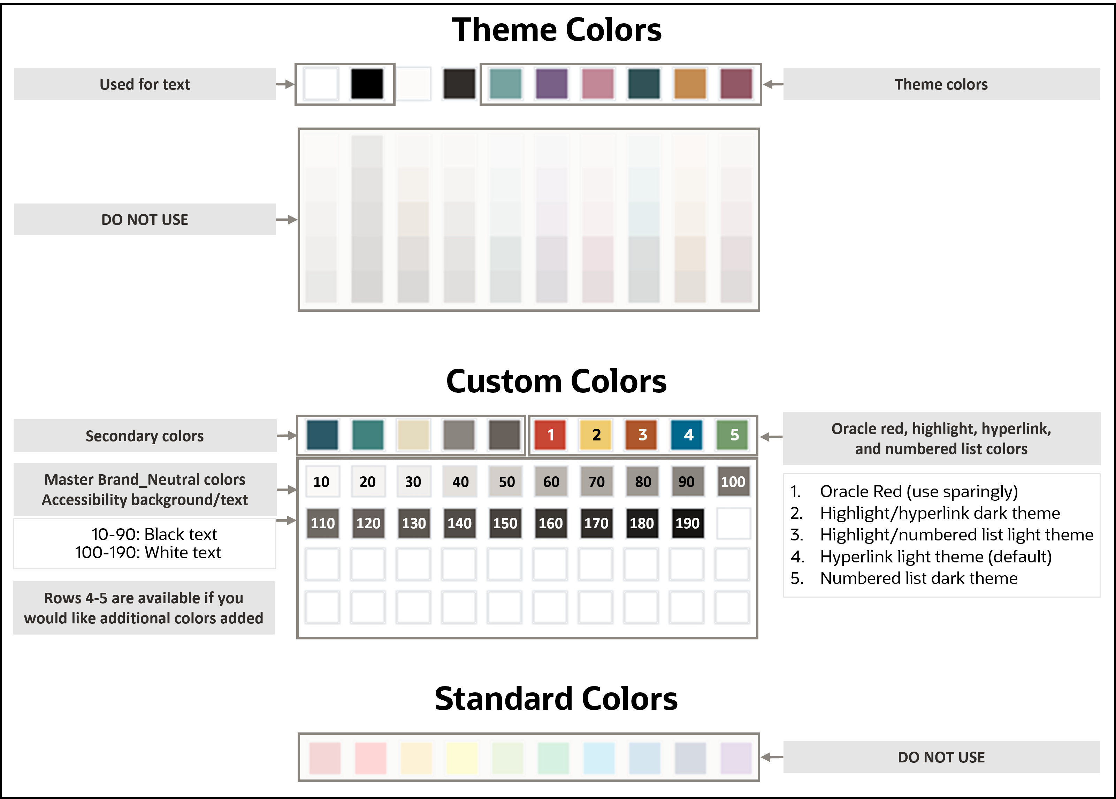
Please delete this page before saving your final document.

Purpose statement
This document provides an overview of features and enhancements included in release <specify release>. It is intended solely to help you assess the business benefits of upgrading to <specify release> and planning for the implementation and upgrade of the product features described.
Disclaimer
This document in any form, software or printed matter, contains proprietary information that is the exclusive property of Oracle. Your access to and use of this confidential material is subject to the terms and conditions of your Oracle software license and service agreement, which has been executed and with which you agree to comply. This document and information contained herein may not be disclosed, copied, reproduced or distributed to anyone outside Oracle without prior written consent of Oracle. This document is not part of your license agreement nor can it be incorporated into any contractual agreement with Oracle or its subsidiaries or affiliates.
This document is for informational purposes only and is intended solely to assist you in planning for the implementation and upgrade of the product features described. It is not a commitment to deliver any material, code, or functionality, and should not be relied upon in making purchasing decisions. The development, release, timing, and pricing of any features or functionality described in this document remains at the sole discretion of Oracle. Due to the nature of the product architecture, it may not be possible to safely include all features described in this document without risking significant destabilization of the code.

Table of contents
Purpose 5
Using and applying styles 5
Heading 1 8
Heading 2 8
Heading 3 8
Small outline 9
Normal outline 9
Small bullets 9
Normal bullet 9
Appendix [X]: [Click or tap here to enter text] 11

List of figures
Figure 1. This is a caption for the photo. It should be less than three sentences. 5

List of tables
Table 1. This is a caption for the table. It should be less than three sentences. 10
Table 2. Sample of data in chart to assist the visually impaired. 11
Table 3. Sample of data in chart to assist the visually impaired. 11

List of figures and tables
Figure 1. This is a caption for the photo. It should be less than three sentences. 5
Table 1. This is a caption for the table. It should be less than three sentences. 10
Table 2. Sample of data in chart to assist the visually impaired. 11
Table 3. Sample of data in chart to assist the visually impaired. 11

Note: A Table of Contents (TOC) is recommended for documents that are more than 10 pages in length. If your statement of direc- tion is shorter, you may remove the TOC page. To remove both the TOC and the page that it appears on, first display hidden characters by clicking on the Paragraph symbol on the Home toolbar. It is a small, square icon that appears to the left of the Quick Style Gallery. Notice the page break displayed as a line at the bottom of this page. Next, highlight all the text on this page and press the Delete key once to remove all the text. Then, highlight the page break and press the Delete key until the page disappears and your cursor is on the first page of body text. The TOC will update semi-automatically with the Heading 1 and Heading 2 styles when you 1) right click on the TOC and then 2) click Update Field in the contextual menu. You may also manually edit the TOC by placing your cursor within the text. Delete this note before publishing.

Figure 1. This is a caption for the photo. It should be less than three sentences.


Purpose
This document provides an overview of features and enhancements included in release <specify release>. It is intended solely to help you assess the business benefits of upgrading to <specify release> and planning for the implementation and upgrade of the product features described.
  - Lorem ipsum secuter locis. Volupta porendu ciatiunt endi rest ommo es dolorest ad molore simaio sum.

Using and applying styles
Styles incorporate information about spacing, tabs, and fonts and are critical to preserving the template’s design. Place cursor to see name of style applied.
The available styles for this template appear in a Styles menu. In Microsoft Word, there is a Quick Style Gallery on the Home tab that displays the most commonly used styles in this template. Clicking the dropdown arrow in the bottom right corner of the Quick Style Gallery shows a listing of all available styles. Another option is to click Control+Shift+S to display the Apply Styles dialog box.

- Checkbox bullets
- Checkbox bullets 130 pillar
- Checkbox bullets black
Checkbox bullets solid
Checkbox bullets solid 130 pillar
- Checkbox bullets solid black

Reference heading
Reference body
- Reference bullet

Reference graphic (6” width)

“Customer quotes are powerful proof points and may be displayed prominently. The most effective quotes include measurable business results. You must get all customer quotes approved by the Oracle Customer Reference Program— for every use.”
Person’s Name
Job Title
Company Name
Customer quotes are powerful proof points and may be displayed prominently. The most effective quotes include measurable business results. You must get all customer quotes approved by the Oracle Customer Reference Program— for every use.”
Person’s Name
Job Title
Company Name
“Customer quotes are powerful proof points and may be displayed prominently. The most effective quotes include measurable business results. You must get all customer quotes approved by the Oracle Customer Reference Program— for every use.”
Person’s Name
Job Title
Company Name
“Customer quotes are powerful proof points and may be displayed prominently. The most effective quotes include measurable business results. You must get all customer quotes approved by the Oracle Customer Reference Program— for every use.”
Person’s Name
Job Title
Company Name
“Customer quotes are powerful proof points and may be displayed prominently. The most effective quotes include measurable business results. You must get all customer quotes approved by the Oracle Customer Reference Program— for every use.”
Person’s Name
Job Title
Company Name
“Customer quotes are powerful proof points and may be displayed prominently. The most effective quotes include measurable business results. You must get all customer quotes approved by the Oracle Customer Reference Program— for every use.”
Person’s Name
Job Title
Company Name

Heading 1
Lorem ipsum dolor sit amet, consectetuer adipiscing elit. Maecenas porttitor malesuada libero, sit amet commodo magna eros quis urna.

Heading 2
Lorem ipsum dolor sit amet, consectetuer adipiscing elit. Maecenas porttitor malesuada libero, sit amet commodo magna eros quis urna.

Heading 3
Lorem ipsum dolor sit amet, consectetuer adipiscing elit. Maecenas porttitor malesuada libero, sit amet commodo magna eros quis urna.

Heading 4
Lorem ipsum dolor sit amet, consectetuer adipiscing elit. Maecenas porttitor.

Heading 5
Lorem ipsum dolor sit amet, consectetuer adipiscing elit. Maecenas porttitor.
Normal (paragraph text)
Small text (7.5pt for tables that do not have table style applied)
Code (for code)
Title heading character (applies bold & color select + spacebar to remove)
Various options for formatting right column named Right column…

Small outline
- Small outline 1 with plenty of text to show how the text flows to the second line of a sentence when there is enough text to do so.
  - Small outline 2 with plenty of text to show how the text flows to the second line of a sentence when there is enough text to do so.
    - Small outline 3 with plenty of text to show how the text flows to the second line of a sentence when there is enough text to do so.
      - Small outline 4 with plenty of text to show how the text flows to the second line.
        - Small outline 5 with plenty of text to show how the text flows to the second line.
          - Small outline 6 with plenty of text to show how the text flows to the second line.

Normal outline
- Normal outline 1 with plenty of text to show how the text flows to the second line of a sentence when there is enough text to do so.
  - Normal outline 2 with plenty of text to show how the text flows to the second line of a sentence when there is enough text to do so.
    - Normal outline 3 with plenty of text to show how the text flows to the second line of a sentence when there is enough text to do so.
      - Normal outline 4 with plenty of text to show how the text flows to the second line.
        - Normal outline 5 with plenty of text to show how the text flows to the second line.
          - Normal outline 6 with plenty of text to show how the text flows to the second line.

Small bullets
- Small bullet with plenty of text to show how the text flows to the second line of a sentence when there is enough text to do so.
  - Small bullet 1 with plenty of text to show how the text flows to the second line.
    - Small bullet 2 with plenty of text to show how the text flows to the second line.
      - Small bullet 3 with plenty of text to show how the text flows to the second line.
        - Small bullet 4 with plenty of text to show how the text flows to the second line.
          - Small bullet 5 with plenty of text to show how the text flows to the second line
            - Small bullet 6 with plenty of text to show how the text flows to the second line

Normal bullet
- Normal bullet with plenty of text to show how the text flows to the second line of a sentence when there is enough text to do so.
  - Normal bullet 1 with plenty of text to show how the text flows to the second line of a sentence when there is enough text to do so.
    - Normal bullet 2 with plenty of text to show how the text flows to the second line of a sentence when there is enough text to do so.
      - Normal bullet 3 with plenty of text to show how the text flows to the second line.
        - Normal bullet 4 with plenty of text to show how the text flows to the second line.
          - Normal bullet 5 with plenty of text to show how the text flows to the second line
            - Normal bullet 6 with plenty of text to show how the text flows to the second line

[Table title]
Table 1. This is a caption for the table. It should be less than three sentences.
COLUMN HEADING | Column Heading | Column heading
Heading if needed  Table row body copy Lorem ipsum dolor sit amet, consectetuer adipiscing elit. Maecenas porttitor congue massa. | Heading if needed  - Paragraph in a table that is lengthy and long and goes on for multiple lines.  Heading if needed  Additional table body text followed by a numbered list:  - Numbered list that is longer than usual multiple lines.  - Numbered list | Table Body followed by a bulleted list:  - Body bullet that is longer than usual and is going on multiple lines.  - Body bullet that is longer than usual and is going on multiple lines.  Table Body followed by a bulleted list:  - Body bullet that is longer than usual and is going on multiple lines.
Table Row Title | Table Body | Table Body
Total Row | Total Row Text | Total Row Text

Appendix [X]: [Click or tap here to enter text]
Table 2. Sample of data in chart to assist the visually impaired.
 | Sales
Decorative texture | 70%
Bark | 30%
Table 3. Sample of data in chart to assist the visually impaired.
 | Sales
Accent 1 | 13.33
Accent 2 | 13.33
Accent 3 | 13.33
Accent 4 | 13.33
Accent 5 | 13.33
Accent 6 | 13.33

Connect with us
Call +1.800.ORACLE1 or visit oracle.com. Outside North America, find your local office at: oracle.com/contact.
blogs.oracle.com facebook.com/oracle twitter.com/oracle
Copyright © 2023, Oracle and/or its affiliates. This document is provided for information purposes only, and the contents hereof are subject to change without notice. This document is not warranted to be error-free, nor subject to any other warranties or conditions, whether expressed orally or implied in law, including implied warranties and conditions of merchantability or fitness for a particular purpose. We specifically disclaim any liability with respect to this document, and no contractual obligations are formed either directly or indirectly by this document. This document may not be reproduced or transmitted in any form or by any means, electronic or mechanical, for any purpose, without our prior written permission.
Oracle, Java, MySQL, and NetSuite are registered trademarks of Oracle and/or its affiliates. Other names may be trademarks of their respective owners.

