

**School of Computing**

**Faculty of Engineering**

**UNIVERSITI TEKNOLOGI MALAYSIA**

**DATA STRUCTURE AND ALGORITHM**

**SCSJ 2013**

**SEMESTER-1 2020/2021**

**Section 07**

**Lecturer:**

**DR RUHAIDAH BINTI SAMSUDDIN**

**Mini Project Documentation**

**EMPLOYEE MANAGEMENT SYSTEM**

**Assigned By**

1. **ADIB NASIR KHAN (A17CS5320)**
2. **Youssef Mohamed Hamed Abdo (A18CS0334)**

**Table of Contents**

1. INTRODUCTION
   1. Project Synopsis
   2. Objective of the Project
2. SYSTEM ANALYSIS AND DESIGN
   1. System Requirements
      1. Use case diagram
      2. Use case description
   2. System Design
3. SYSTEM PROTOTYPE
4. DEVELOPMENT ACTIVITIES
5. **INTRODUCTION**
   1. **Project Synopsis**

This mini project is about “Employee Management System” which will help the admin or owner of a company to manage their employees. In this system, we will implement the concept of Linked List, Stack, Search. Admin will be able to search any worker by name. Admin will be able to sack any of their employees if there occurs any employee overflow or the employee reach retirement age. Basically, the rule is simple, the last person enters the organization will be terminated on that case. Here, we will use Stack to do so. Moreover, the admin will be able to see the supervisor of each worker. He can edit their supervisor and assign any supervisor to them. Admin can approve the work leave applications of the employees. Lastly, the admin will be able to see the reports of the employees. The system is aimed to make the management task of an admin easy, convenient and effective.

* 1. **Objectives of the Project**

This mini project is to help the admin(owner) of a company to keep track of his employees. The objectives of this project are as follows:

* To help the admin to **search** any specific employee record
* To support the admin to **give retirement** to the most senior employee if needed.
* To help the owner of the company to **get performance & experience** of any specific employee
* To help admin to **increase salary** or **give promotion** in a centralized and effective way
* To help admin to **approve leave** by validating employee’s medical record.
* To help the admin to **generate report** about employees.

1. **SYSTEM ANALYSIS AND DESIGN**
   1. **System Requirements** 
      1. **Use Case Diagram**

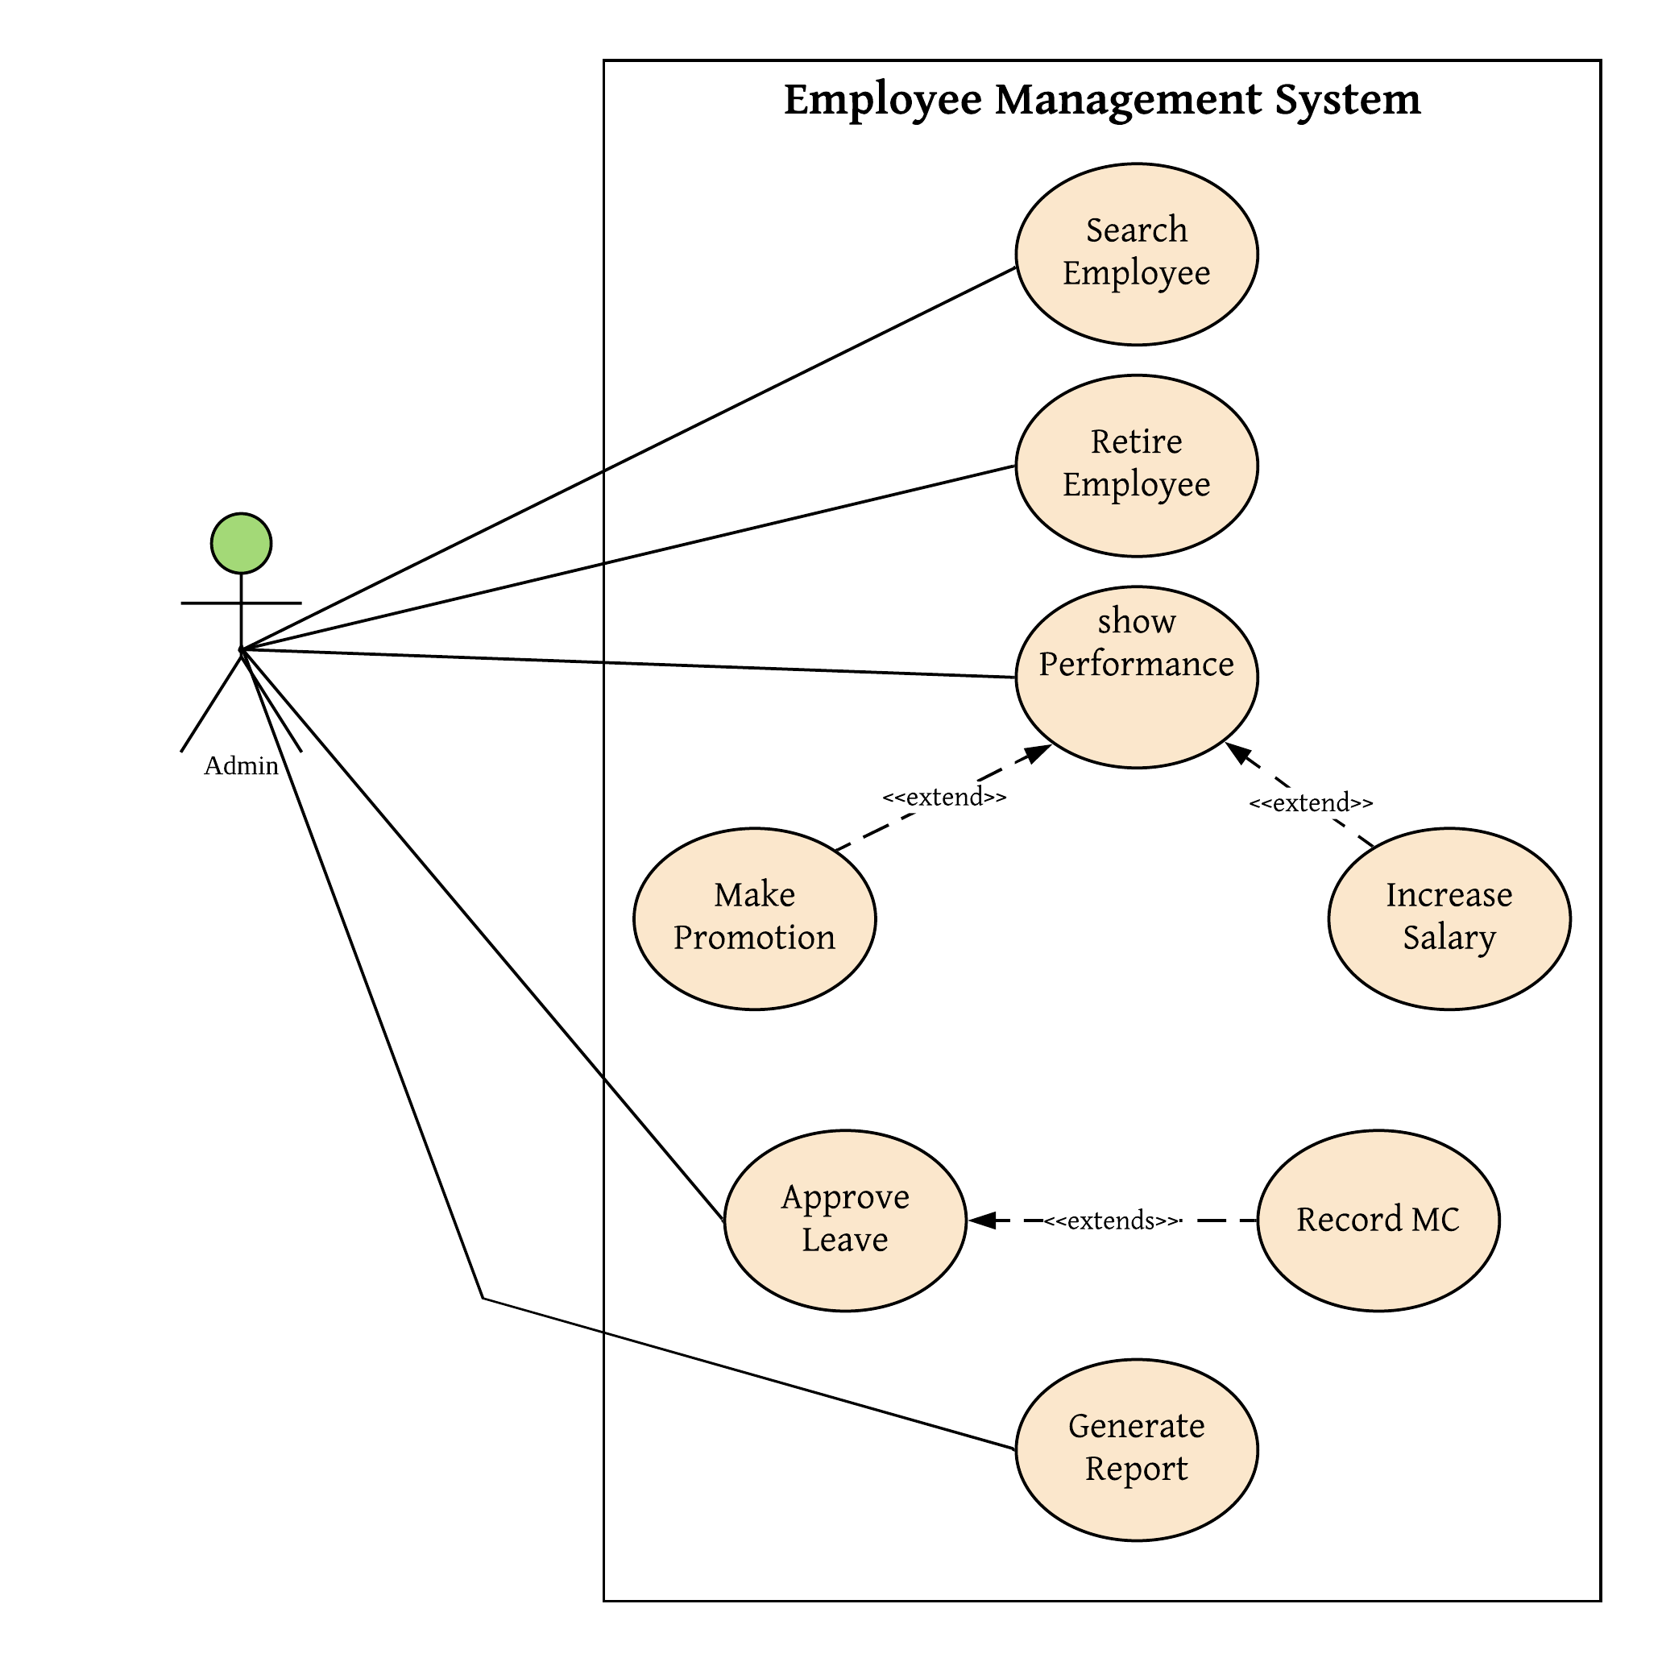

Figure 1: Use Case Diagram for Employee Management System

* + 1. **Use Case Description for Employee Management System**

The system user is the admin (owner) of the company

|  |  |
| --- | --- |
| **Actor** | **Task** |
| Admin | * Can search employee from employee list * Give retirement to the most senior employee * Show experience among the employees * Make promotion * Increase salary according to position * Approve leave if needed * Record MC |

**Detail Description for Each Use Cases**

|  |  |
| --- | --- |
| **Use Case** | **Purpose** |
| Search employee | It allows the admin to search employee by name. |
| Retire employee | This use case helps admin give retirement the most senior employee |
| Show experience | It shows experience of specific employee to the admin |
| Make promotion | It allows admin to give promotion to employees according to performance |
| Increase salary | This one allows the admin to increase the salary of employees according to position |
| Approve leave | It will allow admin to approve leave of employees if needed |
| Record MC | Admin will be able to record MC with this use case |

* 1. **System Design**

***Class diagram***

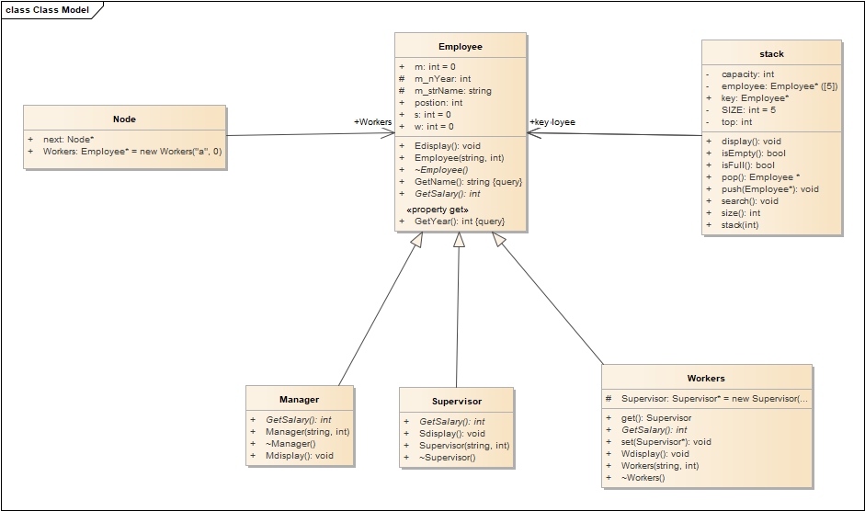

Figure 2: Class Diagram

***Flow Chart (entire system)***

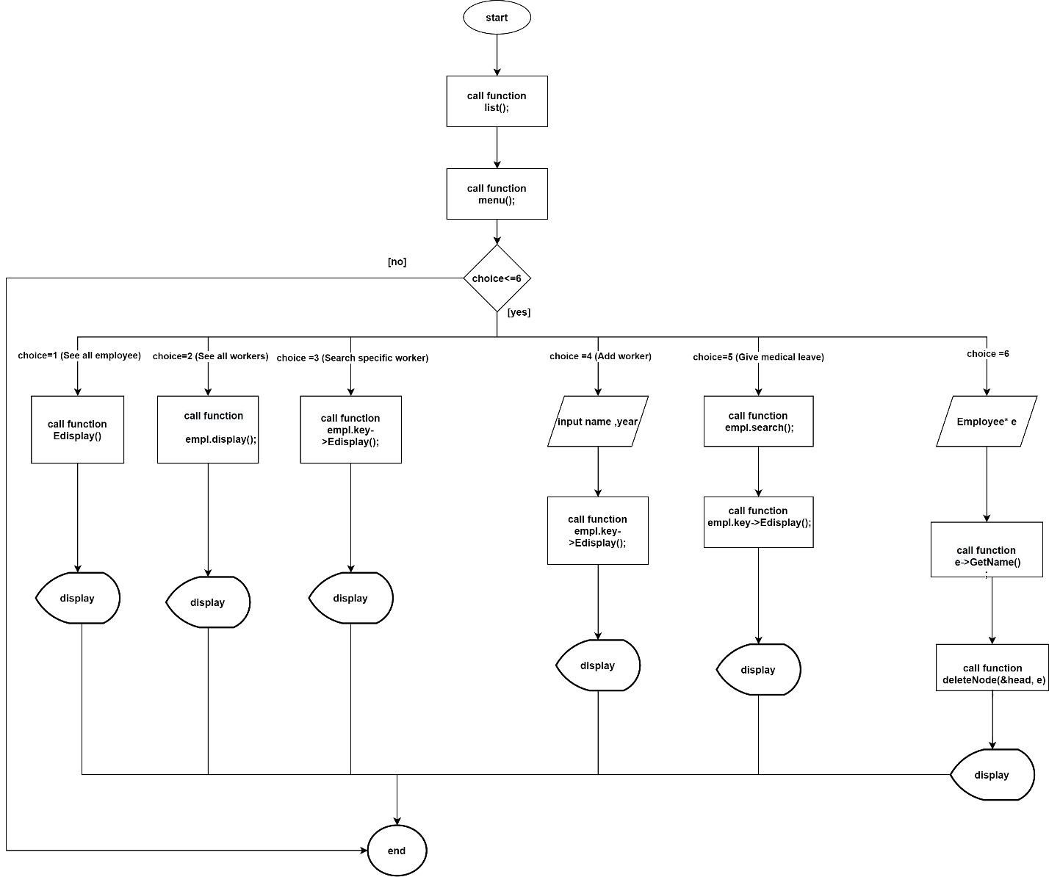

Figure 3: Flow Chart

1. **SYSTEM PROTOTYPE**

Screen 1: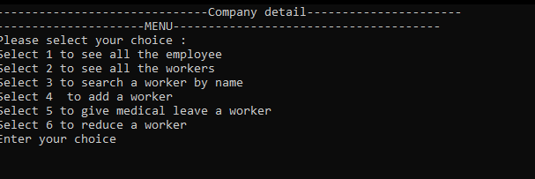

Screen 2: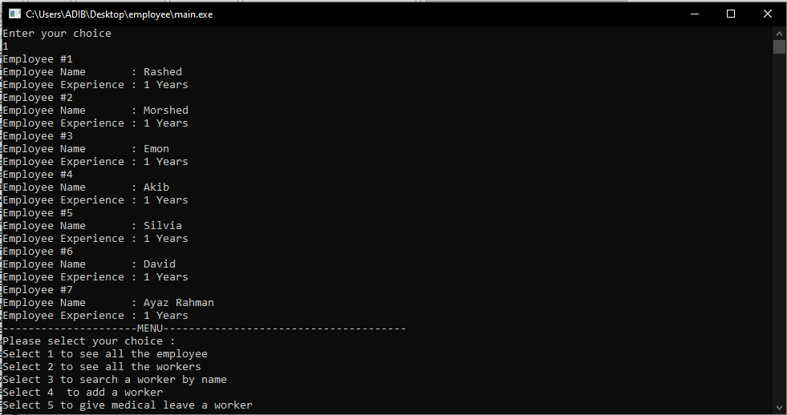

Screen 3: 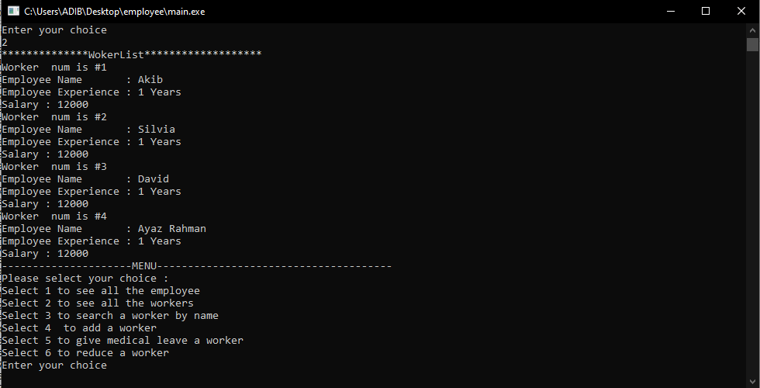

Screen 4: Search employee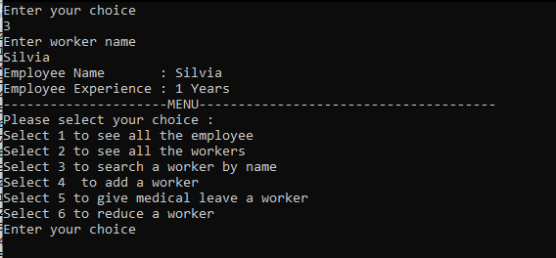

Screen 5: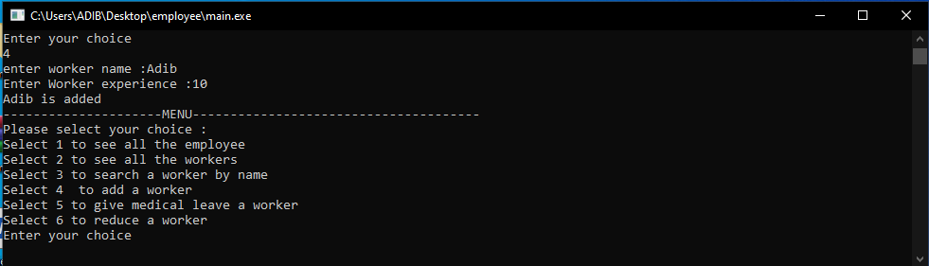

Screen 6: 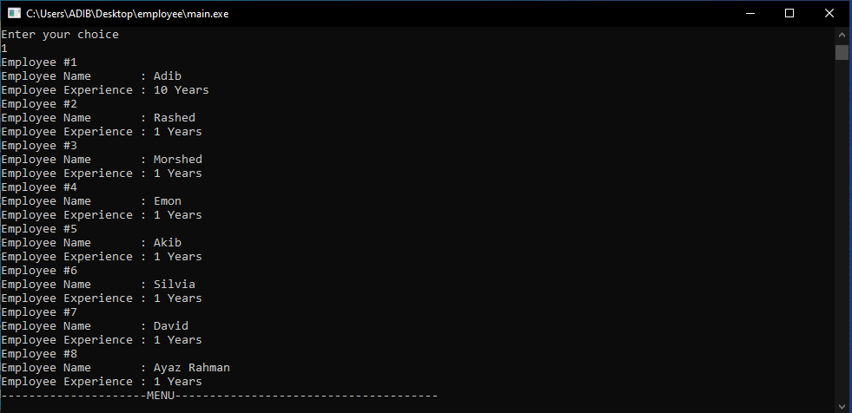

Screen 7: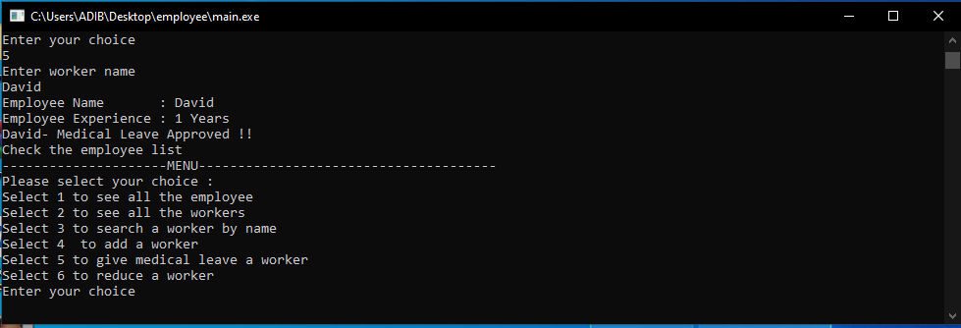

Screen 8:

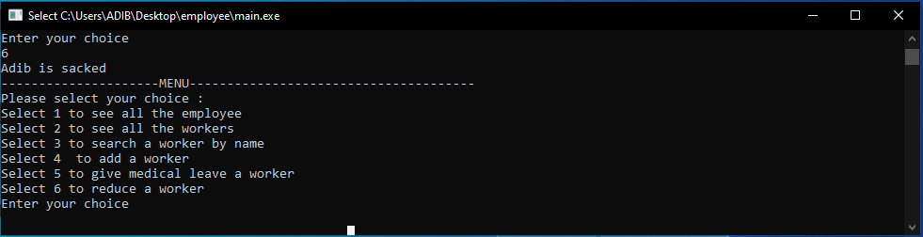

1. **DEVELOPMENT ACTIVITIES**

|  |  |  |
| --- | --- | --- |
| **Meeting Date** | **Members Participate in the meeting** | **Activity** |
| December 10, 2010 | All | Discussion about concept and sharing ideas |
| December 13, 2020 | All | Task distribution among team members |
| January 05, 2021 | All | Prepare presentation |

__________**********__________**********__________

---------End of Document---------

__________**********__________**********__________