END_YEAR_PROJECT

For the project I build an smtp and pop3 server and client.

SMTP protocol

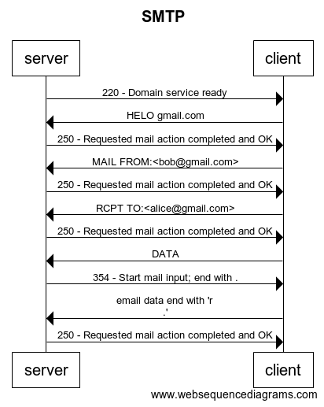

The smtp protocol starts with handshake. The server send 220 and the client response HELO and the email address. The server response 250 and the connection approved.

After that the client send his own email (the email he want to send from) and get approve. After that he send his destinations and get 250 if the address is valid and 515 otherwise.

After that he send DATA ad get 354 code as approval.

He send all the email with the sender, receives, date and subject headers. The email end with "\r\n."

After that the server return 250 after the email was send.

The client send QUIT and after that the server send 212 and disconnect.

Status codes:

* Start code - 220
* Ok, the action is valid/completed - 250
* Start the email send (after DATA request) - 354
* invalid email (at RECPT TO or MAIL FROM) -515
* Bad request(general) - 500
* End communication - 221

Pop3 protocol:

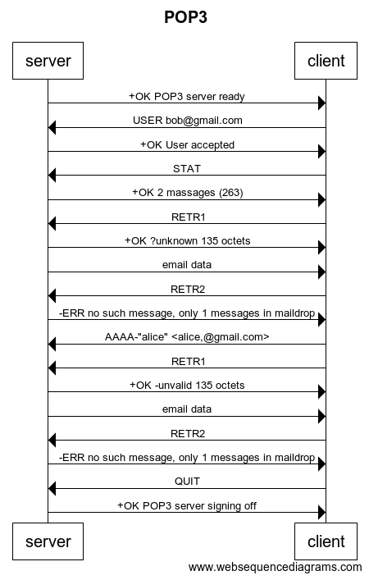

At the start the server send +OK and identify.

After that the client send his email address. The server send +OK if the email is valid and –ERR otherwise. For this demonstration I passed the password validation. After that the client send STAT and the serve send the number of email in the inbox and their total length.

Then the user is logged in.

There is 4 supported command from now:

* LIST: return the number of the massages in the mail box and their total length.
* RETR X: return if the request is valid or not and if the sender name-address is valid, invalid or unknown. If the request is valid it send the email in a separate massage.
* QUIT: return +OK and clo9ze connection
* AAAA: add the email-name combination:

1. AAAA+ : add to valid combinations
2. AAAA- : add to invalid combinations

* the email have to be between <> and the name between “”

The name-email mechanism:

This machine added above the pop3 protocol.

For every email address the server save a dictionary that save witch email are valid for certain user name.

The server add the lines below the code in red.

CLIENT -> SERVER RETR 2

SERVER -> CLIENT +OK ?unknown/+valid/-invalid 200 octets

For every email the server send what is his statues.

The server receives with the AAAA command the changes in the email-name matches.

This mechanize is a basic cod that prevent fishing. The attacker open an email account that similar in his address (for example replace, with .) and the same user name. the receiver doesn’t notice the change and open the fake email.

Statues codes:

* Valid/approval +OK
* Invalid/action failed -ERR
* Unknown email- name combination ?unknown
* Valid email-name combination +valid
* Invalid email-name combination -invalid