Wi-Fi Indoor Positioning System

Based on RSSI Measurements from Wi-Fi Access Points –A Tri-lateration Approach

Onkar Pathak, Pratik Palaskar, Rajesh Palkar, Mayur Tawari

***Abstract***----- Positioning is the most attractive technology today. Various technologies are used now days for positioning purpose. GPS is mainly used for outdoor environment. Non-suitability of GPS in indoor conditions because of its NLOS conditions and signal attenuation has lead to several other techniques of indoor positioning. This paper compares few indoor positioning methods and proposes indoor positioning system using tri-lateration method which uses RSSI data from wi-fi access points to do localization in indoor environment.

**Index terms**: Indoor Positioning, RSSI, Tri-lateration, Access points, signal propagation model.

**1**. **INTRODUCTION**

**P**ositioning finds its applications in locating a person in an area, helping person to navigate or to reach desired location. GPS is the most famous positioning system that we know. To use GPS line of sight must be there between GPS transmitter and receiver. There should not be any shielding effect between transmitter and receiver. However, certain other application demands to locate a person or navigate person in an indoor areas like in shopping malls or college building. GPS fails in such cases because of its inability to work in non-line of sight conditions and signal attenuation due indoor obstacles like walls, roofs, floors etc. Hence, indoor positioning has been challenging task till date.

Various technologies and methodologies has been used in indoor positioning to improve the accuracy. GSM technology is used in indoor positioning. It is based on cellular signals and makes use of existing hardware in mobile phone. GSM fingerprints are used to achieve better accuracy in positioning. In [2], zigbee(IEEE 805.4) is used for indoor localization purpose. Other short range signals like wifi, Bluetooth, Ultra sound are also being used for this purpose. In this paper, indoor positioning system using wifi (WLAN IEEE 802.11n) is explained. In wifi, various methods are used for positioning purpose. In [1] Trilateration method is explained for indoor localization which makes use of the point of intersection of three circles of wifi AP which gives the exact position of user. In trilateration, signal strengths from all the existing wifi AP’s is gathered. Relating the received signal strengths from existing AP’s is converted to distance from respective AP’s using signal propagation models which are described in [8],[9] and [11]. Trilateration algorithm is used afterwards for obtaining the position of user in indoor environment. Trilateration is simple and easy to implement method for indoor localization. Various methods are further used to reduce the errors and to improve the accuracy in trilateration method. Trilateration is also called as dynamic method of positioning. In [4], fingerprinting method is used for indoor positioning. It has got mainly two phases viz. offline training phase and online phase. In *offline training phase*, the database of wifi RSS fingerprints with respective location co-ordinates is prepared. This is the most important phase and accuracy of the system depends on this phase. In online phase, fingerprint database in queried for location of user. Various pattern matching algorithms are used to match the database entries with dynamic RSS. The RSS fingerprint database design is the challenging task in this method. We have explained the indoor positioning system based on wifi technology which uses Trilateration method to estimate user position in indoor environment. The rest of the paper is organized as follows. Section II describes literature survey, III explains the system design, section IV describes indoor signalpropagation model, V explains the trilateration algorithm, finally results are given in VI and future scope in section VII.

**2. LITERATURE SURVEY**

Indoor positioning has always been the topic of interest in wireless technologies. In [1][2], various technologies like wifi, RFID, GSM, ZigBee, Bluetooth which are used in indoor positioning are explained. In [3], authors have presented trilateration method using RSSI measurements from AP’s. Various methods for improving displacement errors in positioning are also suggested. Combination of Trilateration and fingerprints is described in [4] for multi-floor environment. [6] proposes WBI algorithm for indoor positioning using trilateration and RSSI measurements. System also uses Kalmann filter to compensate NLOS propagation effects on positioning errors. Radio wave NLOS indoor propagation model has been explained in [7]. It compares the model with log-distance and free space path loss model. [8] investigate the relationship between RSSI and distance and proposes accurate indoor propagation model for 2.4 GHz. Practical and site specific validation of ITU indoor path loss model is explained in [10]. Path loss models with various factors, indices with their values are calculated by authors. Finally, in [11] authors have compared three strong indoor propagation models and their suitable environments.

**3. SYSTEM DESIGN**

Our Indoor Positioning consists of three parts viz. client device (which can be wifi enabled device like mobile, smartphones, PDA etc), existing network of at least 3 wifi access points (AP’s) and server. The client device is capable of wifi access and receiving wifi signals from all access points in the vicinity. The key purpose of client is to record the wifi signals strength data i.e. RSSI. The network of wifi access points acts as communication channel between client server. All access points used in the system are similar. D-LINK wifi AP’s are used in system. The server is a laptop which runs Windows 7 . The main task of server is of positioning and navigation system. Hence, it is also called as positioning server. The framework for indoor positioning system is depicted in figure 1.

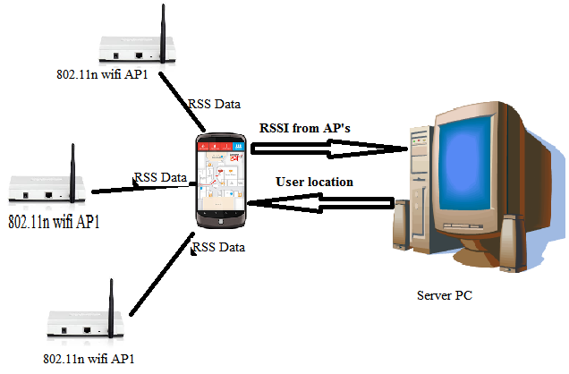

*Figure 1 Framework of indoor positioning system*.

The Android application “WiFiScan” scans the wifi access points in the vicinity of the device. It collects the data like signal strength from the respective access point in dBm, MAC address of AP, channel frequency, SSID etc. This data is the key point in positioning of user in indoor system. Android device then sends this RSS data along with respective MAC address of AP to the positioning server. The server runs the positioning algorithms which calculate the location co-ordinates of the user. Server runs two types of algorithms a) To calculate distance of user from respective AP and b) Tri-lateration algorithm to find exact location of user from distance. Server then sends these location co-ordinates back to the client device. The android device has the front end application showing indoor map of the system. Indoor map in this system is developed using HTML5 Canvas element and invoked in an android application. The location co-ordinates calculated by server are shown in the indoor map as the user position. This is a part of user positioning in indoor environment. As an extension we are also doing the user navigation in indoor environment. Navigation involves the choice of destination in the system. The co-ordinates of destination are known and programmed in indoor map itself. Using the user co-ordinates and destination co-ordinates application helps you to navigate in the system.

**4. INDOOR SIGNAL PROPAGATION MODEL**

RF signal propagation follows the well known laws of physics. An RF wave emitted by an antenna is attenuated due to distance in a direct line of sight (LoS) path. RF signal propagation follows inverse square law with the distance from receiver. Log – Distance path loss model gives the basic relation for signal decay in free space :

$P\left(X\right)=P\left(Xi\right)-10 n log⁡(d)$ (1)

Where,

P(X) = path loss at distance d.

P(Xi) = path loss at known reference point.

n= signal decay exponent.

d= distance between transmitter and receiver.

This model is the basic model for signal decay in free space. In indoor environment, signals are always subjected to reflection, refraction and attenuation. To compensate for power loss due to attenuation, fade margin is added to above basic equation. The signal decay model for indoor system can be given as :

$P\left(X\right)=10 n\log\left(\frac{d}{d0}\right)+20 log⁡(\frac{4πd0}{λ})$ (2)

Where,

P(X) is the path loss at distance d.

n = signal decay exponent.

d= distance between transmitter and receiver.

d0= reference distance (say 1m.)

λ is the wavelength of 2.4GHz signal = 0.125 m.

Xσ is the fade margin.

Fade margin is the system specific and has to calculated empirically for the site. For office buildings generally value of Xσ is 10 dBm.

This empirical model gives you the distance between wifi transmitter and receiver.

**5. TRILATERATION ALGORITHM**

Trilateration algorithm calculates the exact location of user given the exact location of access points and distances from each access points to user. Name of the algorithm suggests that it requires minimum of 3 wifi access points in indoor environment to calculate user location co-ordinates.

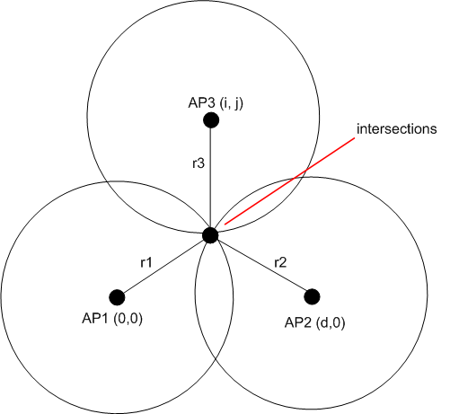

*Figure 2.Trilateration algorithm.*

The three circles are nothing but the three AP’s whose centre co-ordinates are known. The point of intersection of three circles is the position of receiver. Now, knowing d1, d2, d3 i.e. distances from centre of access points and centre co-ordinates(xi,yi,zi) of AP’s the exact location of receiver (x,y,z) can be calculated by solving this set of equations.

(x1-x)2 + (y1-y)2 +(z1-z)2= d12 … (4)

(x2-x)2 + (y2-y)2 + (z2-z)2 = d22 … (5)

(x3-x)2 + (y3-y)2 + (z3-z)2= d32 … (6)

These equations reduce to linear set of simultaneous equations which can be solved easily using matrices. The system gives unique solution (x,y,z) which is the required position of user in indoor environment.

**6. RESULTS AND CONCLUSION**

The test bed in our project is shown as below.

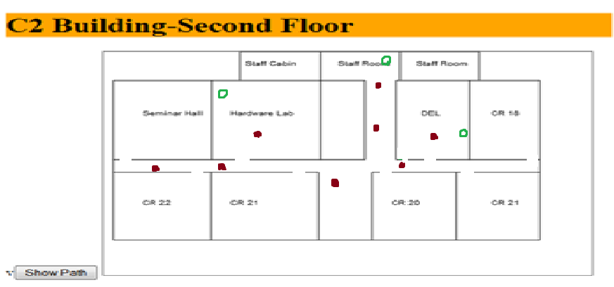

*Figure 3 Test Bed for Indoor Positioning*

The results were taken at C2 Building of Department of Computer Engg., Sinhgad College of Engineering. Indoor map shows various, laboratories, staff cabin and class rooms. The top left corner in the figure is taken as co-ordinates (0,0). The red dot in the figure shows the test locations where results were taken. The green circles indicate the location of wifi access points on the floor. RSS data samples were taken over period of time and used for positioning. Table 1 shows the actual distance, system calculated distance, positions and accuracy. The accuracy in calculating the distance and exact location is as follows.

|  |  |  |  |  |  |
| --- | --- | --- | --- | --- | --- |
| No. | Location | RSS values  (dBm) | Exact Location. (x,y) in meters. | Observed location  (x,y)  In meters. | % Error in positioning.  For x & y resp. |
| 1. | Near HL Lab | -73, -72, -90 | (14, 16) | (15.15, 15.66) | (-8.2, 2.12) |
| 2. | Staff Rooms | -70, -55, -40 | (25, 5.5) | (25.02, 6.72) | (0.8, -22.18) |
| 3. | Corridor 1 | -66, -73, -51 | (24.5, 6,7) | (22.67, 7.14) | (7.46,  -6.56) |
| 4. | Corridor 2 | -52, -78, -92 | (12, 16) | (14.67, 15.66) | (-21.66, 2.26) |
| 5. | DEL | -57, -86, -92 | (27, 12) | (25.84, 11.22) | (4.29,  6.5) |

*Table 1.Results of Indoor Positioning.*

Results show that the positioning accuracy of wifi indoor positioning using tri-lateration method is around 2-2.5 m. The Accuracy of the system can be further improved if more number of similar access points are deployed in the system. Complex nature of indoor environment is the big hurdle for doing positioning in indoor system. Obstacles like walls, glass, metal objects, moving objects need to be handled very carefully while positioning.

**7. FUTURE SCOPE**

Future scope of the system lies there in the efficient indoor navigation system which can be useful in many places. Accuracy in positioning can be improved a lot with the combination various technologies like Bluetooth, GSM and RFID’s. Indoor system for user and device tracking for security reasons can also be the future scope of the system.

**8. REFERENCES**

[1] BCook,GBuckberry, I Scowcroft, J Mitchell, T Allen, “Indoor Location Using Trilateration Characteristics”, University College London, Siemens Communications.

[2] LuisPeneda, AbílioAzenha, AdrianoCarvalho , “Trilateration for Indoors Positioning Within the Framework of Wireless Communications”, IEEE 2009.

[3] Hung-Huan Liu, Yu-Non Yang, “Study on the Use of a Weighted Screening Method for Indoor Positioning Systems”, National Science Counsil, R. O. C.

[4] Hung-Huan Liu , Yu-Non Yang ,“ WiFi-Based Indoor Positioning for Multi-Floor Environment”, IEEE 2011.

[5] FabioBelloni, Ville Ranki, AnttiKainulainen, Andreas Richter, “Angle-based Indoor Positioning System for Open Indoor Environments”, Proceedings of the 6th Workshop on Positioning, Navigation and Communication 2009 (wpnc’09), IEEE 2009.

[6] AhedAboodi, Tat-Chee Wan, “Evaluation of WiFi-based Indoor (WBI) Positioning Algorithm” , 2012 Third FTRA International Conference on Mobile, Ubiquitous, and Intelligent Computing, IEEE.

[7] S. Japertas, E. Orzekauskas , “ Investigation of WI-Fi indoor signals under LOS and NLOS conditions”, International Journal of Digital Information and Wireless Communications.

[8] Atreyi Bose, ChuanHengFoh , “A Practical Path Loss Model For Indoor WiFi Positioning Enhancement”, ICICS 2007, IEEE.

[9] YogitaChapre ,PrasantMohapatra, Sanjay Jha_ and ArunaSeneviratne “Received Signal Strength Indicator and Its Analysis in a Typical WLAN System”, School of Computer Science & Engineering, University of New South Wales, Sydney, Australia.

[10] TheofilosChrysikos, GiannisGeorgopoulos, Stavros Kotsopoulos, ”Site-Specific Validation of ITU Indoor Path Loss Model at 2.4 GHz”, 2009 IEEE.