Security Alert Monitoring & Incident Response Report
Future Interns – Cyber Security Internship (Task 2)
Name of Candidate: Aditya Choudhari
Internship Provider: Future Interns
Domain: Cyber Security (SOC Operations)
Date of Execution: 26 December 2025
Tool Used: Splunk Enterprise
Log Source: SOC_Task2_Sample_Logs.txt
Environment: Windows (Localhost)

1. Introduction
Security Operations Centers (SOC) play a critical role in monitoring, detecting, and responding to cybersecurity threats in real time. SOC analysts continuously analyze logs and alerts generated by systems and networks to identify suspicious activities and prevent potential security incidents.
This task simulates real-world SOC operations by analyzing system and network logs using a SIEM tool. The objective of this task was to monitor security alerts, identify potential threats, classify incidents based on severity, and propose appropriate incident response actions.

2. Objective
The main objectives of this task were:
- To gain hands-on experience with a SIEM tool
- To analyze security logs and identify suspicious activities
- To classify incidents based on severity (High, Medium, Low)
- To document incident response actions and recommendations
- To understand the workflow of a SOC analyst

3. Tool Used
Splunk Enterprise
Splunk Enterprise is a powerful SIEM platform used for collecting, indexing, and analyzing machine-generated data. In this task, Splunk was used to ingest simulated SOC logs and perform keyword-based searches to detect security incidents.

4. Log Source Description
The log file SOC_Task2_Sample_Logs.txt contained simulated security events, including:
- Authentication logs (successful and failed logins)
- Network connection attempts
- File access activities
- Malware detection alerts
The logs were ingested as unstructured text (misc_text), and keyword-based searches were used for incident detection.

5. Incident Detection Methodology
The following approach was used:
- Upload logs into Splunk
- Perform keyword-based searches to identify suspicious activity
- Analyze patterns such as repeated failures, malware alerts, and unusual access
- Classify incidents by severity
- Document impact and response actions
6. Stakeholder Notification Draft
Subject: Security Incident Alert – Malware Detection Identified
Dear Management Team,
During routine security monitoring activities, a security incident related to malware detection was identified through the SIEM monitoring system. The incident has been classified as High Severity due to the presence of malicious indicators such as Trojan and Rootkit signatures within the system logs.
Immediate response actions were initiated, including identification of affected systems, enhanced monitoring, and recommendations for malware removal and system isolation to prevent further impact.
Further analysis is ongoing to ensure that no additional systems are affected and to prevent recurrence of similar incidents. A detailed incident response report has been prepared and is available for review.
Please let us know if any additional actions or clarifications are required.
Regards,
Aditya Choudhari
SOC Analyst Intern
Future Interns

6. Identified Security Incidents
Incident 1: Malware Infection Detected
- Search Query Used:
index=main "malware detected"
- Description:
Multiple malware alerts were detected in the logs, including threats such as Trojan Detected and Rootkit Signature. These alerts indicate that malicious software was present on the system.
- Severity: High
- Impact:
Malware infections can lead to data theft, system compromise, and unauthorized access.
- Recommended Response:
  - Isolate the affected systems
  - Run full antivirus and malware scans
  - Remove infected files
  - Apply security patches and updates
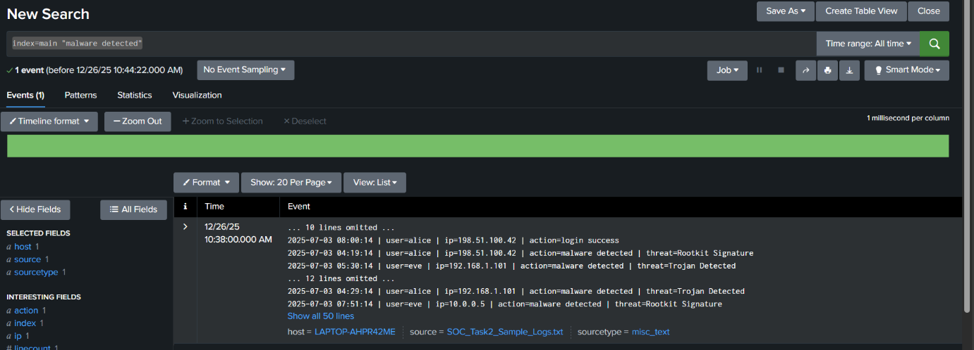

Incident 2: Multiple Failed Login Attempts
- Search Query Used:
index=main "login failed"
- Description:
Failed login attempts were detected, indicating possible brute-force or credential-stuffing attacks.
- Severity: Medium
- Impact:
Repeated failed logins may result in account compromise if successful.
- Recommended Response:
  - Enable account lockout policies
  - Enforce strong password requirements
  - Monitor login attempts and block suspicious Ips
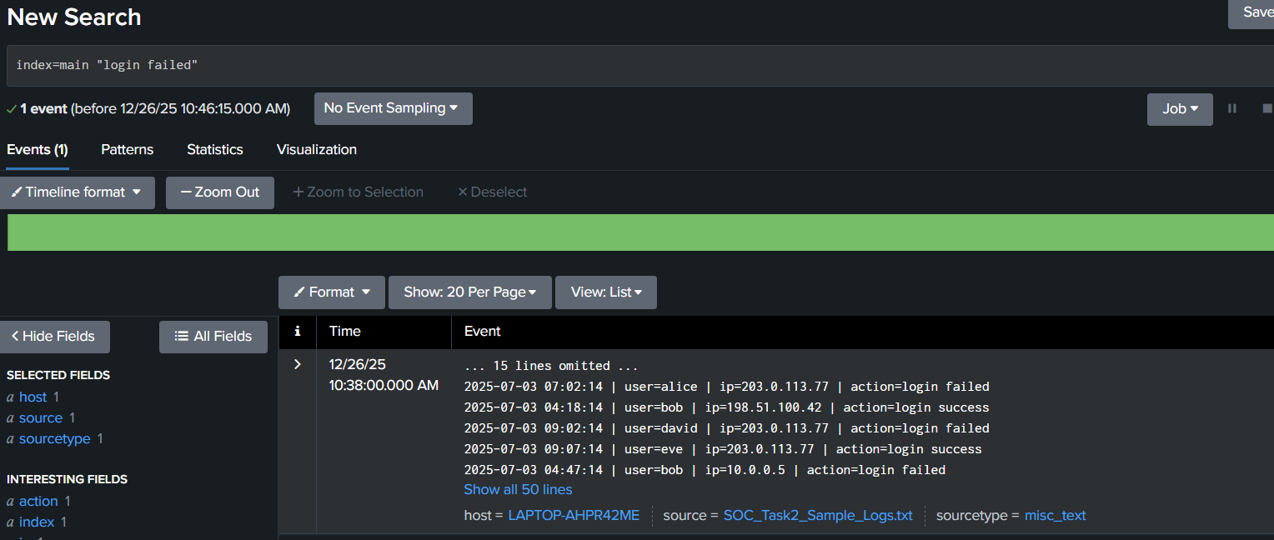

Incident 3: Suspicious IP Address Activity
- Search Query Used:
index=main "203.0.113.77"
- Description:
The same external IP address was involved in multiple activities, including login attempts and access events, indicating suspicious behaviour.
- Severity: Medium
- Impact:
Repeated access attempts from a single IP may indicate reconnaissance or attack preparation.
- Recommended Response:
  - Block or restrict the suspicious IP
  - Monitor network traffic
  - Implement firewall and IDS/IPS rules
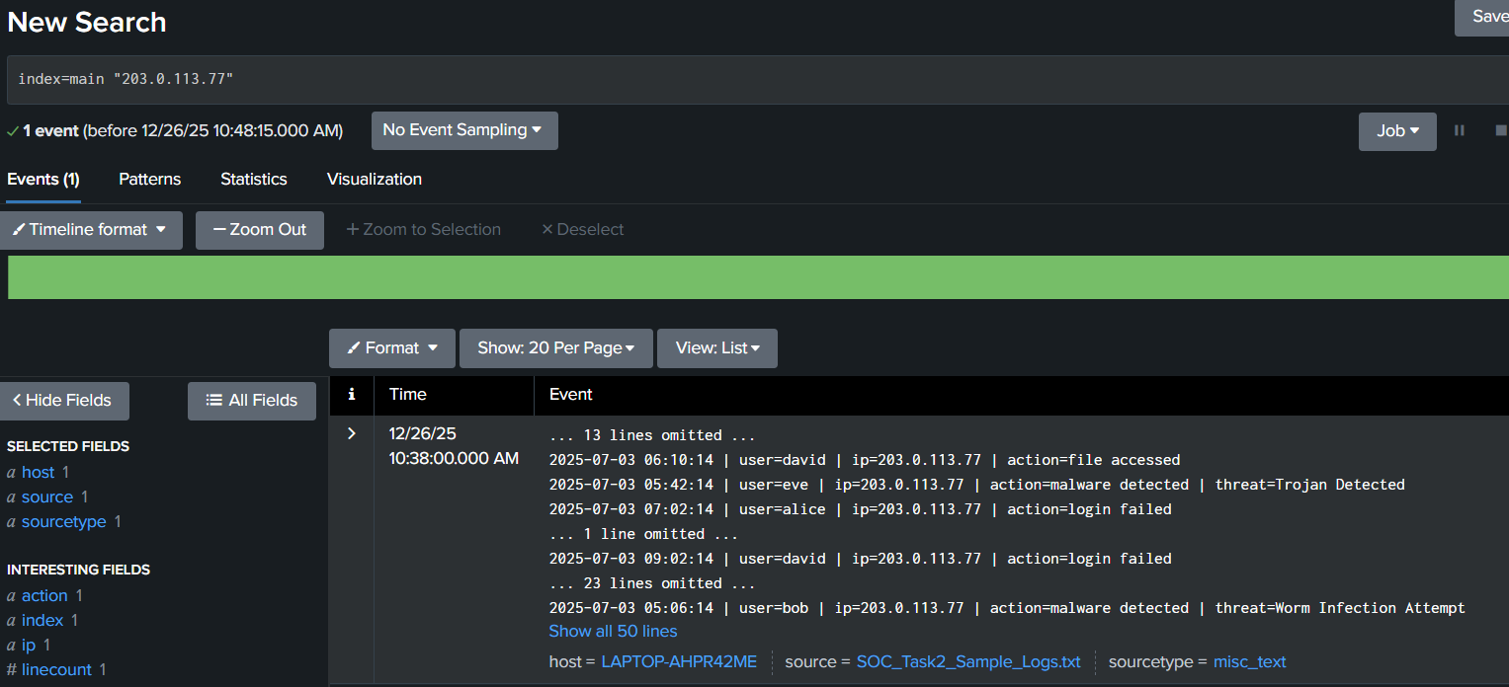

Incident 4: Unusual File Access Activity
- Search Query Used:
index=main "file accessed"
- Description:
File access events were detected that may indicate unauthorized or unusual access to sensitive files.
- Severity: Low
- Impact:
Could lead to data leakage if sensitive files are accessed without authorization.
- Recommended Response:
  - Review user permissions
  - Implement access control policies
  - Enable file activity monitoring
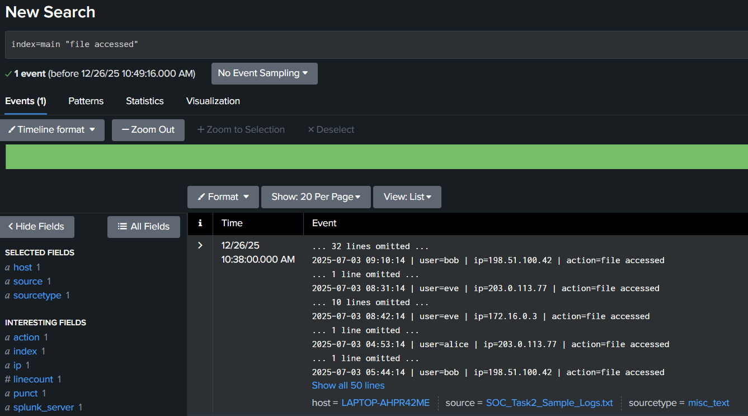

7. Incident Severity Classification Summary
Incident | Description | Severity
Malware Infection | Malware detected in system logs | High
Failed Login Attempts | Possible brute-force attack | Medium
Suspicious IP Activity | Repeated actions from one IP | Medium
Unusual File Access | Possible unauthorized access | Low

8. Challenges Faced
- Understanding SIEM workflows and navigation within Splunk
- Working with unstructured logs and performing keyword-based searches
- Correlating events to accurately identify security incidents
9. Learning Outcomes
Through this task, I learned:
- Basics of SOC operations and alert monitoring
- How to use a SIEM tool for log analysis
- Incident classification and severity assessment
- Importance of timely incident response
- Professional documentation of security incidents

10. Conclusion
This task provided valuable hands-on experience in security alert monitoring and incident response. By analyzing logs using Splunk, multiple security incidents were successfully identified and classified. The exercise highlighted the importance of continuous monitoring, timely detection, and proper response to cybersecurity threats. Implementing the recommended security measures can significantly improve an organization’s security posture.

11. Screenshots & Evidence
Screenshots were captured during the log analysis process using Splunk Enterprise to support and validate the identified security incidents. The evidence includes screenshots of SIEM search queries and corresponding results highlighting suspicious activities such as malware detection, failed login attempts, suspicious IP behaviour, and unusual file access events.
- 
 
 
 
 

