**AZURE DOCUMENT**

1. Why Azure?

This is because Microsoft azure is the fastest growing and the second largest cloud computing platform after AWS (Amazon Web Services).

1. Why Cloud computing?

Take for an example you need to develop and launch an application. For that you will require dedicated networks, servers, developers, storage and application security. There are two disadvantages of it. First it requires very high initial setup capital and secondly there is no guarantee that your application will become successful and will cover your expenses. In case even if it becomes successful then as the no. of users increases you will have to invest more in the new servers to cope up with the increasing demand. This is where cloud computing comes to the rescue.

1. What is Cloud Computing?

Cloud computing is a platform that gives us access to various computing resources like virtual machines, storage, services (ML and data analysis, data storage and backup, media streaming etc) over the internet. It consists of huge datacenters that have massive servers, storage systems and components that are important for an organisation’s working. Users only must pay for the service they wish to use.

1. What is Azure?

Azure is a cloud computing platform and an online portal to access and manage resources and services provided by Microsoft. Given below is the reason why we need azure.

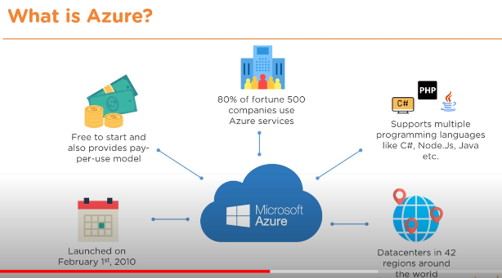

1. AZURE Services

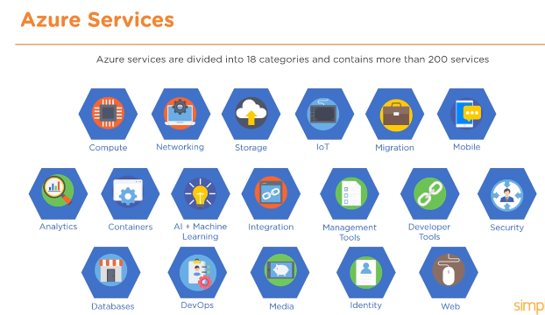

1. Uses of Azure

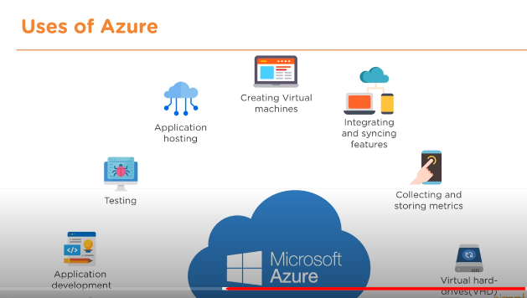

**AWS VS AZURE**

After studying about AWS and AZURE I can say that both are great cloud computing platforms enjoying being in Top 2 and trusted by major industries. I would like to share their recent contribution also.

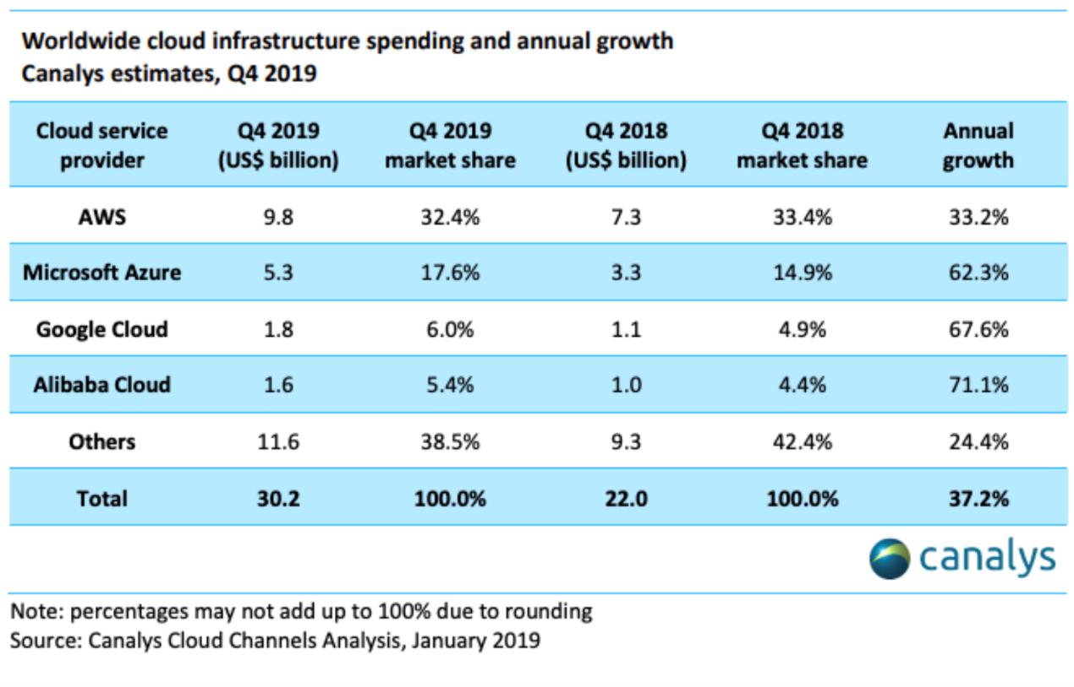

As of February 2020, [Canalys reports](https://www.canalys.com/static/press_release/2020/Canalys---Cloud-market-share-Q4-2019-and-full-year-2019.pdf) AWS with 32.4% of the market, Azure at 17.6%, Google Cloud at 6%, Alibaba Cloud close behind at 5.4%, and other clouds with 38.5%. Now I would compare them based on certain aspects like features, hybrid cloud, developers, pricing.

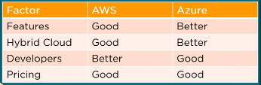

Conclusion is that each cloud computing platform has its own pros and cons and choosing the right one depends entirely on the organisation’s requirement.

**GIT**

1. What is DevOps?

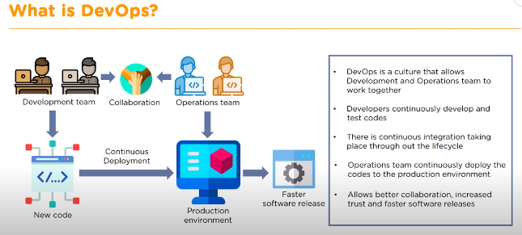

1. Tools in DevOps

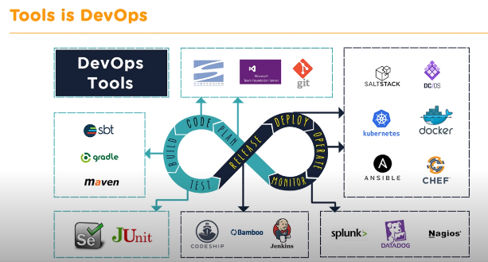

At the Developers side processes of TEST, BUILD, CODE, PLAN takes place, whereas at the Operations side processes like RELEASE, DEPLOY, OPERATE, MONITOR takes place. This tools will interact with each other and the tools are open source or very cost effective.

1. What is GIT?

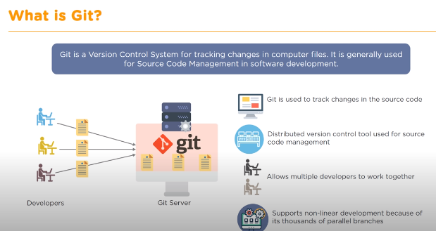

1. Features of GIT

