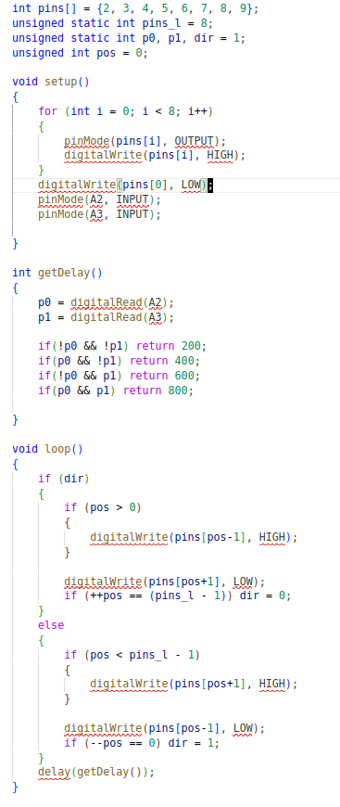Figure 2: had 2 LED
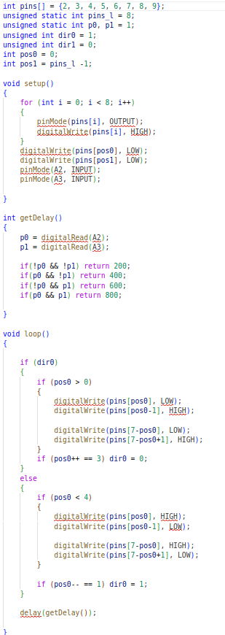Figure 1: LED proti sobe

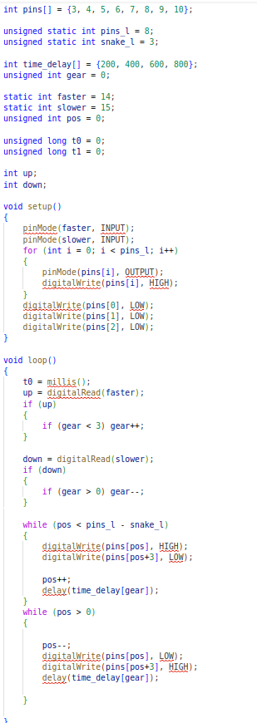Figure 3: Had 3 LED - radsi pouzit kod s 2 LED
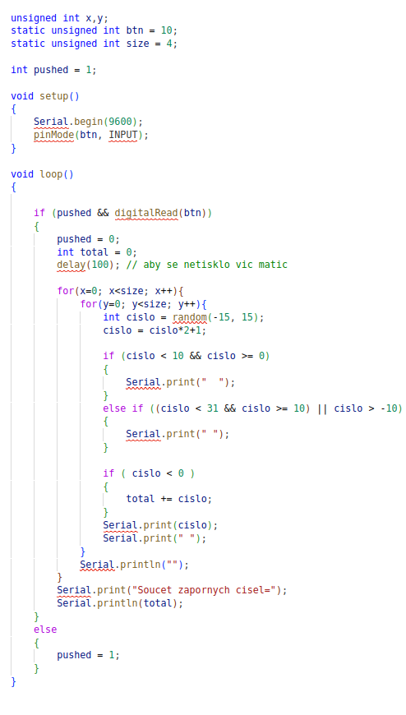Figure 4: Matrix

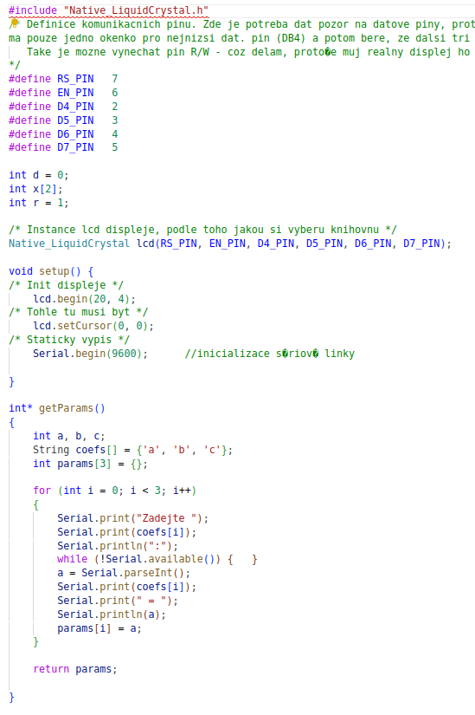Figure 5: Rovnice na LCD 1
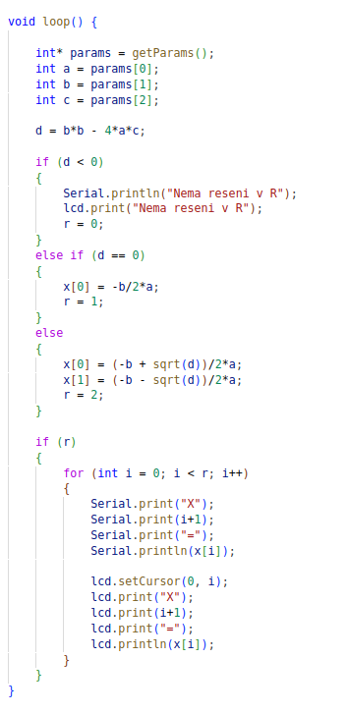Figure 6: Rovnice na LCD 2
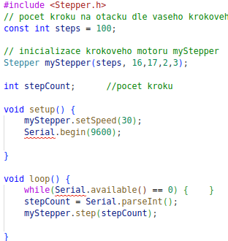Figure 7: Krokovy motor

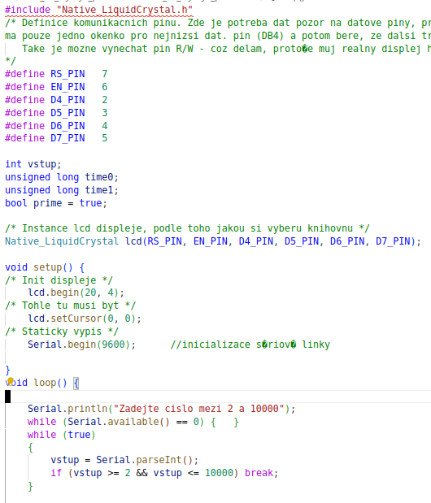Figure 8: Prvocisla 1
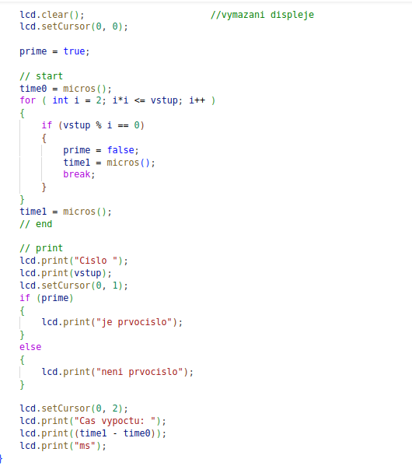Figure 9: Prvocisla 2
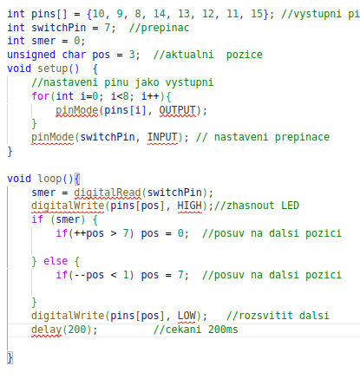Figure 10: Zmena smeru
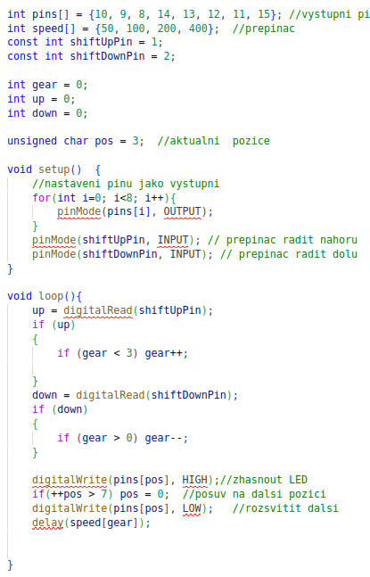Figure 11: Prepinani rychlosti

