Financial Performance Analysis using Python, SQL, Power BI & Statistical Analysis
Name- Aditya Dasarwar
Email- adityadasarwar95@gmail.com
Learner ID- 24CRD03220
Tool- SQL

Project Overview
This project focuses on analyzing financial transaction data to evaluate an organization's overall financial performance. Using Python, SQL, Power BI, and statistical analysis, the project transforms raw financial data into meaningful business insights through data cleaning, analysis, visualization, and hypothesis testing.

Objectives
- Analyze revenue, expenses, and net profit.
- Compare actual performance with budgeted values.
- Evaluate business unit and regional performance.
- Identify top customers and vendors.
- Build an interactive Power BI dashboard.
- Generate actionable business insights for decision-making.

Tools & Technologies
- Python (Pandas, NumPy, SciPy)
- MySQL
- Power BI
- Microsoft Excel

Dataset Summary
- Dataset: Financial Transactions (2022–2023)
- Records: 10,400
- Business Units: Online, Retail, Enterprise
- Regions: East, West, North, South

Total Revenue, Total Expense & Net Profit
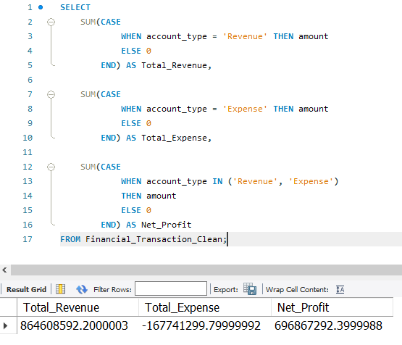

Business Insights
- The query provides an overall financial summary by calculating total revenue, total expenses, and net profit.
- It helps assess the organization's financial performance during the analysis period.
- Comparing revenue and expenses enables management to evaluate profitability and overall business health.

Business Interpretation
- A positive net profit indicates that the company's revenue exceeded its expenses, reflecting healthy financial performance.
- These KPIs serve as the foundation for monitoring business performance and support strategic financial planning.

Revenue & Expense by Category
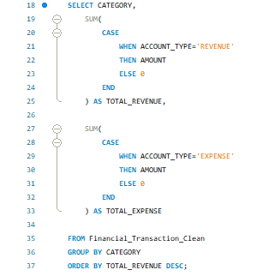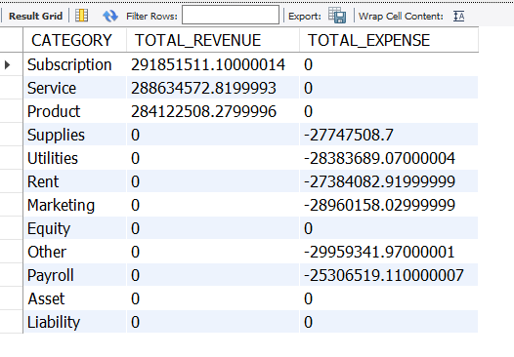
Business Insights
- The query identifies revenue and expense generated by each business category.
- It highlights the highest-performing revenue categories as well as categories with significant operational costs.
- The analysis helps compare category-wise financial contribution.

Business Interpretation
- High-revenue categories should receive continued investment to sustain growth.
- Categories with high expenses should be reviewed regularly to identify opportunities for cost optimization and improved profitability.

Region-wise Financial Performance
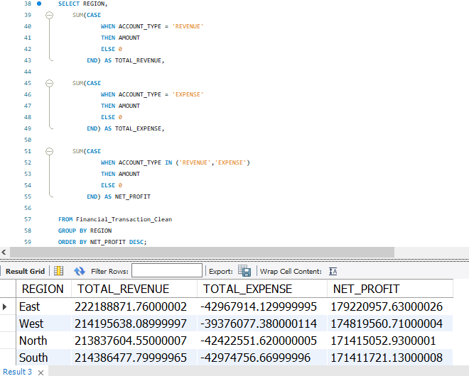

Business Insights
- The query compares revenue, expenses, and net profit across different regions.
- It identifies the best-performing and lowest-performing regions based on profitability.
- Regional comparison helps evaluate overall financial performance and market contribution.

Business Interpretation
- High-performing regions can be used as benchmarks for business growth and expansion.
- Lower-performing regions should be analyzed further to identify operational challenges and improvement opportunities.
Business Unit Performance
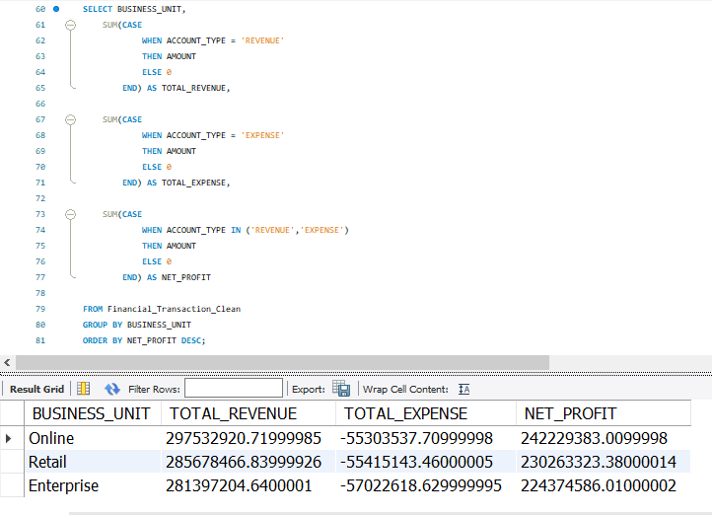

Business Insights
- The query evaluates the financial performance of each business unit.
- It compares total revenue, expenses, and net profit across Online, Retail, and Enterprise units.
- The analysis identifies the business unit contributing the highest profitability.

Business Interpretation
- High-performing business units should continue receiving strategic investment and operational support.
- Underperforming units require further investigation to improve efficiency, increase revenue, and reduce operational costs.

Monthly Revenue & Expense Trend Analysis
Query:
SELECT
YEAR(TRANSACTION_DATE) AS YEAR,
MONTH(TRANSACTION_DATE) AS MONTH,

SUM(CASE
WHEN ACCOUNT_TYPE='REVENUE'
THEN AMOUNT
ELSE 0
END) AS TOTAL_REVENUE,

SUM(CASE
WHEN ACCOUNT_TYPE='EXPENSE'
THEN AMOUNT
ELSE 0
END) AS TOTAL_EXPENSE

FROM Financial_Transaction_Clean

GROUP BY
YEAR(TRANSACTION_DATE),
MONTH(TRANSACTION_DATE)

ORDER BY
YEAR,
MONTH;
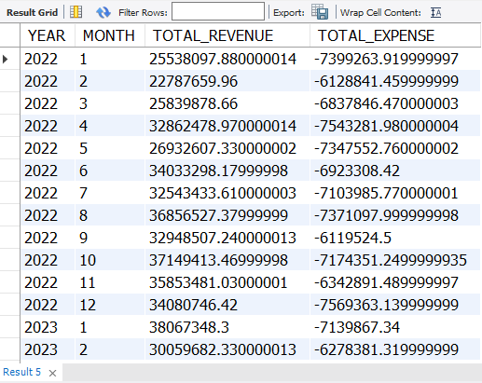

Business Insights
- The query analyzes monthly revenue and expense trends over the two-year period.
- It identifies periods of revenue growth, seasonal fluctuations, and changes in operational expenses.
- Monthly trend analysis helps monitor business performance and detect unusual financial patterns.

Business Interpretation
- Management can use monthly trends for forecasting future revenue and planning operational budgets.
- Months with unusually high expenses or low revenue should be investigated to improve financial planning and resource allocation.

Budget vs Actual Revenue Analysis
Query:
SELECT
YEAR(f.transaction_date) AS Year,
MONTH(f.transaction_date) AS Month,
f.business_unit,

SUM(
CASE
WHEN f.account_type = 'Revenue'
THEN f.amount
ELSE 0
END
) AS Actual_Revenue,

b.budgeted_revenue,

SUM(
CASE
WHEN f.account_type = 'Revenue'
THEN f.amount
ELSE 0
END
) - b.budgeted_revenue AS Revenue_Variance

FROM Financial_Transaction_Clean f

INNER JOIN Budget_Clean b
ON YEAR(f.transaction_date)=b.year
AND MONTH(f.transaction_date)=b.month
AND f.business_unit=b.business_unit

GROUP BY
YEAR(f.transaction_date),
MONTH(f.transaction_date),
f.business_unit,
b.budgeted_revenue

ORDER BY
Year,
Month,
f.business_unit;
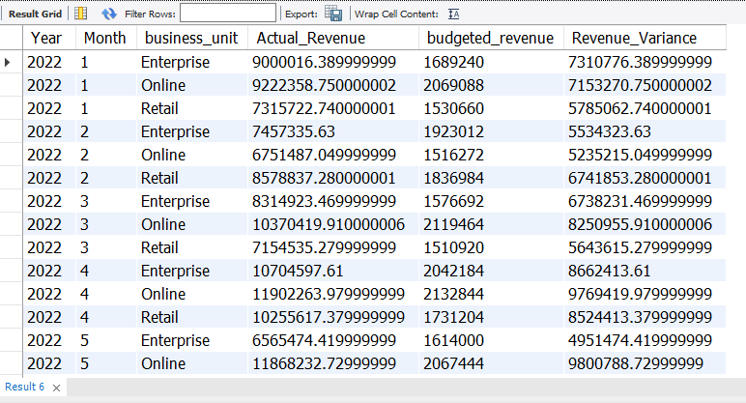

Business Insights
- The query compares actual revenue with budgeted revenue for each month and business unit.
- It calculates revenue variance, helping identify periods where performance exceeded or fell short of expectations.
- Variance analysis supports performance evaluation and financial control.

Business Interpretation
- Positive revenue variance indicates that actual revenue exceeded budget targets, reflecting strong business performance.
- Negative variance highlights areas requiring corrective action, enabling management to improve future budgeting and revenue planning.

Budget vs Actual Expense Analysis
Query:
SELECT
YEAR(f.transaction_date) AS Year,
MONTH(f.transaction_date) AS Month,
f.business_unit,

ROUND(
ABS(
SUM(
CASE
WHEN f.account_type = 'EXPENSE'
THEN f.amount
ELSE 0
END
)
),2
) AS Actual_Expense,

b.budgeted_expense,

ROUND(
ABS(
SUM(
CASE
WHEN f.account_type = 'EXPENSE'
THEN f.amount
ELSE 0
END
)
) - b.budgeted_expense,
2
) AS Expense_Variance,

ROUND(
(
(
ABS(
SUM(
CASE
WHEN f.account_type = 'EXPENSE'
THEN f.amount
ELSE 0
END
)
) - b.budgeted_expense
)
/ b.budgeted_expense
) * 100,
2
) AS Expense_Variance_Percentage

FROM Financial_Transaction_Clean f

INNER JOIN Budget_Clean b
ON YEAR(f.transaction_date) = b.year
AND MONTH(f.transaction_date) = b.month
AND f.business_unit = b.business_unit

GROUP BY
YEAR(f.transaction_date),
MONTH(f.transaction_date),
f.business_unit,
b.budgeted_expense

ORDER BY
Year,
Month,
f.business_unit;
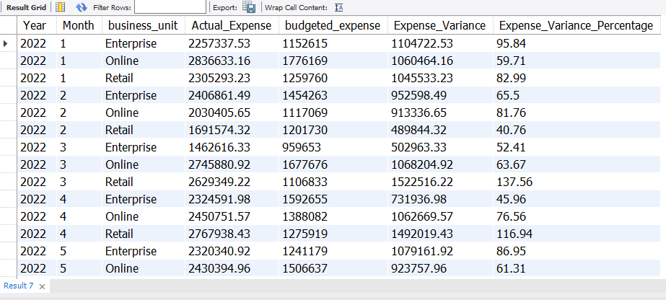
Query 8: Customer Revenue Analysis
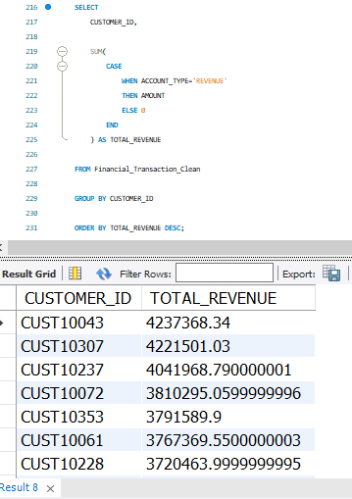

Business Insights
- The query ranks customers based on total revenue generated.
- It identifies high-value customers who contribute the most to overall business revenue.
- The ranking helps understand customer profitability.

Business Interpretation
- High-value customers should be prioritized through loyalty programs and personalized engagement.
- Customer revenue analysis supports strategic sales planning and customer retention initiatives.

Query 9: Customer Contribution Percentage
SELECT
CUSTOMER_ID,

SUM(
CASE
WHEN ACCOUNT_TYPE='REVENUE'
THEN AMOUNT
ELSE 0
END
) AS TOTAL_REVENUE,

ROUND(
(
SUM(
CASE
WHEN ACCOUNT_TYPE='REVENUE'
THEN AMOUNT
ELSE 0
END
) * 100
) /
(
SELECT SUM(AMOUNT)
FROM Financial_Transaction_Clean
WHERE ACCOUNT_TYPE='REVENUE'
),
2
) AS CUSTOMER_CONTRIBUTION_PERCENTAGE

FROM Financial_Transaction_Clean

WHERE CUSTOMER_ID IS NOT NULL

GROUP BY CUSTOMER_ID

ORDER BY TOTAL_REVENUE DESC

LIMIT 10;
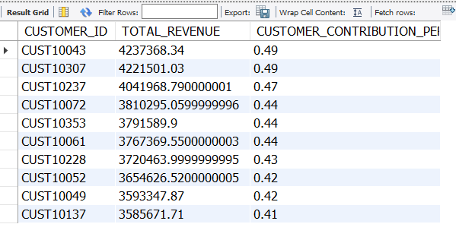

Business Insights
- The query calculates the percentage contribution of the top customers to total revenue.
- It identifies customers with the greatest financial impact on the organization.
- The analysis highlights revenue concentration among key customers.

Business Interpretation
- Businesses should strengthen relationships with top-contributing customers to ensure long-term revenue stability.
- Customer concentration analysis helps reduce dependency risk and supports strategic account management.

Query 10: Top 10 Vendor Payment Analysis
SELECT
VENDOR_ID,

ROUND(
ABS(
SUM(
CASE
WHEN ACCOUNT_TYPE='EXPENSE'
THEN AMOUNT
ELSE 0
END
)
),
2
) AS TOTAL_PAYMENT

FROM Financial_Transaction_Clean

WHERE VENDOR_ID IS NOT NULL

GROUP BY VENDOR_ID

ORDER BY TOTAL_PAYMENT DESC

LIMIT 10;
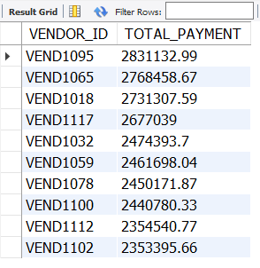

Business Insights
- The query identifies the top 10 vendors based on total payments.
- It highlights vendors responsible for the largest share of organizational expenditure.
- The analysis provides visibility into supplier spending patterns.

Business Interpretation
- High-value vendor contracts should be reviewed periodically to optimize procurement costs.
- Understanding vendor payment concentration supports better supplier management and negotiation strategies.

Query 11: Pareto (80/20) Customer Analysis
WITH CustomerRevenue AS
(
SELECT
customer_id,

SUM(
CASE
WHEN account_type = 'REVENUE'
THEN amount
ELSE 0
END
) AS Customer_Revenue

FROM Financial_Transaction_Clean

WHERE customer_id IS NOT NULL

GROUP BY customer_id
)

SELECT
customer_id,

ROUND(Customer_Revenue,2) AS Customer_Revenue,

ROUND(
SUM(Customer_Revenue)
OVER(ORDER BY Customer_Revenue DESC),
2
) AS Running_Revenue,

ROUND(
(
SUM(Customer_Revenue)
OVER(ORDER BY Customer_Revenue DESC)
/
SUM(Customer_Revenue)
OVER()
) * 100,
2
) AS Cumulative_Percentage

FROM CustomerRevenue

ORDER BY Customer_Revenue DESC;
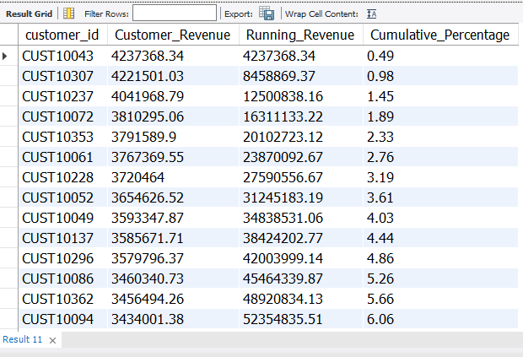

Business Insights
- The query performs a Pareto (80/20) analysis by calculating cumulative customer revenue.
- It identifies the small group of customers contributing the majority of total revenue.
- The cumulative percentage helps classify customers based on their business impact.

Business Interpretation
- The organization should prioritize retaining high-value customers, as they contribute a significant portion of overall revenue.
- Pareto analysis enables management to focus marketing, sales, and customer relationship efforts on the most valuable customer segments.

