WaveRight Solutions Network Design Document

Imran Khan
Study.com
September 23, 2026

WaveRight Solutions Network Design Document
WaveRight Solutions is an IT services company with three departments: Administration, Sales, and Support. The company is moving into a new office sized for about 50 employees. The office needs an IP network that carries internet traffic, file and printer sharing, VoIP calls, and access to central servers. This document sets out the requirements, the physical and logical topology, the IPv4 addressing plan, and a reflection on one design problem.
Network Requirement Analysis
Users and Departments
The design assumes 50 staff at opening: 8 in Administration, 22 in Sales, and 20 in Support. Each department does different work, and that work drives its network needs. Administration handles payroll, contracts, and employee records, so its traffic carries the most sensitive data in the company. Sales staff run a cloud CRM, email, and video meetings with clients, and several of them work from client sites and connect back through a VPN. Support staff spend most of the day on the phone and in remote-desktop sessions to client systems, and they move large files such as log bundles, installers, and disk images.
Devices
Table 1 lists the end devices. Each desk has a PC or docked laptop and an IP desk phone on separate cable drops. Each staff member also carries one wireless device, usually a laptop off its dock or a smartphone on the staff Wi-Fi. The shared equipment sits in the server room: five servers (two domain controllers that also run DNS and DHCP, a file server, an IP-PBX for call control, and a backup appliance), five switches, one firewall, a UPS network card, a console server, and one IT management workstation. Guests and visiting clients get internet-only Wi-Fi with room for about 30 guest devices at once.
Table 1
User and Device Inventory by Department
Department | Staff | Wired PCs | IP phones | Wireless staff devices | Printers | Access points
Administration | 8 | 8 | 9 | 8 | 1 | 2
Sales | 22 | 22 | 23 | 22 | 1 | 2
Support | 20 | 20 | 21 | 20 | 2 | 2
Total | 50 | 50 | 53 | 50 | 4 | 6
Note. Phone counts include one reception phone in Administration and one conference phone each in Sales and Support. Servers, switches, the firewall, and management devices are shared and appear in Table 2.
Applications and Bandwidth
The network must carry six kinds of traffic: voice calls, video meetings, cloud business applications (email, CRM, and ticketing), remote-desktop sessions, file and print sharing, and nightly backups. Voice sets the strictest limits. A G.711 call at 50 packets per second uses 87.2 kb/s on Ethernet in each direction once packet headers are counted (Cisco Systems, 2023). If all 53 phones were on calls at the same time, voice would need about 4.6 Mb/s. The amount is small, but voice breaks up when its packets wait in a queue behind a large download. For that reason the phones mark voice packets, and every switch and the firewall give those packets priority.
For internet sizing, the design allows 2.5 Mb/s per HD video meeting and an average of 1 Mb/s per user for cloud applications and remote-desktop work. A busy hour with 15 video meetings, 50 active users, and 20 outside calls on the SIP trunk comes to about 90 Mb/s. The primary circuit is 500 Mb/s symmetrical business fiber. That leaves room for Support file transfers, offsite backups, and new hires. A 100 Mb/s cable or LTE link takes over if the fiber fails, which keeps calls and the CRM running during an outage.
How the Requirements Shape the Design
Four conclusions come out of this analysis. First, the three departments have different security needs, so each one gets its own VLAN and subnet, and access control lists decide which traffic may pass between them. Administration records stay off the segments that Sales, Support, and guests use. Second, voice needs its own VLAN and QoS priority, and the phones and access points need Power over Ethernet (PoE+). Third, the company cannot serve clients without phones and the CRM, so the failure of one switch, one cable, or one internet circuit should not take a department offline. Fourth, the company is growing. Every subnet and switch has spare capacity, and the address block has room for new segments without renumbering.
Topology Design
Physical Topology
Figure 1 shows the physical layout. The office is on one floor, and every desk is within 90 m of cable run from the server room. That distance lets every device connect back to one main distribution frame (MDF) in an extended star, with no intermediate wiring closets. The MDF rack holds the firewall, two Layer 3 core switches, three 48-port PoE+ access switches, the servers, patch panels, and a UPS.
Each access switch serves one zone of the floor (Administration, Sales, or Support) and has two 10 Gb/s fiber uplinks, one to each core switch. The two core switches connect to each other over a pair of 10 Gb/s links and act as one logical switch through stacking or multi-chassis link aggregation. Each server has one link to each core switch. Desks get two Cat6 drops, one for the PC and one for the phone. Six Wi-Fi 6 access points mount on the ceiling, two per zone, and draw power from the access switches.
The port count confirms the switch sizing. The floor needs 113 copper ports (50 PCs, 53 phones, 4 printers, and 6 access points) out of 144 available, which leaves 31 ports for new desks. The PoE load is about 470 W for 53 phones and six access points, split across three switches.
Figure 1
Physical Topology of the WaveRight Office Network
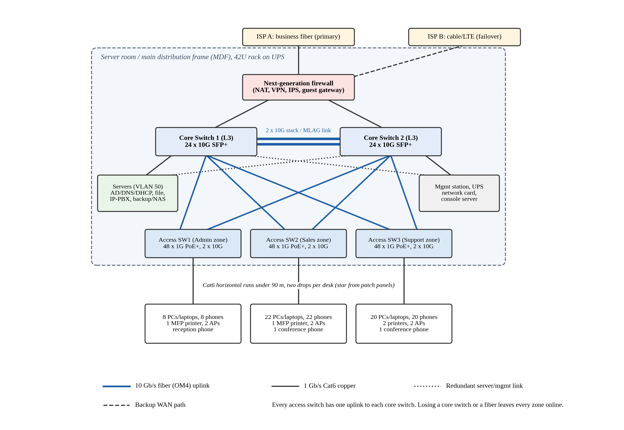
Note. All switching equipment sits in one MDF rack. Blue lines are 10 Gb/s fiber uplinks, and black lines are 1 Gb/s Cat6 copper.
Logical Topology
Figure 2 shows the logical design, a two-tier hierarchy with a collapsed core. The access layer connects end devices and enforces port-level controls: 802.1X authentication, DHCP snooping, port security, and BPDU guard. Each desk port carries the department data VLAN untagged and the voice VLAN tagged, so the phone and the PC land in separate subnets. The core layer routes between VLANs through switched virtual interfaces (SVIs), applies access control lists, and relays DHCP requests to the server VLAN. The two core switches share each gateway address through the Virtual Router Redundancy Protocol (VRRP). If Core 1 fails, Core 2 answers for the same gateway address within a few seconds, and hosts keep their settings.
The firewall sits between the core and the internet. It translates internal addresses to the public address (port address translation), inspects traffic, ends remote-access VPN sessions for Sales staff, and acts as the gateway for the guest VLAN. Guest traffic never enters the core routing table, so a guest device has no route to company systems. Staff Wi-Fi runs WPA3-Enterprise, and the RADIUS server places each user in the VLAN of their department. A Sales laptop gets a Sales address whether it is docked or on Wi-Fi, and the same access rules apply to it in both places.
The traffic policy is short. Administration, Sales, and Support can reach the servers, the printers, and the internet, but no department VLAN can reach another department VLAN. Phones reach only the IP-PBX and the SIP trunk. The management VLAN accepts SSH and HTTPS only from the IT workstation.
Figure 2
Logical Topology With VLANs, Subnets, and Routing Points
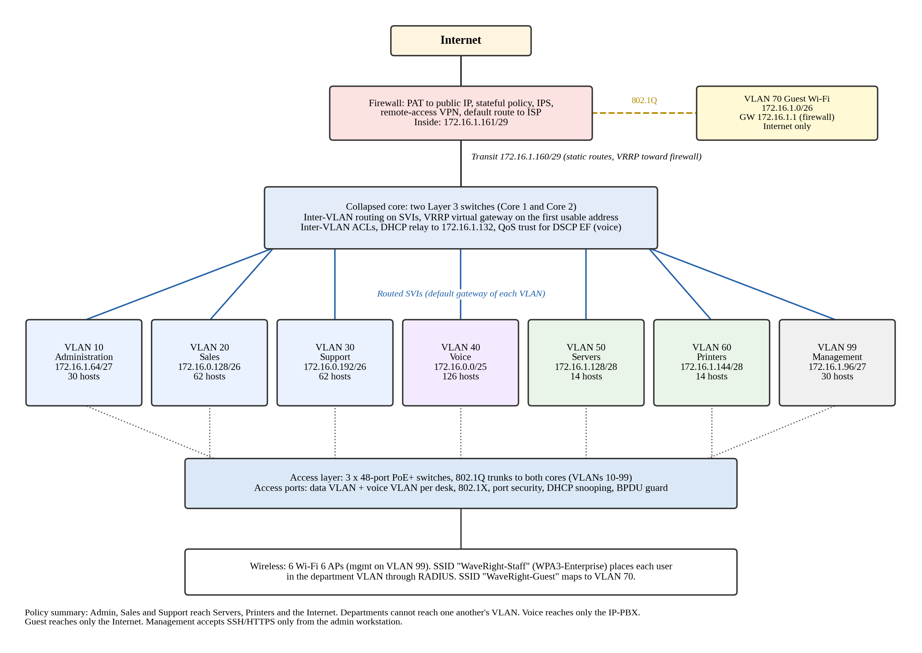
Note. Each VLAN box shows the network address and the number of usable host addresses. Guest Wi-Fi routes through the firewall and bypasses the core.
Design Rationale
I compared three layouts before choosing this one. A flat network with one or two switches is cheap, but it puts about 200 devices in one broadcast domain, gives no separation between Administration data and guest devices, and stops working when its main switch fails. A full three-tier design with separate core and distribution layers suits a campus with several buildings, and on one floor it would add cost and complexity with no gain. The collapsed core sits between the two. It keeps the traffic separation and redundancy of a larger design with only five switches.
The chosen design meets the four requirements as follows. For performance, each desk has a dedicated 1 Gb/s port, each access switch has 20 Gb/s of uplink capacity (an oversubscription ratio of 2.4:1), and voice gets QoS priority from the phone to the firewall. For fault tolerance, dual core switches, dual uplinks, VRRP, two domain controllers, two internet circuits, and a UPS remove the single points of failure in switching, cabling, and internet access. The firewall remains a single device, and a second unit in high-availability mode is the first upgrade when the budget allows. For scalability, a fourth access switch plugs into spare core ports, and a second floor needs only a new wiring closet with fiber back to the core. For departmental structure, the zones and VLANs follow the organization chart, and VLAN membership follows the user, so moving a person to a new desk needs no re-cabling.
IP Addressing and Subnetting Plan
Address Block
The internal network takes 172.16.0.0/22 from the private 172.16.0.0/12 range defined in RFC 1918 (Rekhter et al., 1996). Private addresses are not routed on the internet, so the firewall translates them to the public address assigned by the ISP. A /22 holds 1,024 addresses. A single /24 (256 addresses) was not enough, because the plan needs 424 addresses even after VLSM. I also avoided 192.168.0.0/24 and 192.168.1.0/24 because many home routers ship with them, and a Sales laptop on a home network with the same subnet would have routing conflicts over the VPN.
Subnet Sizing Method
Each subnet was sized in four steps. The first step counts the current devices. The second adds three addresses for router interfaces (the VRRP virtual gateway, Core 1, and Core 2). The third adds room for growth, between 25 and 60 percent depending on the segment. The last step picks the smallest prefix whose usable host count, 2ⁿ − 2, covers the total. The subnets were then allocated from largest to smallest, so each one starts on a boundary that matches its size. This variable-length subnet masking (VLSM) approach leaves no gaps between subnets and keeps all unused space in one contiguous block. Table 2 shows the result.
Table 2
VLSM Subnet Allocation for 172.16.0.0/22
VLAN / segment | Hosts needed (now / planned) | Prefix | Network | Subnet mask | Usable range | Broadcast | Usable hosts
40 Voice | 56 / 90 | /25 | 172.16.0.0 | 255.255.255.128 | 172.16.0.1 – 172.16.0.126 | 172.16.0.127 | 126
20 Sales | 47 / 58 | /26 | 172.16.0.128 | 255.255.255.192 | 172.16.0.129 – 172.16.0.190 | 172.16.0.191 | 62
30 Support | 43 / 58 | /26 | 172.16.0.192 | 255.255.255.192 | 172.16.0.193 – 172.16.0.254 | 172.16.0.255 | 62
70 Guest Wi-Fi | 31 / 50 | /26 | 172.16.1.0 | 255.255.255.192 | 172.16.1.1 – 172.16.1.62 | 172.16.1.63 | 62
10 Administration | 19 / 28 | /27 | 172.16.1.64 | 255.255.255.224 | 172.16.1.65 – 172.16.1.94 | 172.16.1.95 | 30
99 Management | 15 / 24 | /27 | 172.16.1.96 | 255.255.255.224 | 172.16.1.97 – 172.16.1.126 | 172.16.1.127 | 30
50 Servers | 8 / 12 | /28 | 172.16.1.128 | 255.255.255.240 | 172.16.1.129 – 172.16.1.142 | 172.16.1.143 | 14
60 Printers | 7 / 10 | /28 | 172.16.1.144 | 255.255.255.240 | 172.16.1.145 – 172.16.1.158 | 172.16.1.159 | 14
Transit (firewall to core) | 4 / 4 | /29 | 172.16.1.160 | 255.255.255.248 | 172.16.1.161 – 172.16.1.166 | 172.16.1.167 | 6
Reserved for growth | – | – | 172.16.1.168 | – | 172.16.1.168 – 172.16.3.255 | – | 600
Note. Hosts needed include three router addresses in every routed VLAN and one firewall address in the guest VLAN. Allocated space totals 424 of 1,024 addresses.
Table 3 shows how addresses are assigned inside each subnet. The gateway is always the first usable address, and Core 1 and Core 2 always take the next two. Servers, printers, switches, and access points get static addresses so that DNS records, print queues, and monitoring do not break when a lease changes. User devices and phones get DHCP from the domain controller at 172.16.1.132, relayed by the core. Guest devices get DHCP from the firewall with a one-hour lease, so short visits do not use up the pool.
Table 3
Gateway, Static, and DHCP Assignments per VLAN
VLAN | Default gateway | Core 1 / Core 2 | Static and reserved | DHCP pool (addresses)
10 Administration | 172.16.1.65 (VRRP) | .66 / .67 | .68 – .72 | 172.16.1.73 – .94 (22)
20 Sales | 172.16.0.129 (VRRP) | .130 / .131 | .132 – .139 | 172.16.0.140 – .190 (51)
30 Support | 172.16.0.193 (VRRP) | .194 / .195 | .196 – .203 | 172.16.0.204 – .254 (51)
40 Voice | 172.16.0.1 (VRRP) | .2 / .3 | .4 – .10 | 172.16.0.11 – .126 (116)
50 Servers | 172.16.1.129 (VRRP) | .130 / .131 | .132 – .142 (DC1 .132, DC2 .133, file .134, IP-PBX .135, backup .136) | None
60 Printers | 172.16.1.145 (VRRP) | .146 / .147 | .148 – .158 (4 printers from .148) | None
70 Guest Wi-Fi | 172.16.1.1 (firewall) | Not routed on core | .2 – .9 | 172.16.1.10 – .62 (53)
99 Management | 172.16.1.97 (VRRP) | .98 / .99 | .100 – .126 (switches, APs, UPS, console, IT workstation) | None
Transit | Firewall 172.16.1.161 | .162 / .163 (VRRP .164) | .165 – .166 spare | None
Note. Short forms such as .66 share the first three octets of the gateway in the same row.
Addressing Rationale
VLAN numbers follow a pattern: 10, 20, and 30 for departments, 40 for voice, 50 and 60 for shared services, 70 for guests, and 99 for management. A technician can tell what a port carries from the VLAN number alone, and the fixed gateway positions make a misconfigured host easy to spot. The department subnets run at 63 to 76 percent of their usable addresses on opening day (19 of 30 in Administration, 47 of 62 in Sales, and 43 of 62 in Support). That level avoids waste and still leaves room for new hires before any subnet needs to grow. The voice subnet is larger on purpose because phones are cheap to add and conference rooms tend to multiply.
The allocation takes 424 of 1,024 addresses (41 percent) and leaves 172.16.1.168 through 172.16.3.255 (600 addresses) free in one block. That space can hold another department /26, a camera VLAN, a second guest network, or a second floor without changing any existing address.
Reflection on Design Choices
The hardest part of this design was sizing the subnets. My first plan split one 192.168.10.0/24 network into eight equal /27 subnets of 30 hosts each. The math looked clean, but it failed once I counted real devices. Sales needs 47 addresses and the voice VLAN needs 56, so neither fits in a /27. Moving those two to larger subnets used up the /24, since a /25 for voice and two /26 subnets for Sales and Support already total 256 addresses. I had also left out router addresses. With VRRP, every routed subnet gives up three addresses to the virtual gateway and the two core switches, which turned a /29 for printers into a subnet with room for only three printers.
The final plan fixes both problems. It moves to 172.16.0.0/22, sizes each subnet from a device count plus router addresses plus growth, and allocates with VLSM from largest to smallest. The result wastes little space and keeps 600 addresses free in one block.
This lesson applies outside a classroom. Small companies tend to outgrow a /24 within a few years, and renumbering a live network means touching every static device, DHCP scope, firewall rule, and phone. WaveRight can add staff, a camera system, or a second floor without that work. The same plan keeps Administration records away from guest devices, keeps calls clear during large downloads, and keeps the office online if a core switch or the fiber circuit fails.

References
Cisco Systems. (2023, December 11). Modify bandwidth consumption calculation for voice calls (Document ID 7934). https://www.cisco.com/c/en/us/support/docs/voice/voice-quality/7934-bwidth-consume.html
Rekhter, Y., Moskowitz, B., Karrenberg, D., de Groot, G. J., & Lear, E. (1996). Address allocation for private internets (RFC 1918). Internet Engineering Task Force. https://doi.org/10.17487/RFC1918

