API untuk ambil list Jamaah Aktif
URL :https://intern.amhtechno.com/main/sendmem.php?uOP=send
Method : POST

Parameter :
- from (diisi tanggal mulai)
- to (diisi tanggal sampai)

Contoh request menggunakan RESTMAN atau POSTMAN

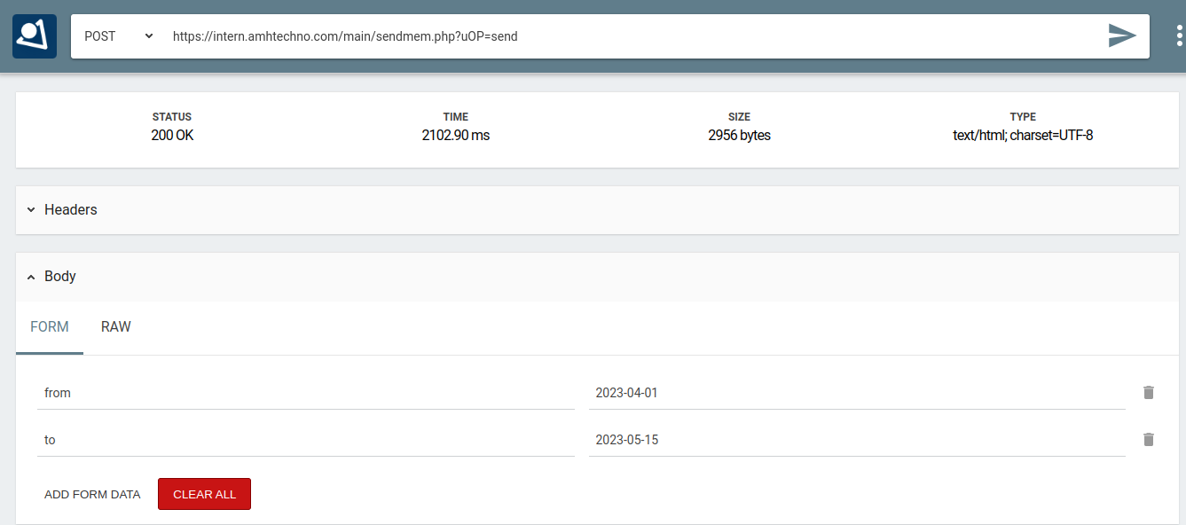

Contoh response sukses
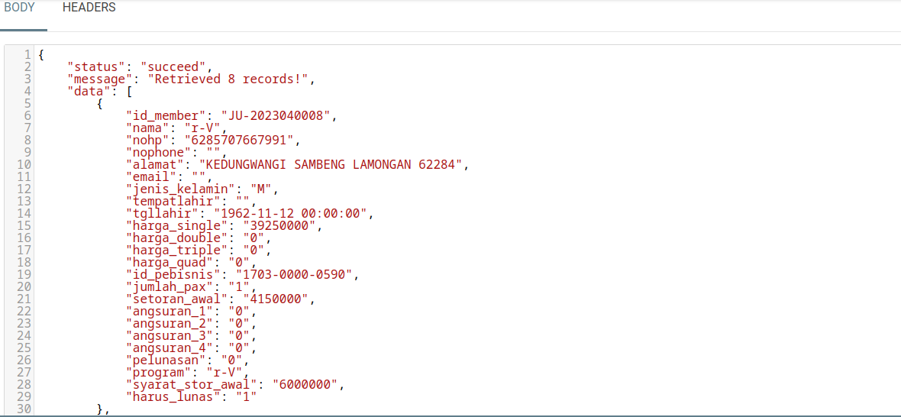

Contoh Response Text Sukses:

{
"status": "succeed",
"message": "Retrieved 8 records!",
"data": [
{
"id_member": "JU-2023040008",
"nama": "r-V",
"nohp": "6285707667991",
"nophone": "",
"alamat": "KEDUNGWANGI SAMBENG LAMONGAN 62284",
"email": "",
"jenis_kelamin": "M",
"tempatlahir": "",
"tgllahir": "1962-11-12 00:00:00",
"harga_single": "39250000",
"harga_double": "0",
"harga_triple": "0",
"harga_quad": "0",
"id_pebisnis": "1703-0000-0590",
"jumlah_pax": "1",
"setoran_awal": "4150000",
"angsuran_1": "0",
"angsuran_2": "0",
"angsuran_3": "0",
"angsuran_4": "0",
"pelunasan": "0",
"program": "r-V",
"syarat_stor_awal": "6000000",
"harus_lunas": "1"
]
}

Contoh response gagal

