**AC21009 - Report**

**Adithya Menon, Mandar Tamhane, Rauf Nawaz Tarar Sultana**

**Word Count : 567**

In our first meeting we decided on a basic architecture and a rough idea of the tasks each of us would work on. We wrote a very basic version of the pseudo code for the basic functionality of the system. We then worked on our own to create these functions and used GitHub to collaborate. Using GitHub was helpful as we didn’t have to track changes individually. It also helped us keep track of which functions are done and which functions needed working on

We figured that the best way to go about addressing the problems would be to go step-by-step, in a way that all of us would have a rough idea of what all of us are doing but be very clear of what we are doing individually. This divided our load into parts where we could debug and fix our individual problems expertly.

Our biggest concern was testing as each of us had parts of the problem, but not the whole solution. We had divided into three parts, which were the basic repository functions (creating, editing, adding files, deleting files), the CVS functions (the archiving, the tracking changes, logging changes), and the multiple user functions (creating and managing groups, managing permissions). Because of these functions depending quite heavily on each other, testing proved to be a huge challenge till the end when all of our individual modules were robust enough to be integrated together.  
  
By the end, all of us had very good understanding of what our functions do, what everyone else’s code does and how it can be modified to work seamlessly. This made the final part of the project quite enjoyable as everything started working as designed. We made a flowchart of our system and started integrating it one-by-one.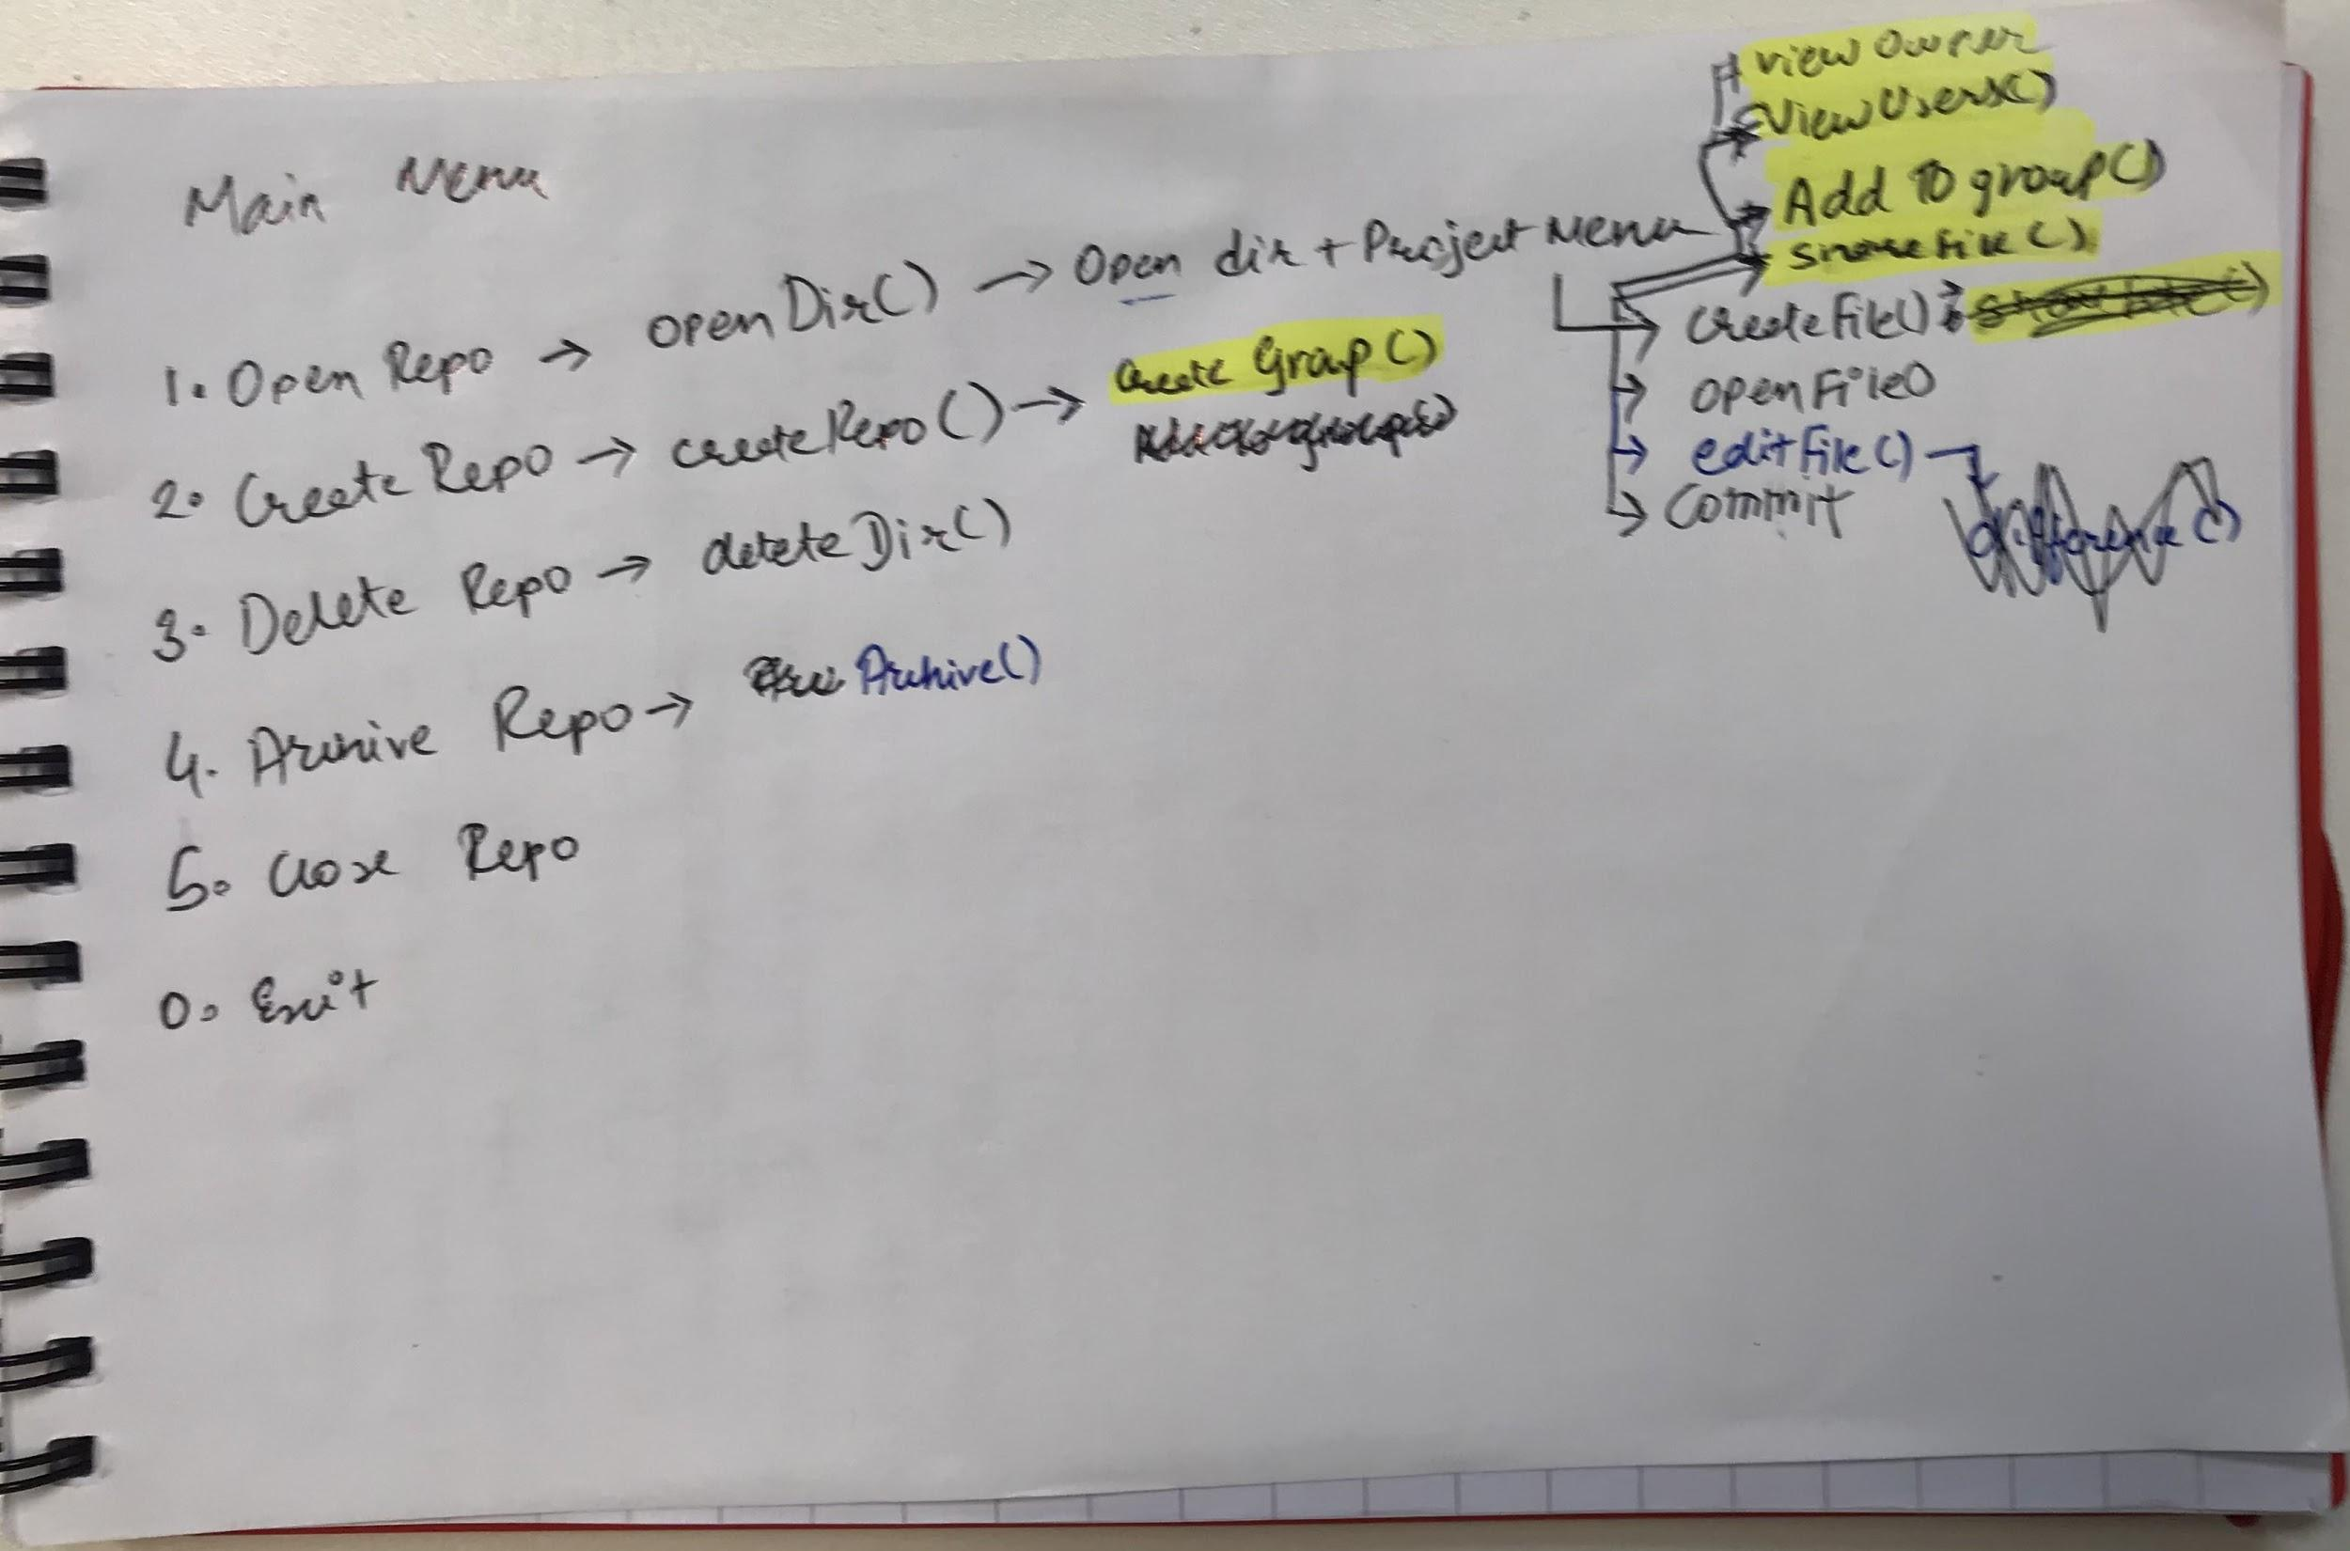

One of our biggest challenges was also the syntax of BASH scripting. Since we are used to programming in Java and C, the syntax was quite unique to get a hang of. We had semicolons and parentheses where they didn’t need to be. We also had some difficulties in understanding where to use quotes and brackets when declaring and using variables. Using nested loops (for menus) was quite easy though because of the fi and esac commands, signifying the end of a particular loop. Everyone also used proper indentation which made it easier to understand as well.

During our previous programming assignments we realised how important comments are and this was a perfect example for that. We didn’t have to tell anyone to use comments because everyone was quite aware of the complexity of the code and commented it out quite well. Understanding each other’s code is a very important step in collaborating, and we had no troubles at all in that department. We feel that using comments extensively also helped us in the end to merge all our functions with each other.

Overall, we feel like the project required a lot of planning and a lot of inter-functional dependency. If we could start it over again, we would’ve split tasks in each of our three different sections and done it section by section instead of depending individually for each section. That would’ve probably helped a bit more in the testing department as well as widened our individual programming skills in a simpler way. However, we are all quite glad that our code works well and that everything went according to the plan.