

**Autonomous Security System**

**Group Number:10**

**CSE 6th Semester(Section-B)**

Adarsh Kumar (201500255)

Atam Prakash Yadav (201500252)

Srinjoy Dutta (201500203)

**Under the Guidance Of:**

**Mr. Chinmoy Kar (Assistant Professor, CSE)**

**Department of Computer Science and Engineering**

**Contents**

|  |  |
| --- | --- |
|  | 1. Abstract |
|  | 1. Introduction |
|  | 1. Problem Definition 2. Solution Strategy |
|  | 1. Objective |
|  | 1. Features |
|  | 1. Project Description |
|  | 1. Working of the System |
|  | 1. Architecture Design |
|  | 1. Target Customer |
|  | 1. Literature Survey |
|  | 1. Gantt Chart |
|  | 1. References |
|  |  |

**Abstract**

The proposed security system is an efficient way to enhance the security system using face verification and face identification. This system is based on face detection and face recognition.

The proposed solution will save the time of user and very cost effective. There will be no physical interaction between user and security system. It is a modern and advanced technique to improve the security.

**Introduction**

This security system will be used for verification of people and identification of people. It will be developed on the concept of face detection and face recognition. This will generate different kind of information for different purposes. It will help organisation to maintain high quality Security.

**Problem Definition**

A system which would address to the following limitations**:**

Other security system can lead to the false rejection and false acceptance due to user’s physical interaction. for Example, Biometric scanner can have problem in capturing an accurate finger print image as well. Therefore, requirement of an enhanced security system for user’s verification and identification purpose.

**Solution Strategy**

The planned solution strategy:

Develop a Security System using face detection and face recognition to solve the problem.

The first step will be saved image to the database, then it will detect the faces. After that it will match the faces with the database and by recognizing the faces it will provides accurate information about them.

**Objective of the project**

It provides no physical interaction on behalf of the user. It is accurate and allows for high enrolment and verification system. Faster than other biometric System available for identification.

**Features**

It will improve the security level since it is fully autonomous. It has easy integration process and inexpensive technique of identification and it’s accuracy level is very high as compared to biometric method.

**Project Description**

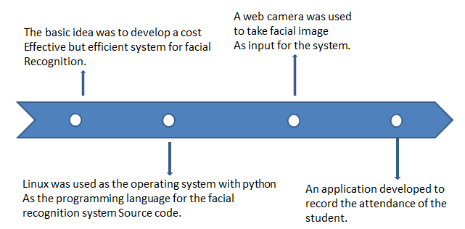

**Working**

Demo version of the system is developed using webcam. The application, after complete development process will work on camera and GPU. It essentially require wi-fi or internet connection.

**Working of the System**

Firstly, image will be captured by camera (image acquisition). Then, Face detection will be performed. After that, Image processing (using Siamese convolution neural network) will be performed on detected face. Image processing will provide specific characteristic of face.

**Architecture Design**

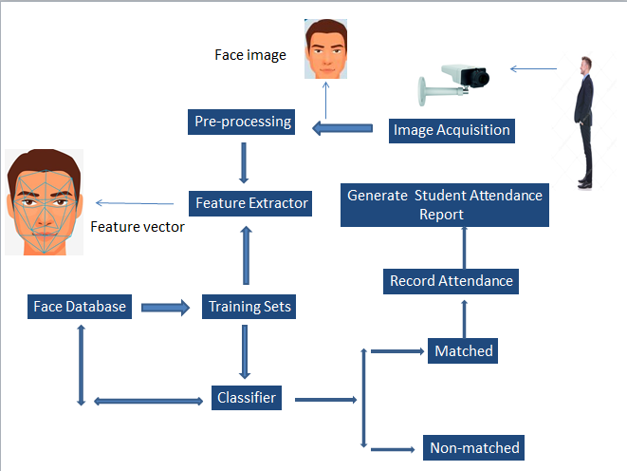

Fig. No: 1 Prototype of the system

Fig. 2 Block Diagram of overall system

**Step-1 Face detection**

Image of the person will be captured. Then, the lighting condition should be fair enough to obtain higher accuracy. To detect a face, a method called histogram of oriented gradient will be used.

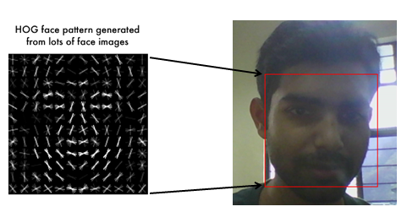

Fig. 3 Face detection using Histogram object gradient

**Step-2 Posing and Projecting Faces**

#### Problem related to turn or angle face will be solved and change it to centre image. The basic idea is we will come up with 68 specific points (called landmarks) that exist on every face.

#### 

#### Fig .4 68 Specific points on face

#### 

#### Fig. 5 68 specific points called Landmark (Blue Color)

**Step-3 Face Recognition System Development**

Face recognition system will be developed using deep convolutional neural network (Siamese Convolution Neural Network). This neural network will be trained to generate 128 measurement(embedding) of each face. After its training process, it can generate measurement for any face of any images. Finally, test image will be searched in database of all known people (whose 128 measurement are already saved) who has the closest measurement.

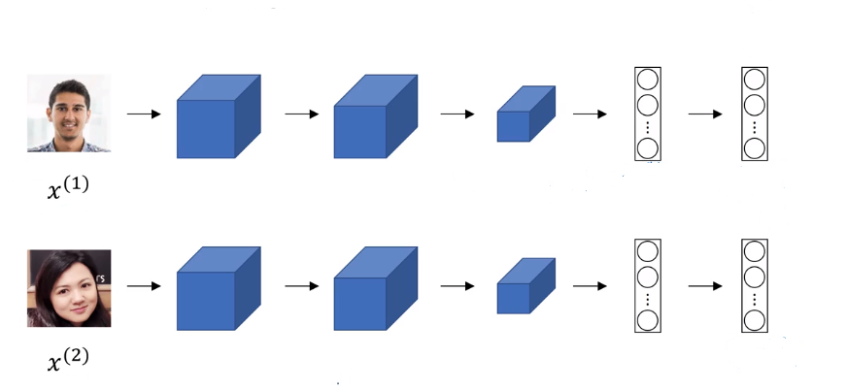

Fig.6 Siamese Neural Network

**Target Customers**

Institutions: Students attendance purpose- Automatic attendance will be taken. It will save time up to 5 to 10 min during classes. Entry/exit inside campus and particular section/block area.

Hospital: patient security-Only Authenticate person will allow to enter in ICU, authentication of register doctors.

Any secure organization - where access permission need to be controlled.

ATM- Prevent from Unauthorised Access to ATM machine.

**Literature Survey**

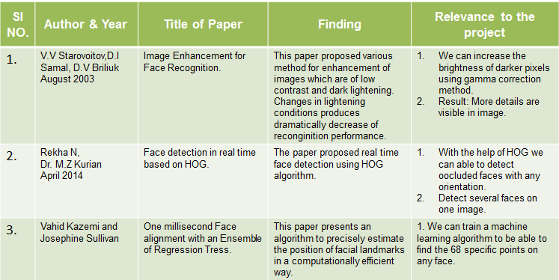

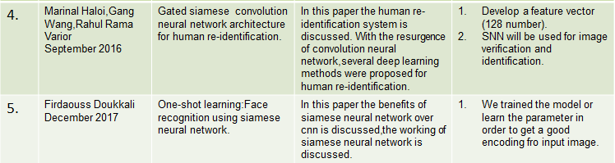

**Gantt Chart**

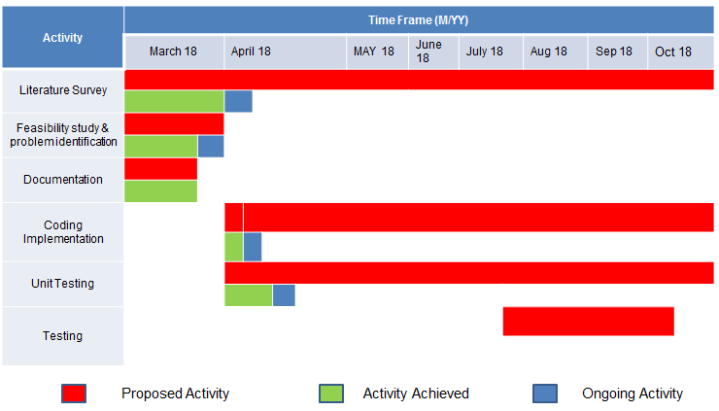

**References**

[1]. V.V Starovoitov, D.ISamal, D.V Briliuk,” Image Enhancement for Face Recognition.”, Submitted to International Conference on Iconics, 2003,St .Peterburg,Russia

[2]. Rekha N,Dr. M.Z Kurian,” Face detection in real time based on HOG.”,International Journal of Advanced Research in Computer Engineering & Technology(IJARCET),Volume 3 Issue 4, April 2014

[3].Vahid Kazemi and Josephine Sullivan,”One millisecond Face alignment with Ensemble of Regression Tress.”,Royal Institute of technology,Computer vision and active perception lab,Stockholm,Sweden@csc.kth.se

[4].Marinal Haloi, Gang Wang, Rahul Rama Varior,” Gated siamese convolution neural network architecture for human re-identification.” ,School of Electrical and electronic Engineering Nanyan Technological University.@ntu.edu.org.

September 2016

[5]. Firdaouss Doukkali,” One-shot learning: Face recognition using siamese neural network.”

December 2017