Continuous Compliance and Change Management in AWS
Student Lab Documentation
Name: Chibuike Adiele
Lab Title: Continuous Compliance Alerting with AWS Config & SNS
Region Used: us-east-1 (N. Virginia)

1. Objective
The objective of this lab was to implement continuous compliance monitoring in AWS using AWS Config and Amazon SNS. The goal was to automatically detect and alert when an Amazon S3 bucket becomes publicly accessible, simulating a real-world security misconfiguration and response workflow.

2. Architecture Overview
The solution consists of the following components:
- AWS Config – Monitors configuration changes in AWS resources.
- AWS Config Managed Rule – s3-bucket-public-read-prohibited to detect public S3 buckets.
- Amazon SNS – Sends real-time email alerts when non-compliance is detected.
- Amazon S3 – Used both for AWS Config log storage and for the test bucket.

3. AWS Config Setup
AWS Config was enabled to record all supported resources in the region. A service-linked IAM role was automatically created to allow AWS Config access to resource configurations.
A dedicated S3 bucket (config-bucket-adiele-2026) was created to store AWS Config logs. This bucket remained private and contained a restrictive bucket policy allowing access only to the AWS Config service.
AWS Config recording was confirmed to be active before proceeding.
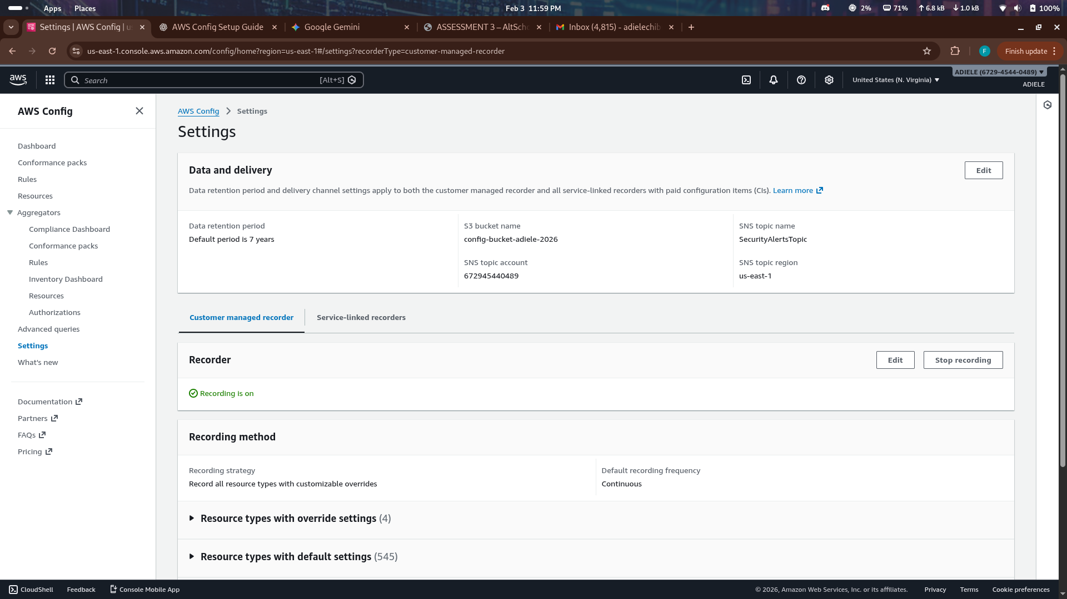

4. SNS Configuration
An SNS topic named SecurityAlertsTopic was created to act as the notification channel.
An email subscription was added using a personal email address and explicitly confirmed, ensuring alerts could be delivered successfully.
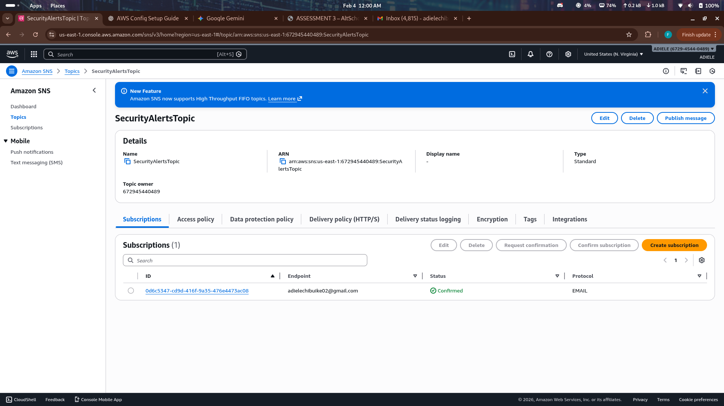

5. Compliance Rule Configuration
The AWS managed rule s3-bucket-public-read-prohibited was added in AWS Config. This rule evaluates whether any S3 bucket allows public read access.
The SNS topic SecurityAlertsTopic was linked to AWS Config’s delivery channel to ensure compliance notifications were sent automatically.
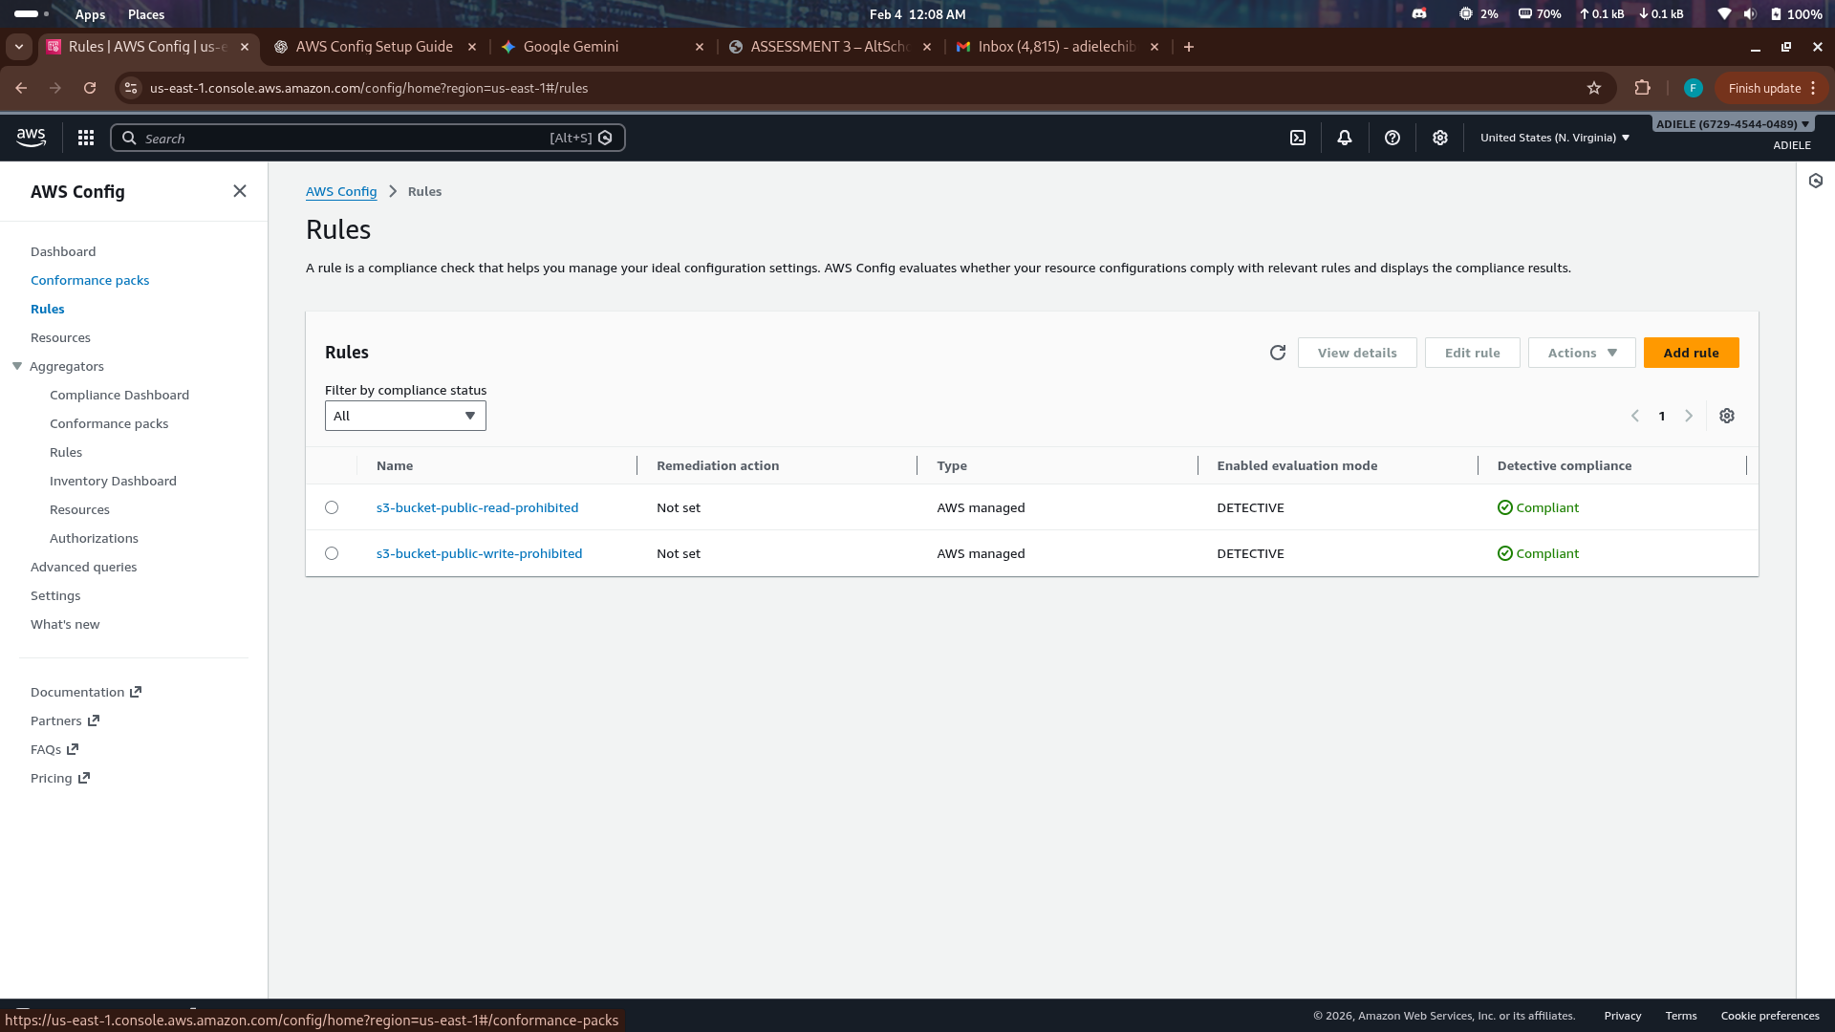

6. Break Phase – Introducing Non-Compliance
To test the alerting mechanism, a separate S3 bucket named:
config-bucket-test-adiele-2026
was created. Public access blocking was disabled, and a bucket policy was applied to allow public read (s3:GetObject) access.
After a short evaluation period, AWS Config detected the violation and marked the resource as NON_COMPLIANT.

7. Alert Observation
Once the rule evaluation completed, an email alert was received in real time via Amazon SNS. The email clearly indicated:
- The affected S3 bucket
- The violated rule
- The non-compliant status
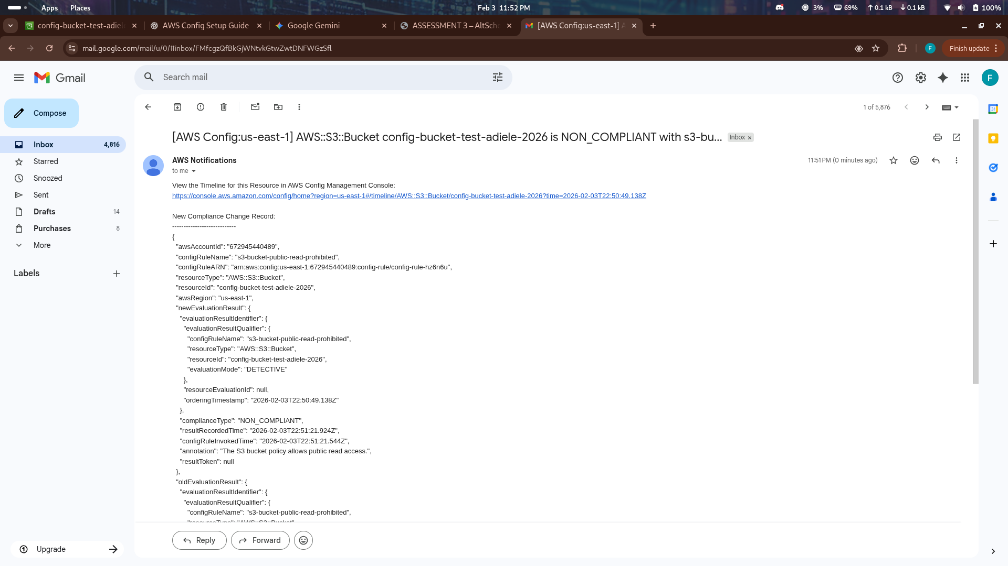

8. Investigation
Using the AWS Config console, the resource timeline for the S3 bucket was reviewed. The timeline showed the exact configuration change that caused the bucket to become public, confirming AWS Config’s ability to provide audit visibility.
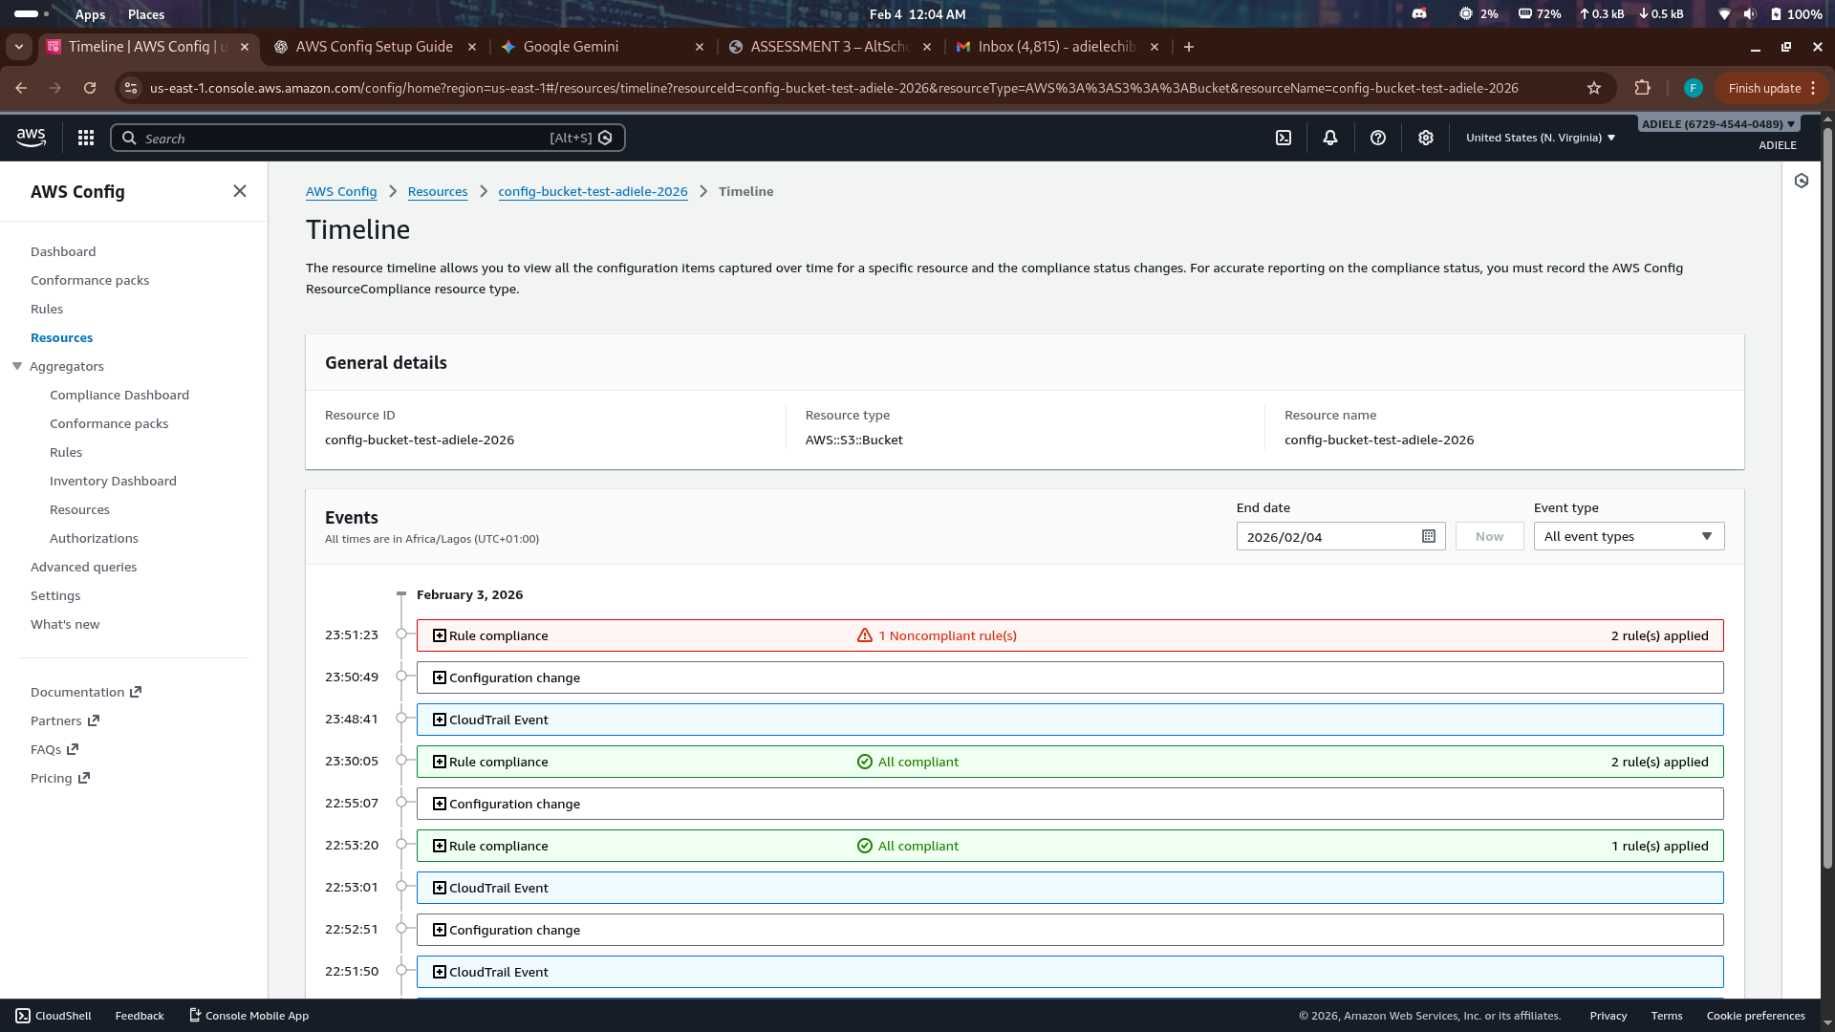

9. Fix Phase – Restoring Compliance
To remediate the issue:
- The public bucket policy was removed
- “Block all public access” was re-enabled on the S3 bucket
After reevaluation, AWS Config marked the resource as COMPLIANT, and the rule status returned to green.
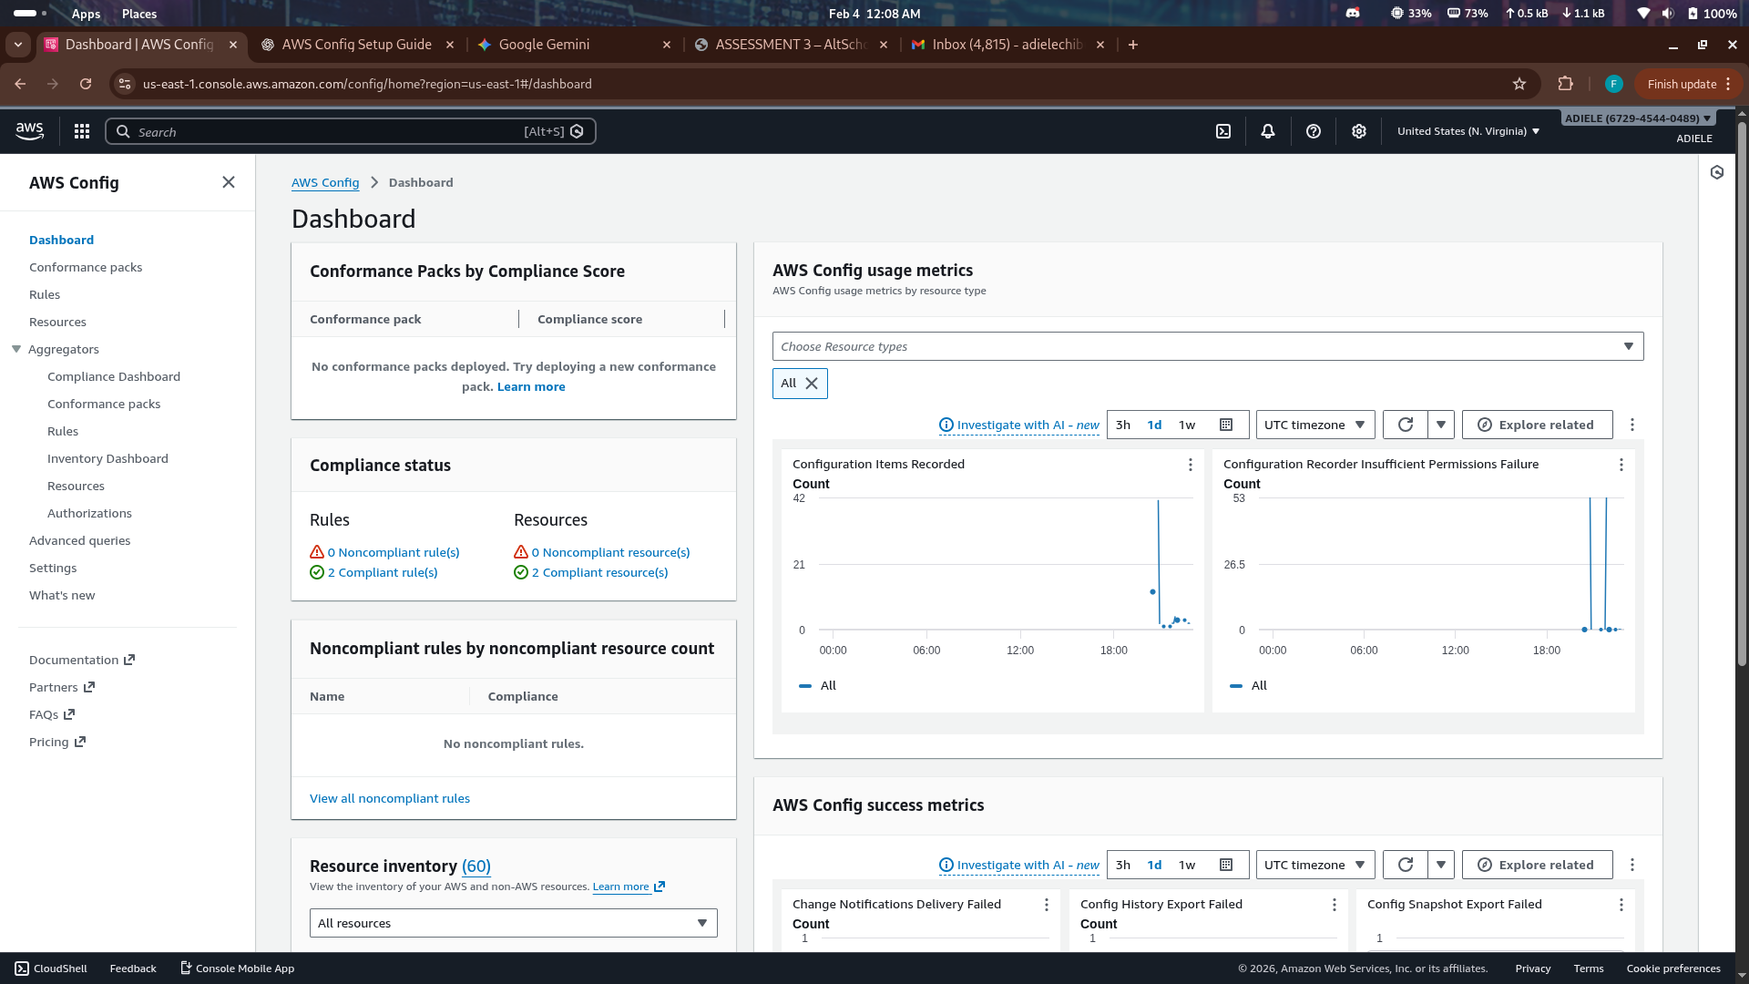

10. Conclusion
This lab demonstrated how AWS Config and SNS can be combined to implement continuous compliance monitoring and automated alerting. The solution successfully detected a security misconfiguration, generated a real-time alert, enabled investigation through configuration history, and verified remediation.
This approach reflects real-world cloud security best practices for governance, risk management, and continuous monitoring.

