This Document Covers
1. A working solution with clear run instructions. Another engineer should be able to clone and run it within 5 minutes. – This would be added into the a readme file on Github.
2. A README covering: problem framing (how you interpreted the brief), assumptions you made, design choices and trade-offs (why this approach over alternatives you considered), known limitations, and what changed when you applied the change request.
3. 2 short ADRs (Architecture Decision Records) covering your two most important design choices. Name the decision, list the alternatives you considered, and explain why you chose what you chose. 4. Automated tests covering: decision logic (your data integrity rules), at least one integration or end-to-end path, and the change request scenario.
5. A development process note describing how you used AI tools: I used AI tools to solve the problem and explain how to generate a mock solution. Because I have Developed spring boot applications and Api’s, I used my own templates for the development, I started with the GET methods and used AI to solve for a quickest solution. I used a JDBC template to use SQL for retrieving my data. AI suggested me to certain rules for inserting data which I modified and explained below in my write up. From here I manually coded the solution as AI tools wasn’t able to exactly replicate a solution at hand. The exact example was to update both table states after having checked if same events was sent through, whilst accepting all events for audibility and traceability.
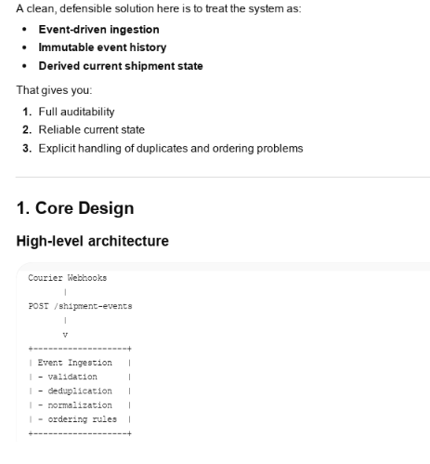
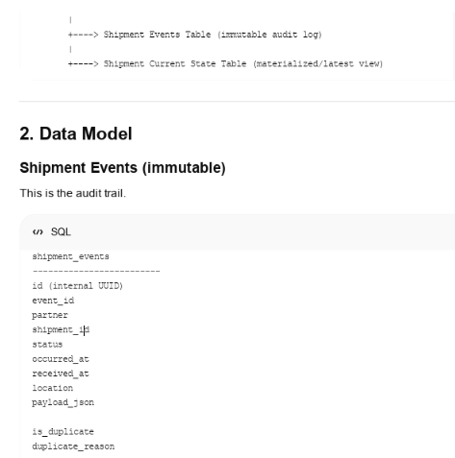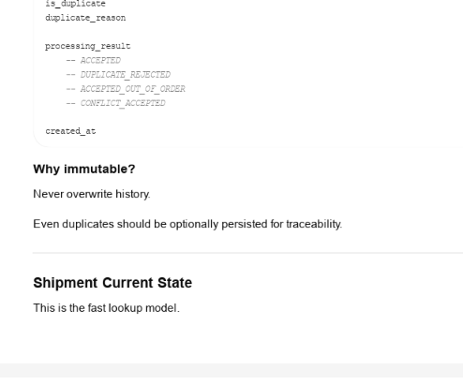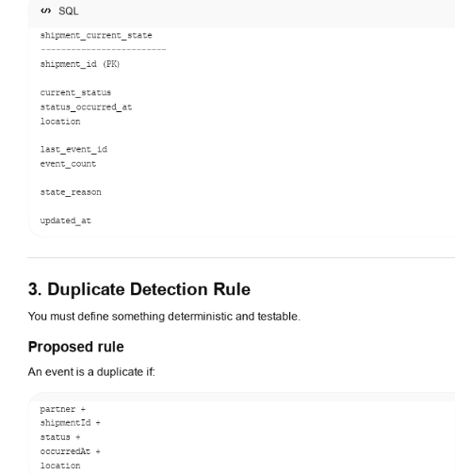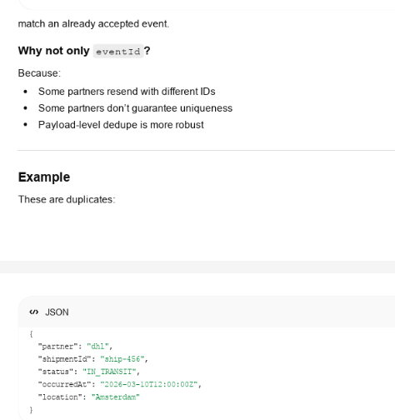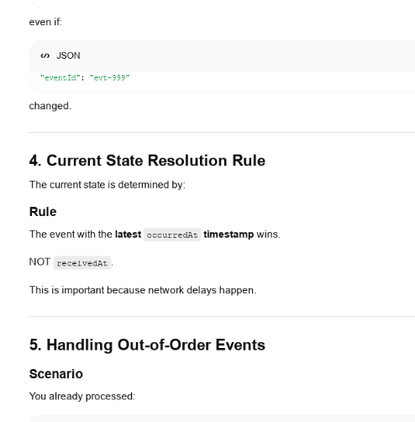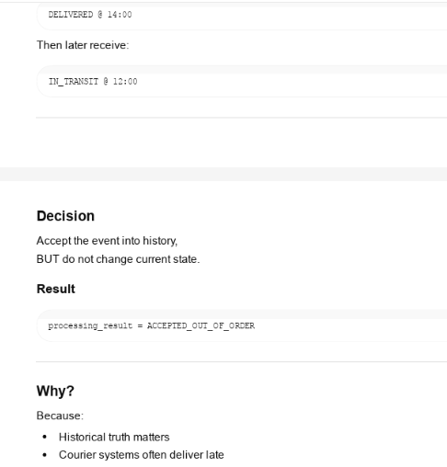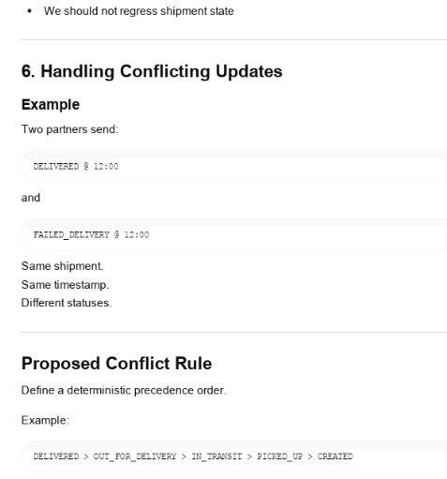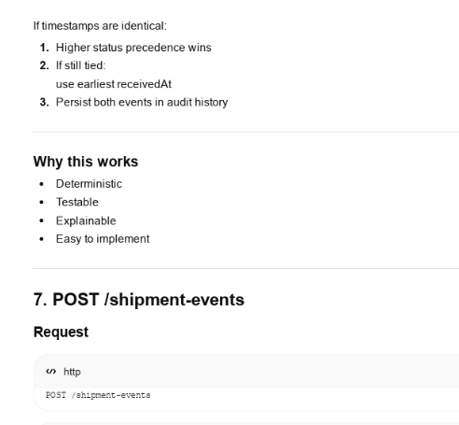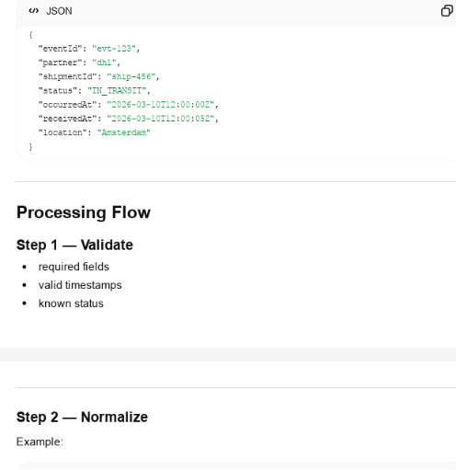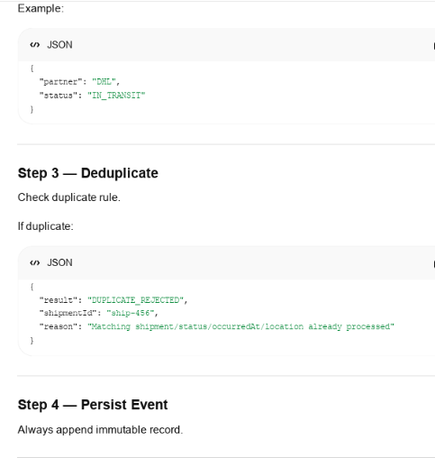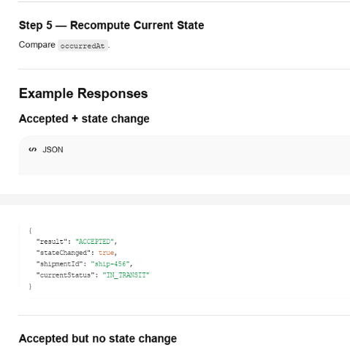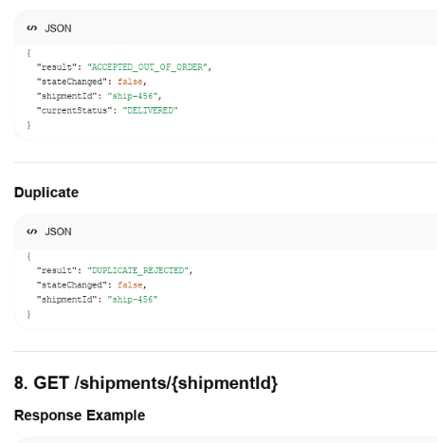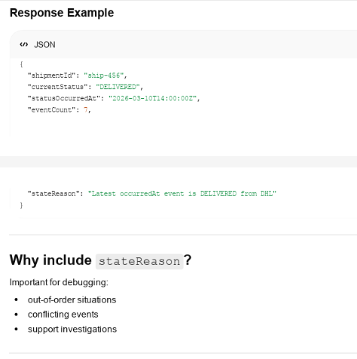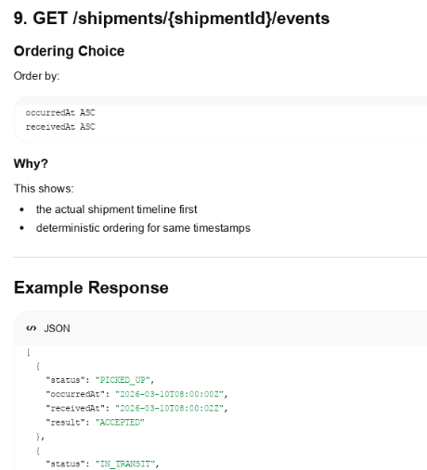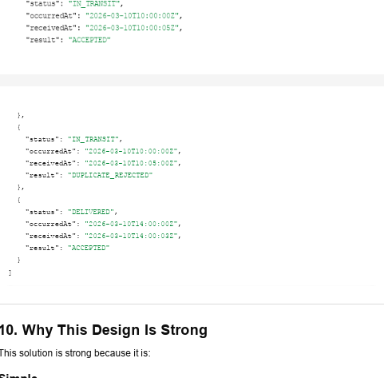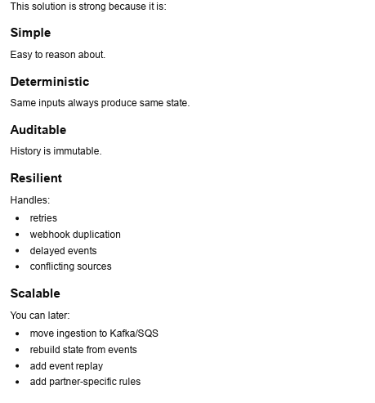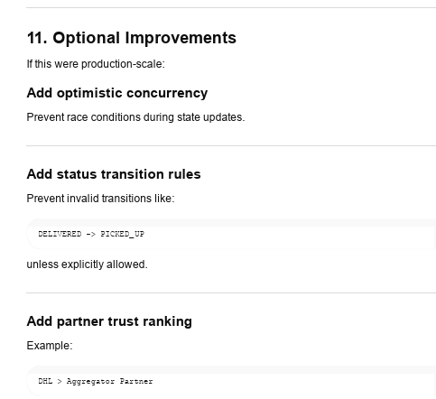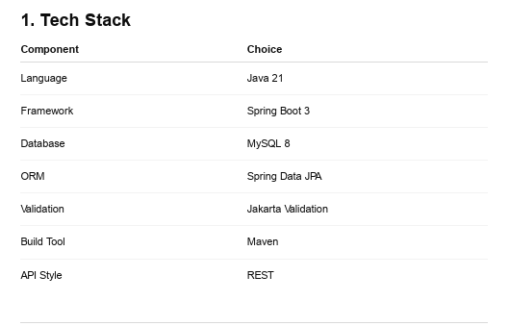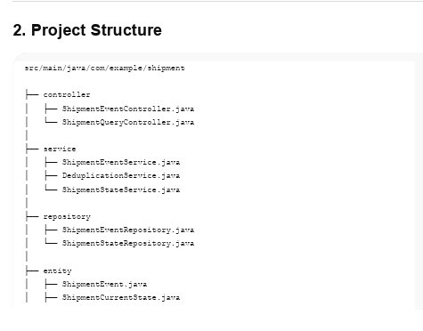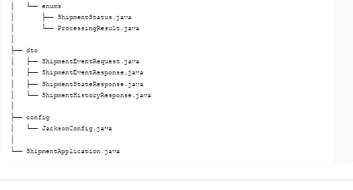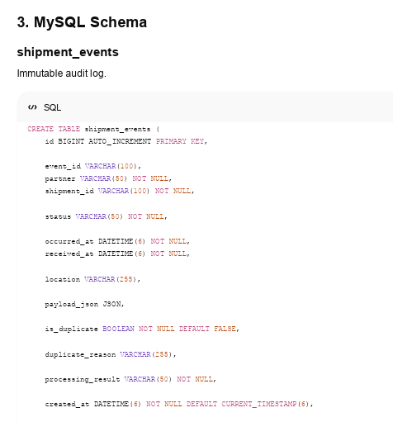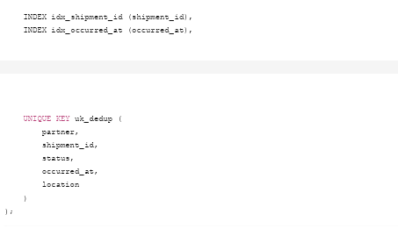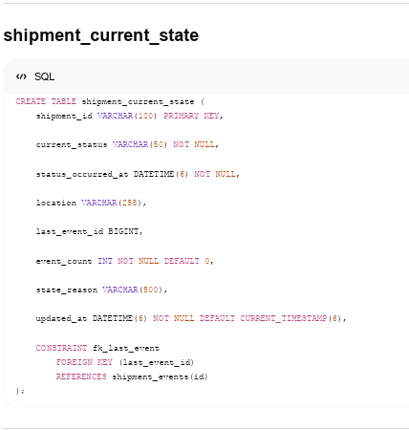
Working Screen Shots of the Test Cases
