Lab 1

CSCI 132 – Summer 2022

This lab has three parts. Upload your code to the Gradescope Lab1.

1. Create the Lab 1 using maven quickstart archtype. You can either use command line to create the program or use Intellij Idea to do this. I will teach you how to do this in the class. This part is very easy and easy points.
2. Convert the following python program to Java. You can create a class called PythonDemo and implement the following methods. Create a main method inside the PythonDemo class as well.

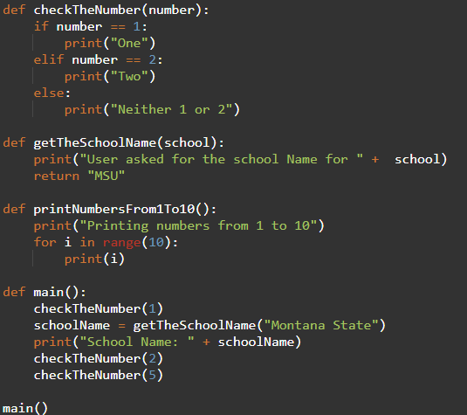

1. Create a new class called **LoopDemo** and do the following. You can create a new main method in the **LoopDemo** class and include the solution for the following questions.
   1. Create an integer array with following values: {20, 34, 54, 100, -1, 34, 20, 23, 89, 45, 45,99, 121, 343}
   2. Use a for loop to find the largest value in the above array and print it.
   3. Use a while loop to find the minimum value of the above array and print it
   4. Use a for each loop to find the average of the above array and print it.
   5. Use a java do while loop to find the
   6. Print the above array in reverse order. Use any type of looping mechanism you like. Hint: Array’s last element index is n-1 and you can decrement the looping variable instead of increasing it.

for (int i=10; i>=0;i--) {

//do something

}

**In case you need to copy the above Python program here is the code.**

def checkTheNumber(number):

if number == 1:

print("One")

elif number == 2:

print("Two")

else:

print("Neither 1 or 2")

def getTheSchoolName(school):

print("User asked for the school Name for " + school)

return "MSU"

def printNumbersFrom1To10():

print("Printing numbers from 1 to 10")

for i in range(10):

print(i)

def main():

checkTheNumber(1)

schoolName = getTheSchoolName("Montana State")

print("School Name: " + schoolName)

checkTheNumber(2)

checkTheNumber(5)

main()