Lab 3

CSCI 132 – summer 2022

This lab has 3 parts. Upload the zip filed of your Lab folder to the Gradescope

1. Create the Lab 1 using maven quickstart archtype. You can either use command line to create the program or use Intellij Idea to do this. Please include the pom file when you upload the lab.
2. Create classes for following hierarchy below. the hierarchy shows the inheritance that you should use. HourlyEmployee inherits from Employee, CommisionPlusBase inherits from CommissionEmployee which inherits from Employee: Each class should contain
   1. An employee should have a first name, last name, and Id number
   2. A Hourly employee should have a wage and a number of hours worked.
   3. A commission employee should have a commission rate and gross sales
   4. and a commission + base employee should have a base salary.
   5. You can either explicitly set the inherited data of the parent classes (e.g first name, last name, and ID number of Employee) OR you can call the super with the proper parameters to send the data needed to the constructors of the parent classes, The second option is considered better.
   6. **Each class should have appropriate constructors, and a print method (to print specific type of employee).**

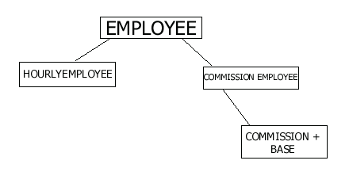

1. Write a Java method that repeatedly selects and removes a random entry from an array until the array holds no more entries. You can create a class called RandomArray and create a method in this class. you can also create a main method inside the same class and check this method on an array that you created.