Adigarla Lavanya
Java Day 1

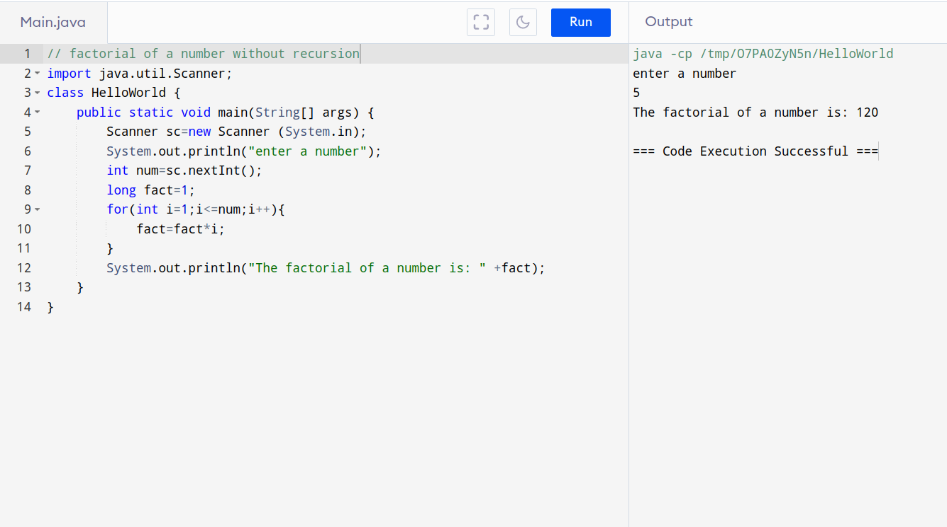

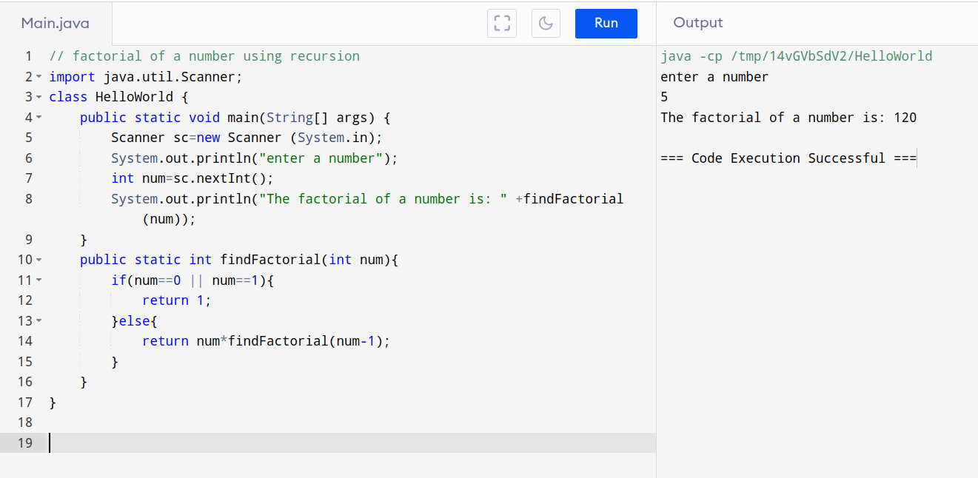

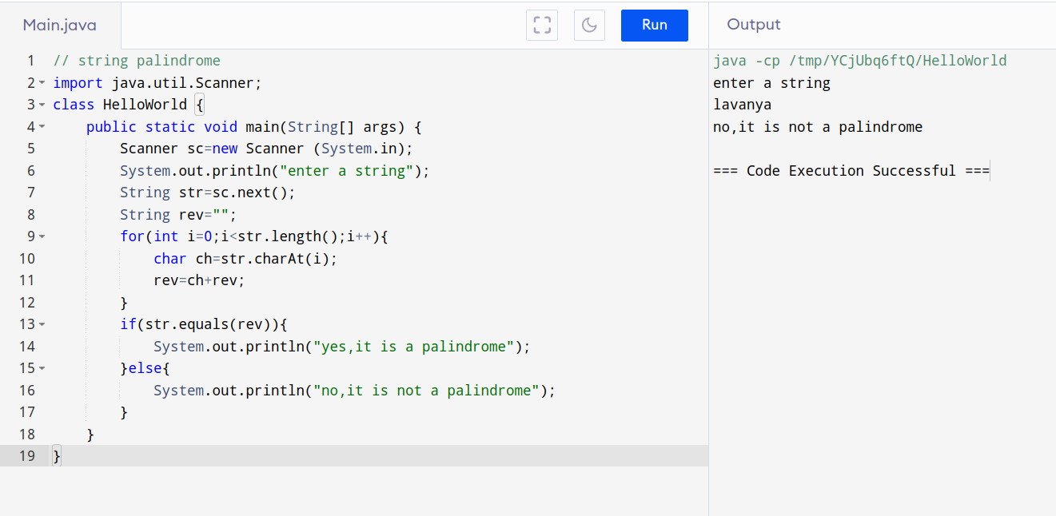

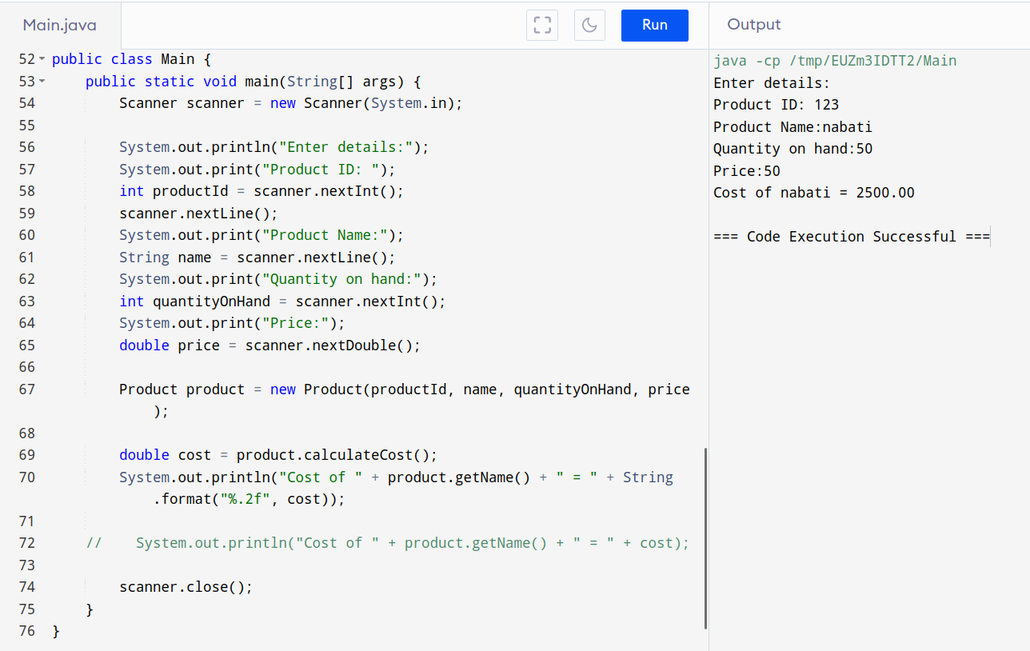

//Employee class

import java.util.Scanner;

public class Employee {
private int employeeId;
private String name;
private String designation;
private double basicSalary;
private double allowances;
private double deductions;

public Employee(int employeeId, String name, String designation, double basicSalary, double allowances, double deductions) {
this.employeeId = employeeId;
this.name = name;
this.designation = designation;
this.basicSalary = basicSalary;
this.allowances = allowances;
this.deductions = deductions;
}

public double calculateNetSalary() {
return basicSalary + allowances - deductions;
}

public int getEmployeeId() {
return employeeId;
}

public void setEmployeeId(int employeeId) {
this.employeeId = employeeId;
}

public String getName() {
return name;
}

public void setName(String name) {
this.name = name;
}

public String getDesignation() {
return designation;
}

public void setDesignation(String designation) {
this.designation = designation;
}

public double getBasicSalary() {
return basicSalary;
}

public void setBasicSalary(double basicSalary) {
this.basicSalary = basicSalary;
}

public double getAllowances() {
return allowances;
}

public void setAllowances(double allowances) {
this.allowances = allowances;
}

public double getDeductions() {
return deductions;
}

public void setDeductions(double deductions) {
this.deductions = deductions;
}
public static void main(String[] args) {
Scanner scanner = new Scanner(System.in);

System.out.print("Enter employee ID:");
int employeeId = scanner.nextInt();
scanner.nextLine();
System.out.print("Enter employee name:");
String name = scanner.nextLine();
System.out.print("Enter employee designation:");
String designation = scanner.nextLine();
System.out.print("Enter employee basic salary:");
double basicSalary = scanner.nextDouble();
System.out.print("Enter employee allowances:");
double allowances = scanner.nextDouble();
System.out.print("Enter employee deductions:");
double deductions = scanner.nextDouble();

Employee employee = new Employee(employeeId, name, designation, basicSalary, allowances, deductions);

double netSalary = employee.calculateNetSalary();
System.out.println("Net Salary:" + netSalary);
scanner.close();
}
}

