App ka name SmartKitchen se change kar ke CookSmart kar do
And APP ka logo change kar do
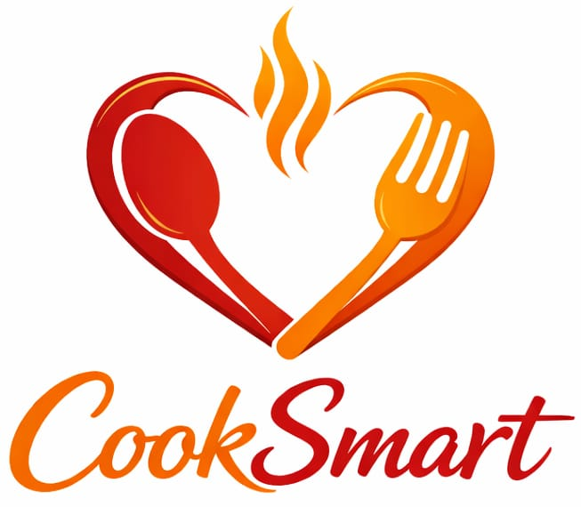
Logo ka background color white hai to use transparent kar dena uske bad logo ko app me set kar dena

Login page: -

Home page: -

Ye jo right side me filter hai use remove karo
And ye jo green color ka circle hai waha pe ek male/female ka animation type ya character ka image aana chahiye
And jo Hello, Chef likja hai yaha pe Hello (user name) hona chahiye

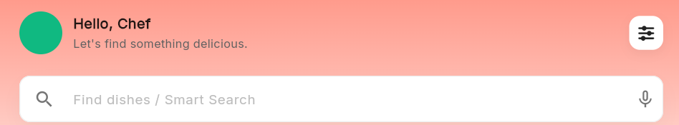
Ye jo find dishes/Smart search ka option hai na ye work karna chahiye aur jab user es search bar pe click kare recipe search karne ke liye to ye ek new page me open hona chahiye aur recipe seggest bhi karna chahiye jaise youtube me hoota hai
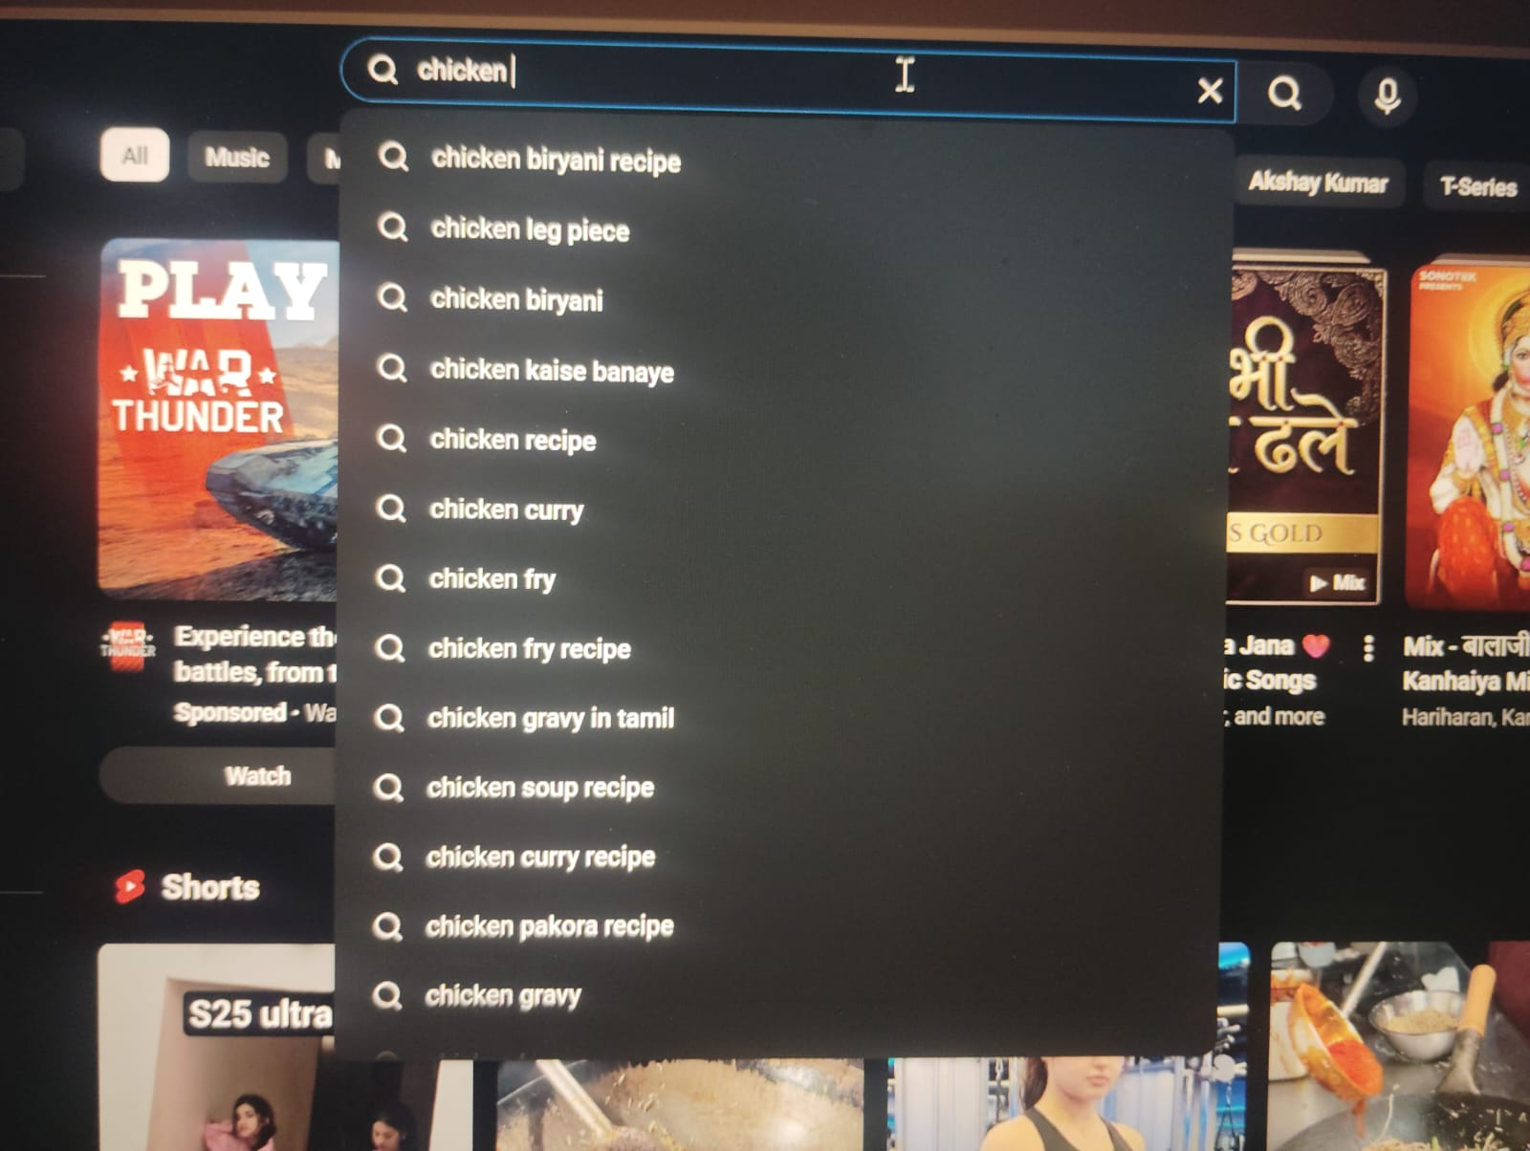
Aise hi chahiye


And ye jo filter hai ye sab proper work karna chahiye

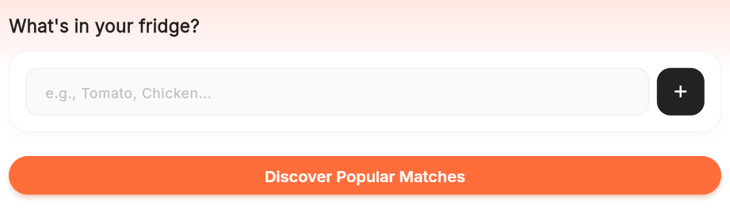
Jab user item type kar ke search kare to kam se kam 30 + recipe AI generate kare
Aur eske liye spoonacular API ka use karo

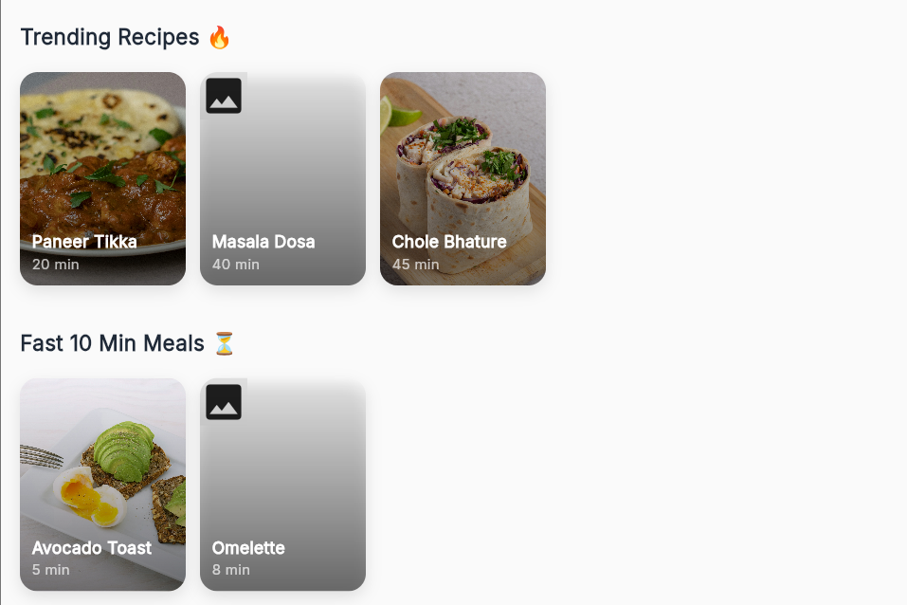
Ye trending recipes and fast 10 min meals home page pe dikhna chahiye “Discover Popular Matches “ button ke niche aur jab user like paneer tikka,Masala Dosa, chole bhature pe click kare to eska pura recipe aana chahiye wobhi API ke through
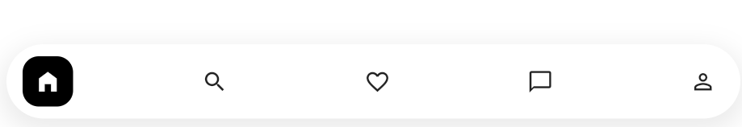

Bottom navigation bar me se search page and Favorite page ko remove kar do
And bottom navigation me setting page ko add kar do

Chatbot page: -
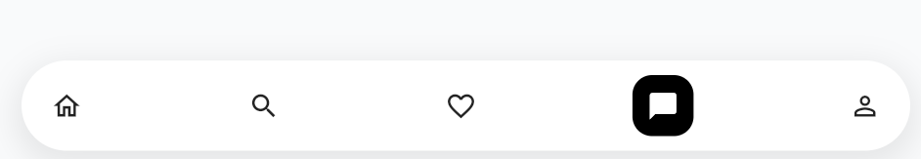
Smart Recipe Suggestion
User jo likhe uske basis par recipe suggest karo:
- “healthy breakfast”
- “paneer recipe”
- “quick snacks”
👉 Bot automatically:
- Recipe list show kare
- Ingredients + time + calories

🔹 2. Voice Input 🎤
Typing ke bajaye:
- User bol sakta hai: “mujhe dinner ke liye kuch batao”
- Speech → Text → Recipe

🔹 3. Personalized Recommendation 👤
User ka data use karo:
- Veg / Non-veg preference
- Calories goal
- Favorite cuisine
👉 Example:
- “Aaj kya khaun?” → personalized suggestion

🔹 4. Step-by-Step Cooking Mode 👨‍🍳
Chatbot guide kare:
- Step 1: Oil heat karo
- Step 2: Onion add karo
👉 User bole: “next step” → next instruction

🔹 5. Ingredient Based Search 🥦
User bole:
- “mere paas potato aur tomato hai”
👉 Bot:
- Possible recipes suggest kare

🔹 6. Image Recognition (Advanced 🔥)
User photo upload kare:
- Fridge ka photo
👉 Bot:
- Identify ingredients
- Recipe suggest kare

🔹 7. Nutrition & Calories Info 📊
Har recipe ke saath:
- Calories
- Protein
- Fat
👉 Fitness users ke liye useful

🔹 8. Save & Favorite ❤️
Chatbot me hi option:
- “Save this recipe”
- Favorite list me add ho jaye

🔹 9. Multi-language Support 🌍
- English
- Hindi / Hinglish
👉 Example:
- “Mujhe jaldi breakfast recipe batao”

🔹 10. Quick Buttons (UI Improvement)
Chatbot ke niche buttons add karo:
- 🍳 Breakfast
- 🍛 Lunch
- 🍲 Dinner
- 🥗 Healthy
👉 User ko type karne ki zarurat nahi

🔹 11. Chat History 📜
- Previous conversations save karo
- User baad me dekh sake

🔹 12. AI Suggestions (Pro Feature 🔥)
- “Aaj rainy day hai” → pakoda suggestion
- “Weekend” → special recipes

🔥 Bonus UI Ideas
- Typing animation (“Bot is typing…”)
- Recipe cards inside chat
- Images + ratings

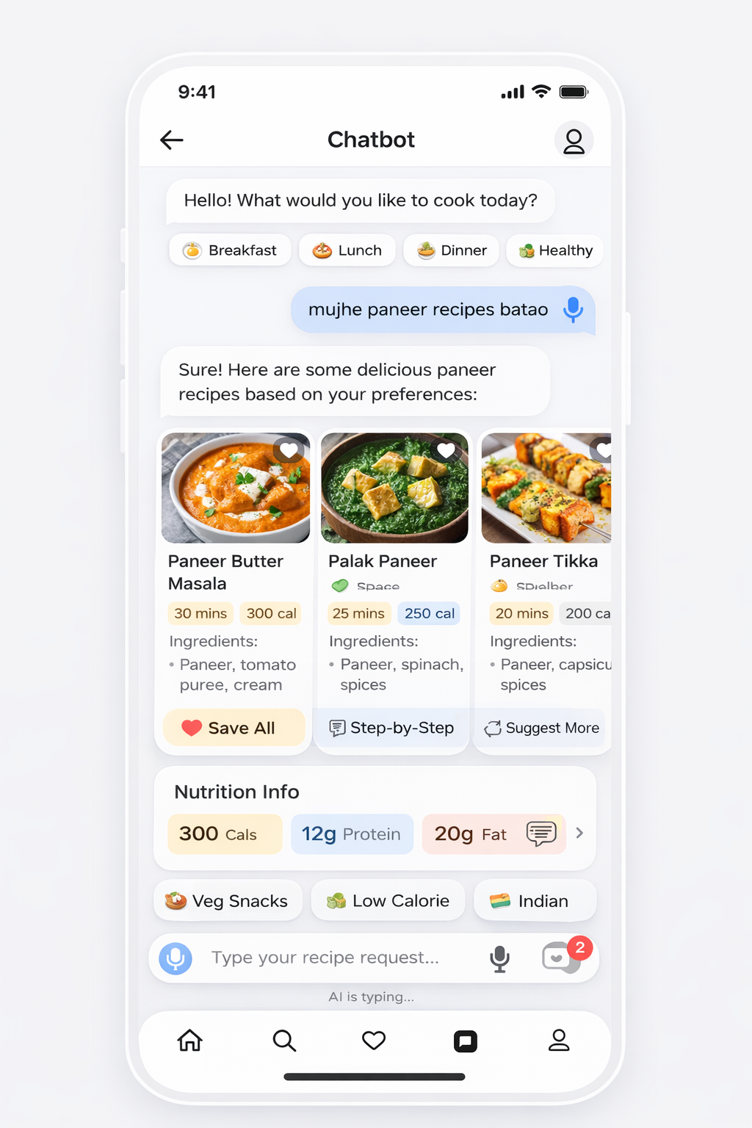
Last me page aisa hi dikhna chahiye aur apne main UI color se matvh hona chahiye

Profile page: -
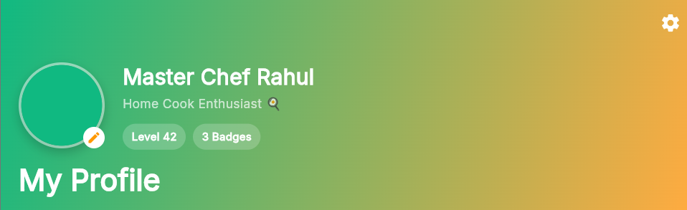

Yaha pe animation type male/femae ka image laha sakte hai and jo “Master Chef Rahul” likha hai uske jage pe bas user ka nam aana chahiye
And jo master chef Rahul ke niche “Home Cook Enthusiast” likha hai and “Level 42 , 3 Badges“ in dono ko remove kar do
And ye jo My Profile likha hai na wo top pe likha hona chahiye
And jo setting ka symbol aarha hai top right me use remove kar do

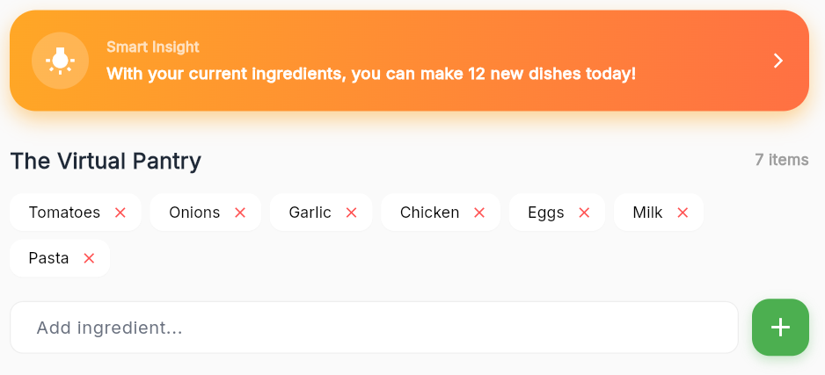
Ye bhi remove kar do smart Insight and the virtual pantry dono
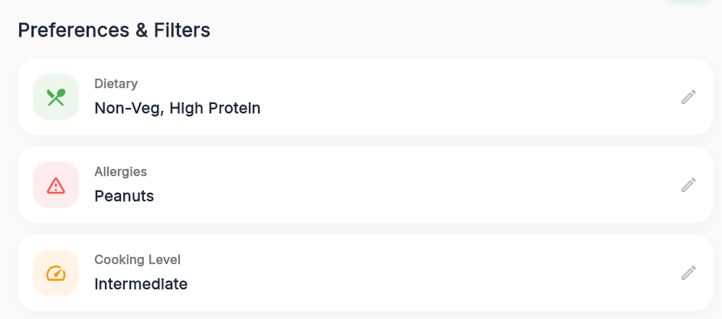
Ye preferences & filters bhi remove kar do

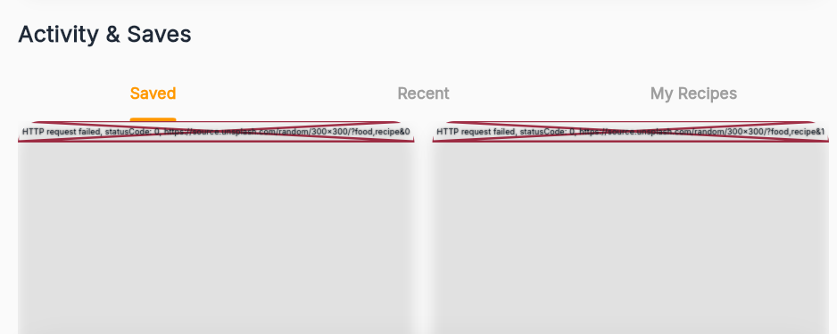
Activity & save me se My Recipes ka option remove kar do
Option saved me bas wahi recipes save honi chahiye jo user save kare
And recent option me recipe temporary show karna chahiye like aaj pura din me user jitna
recipe search kiya ho next day recent option me se old recipe automatic remove ho jaye

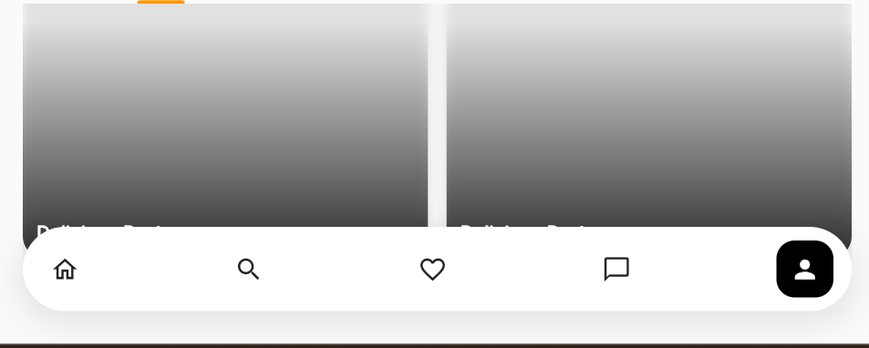
Ye jo images bottom navigation bar ke pichhe chhup ja raha hai wo chhupna nahi chahiye
Images ka ending part bottom navigation bar ke upper hi hona chahiye

Setting Page:-
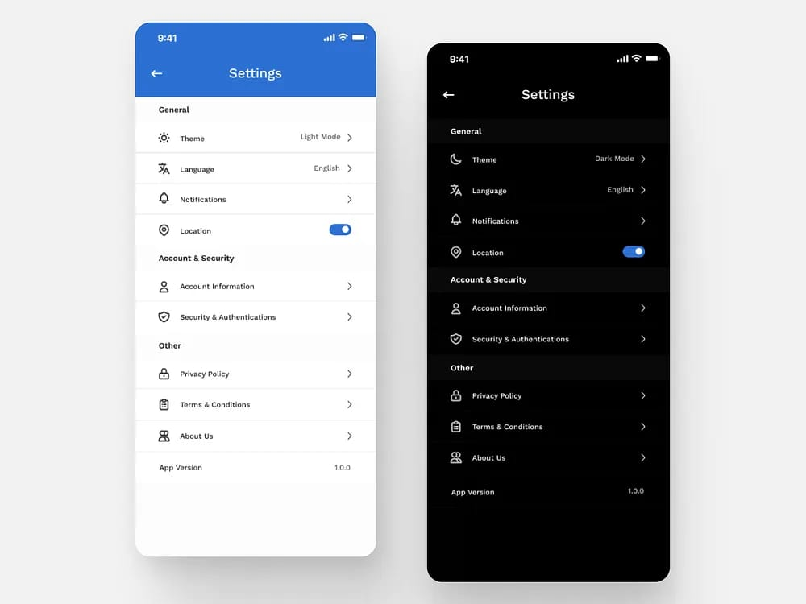
mujhe yahi sab options chahiye setting ke andar :-
- Theme
- Account Setting
- Language
- Notifications
- Account Information
- About App
- Logout
Theme: -
- Dark mood
- Light mood
Account setting: -
- Edit Profile
- Email change
- Change password
- Phone number update
Language: -
- English
- Hindi
- Marathi
- Bhojpuri
- Hinglish
Notification: -
- Daily recipe suggestion ON/OFF
- Meal reminder ON/OFF
- New recipes alert
- Achievement notification
Account Information: -
- User name
- User contact no.
- User email
- Date when user start use to this app
About App: -
- Version info
- Developer info
- Terms & conditions
Logout button: -

-: Chapter Close :-

