# **CASE – II**

Author: Ömer Adıgüzel

I performed the optimization case study in Lingo software.

To see the results please kindly follow the below instructions.

**Step -1:** Download and Install Lingo

Go to: <https://www.lindo.com/index.php/ls-downloads/try-lingo> and by depending on the OS (Linux, Windows, etc..) download the version.

**Step -2:** For Windows LINGO-WINDOWS-64x86-18.0 is downloaded to computer. Unzip the file

**Step -3:** Install the software by using LINGO-WINDOWS-64x86-18.0.exe file

**Step -4:** Start the Lingo

**Step -5:** Choose Demo option, it enables 60 day free trial.

Open new file by pressing F2 and write the code given below and press Ctrl + U.

**#### START OF THE CODE**

SETS:

week/1..9/:y,x,t,b,s;

ENDSETS

DATA:

x= 50 60 70 25 55 32 45 54 0;

s= 5 3 6 2 6 3 5 7 0;

ENDDATA

min=@sum(week(I):B(I))*500+@sum(week(I)|I#lt#8:y(I+1))*0.25;

y(1)=200;

y(9) = 75;

@FOR(week(I)|I#lt#8:y(I)+t(I)-x(I)-s(I)=y(I+1));

@FOR(week(I):y(I)+t(I)-x(I)-s(I)>=0);

@FOR(week(I):t(I)<=b(I)*100000);

@FOR(week:@bin(b));

**#### END OF THE CODE**

**EXPLANATIONS:**

**week:** Create and array called week starting from 1 to 8

**y:** the variable that stands for the inventory, first value is 200 and the last value is 75

**x:** the demand amount to be forecasted

**s:** the safety stock value

**t:** Order amount to be optimized

**b:** Binary variable, stands for whether the order is given or not

**@FOR(week(I)|I#lt#8:y(I)+t(I)-x(I)-s(I)=y(I+1));**

The equation stands for: The inventory of the current week + Given Order Amount – Customer Demand – Safety Stock = Next weeks starting inventory

**@FOR(week(I):y(I)+t(I)-x(I)-s(I)>=0);**

This equation defines the no lead time constraint.

**@FOR(week(I):t(I)<=b(I)*100000);**

**@FOR(week:@bin(b));**

The binary variable is defined here, the fixed transport cost is controlled here, the variable here also is controlled with a big number bigM coefficient.

[**min=@sum(hafta(I):B(I))*500+@sum(hafta(I)|I#lt#8:y(I+1))*0.25**](mailto:min=@sum(hafta(I):B(I))*500+@sum(hafta(I)|I#lt#8:y(I+1))*0.25)**;**

This is the equation to be minimized, first part stands for whether the order is given or not that will cost 500 TRY, and the second part is the stocks holding costs.

# RESULTS

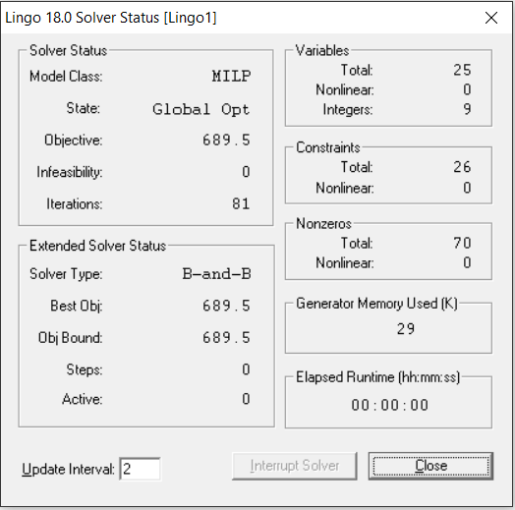

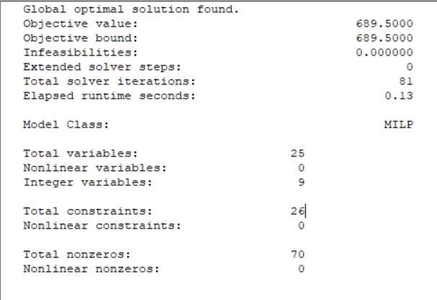

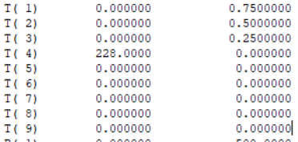

# Conclusion

At the beginning of the equation, demands are forecasted randomly,

x= 50 60 70 25 55 32 45 54 0;

9 points are chosen randomly, the last data is zero since we are talking about 8 weeks.

And Also the safety stocks are chosen randomly

s= 5 3 6 2 6 3 5 7 0;

9th data pointh, 9th week is also 0, since the asked mission is completed we do not need safety stock.

The final cost estimation is calculated as 689.5 TRY. 81 iteration is used.