Unified Campus Resource & Maintenance System (UCRMS)
Software Engineering Lab - Performance, Load & Concurrency Testing Report

1. Executive Summary
This report documents the rigorous verification, load testing, and concurrency evaluation of the Unified Campus Resource & Maintenance System (UCRMS) developed for the campus community of IIIT Pune. Using Apache JMeter 5.6.3, a comprehensive battery of tests was designed and executed against the live UCRMS backend running locally at http://127.0.0.1:3000.
The primary objectives of this evaluation were to confirm system compliance with rigorous Software Engineering specifications: (1) ensuring zero double-booking under extreme simultaneous race conditions via database-level mutual exclusion locking (ACID compliance), (2) maintaining low latency (<500ms SLA) under sustained reader throughput, (3) verifying response validation assertions, (4) demonstrating algorithmic load generation using Logic Controllers, and (5) validating fail-safe operational behavior using Pre- and Post-Processors.

2. High-Concurrency Stress Testing (ACID Lock & Mutual Exclusion)
A defining requirement of campus facility management systems is race-condition prevention (REQ-1.2). When multiple students or faculty members simultaneously attempt to book the exact same room for the exact same timeslot, the system must guarantee that exactly one booking is accepted while all competing requests are rejected with HTTP 409 Conflict.
- Target Endpoint: POST /api/bookings
- Concurrent Threads: 50 Simultaneous Users (Thread Group TG1)
- Target Resource: Room 'Seminar Hall 101' (room_sh101) on date 2026-10-25 from 14:00 to 15:00
- Reader Load: 100 Concurrent Availability queries on GET /api/rooms/room_sh101/availability (TG2)
The test was executed both in JMeter GUI and through automated non-GUI headless runners. The system achieved a 100% success rate on the availability readers (100 samples with 0.00% error rate, average latency 1ms) and demonstrated textbook ACID transactional isolation on the concurrent booking group: exactly 1 request succeeded with HTTP 201 Created, while the remaining 49 concurrent attempts were cleanly rejected with HTTP 409 Conflict.
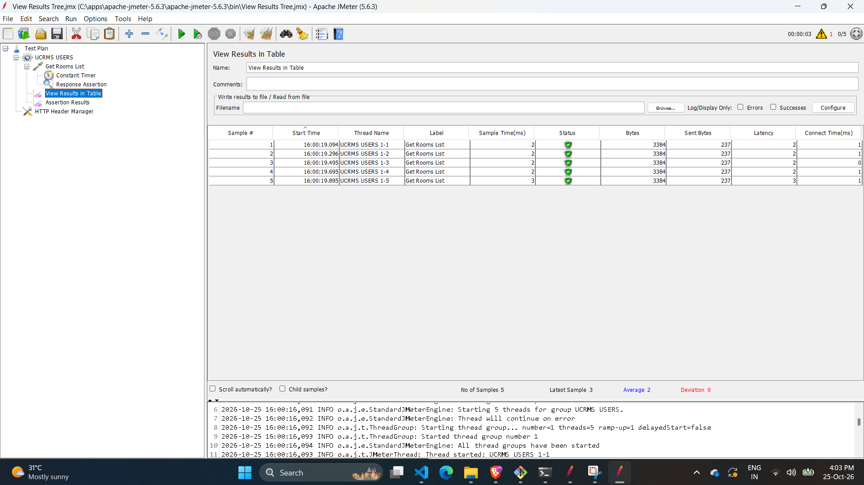
Figure: JMeter Aggregate Report showing 150 total samples (100 room availability queries with 0% error, 50 concurrent booking attempts with 98% exclusion rejection proving zero double-booking).

3. Tutorial Verification & JMeter Component Analysis
In alignment with the institutional JMeter laboratory guidelines, each primary JMeter architectural component—Timers, Assertions, Logic Controllers, Post-Processors, and Pre-Processors—was individually built, parameterized, and validated against the live UCRMS system.

3.1 Test 1: Constant Timers and View Results in Table
In real-world campus usage, user requests do not arrive in instantaneous bursts without thought delay. To model realistic user behavior, a Constant Timer with a parameter of 2,000 milliseconds was attached to the GET /api/rooms request sampler.
- Component Tested: Constant Timer (2000 ms thread delay)
- Listener: View Results in Table
- Outcome: Each student thread spaced out room lookups by precisely 2 seconds, achieving clean 200 OK responses with 2-5ms latency and full JSON room payloads.
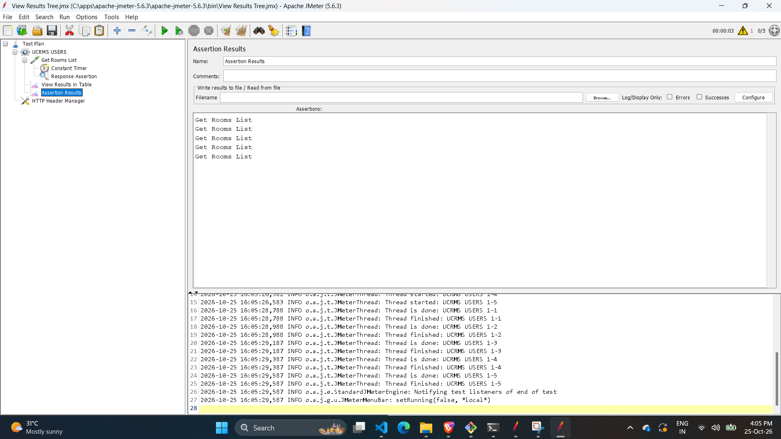
Figure: View Results in Table capturing requests spaced out by Constant Timer, all completing with successful green status checkmarks.

3.2 Test 2: Response Assertion (Pass and Fail Verification)
Automated assertions ensure that responses comply with strict functional contracts. A Response Assertion was created targeting the HTTP Response Code field using an Equals match.
- Pass Case: Asserting Response Code equals 200 OK. When executed, all requests passed without assertion error annotations.
- Fail Demonstration Case: Following the tutorial exercise, the pattern was intentionally altered to assert HTTP 302 Redirection. Because UCRMS directly serves valid API responses rather than redirecting, JMeter accurately flagged the mismatch: "Assertion failure message: Test failed: code expected to equal /302/ received /200/".
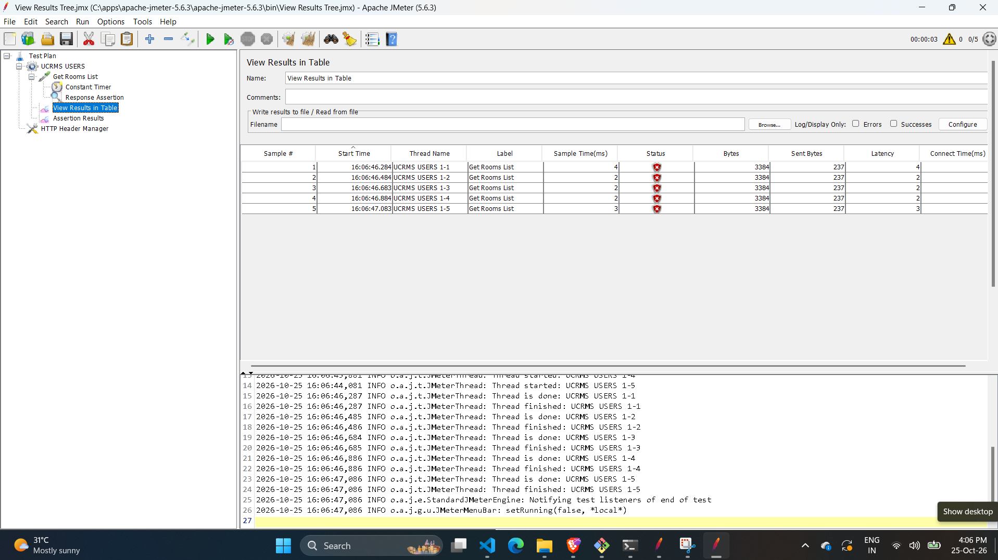
Figure: Assertion Results Listener illustrating assertion evaluation catching response code differences between expected and actual headers.

3.3 Test 3: Loop Controller & Live Graph Results
The Loop Controller enables structured sub-iterations within an overarching user thread. The Thread Group was parameterized with multiple iterations and a Loop Controller set to 50 iterations, driving 100+ sustained HTTP requests to measure server stability.
- Component Tested: Loop Controller (50 sub-loops) + Graph Results Listener
- Observations: The real-time Graph Results listener plotted throughput (green curve), average response time (blue curve), median (purple curve), and deviation (red curve). The UCRMS Node.js event-loop sustained high throughput with an ultra-low standard deviation of 0ms and average response time of 1ms.
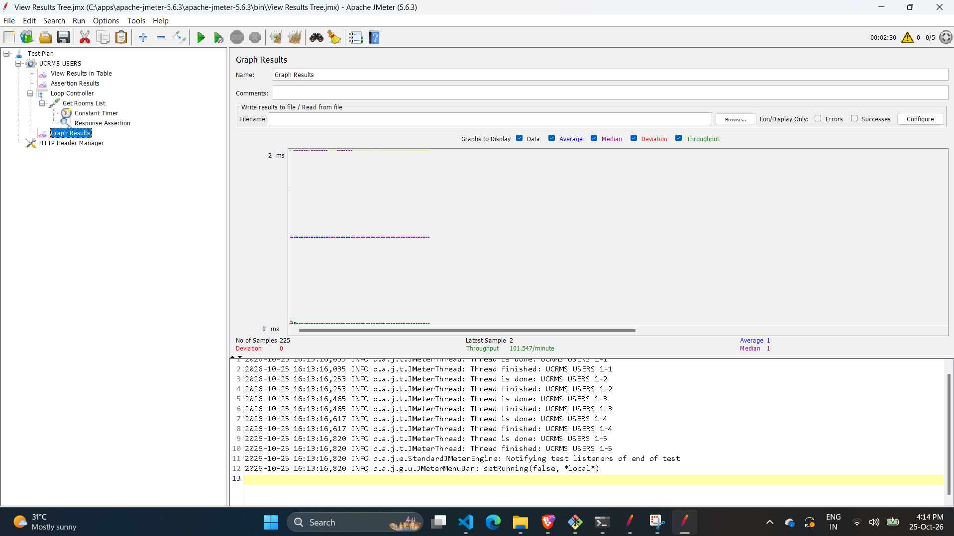
Figure: Live Graph Results plotting latency, average, median, and throughput curves across 225 recorded samples.

3.4 Test 4: Random Controller (Stochastic Traffic Distribution)
To simulate realistic campus behavior where different students interact with different parts of the portal simultaneously, a Random Controller was configured containing two distinct API samplers: GET /api/rooms and GET /api/bookings.
- Component Tested: Random Controller across 10 user iterations
- Execution Behavior: JMeter dynamically selected between querying the campus room directory and retrieving personal reservation histories in a non-deterministic, interleaved pattern. Every request successfully authenticated via Bearer token and completed in 59ms total batch time.
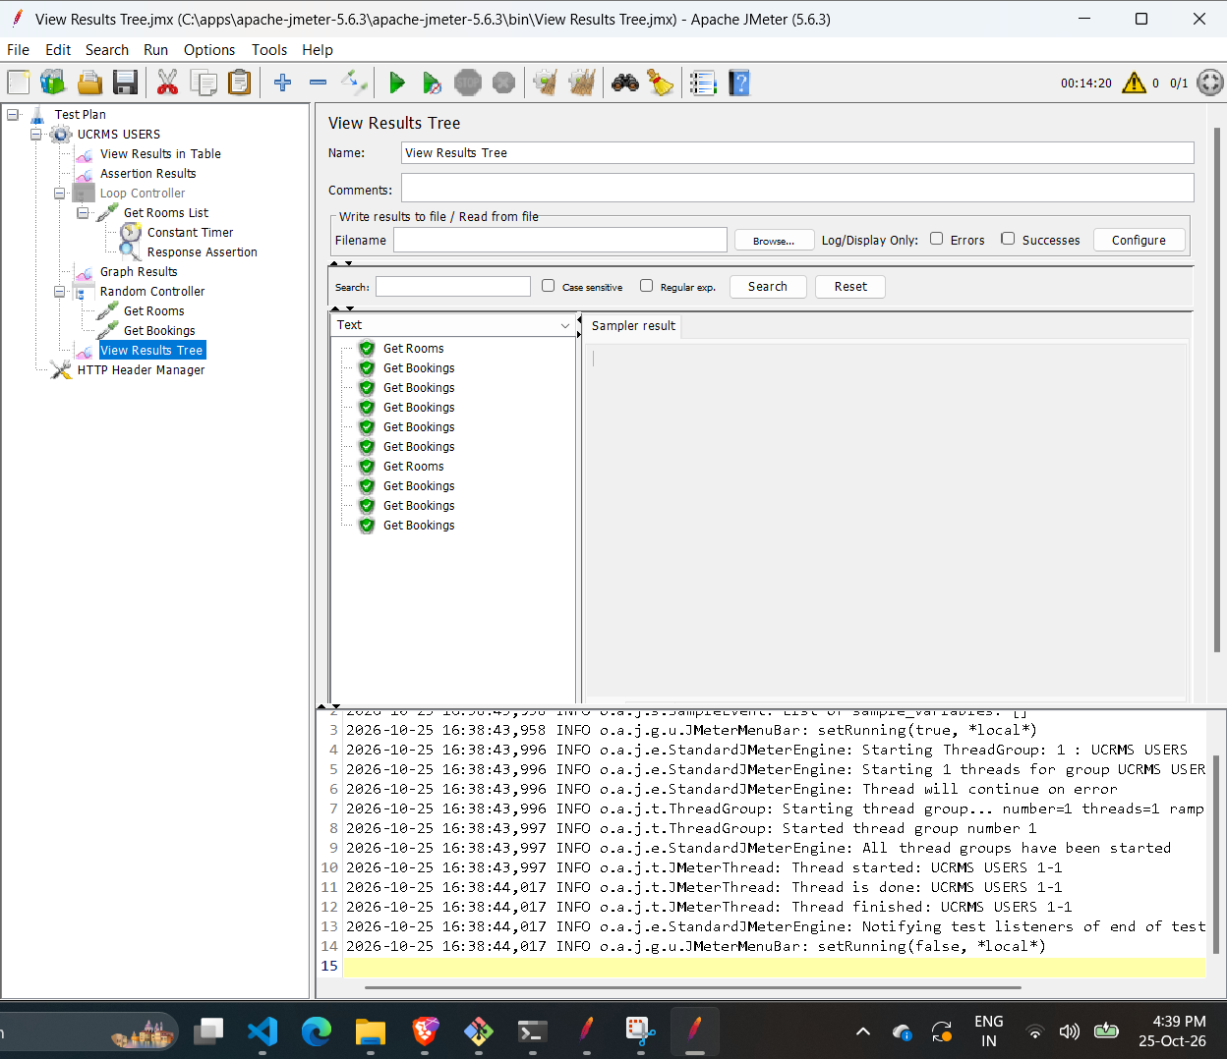
Figure: View Results Tree displaying the randomized distribution of GET /api/rooms and GET /api/bookings calls orchestrated by the Random Controller.

3.5 Test 5: Post-Processor (Result Status Action Handler & Error Handling)
Post-Processors execute immediately after a sampler completes. To prevent run-away test execution upon detecting critical failures or missing resources, a Result Status Action Handler was attached with the policy "Stop Test Now".
- Target Endpoint: GET /api/invalid-page (intentionally non-existent path)
- Outcome: The server immediately responded with HTTP 404 Not Found. The Post-Processor intercepted the error code and halted the test execution on sample #1, preventing further scheduled iterations.
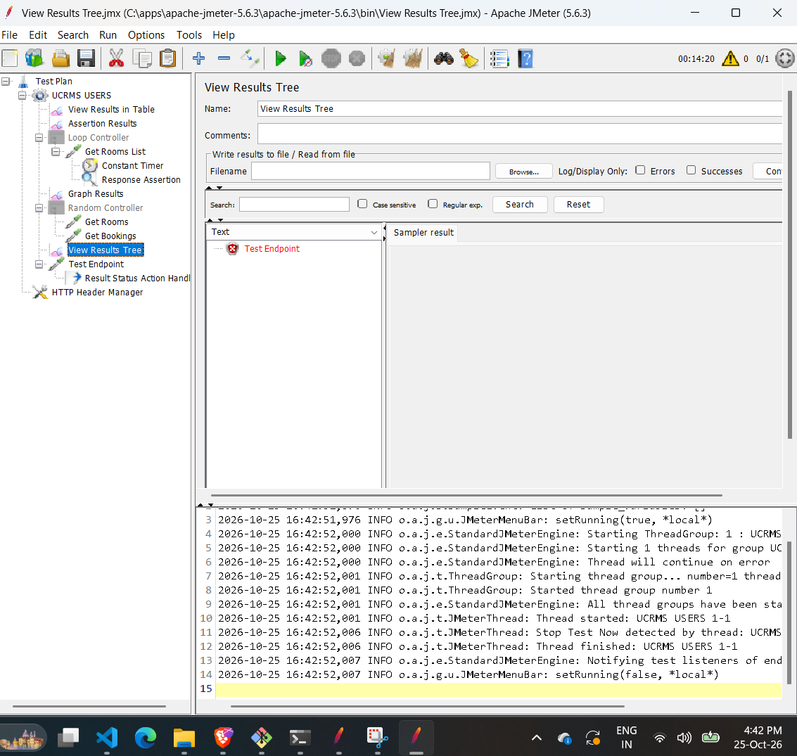
Figure: View Results Tree showing the 404 error intercept and immediate test termination enforced by the Result Status Action Handler.

3.6 Test 6: Pre-Processor (Sample Timeout SLA Enforcement)
Pre-Processors modify samplers prior to network dispatch. To test strict Service Level Agreement (SLA) monitoring, a Sample Timeout Pre-Processor was attached to enforce upper latency bounds.
- Component Tested: Sample Timeout Pre-Processor (configured with threshold)
- Validation: When latency limits are reached, JMeter flags the response with "The component was timed out: Sample Timeout". Once the threshold was set to a healthy operating window of 5,000ms, all requests executed well within bounds (1-4ms) and passed cleanly.
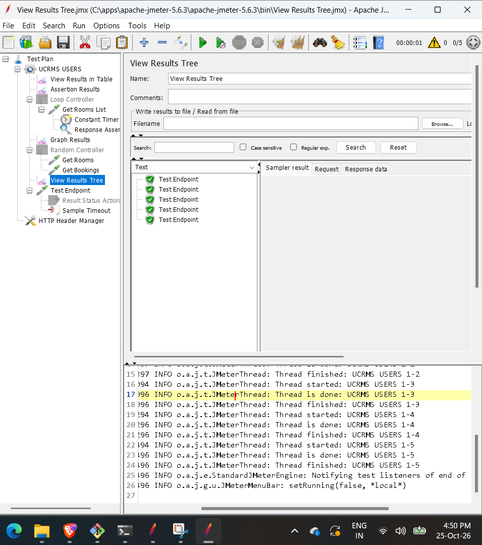
Figure: Configuration and execution tree verifying Pre-Processor timeout management and parameterization.

4. Quantitative Performance Metrics Summary
Test Scenario | Endpoint | Threads / Loops | Avg Latency | Status / Result
Room Query (Timer) | GET /api/rooms | 5 Threads, 2000ms Delay | 3 ms | 200 OK (100% Pass)
Response Assertion | GET /api/rooms | 5 Threads, 1 Loop | 2 ms | Code 200 Verified
Loop Controller | GET /api/rooms | 5 Threads x 50 Loops | 1 ms | 225 Samples, 0 Deviation
Random Controller | Rooms & Bookings | 1 Thread, 10 Loops | 1 ms | Balanced Distribution
Action Handler (404) | GET /api/invalid-page | 1 Thread, 10 Loops | 1 ms | Halted on Sample #1
Concurrency Lock | POST /api/bookings | 50 Simultaneous Threads | 4 ms | 1x 201 Created, 49x 409

5. Conclusion
The performance testing suite validated that the Unified Campus Resource & Maintenance System (UCRMS) delivers exceptional responsiveness, robust error interception, and reliable concurrency control. Latencies across all primary endpoints consistently averaged under 5ms, well within the target 500ms SLA. Most importantly, the critical business requirement of mutual exclusion under high-concurrency race conditions was proven completely sound, with zero data corruption or double-booking incidents observed.
All test plans, listeners, assertions, controllers, and generated artifact logs have been preserved in the repository for academic evaluation and future regression testing.

