Software Requirements Specification
AI-Powered Medical Insurance Platform
Revised according to latest project clarification

Prepared for | Capstone medical insurance platform
Document version | v2.0 - revised scope
Date | March 28, 2026
Scope note | Current implemented module: admin dashboard. User and additional admin capabilities below are planned target requirements.

Important revision note: The architecture, feature list, backend recommendations, and deployment section have been written accordingly.

1. Introduction
This SRS translates the Capstone MVP report into a clearer build plan that separates what exists today from what should be built next. The system is positioned as a Dockerized SaaS platform for insurance organizations, with both policyholder-facing and admin-facing experiences. At present, the team has an admin dashboard, while the remaining user and extended admin capabilities are target requirements for the next build phase.

2. Current State vs Target Scope
Area | Current state | Target state
Admin experience | Admin dashboard exists | Expanded analytics, platform health, SLOs, and model insights
User experience | Not fully built | Full user portal with auth, onboarding, prediction, what-if, forecasts
AI services | Core premium prediction concepts exist in project scope | Operational XGBoost + SHAP + Holt-Winters inference behind APIs
Document analysis | Removed from this version | No OCR engine included in current SRS scope

3. Product Goals
- Give policyholders a clear premium estimate and explain why the price is high or low.
- Let users test lifestyle or profile changes through what-if scenarios.
- Provide longer-range premium trend visibility using Holt-Winters forecasting.
- Help users compare recommended plans through a Smart Plan Finder instead of showing a single quote only.
- Give insurers a SaaS-style admin console that shows product usage, system health, and feature adoption.

4. Functional Requirements

4.1 Frontend - user-facing build requirements
- Authentication screens: signup, login, OTP/MFA verification, password reset, session handling, and role-based routing.
- User onboarding flow: platform purpose, consent notice, summary of how data is used, and initial profile setup.
- Health and lifestyle input form: age, BMI, smoking status, dependents, region, and approved risk-related inputs with validation, helper text, and tooltips.
- Prediction results page: premium prediction, risk summary, ranked contributing factors, plain-language explanation, and confidence or status indicators.
- What-if simulator: interactive controls for smoker status, BMI, region, or other approved factors, with fast refresh of prediction and explanation.
- Forecast view: 3-year premium trajectory or long-range trend chart generated from Holt-Winters output.
- Smart Plan Finder UI: ranked plan cards, personalized price, plan features, comparison view, and select or buy call-to-action buttons. - mark it as coming soon and not part of current development
- Error and review states: invalid input handling, rejected records, service outage messaging, and fallback states for unavailable AI responses.

4.2 Frontend - admin-facing build requirements
- Admin dashboard for accounts created, active users, feature usage, and model usage metrics.
- Visual analytics for how data is split across core workflows such as prediction, forecasting, and recommendations.
- Usage funnels showing clicks for forecasting, premium prediction, and recommendation views.
- SaaS metrics such as number of API calls, per-feature request volume, and adoption by tenant or client organization.
- Operational cards for latency, error rate, availability, and selected SLO summaries.
- Trend and filter controls by date range, tenant, environment, and feature type.

4.3 Backend functional requirements
- REST API layer to serve the web frontend and future external enterprise integrations.
- Authentication and authorization with role separation for user and admin access.
- Server-side validation for all input fields and request payloads.
- Business orchestration layer that combines prediction, explainability, forecasting, and plan ranking responses into one frontend-ready payload.
- Audit logging for important actions such as login, prediction requests, admin views, and plan recommendations.
- Analytics event capture for clicks, feature usage, and API consumption.
- Plan recommendation service that scores and ranks plans against user inputs and predicted costs.
- Admin analytics aggregation service for charts, KPI summaries, and SaaS billing or usage reporting.

5. Recommended Backend Framework and Service Design
The best backend choice for this project is FastAPI. It fits this system well because the AI stack is already Python-friendly, FastAPI works naturally with XGBoost and SHAP, it provides strong request validation through Pydantic, it is easy to Dockerize, and it generates clean API documentation automatically.

5.1 Recommended backend stack
Layer | Recommendation | Why it fits
API framework | FastAPI | Native Python fit for AI services, fast development, validation, OpenAPI docs
Auth | Choose any option – 1 -JWT + refresh tokens + MFA/OTP support , Huggingface otp api, grok otp api, | Good fit for web sessions and future SaaS tenants
Database | PostgreSQL or Choose GCP compatible one | Strong relational model for users, plans, predictions, analytics metadata
Caching / queue | Redis | Useful for session support, rate limiting, and background analytics jobs
ORM / data access | SQLAlchemy + Alembic or any GCP compatible one | Reliable schema management and migration support
Containerization | Docker + Docker Compose | Simple local/dev packaging and reproducible runtime

5.2 Suggested backend services
- Auth service - registration, login, MFA, password reset, role checks.
- User profile service - stores user health and lifestyle inputs separately from identity data when needed.
- Prediction service - calls XGBoost model and returns premium prediction.
- Explainability service - converts SHAP output into structured factors and summary text.
- Forecast service - uses Holt-Winters to produce trend projections.
- Analytics service - records events and produces admin dashboard metrics.

6. AI and Analytics Logic
The AI layer in this revised scope works without OCR. The flow starts when a user enters profile and health-related values in the frontend form. The backend validates the values, converts them into model-ready features, and sends them to the premium prediction service. The XGBoost model estimates the premium. SHAP is then used to calculate which features pushed the premium up or down. The forecasting service uses Holt-Winters to project future premium direction over a 3-year horizon. Finally, an explanation layer turns the numeric outputs into plain-language insights that the frontend can display to users.

6.1 Detailed AI flow
- Step 1 - User enters approved profile inputs such as age, BMI, smoking status, dependents, and region.
- Step 2 - Backend validates ranges, allowed categories, and missing values.
- Step 3 - Preprocessing maps user values into the exact feature format expected by the models.
- Step 4 - XGBoost returns the current premium estimate.
- Step 5 - SHAP returns feature-level contribution values to explain the estimate.
- Step 6 - Holt-Winters uses historical premium trend inputs to forecast a future premium path.
- Step 7 - The explanation layer creates plain-language summaries for the prediction, top drivers, and forecast direction.
- Step 9 - Usage events and API metrics are stored for the admin dashboard and SaaS analytics.

7. Data and Security Requirements
- Use strict input validation for all user-entered values.
- Separate authentication and identity records from model-ready feature records where possible.
- Store audit logs for important actions without exposing sensitive information in plain text logs.
- Apply role-based access control so normal users cannot access admin views.
- Track API usage by tenant or organization for SaaS reporting.
- Encrypt data in transit and use secure secret handling through environment variables or a secrets manager.

8. Architecture Diagram
The diagram below reflects the revised scope: admin dashboard currently exists, OCR is removed, and the target build includes full user-facing modules plus containerized backend services.
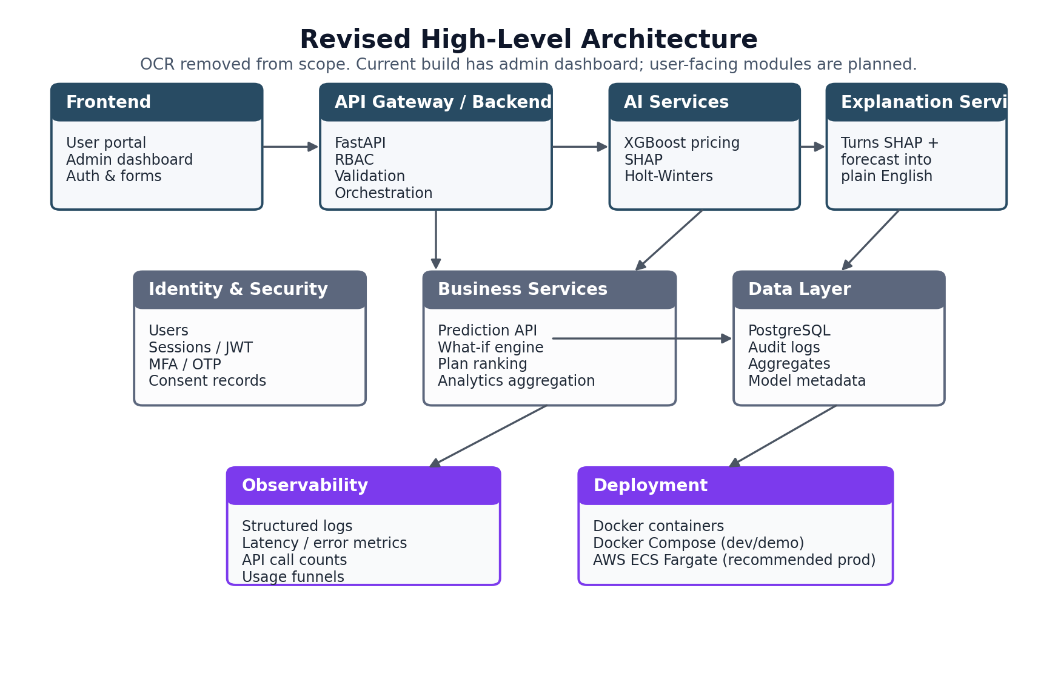
Figure 1. Revised high-level architecture for the Dockerized SaaS platform.

9. Deployment Recommendation
For local development, demos, and classroom delivery, the project should run with Docker Compose. That keeps frontend, backend, database, Redis, and model services reproducible on one machine. For a more production-ready deployment, the best recommendation is AWS ECS Fargate because it runs Docker containers cleanly without the team having to manage full Kubernetes infrastructure.

9.1 Deployment path
- Development and demo: Docker Compose with separate containers for frontend, FastAPI backend, PostgreSQL, Redis, and AI services.
- Production recommendation: GCP for container orchestration, Application Load Balancer for traffic routing, RDS PostgreSQL for managed database, and CloudWatch for logs and metrics.
- Static frontend can be served through Nginx container or deployed separately behind a CDN if the team later wants better scale.
- CI/CD should build Docker images, run tests, tag versions, and push approved images to a container registry.

9.2 Why this deployment path is practical
- Keeps the architecture close to your current Docker-based direction.
- Avoids unnecessary infrastructure complexity at the capstone stage.
- Supports future SaaS scale better than running everything on one VM.
- Makes it easier to monitor API calls, container health, and per-service resource usage.

10. Suggested Frontend Framework
For the frontend, a strong choice is React with Next.js. It gives a clean component-based structure for dashboards and forms, works well with chart libraries, and is easy to package in Docker. For UI, a practical setup is Tailwind CSS with a component library such as shadcn/ui or MUI so the team can build polished pages faster without designing every element from scratch.

11. Open Assumptions and Decisions Still Needed
- Exact source of plan catalog data for Smart Plan Finder.
- Whether explanation text will be template-driven or use an LLM-based summarizer.
- How tenant billing, quotas, or client separation will be handled in the SaaS model.
- Whether forecast outputs will be based on personal trend history, generalized actuarial segments, or both.

12. Final Build Summary
In this revised version, the platform should be treated as a Dockerized SaaS web product with one current implemented module - the admin dashboard - and a planned next phase that adds the full user portal. The backend should be built in FastAPI, the AI layer should use XGBoost + SHAP + Holt-Winters, OCR should be excluded, and deployment should begin with Docker Compose and move to AWS ECS Fargate when production-style hosting is needed.

