JAVA MINI PROJECT REPORT

Electricity Consumption
Analyzer
Case Study 184

Project Title | Electricity Consumption Analyzer
Programming Language | Java
Core Concepts | Arrays, loops, methods, operators, conditional statements, searching
Prepared by | Aditya Khare

A menu-driven Java program to record, analyze, and search monthly electricity consumption.

1. Introduction
The Electricity Consumption Analyzer is a console-based Java application designed to organize monthly electricity usage records for customers. It stores customer IDs, names, and consumption values, then calculates summary statistics and helps identify customers whose usage meets or exceeds a selected threshold.

2. Objectives
- Record customer ID, name, and monthly electricity consumption in kWh.
- Calculate average monthly consumption.
- Find the customer with the highest consumption.
- Detect high-consumption accounts using a threshold entered by the user.
- Generate a formatted analysis report and search customer records by ID or name.
- Demonstrate core Java concepts through a modular, menu-driven program.

3. Software and Concepts Used
Concept / Tool | Use in the project
Java | Main programming language.
Scanner | Reads user input from the console.
One-dimensional arrays | Stores customer IDs, names, and consumption values.
Loops | Processes records and calculates totals.
Operators | Adds consumption values and divides by customer count.
if-else | Classifies each record as high usage or normal.
Methods | Separates data entry, calculation, reporting, and searching.
Linear search | Locates a record by ID or exact name.

4. Program Modules

1. Consumption Entry
Allows the user to enter the number of customers and provide each customer's ID, name, and monthly consumption. Negative consumption values are rejected.

2. Average Calculation
Adds all consumption values and divides the total by the number of records.

3. Highest Consumption
Compares values and displays the customer with the highest usage.

4. High Usage Detection
Compares each customer's consumption with a user-provided threshold and labels the record as HIGH USAGE or Normal.

5. Analysis Report
Displays all records along with total consumption, average consumption, customer count, and the highest-use customer.

6. Customer Search
Searches customer records by ID or name and displays the matching details.

7. Exit
Closes the program when the user chooses the exit option.

5. Program Screenshots
The screenshots below illustrate the program interface and representative outputs based on the sample records included in the supplied source code.
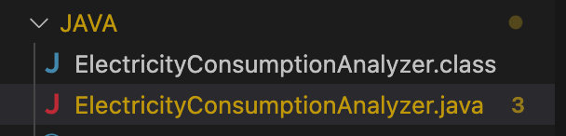
Screenshot 1. Java source and compiled class visible in the IDE.
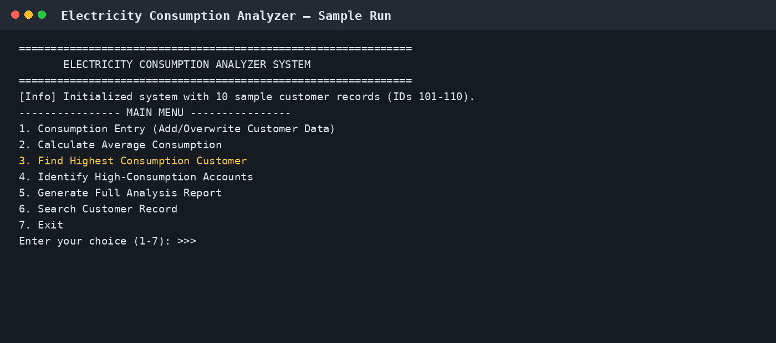
Screenshot 2. Main menu and available program options.
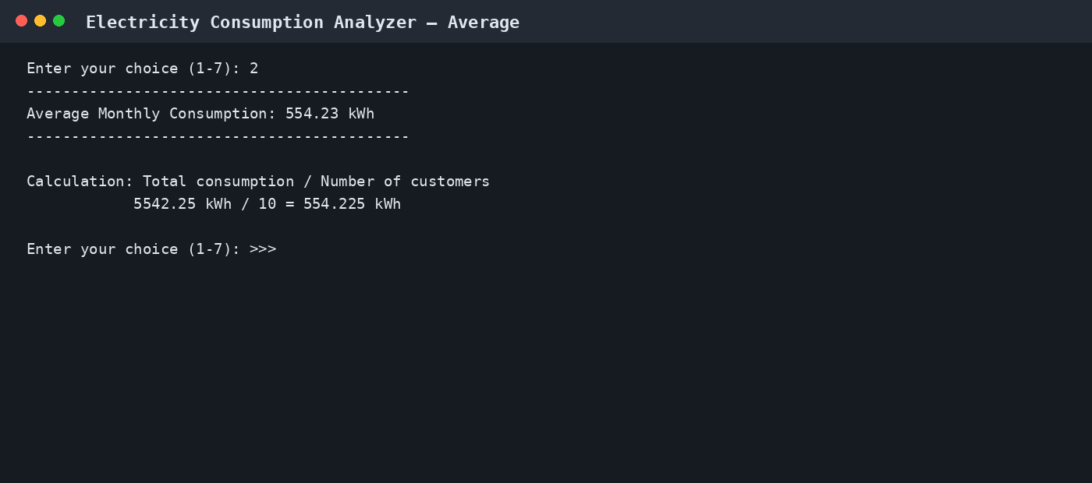
Screenshot 3. Average monthly consumption output.
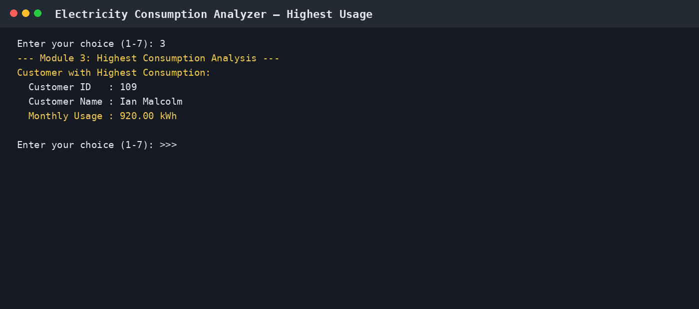
Screenshot 4. Highest-consumption customer output.
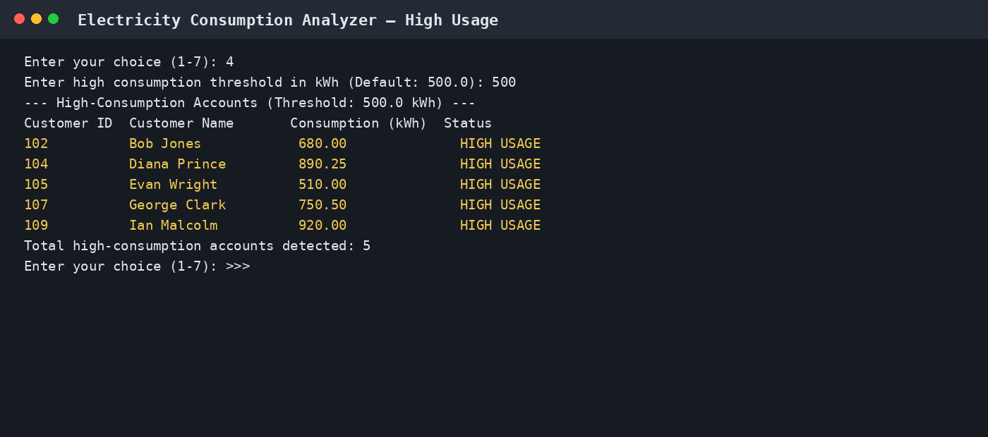
Screenshot 5. High-usage detection with a 500 kWh threshold.
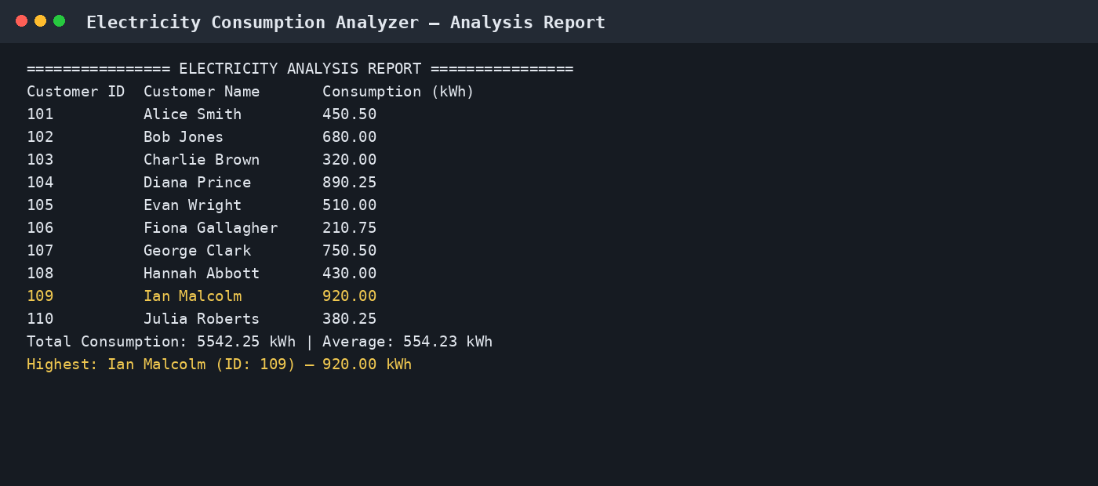
Screenshot 6. Full analysis report with summary metrics.
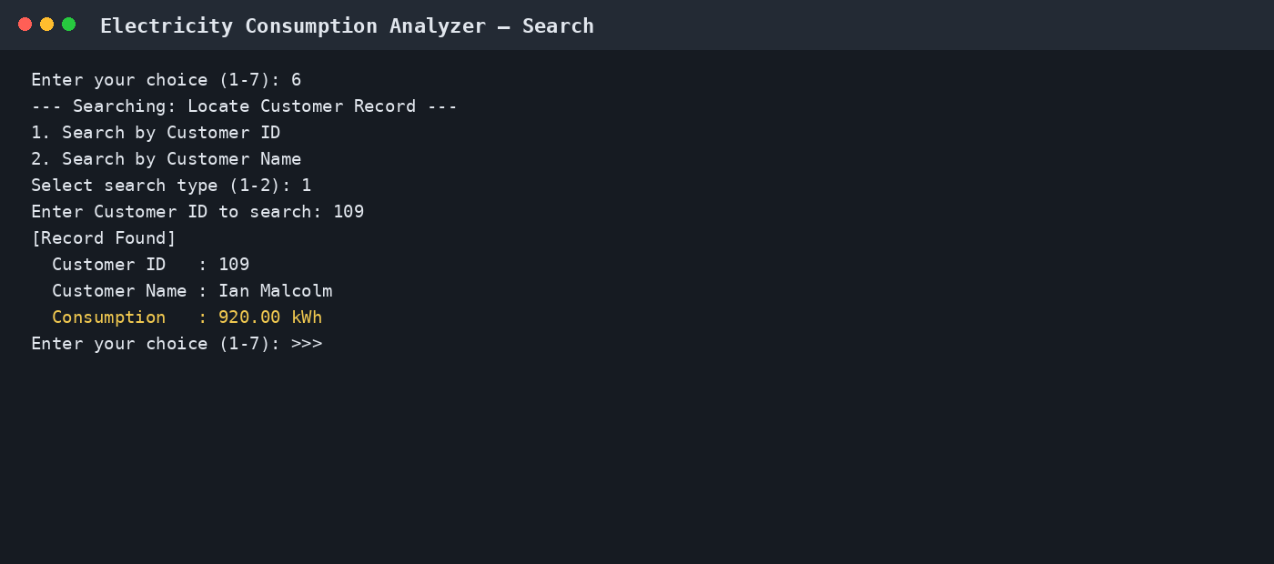
Screenshot 7. Searching for a customer by ID.

6. Sample Results
Metric | Sample result
Number of sample customers | 10
Total consumption | 5542.25 kWh
Average consumption | 554.225 kWh (displayed as 554.23 kWh)
Highest consumption | Ian Malcolm, Customer ID 109 — 920.00 kWh
High-usage accounts at 500 kWh threshold | 5

7. Algorithm / Workflow
- Start the program and initialize the sample customer arrays.
- Display the menu and read the user's choice using Scanner.
- Run the selected module: data entry, average, highest usage, high-usage detection, report, or search.
- Use loops and conditions to process the records and display the result.
- Return to the menu until the user selects Exit.

8. Conclusion
The Electricity Consumption Analyzer demonstrates how fundamental Java features can be combined to solve a practical record-analysis problem. Arrays store related customer data, loops process the records, methods keep the program organized, and conditional statements identify high usage. The report and search options make the sample application easier to use and demonstrate its core functionality.

9. Future Enhancements
- Save customer records to a file so that data remains available after the program closes.
- Add validation to prevent duplicate customer IDs and blank customer names.
- Allow partial-name searching and updating or deleting existing records.
- Add electricity tariff rates and calculate estimated bills.

