Movie Ticket Booking System – Component Explanations

App Component (app.ts)
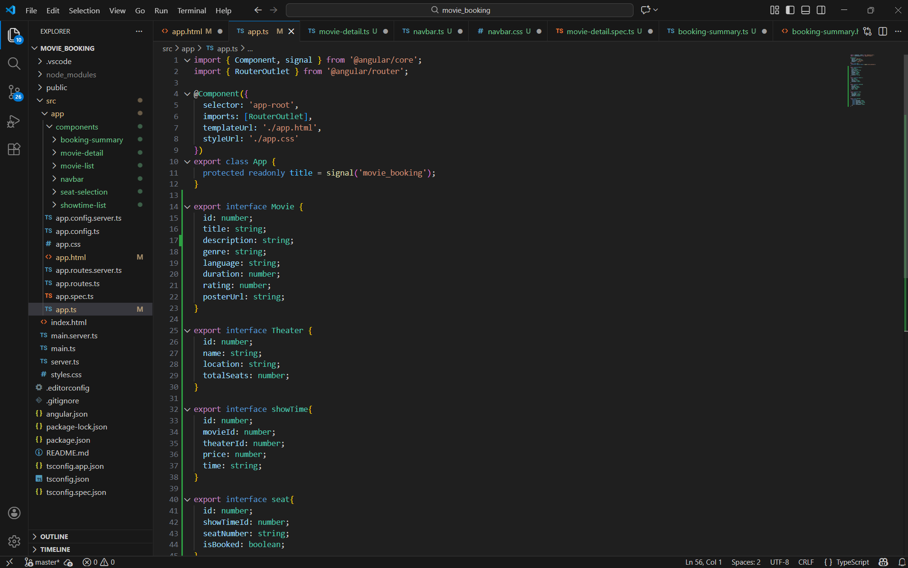
This is the root component of the Angular application. It bootstraps the app, loads routed components using RouterOutlet, and defines global interfaces such as Movie, Theatre, Showtime, and Seat for structured data modeling.

Booking Summary Component (HTML)
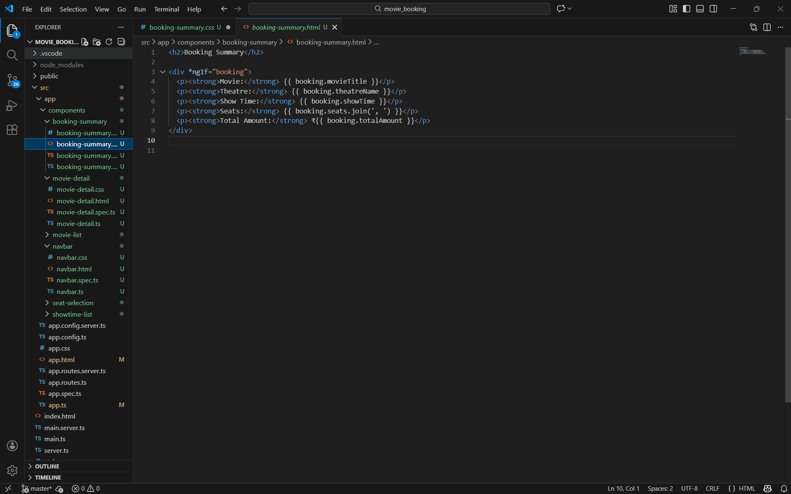
This template displays the final booking details such as movie name, theatre, show time, selected seats, and total amount using Angular data binding and *ngIf for conditional rendering.

Booking Summary Component (TypeScript)
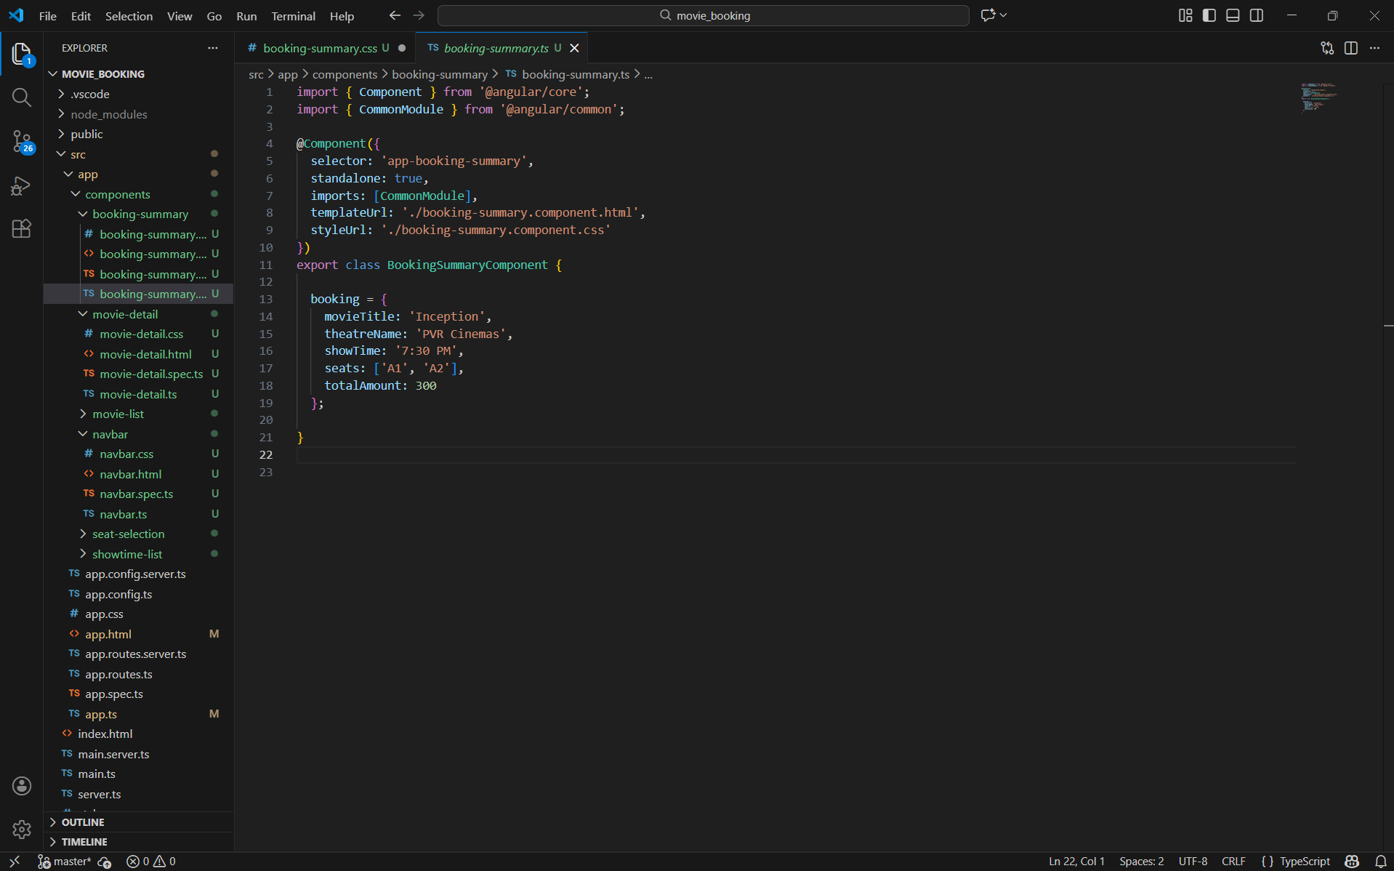
This component defines a hard-coded booking object used by the template. It demonstrates structured data usage and acts as a confirmation view in the booking workflow.

Movie Detail Component (HTML)
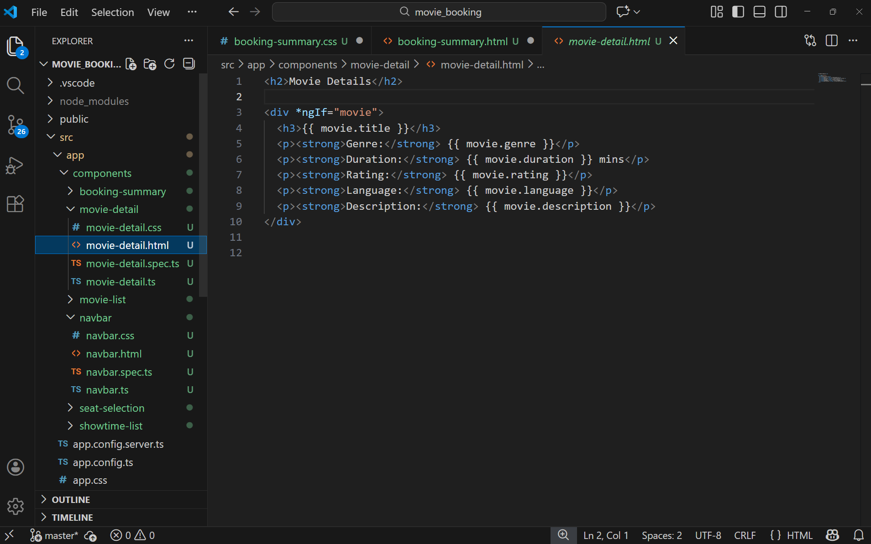
This template shows detailed information about a single movie. It uses interpolation to display movie properties and *ngIf to ensure data exists before rendering.

Movie Detail Component (TypeScript)
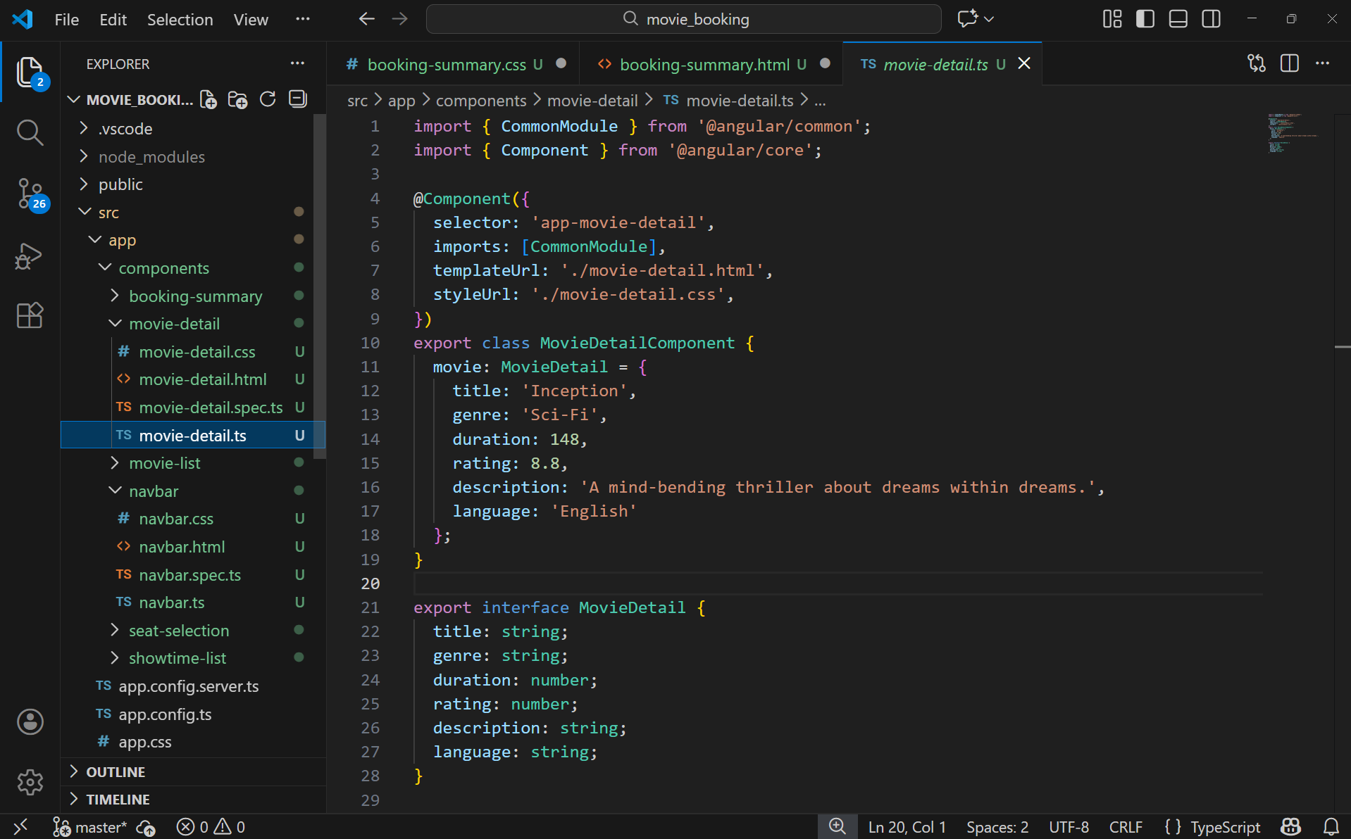
This component holds a single movie object typed using an interface. It demonstrates component-level data binding and structured data modeling for movie details.

Movie List Component (HTML)
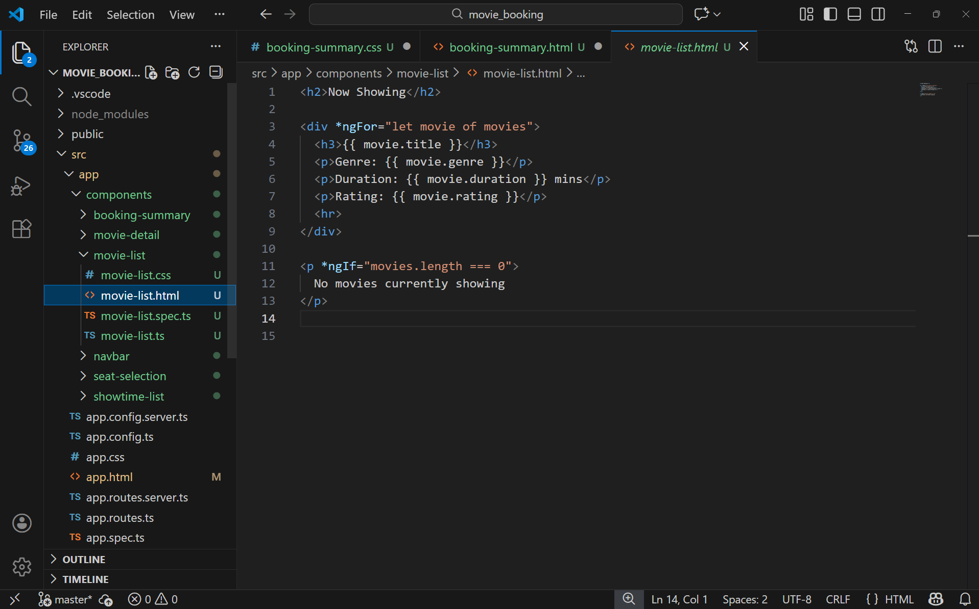
This template displays a list of currently showing movies using *ngFor. It also uses *ngIf to handle the case when no movies are available.

Movie List Component (TypeScript)
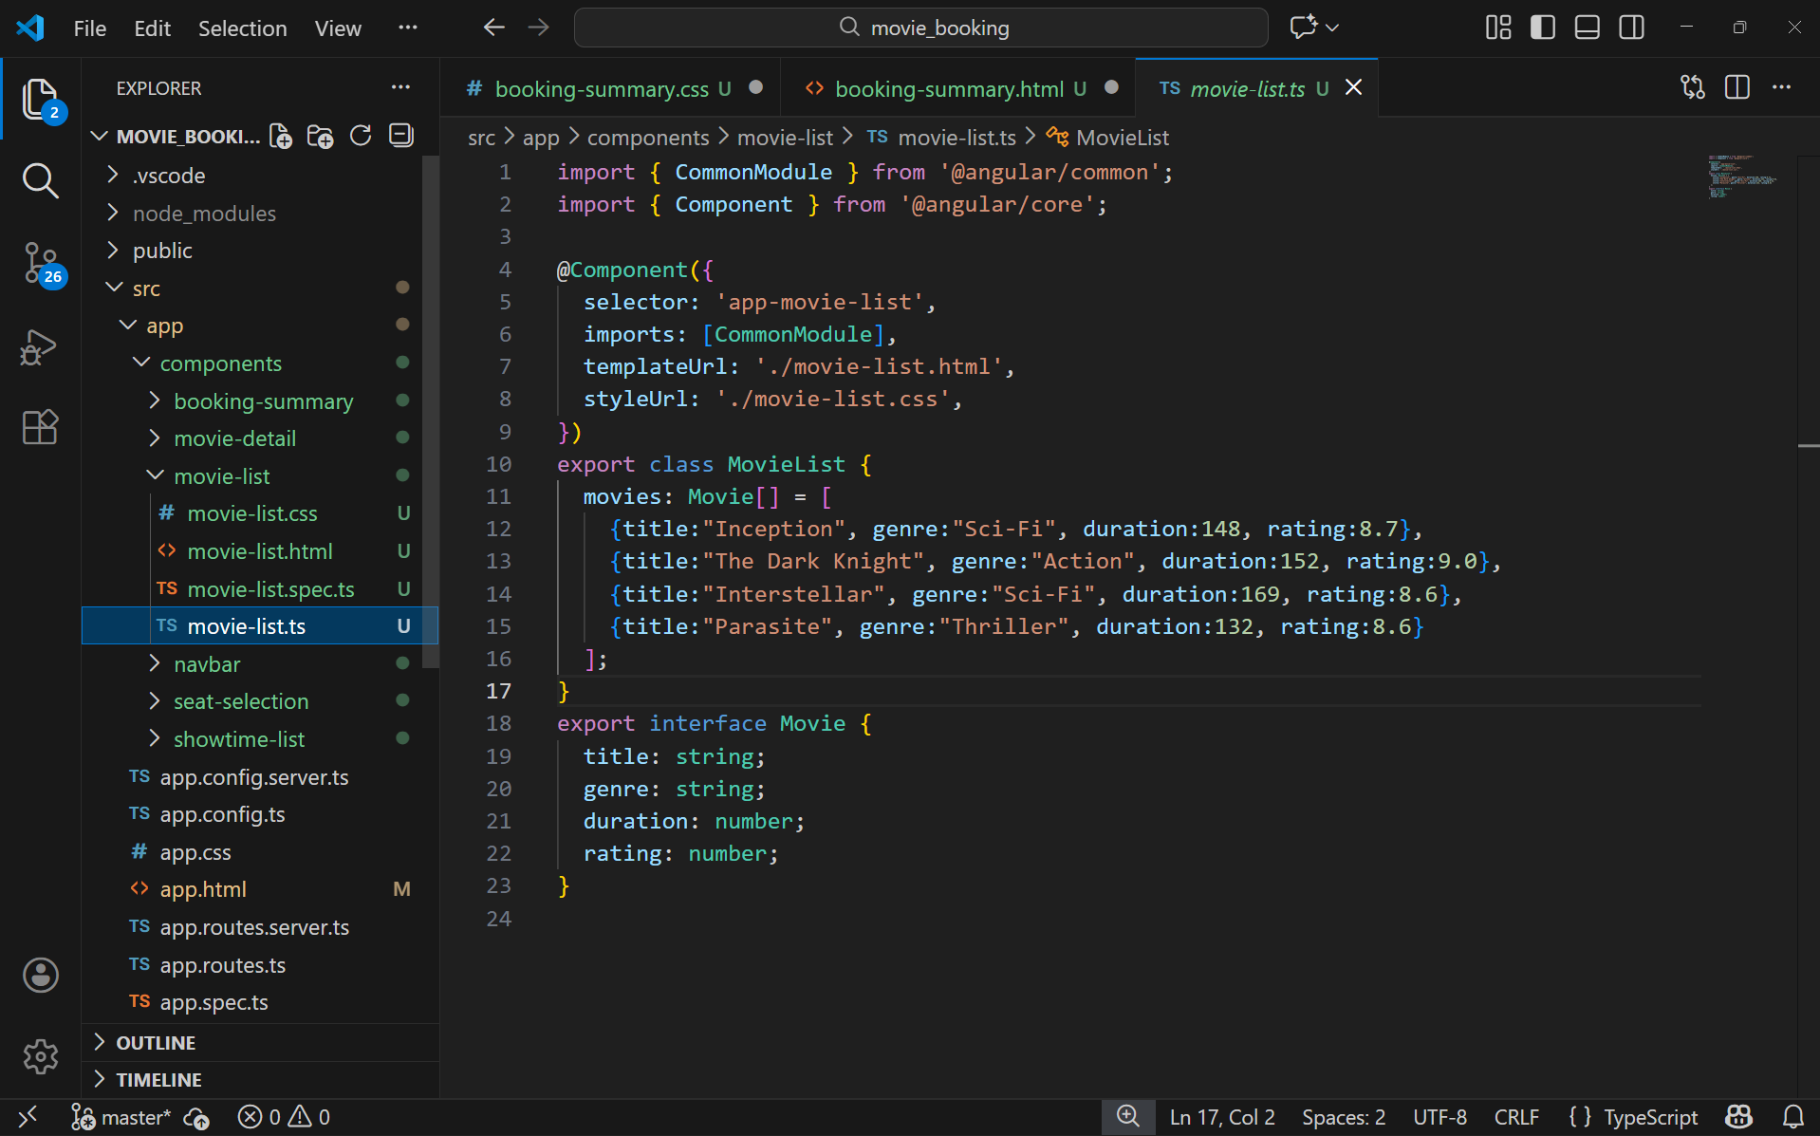
This component defines an array of movies using a Movie interface. It provides mock data and demonstrates list rendering through Angular directives.

Navbar Component (HTML)
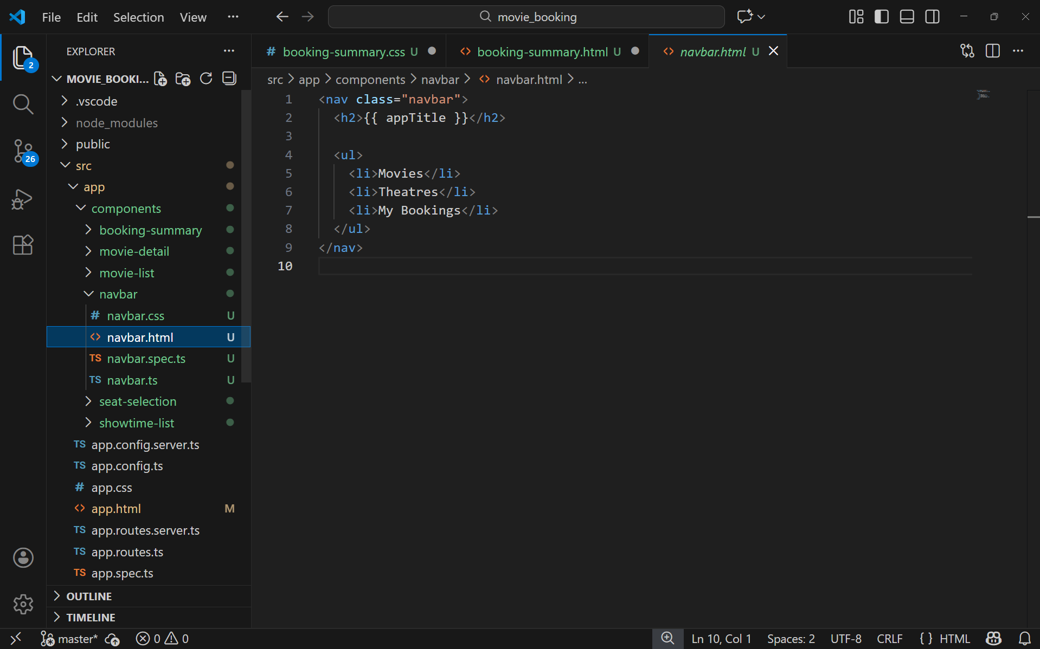
This template defines the navigation bar of the application. It displays the application title using data binding and lists navigation options such as Movies, Theatres, and My Bookings.
Navbar Component (TypeScript)
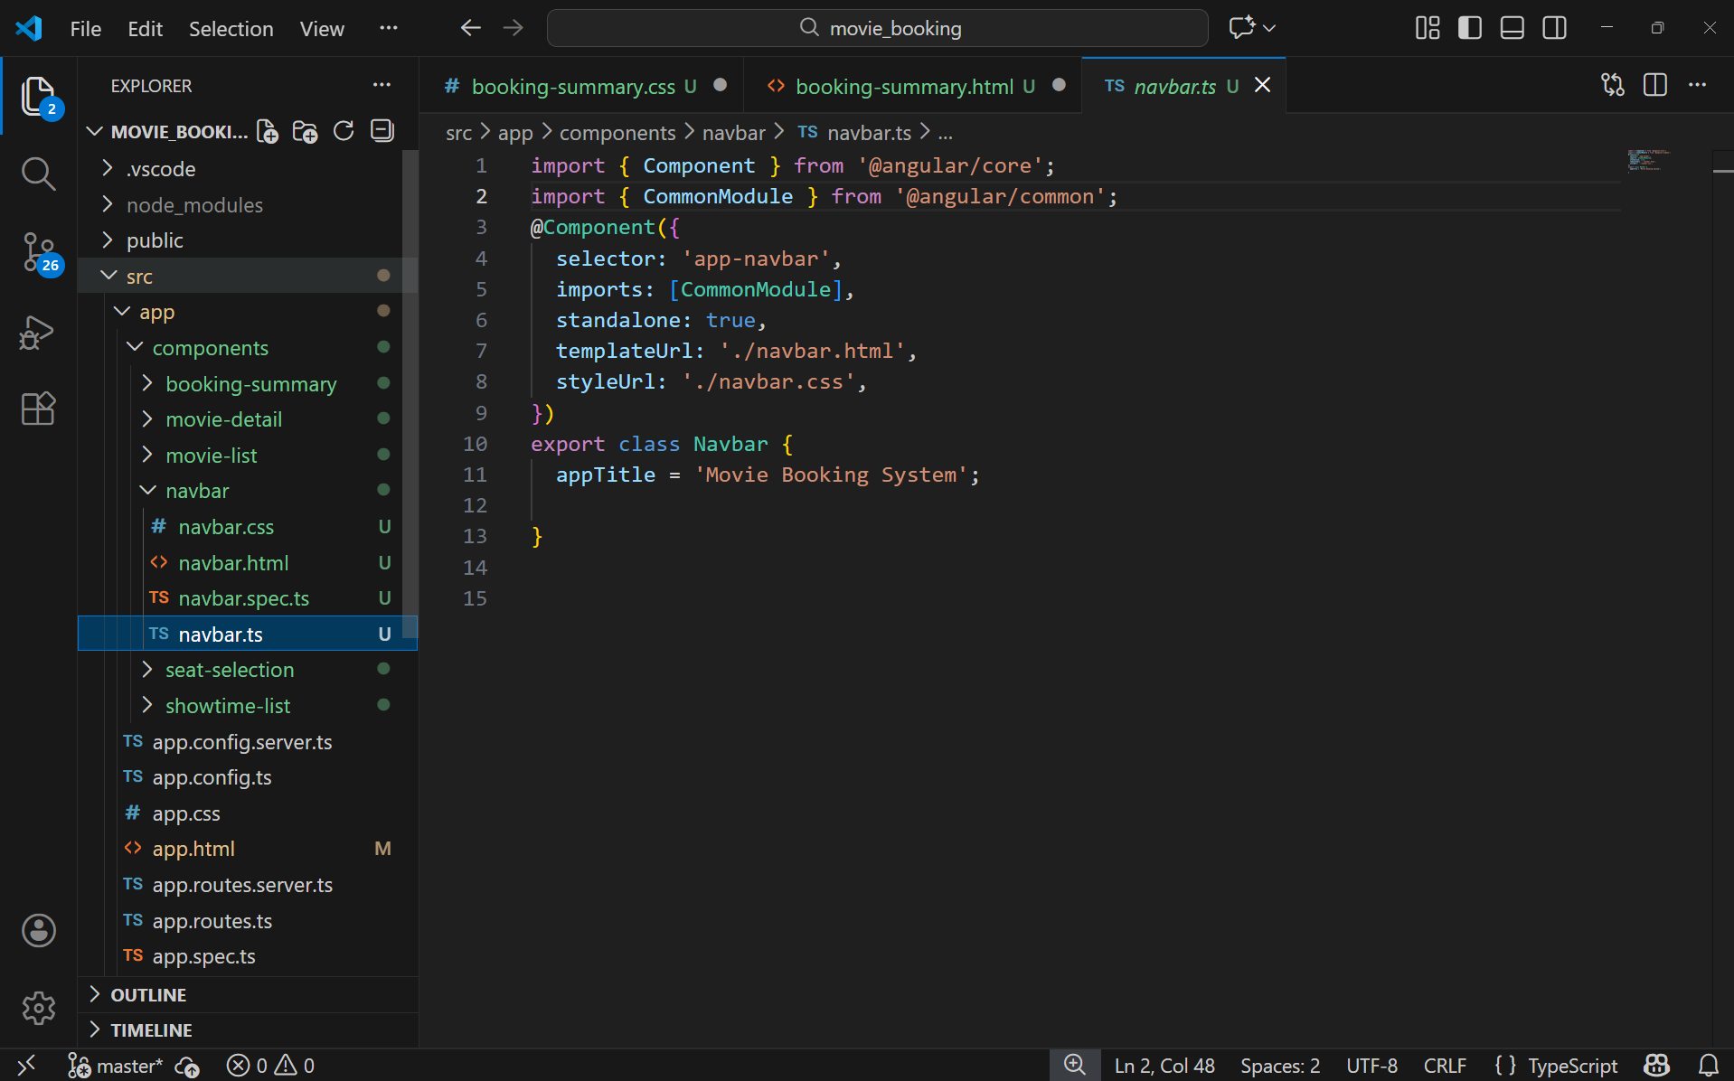
This component controls the navbar logic. It defines the application title and connects the HTML template with Angular using a standalone component configuration.
Seat Selection Component (HTML)
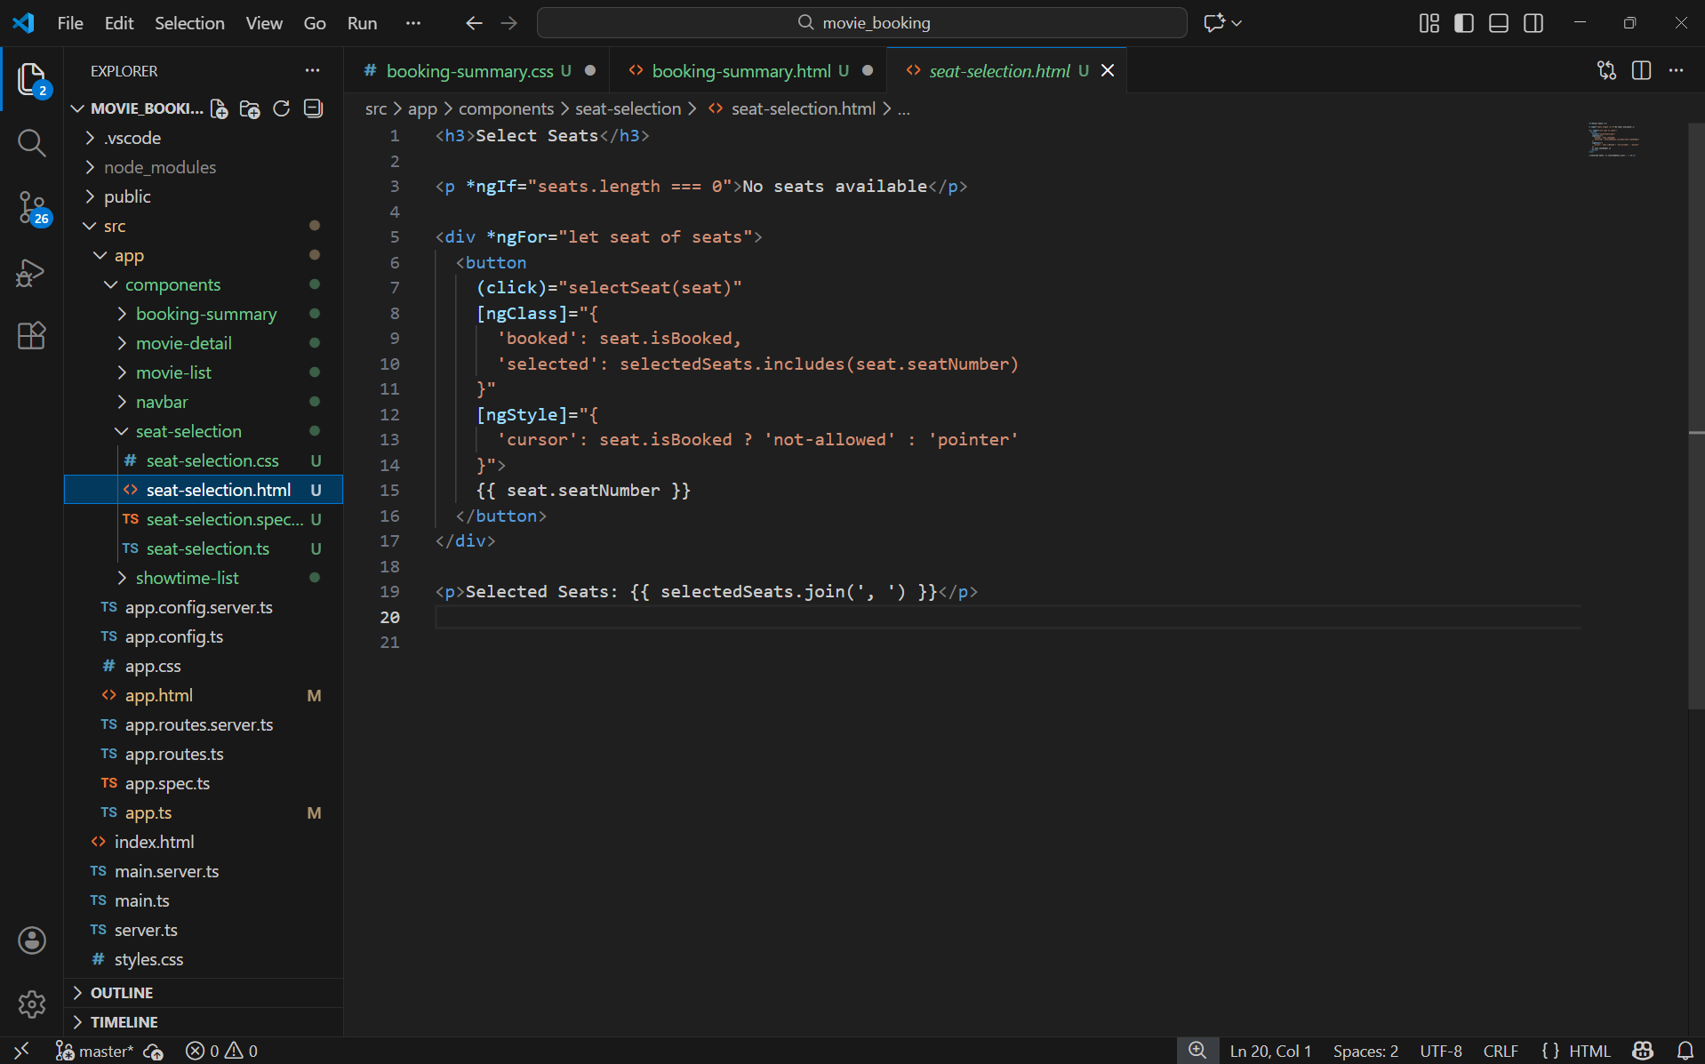
This template displays available seats using *ngFor. It uses event binding for seat selection, *ngIf for empty state handling, and ngClass/ngStyle for dynamic styling based on seat status.
Seat Selection Component (TypeScript)
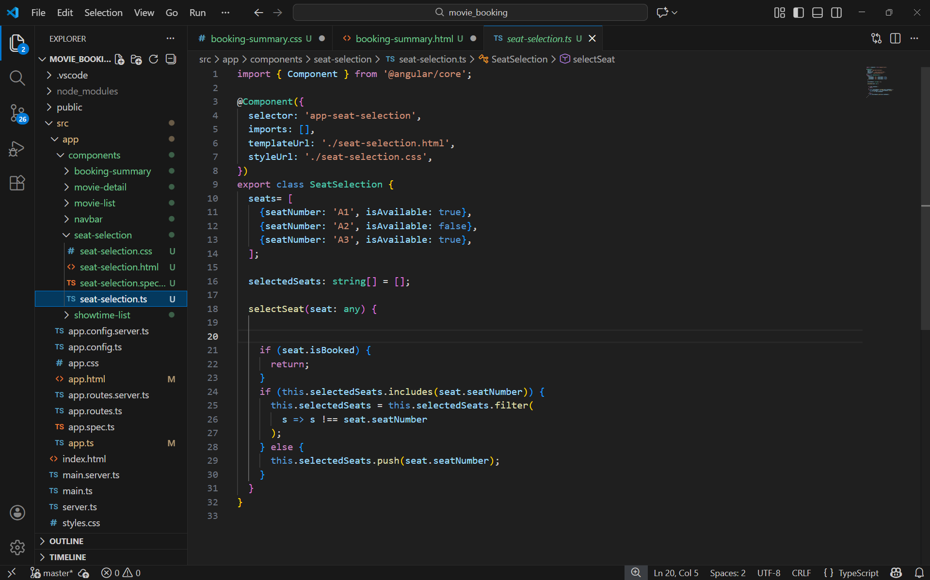
This component manages seat selection logic. It maintains a list of seats and selected seats, and updates the selection state when the user interacts with the UI.
Showtime List Component (HTML)
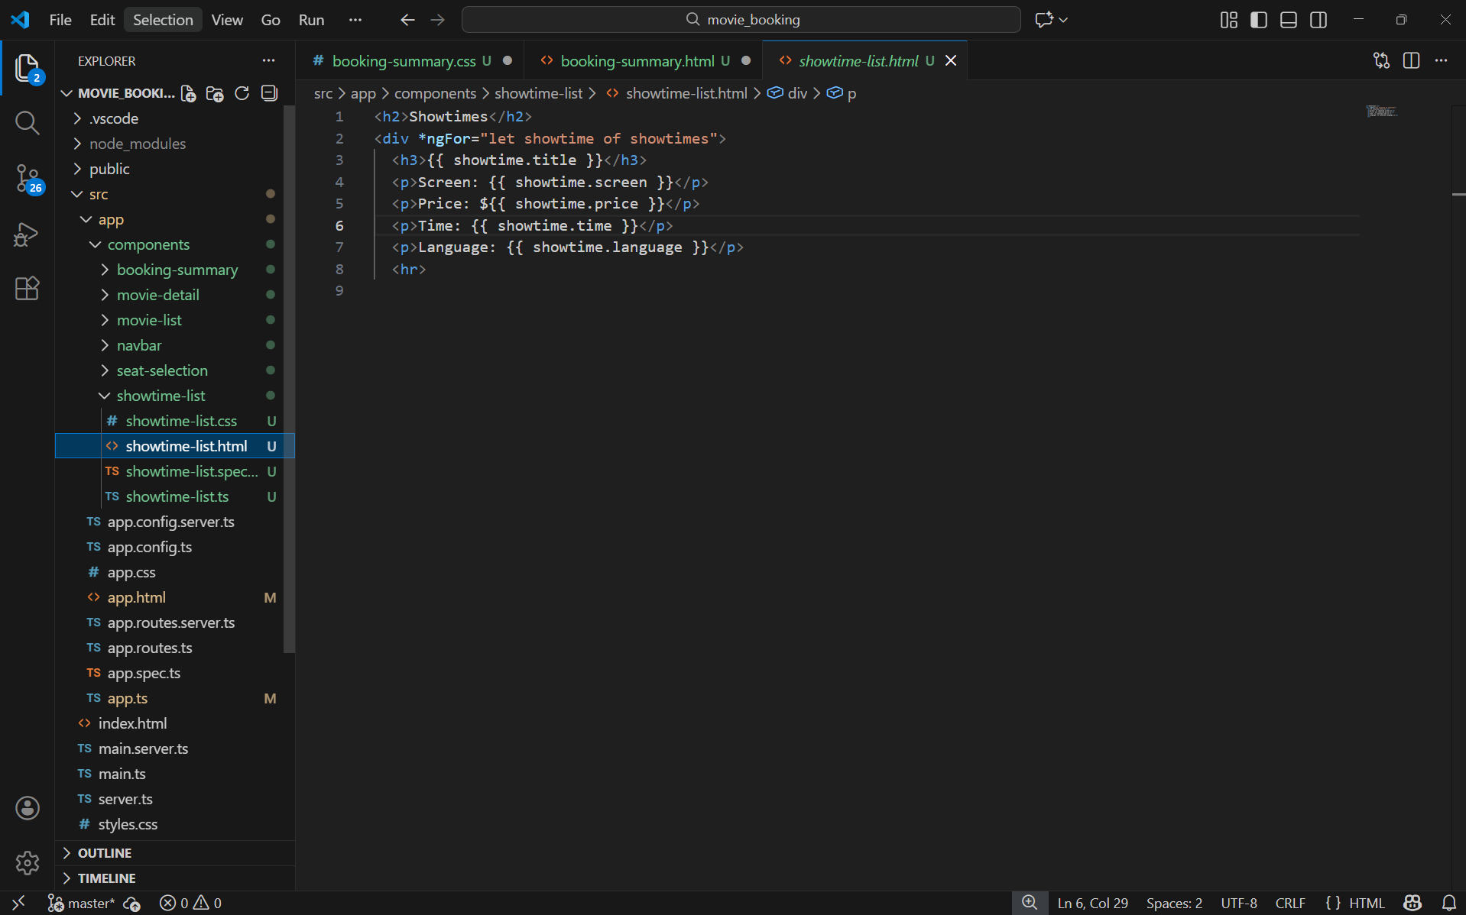
This template renders a list of showtimes using *ngFor. It displays show details such as screen, price, time, and language for each available show.
Showtime List Component (TypeScript)
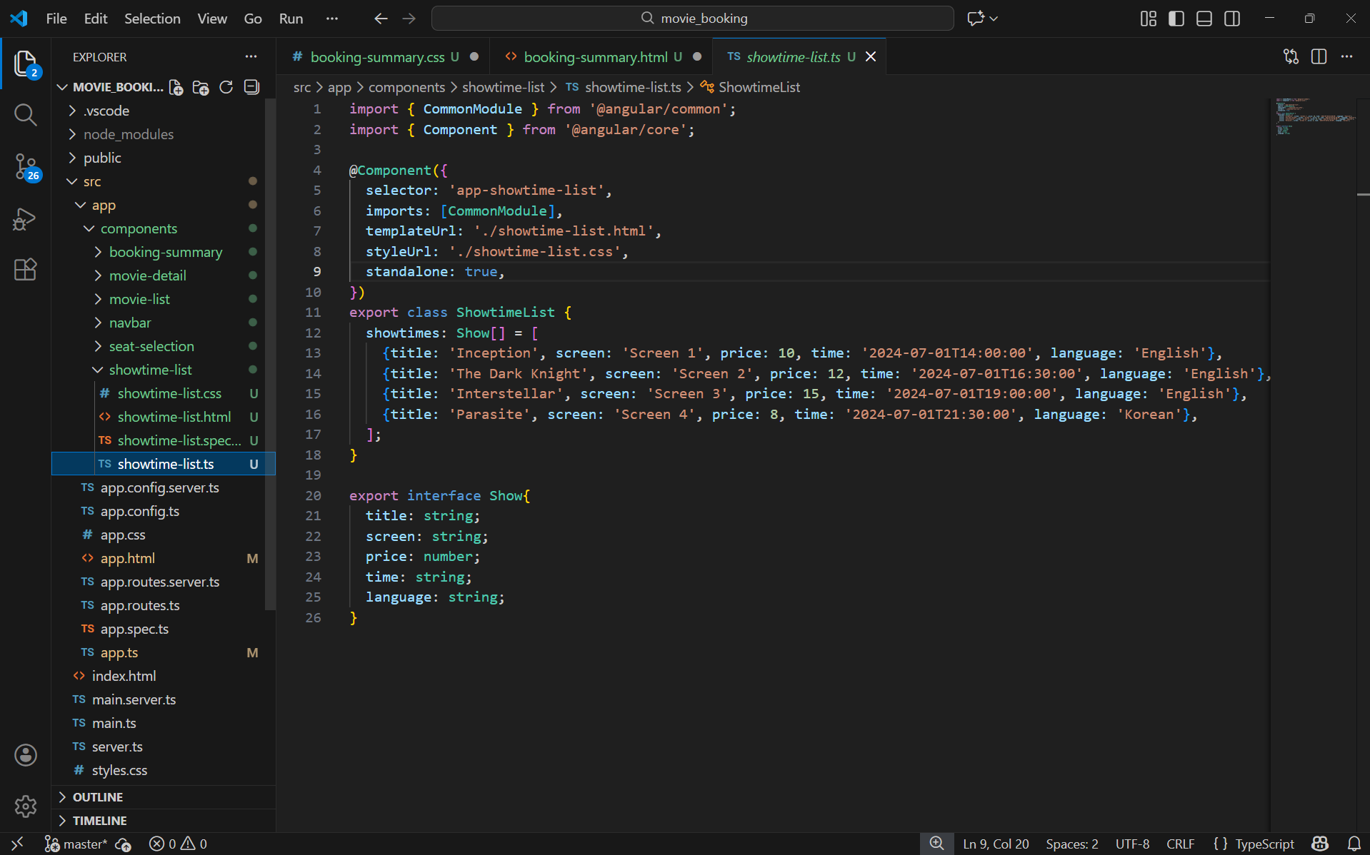
This component defines an array of showtime objects using a TypeScript interface. It supplies structured data to the template for rendering showtime listings.

