# **Practical 10: CI/CD Deployment with GitHub Actions, Render, and Vercel**

## **Code:**

### **1) GitHub Actions Workflow Configuration**

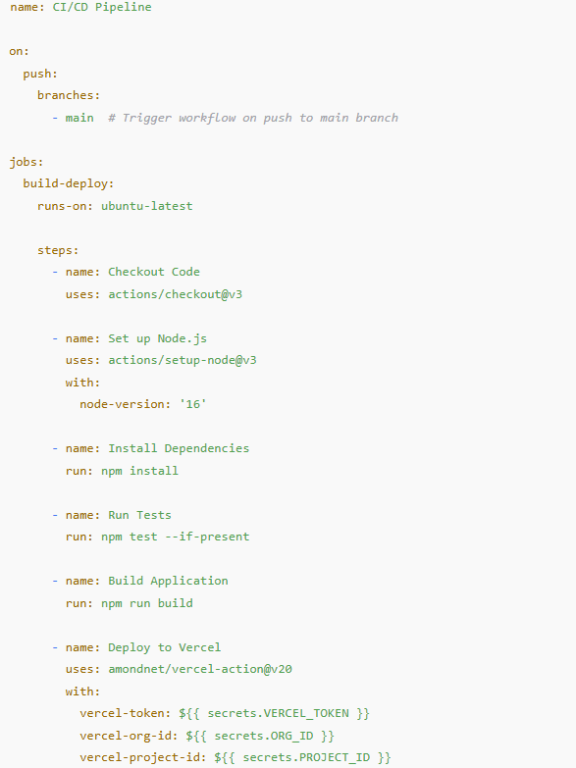

### **2) Example App.jsx (React Frontend Component)**

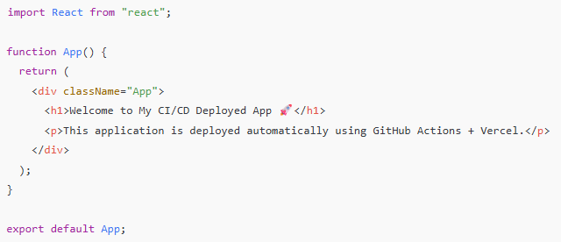

### **3) Example package.json**

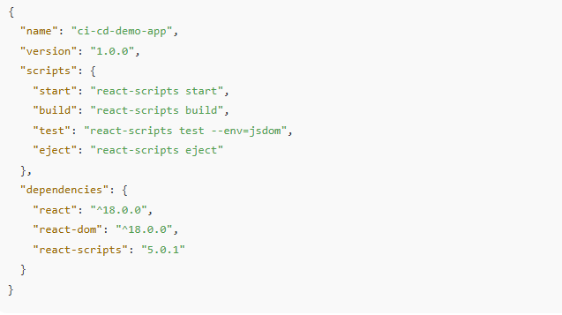

## 

## **Output:**

### **1) GitHub Repository & Actions**

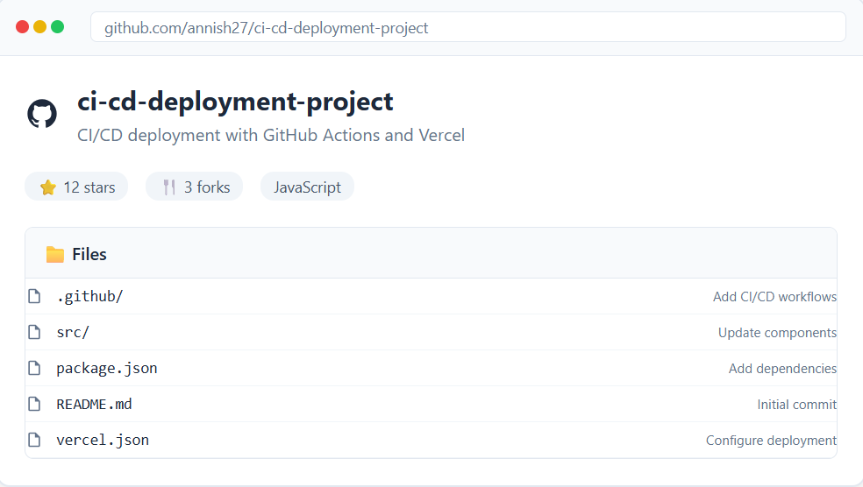

* **Fig 1:** Project GitHub Repository (show repo with workflow file in .github/workflows/)

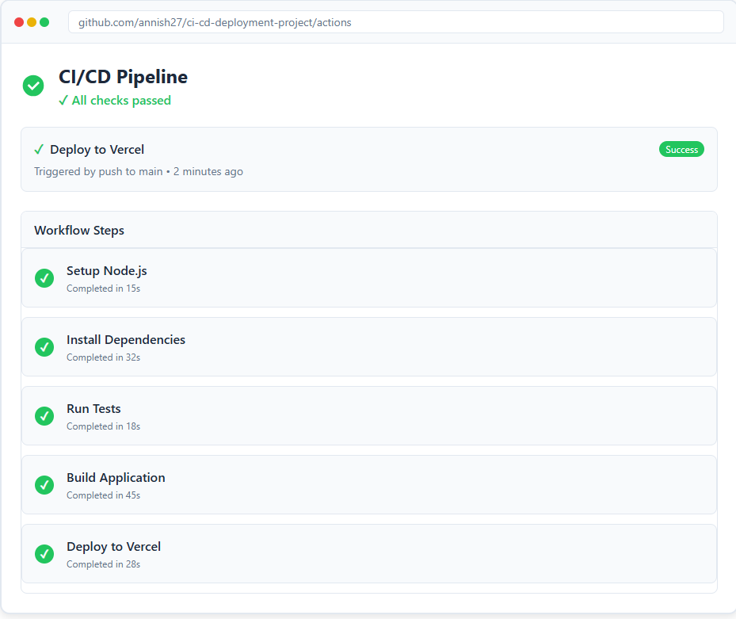

**Fig 2:** GitHub Actions Pipeline Run (successful workflow execution – build, test, deploy)

### **2) Vercel Deployment**

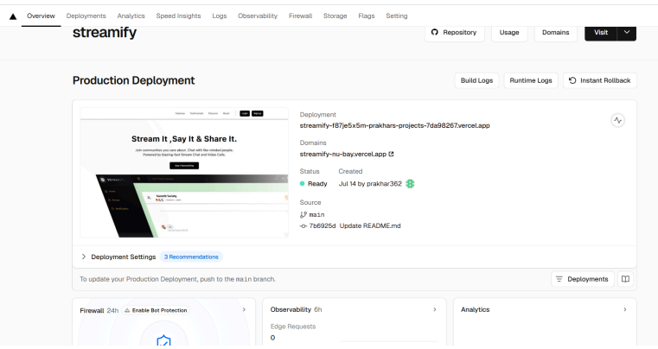**Fig 3:** Vercel Projects Page (showing deployed project)

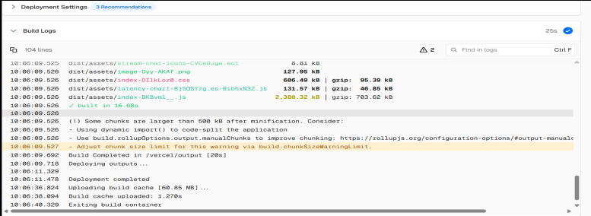

* **Fig 4:** Vercel Features Page (overview of domains, build logs, environment

settings)

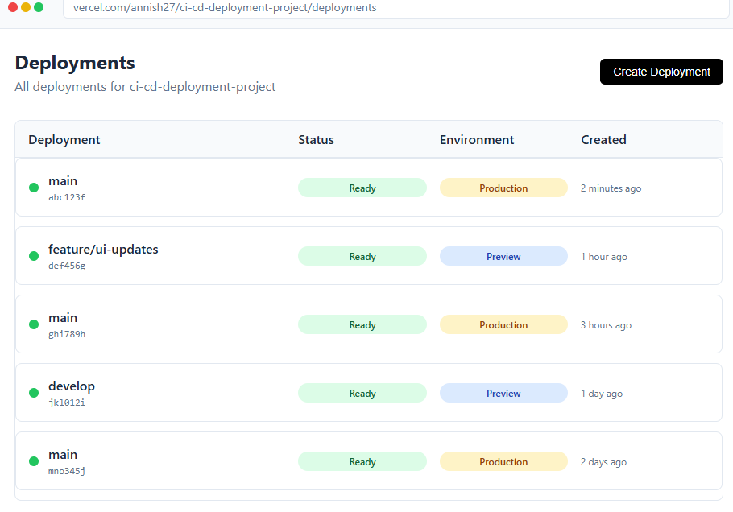

* **Fig 5:** Vercel Deployments Page (list of all deployments – preview & production)

### **3) Final Application**

### 

### **Fig 6.1:** Home Page (live app deployed on Vercel with CI/CD)

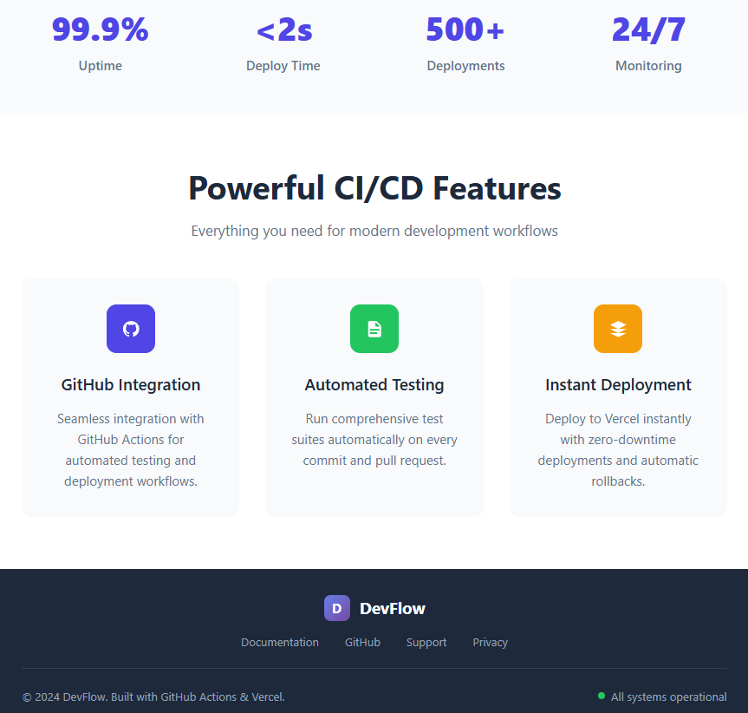

**Fig 6.2 :** Landing page for a service called DevFlow.