**Experiment No. 5**

**Aim:** Create secure, production-ready **RESTful APIs**

**Code:**

App.jsx

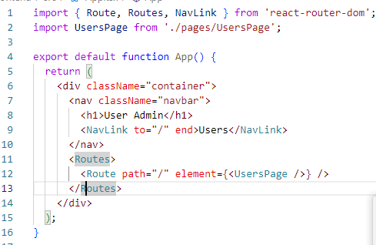

Pages/UserPage.jsx

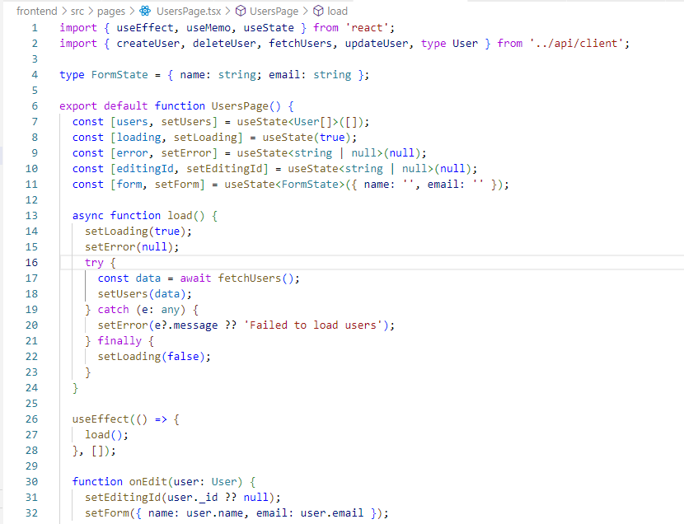

Style.css

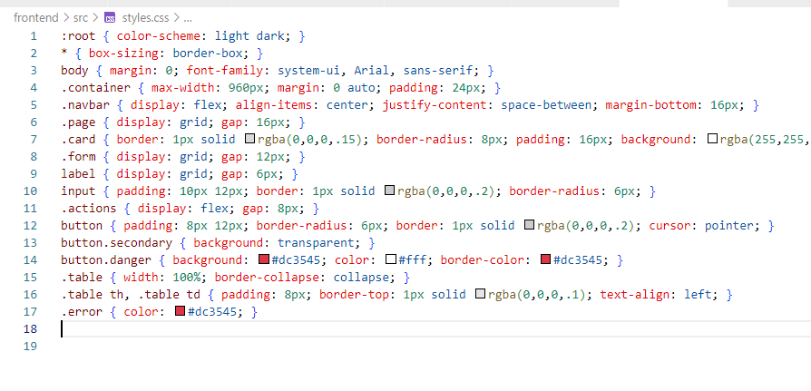

**Output:**

**Add User**

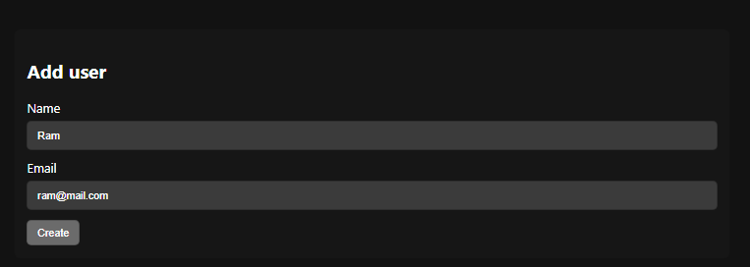

**Delete User**

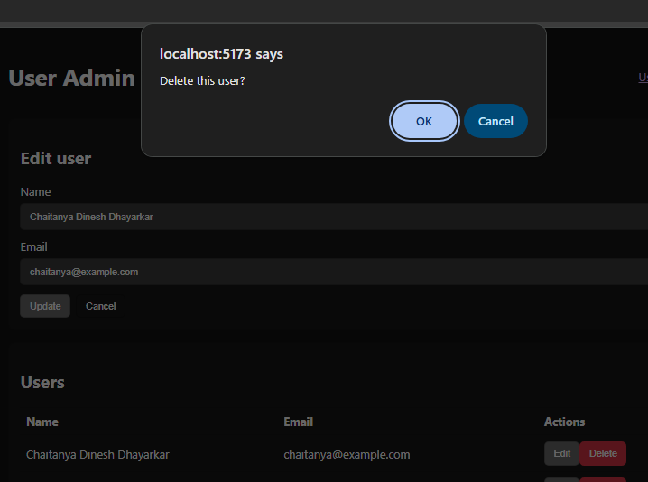

**Host on GitHub**

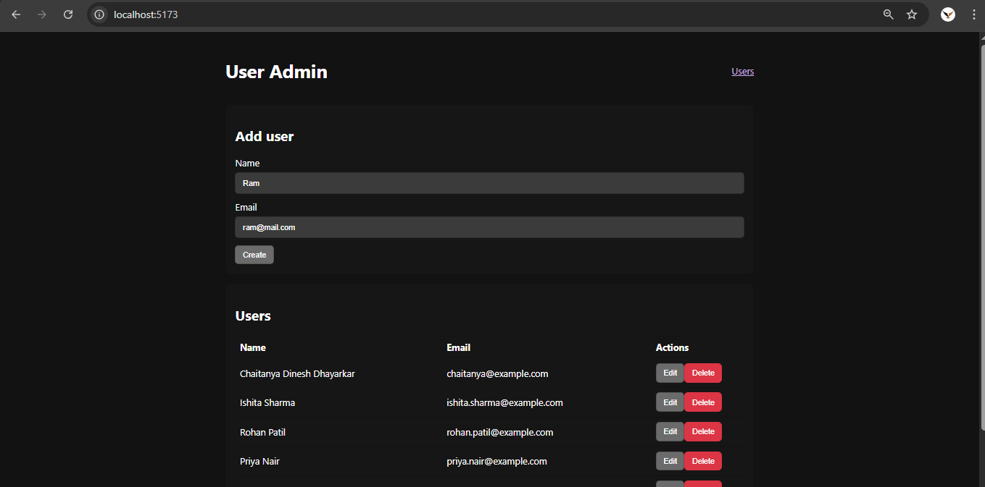

**Conclusion:**

We have successfully implemented and executed Create secure, production-ready RESTful APIs.