**Experiment No. 7**

**Aim:** Validating RESTful APIs using Postman.

**Code:**

**GET Request:**

Select GET Method:

[*https://reqres.in/api/users*](https://reqres.in/api/users)

Testing Script

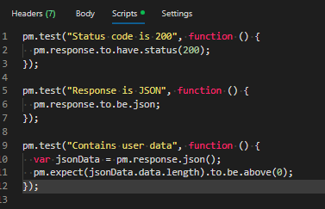

Add api_key in Authorization:



Test result

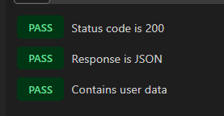

**POST Request:**

Select POST Method:

[*https://reqres.in/api/users*](https://reqres.in/api/users)

Body (JSON): Go to Body → raw → JSON → add this:

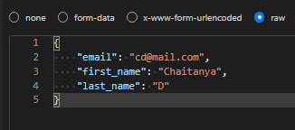

Add api_key in Authorization:



Testing Scripts: Validate POST Response

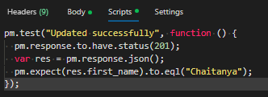

Test Result:



**PUT Request:**

Select PUT Method

[*https://reqres.in/api/users/12*](https://reqres.in/api/users/12)

*Body(JSON): Body → raw → JSON*

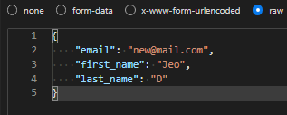

Testing script:

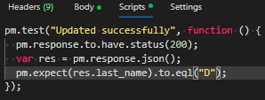

Add api_key in Authorization:



Test result:



**DELETE Request:**

Select DELETE Method:

[*https://reqres.in/api/users/1*](https://reqres.in/api/users/1)

Add api_key in Authorization:



Testing script:

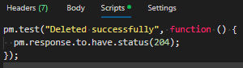

*Test Result:*

**

**Output:**

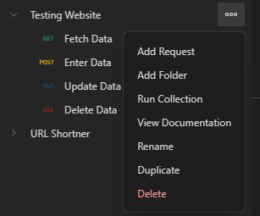

Run All Tests at Once

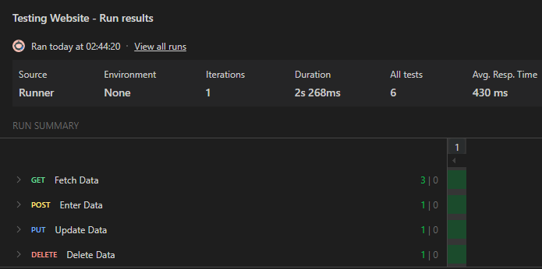

**Conclusion:**

Postman helps validate RESTful APIs by testing endpoints for correct responses, status codes, and data.

Using test scripts, we can automate checks like email format or record count, ensuring the API works as expected.